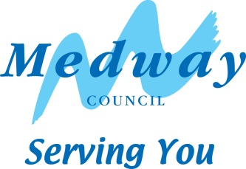
Self-Build and Custom Housebuilding Register

Total interest in self build plots for Base Periods 1-8
(1/4/2016 – 30/10/2023)

Base Period – table showing number of applications on the Register | Individuals | Associations
One (1/4/2016 – 30/10/2016) | 15 | 0
Two (31/10/2016 – 30/10/2017) | 39 | 0
Three (31/10/2017 – 30/10/2018) | 14 | 1
Four (31/10/2018 – 30/10/2019) | 14 | 1
Five (31/10/2019 – 30/10/2020) | 17 | 0
Six (31/10/2020 – 30/10/2021) | 12 | 0
Seven (31/10/2021 – 30/10/2022) | 12 | 0
Eight (31/10/2022 – 30/10/2023) | 9 | 0
TOTAL PLOTS REQUIRED INDIVIDUALS | 132 | -
TOTAL PLOTS REQUIRED ASSOCIATIONS | - | 2

No. of self/custom build plots granted planning permission since 1/4/2016:  - MC/17/3572 – 6 plots on land west of Merryboys Farm House, Cooling Common  - MC/18/0096 superseded by MC/21/2065 – 5 plots on land adjoining 35 Cooling Road, High Halstow  - MC/20/1025 – 3 plots on land at 309 Lower Rainham Road  - MC/22/1317 – 4 plots on land to the rear of Fenn House Farm, Fenn Street, St Mary Hoo | TOTAL 18
Average age of applicant | 47.9

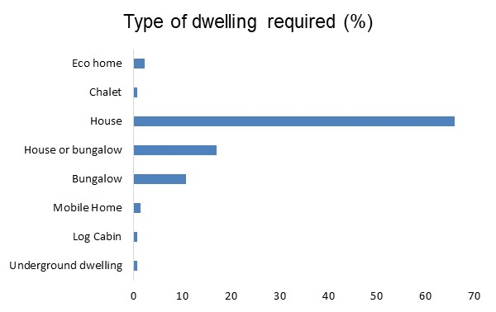
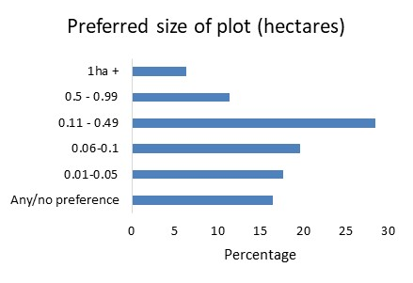

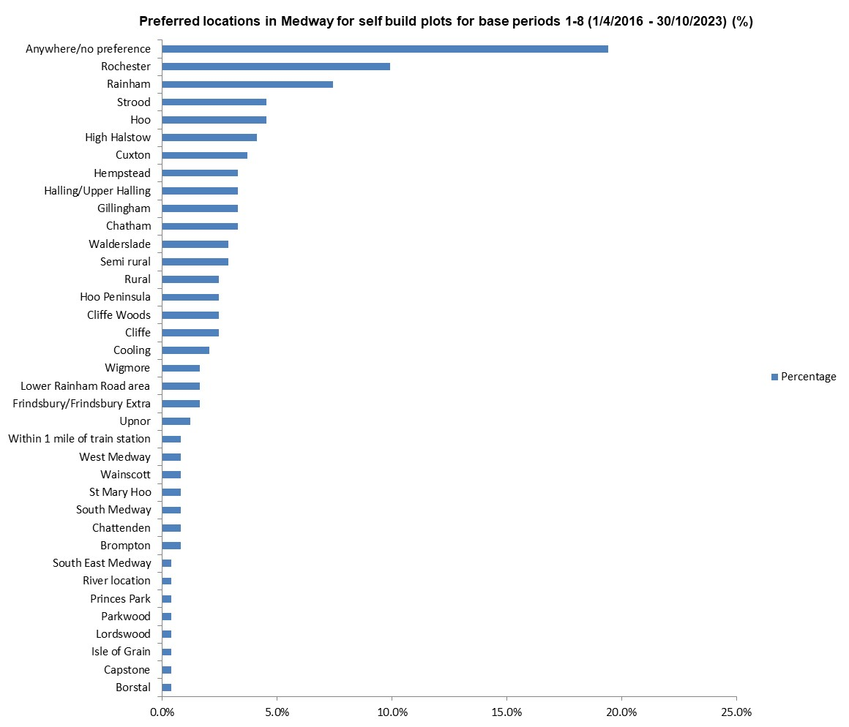

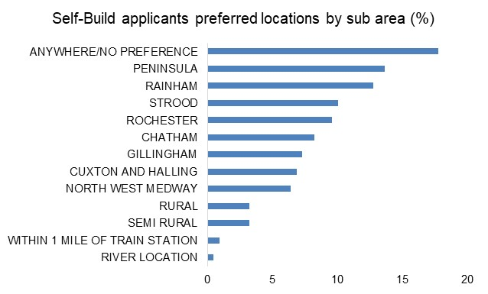
Please note: some applicants have given more than one location as a preferred area to self/custom build.

