Move in a healthy direction.
Getting started with a Workplace Wellbeing Programme

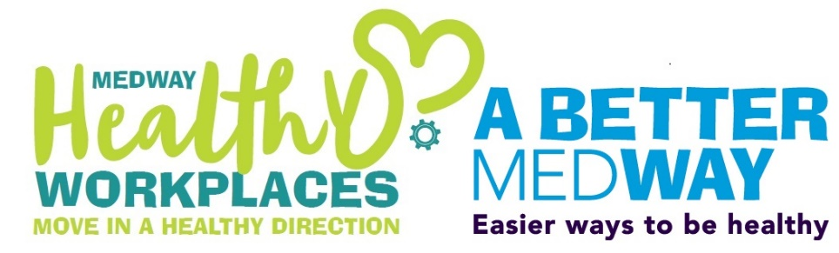

HEAL THY WORKPLACE PROGRAMME

Getting started with a Workplace Wellbeing Programme

Workplace Health programme
Health and wellbeing in the workplace: feeling great makes a big difference to creating a successful team.
Our handy health and wellbeing guide can help your business.
The programme can help to:
- reduce sickness.
- increase productivity.
- boost morale and engagement levels.
- reduce colleague absence and colleague turnover.

Determine your starting point
Firstly, identify any patterns in sickness and turnover across your organisation and look at how to address these issues. It’s important to ask your team what they need. You can have great ideas but if they don’t meet the needs and expectations of your staff, they
won’t have a lasting impact. You could conduct a staff health and wellbeing survey or simply talk to them, particularly if you have a small team. By joining the Medway Healthy Workplace programme, you can use our survey and get your free workplace health report. Any themes identified from sickness and turnover along with staff feedback provide the basis to help you set up your wellbeing plans.

Involvement
It’s vital to have Senior Management support and equally to involve staff from all levels of the organisation to drive something meaningful and
worthwhile. Speak to colleagues that can champion the wellbeing cause and assist you in the running a workplace wellness programme. You might have someone in accounts who can champion healthy eating, or a colleague keen on fitness who can share their passion and motivate others in activities during break-times or social activities after work. Consider offering training for the champions so that they feel supported in giving out the health messages. Our A Better Medway Champions Training can support this.
Action Plan

Join the Healthy Workplaces Programme and get your business moving in a healthy direction:
Workplacehealth@medway.gov.uk
01634 334307
Visit our website:
medway.gov.uk/healthyworkplace
Once you know what you need to focus on, draw up an action plan with your staff champions. Keep a track of national health campaigns (which include themed days and weeks) that could provide great resources. Use the expertise of your teams for help. You may be surprised to find colleagues with extra knowledge in keeping fit, nutrition and mental wellbeing.

Utilise
Utilise resources on offer in the community and from your own staff. You might have someone who is into fitness, or knowledgeable in mental wellbeing. Find out what local programmes, such as the Medway Healthy Workplaces programme, can offer for advice, guidance, and support.

Evaluate
Evaluate and adapt what you are offering. If something didn’t work so well, try something different next time. Annual staff surveys are a fantastic way to check on progress against the organisation’s action plan. Monitor absence rates and turnover.

Go for it
Businesses who have implemented health and wellbeing initiatives report a return on investment of between £2 and £32 for every £1 spent and with free support on offer from local councils, you can run a programme on a small budget. What better investment could you make in your business today?

