Social Isolation

Summary
Social isolation occurs when a person has little or no social interaction with other people and society. It is different from loneliness, which is concerned with negative feelings that an individual may have due to of a lack or loss of meaningful social relationships.
Social isolation can affect anyone, although, older people are one group of the population at particular risk. Older people may experience a reduction in household income, loss of a partner and deterioration of physical health. All of which can have an impact on social contact.
The concepts of social isolation and loneliness are frequently used interchangeably but are defined as two distinct concepts. Loneliness’ is a subjective negative feeling of a lack or loss of meaningful social relationships (e.g. loss of a partner or children relocating), while ‘social isolation’ is an objective measurement to indicate a lack of social interaction and relationships caused by loss of mobility or deteriorating health.[1]
It is possible to have very few social contacts or relationships without feeling lonely and conversely individuals can live a seemingly rich social life and feel lonely nevertheless.[2]

Who is at risk and why
Loneliness and social isolation can have a considerable impact on the health and wellbeing of an individual. Loneliness is associated with a range of negative health outcomes including mortality, dementia, high blood pressure, increased stress levels and suppression of the immune system .[3] Research has shown that people with stronger social relationships have a 50% increased likelihood of survival than those with weaker social relationships. This difference on survival is comparable with well-established risk factors for mortality such as smoking, obesity and physical inactivity.[3]
There are a number of population groups that have an increased vulnerability to social isolation. Older people are significantly more likely to suffer from social isolation with contributing factors being “loss of friends and family, loss of mobility or loss of income”. Other population groups at risk include, carers, refugees and those with mental health problems.[4]

Level of need in the population
It is estimated nationally that across the present population aged 65 and over, that 5%–16% are lonely [5] and 12% feel socially isolated.[6] If this estimate was applied to Medway this would result in an estimate of 4,698 people over 65 years old being socially isolated and between 1,958 and 6,264 people being lonely. Population projections for Medway highlight that the rapid increase in the ageing population, the need to plan for this across all areas of health and social care and the importance of feeling safe within the home to reduce social isolation.
In order to identify the areas within Medway where social isolation is more likely to occur, one data source to consider is the census. A crude way to do this is to use the 2011 Census to calculate the proportion of the population living alone, which can be done separately for those under 65 and those aged 65 years and over. This is a reliable source of data but does not take account of people’s circumstances in terms of health, mood, mobility and engagement with social networks.
Another way to identify areas within Medway where social isolation is more likely to occur is to use modelled estimates based on other data. MOSAIC Public Sector is a tool designed to help understand the characteristics and distribution of different types of people living within an area. It is produced by Experian Ltd and is one of a number of social-segmentation products available on the market today. The classification is built by drawing on a large database of Census and consumer demographic variables. Statistical analysis is used to identify clusters of associated variables to form distinct person types which have similar needs, attitudes or behaviours. Every household and residential postcode in the UK has been classified into a number of ‘groups’ which sub-divide into ‘types’. The underlying premise is that similar people live in similar places, do similar things and have similar lifestyles, although it is important to take account that every individual has a unique set of circumstances and values and not all of the population within a given area may have similar characteristics.
The MOSAIC social segmentation system from October 2013 has been used as the basis of this report. Although updated in 2014, the older version has been used for two main reasons:
- The background indicators are more relevant to social isolation and therefore provide a better set of proxy measures.
- The number of households of each MOSAIC type living in Medway was not available at the time of writing the report.
The results are highlighted in figures 2 and 3.
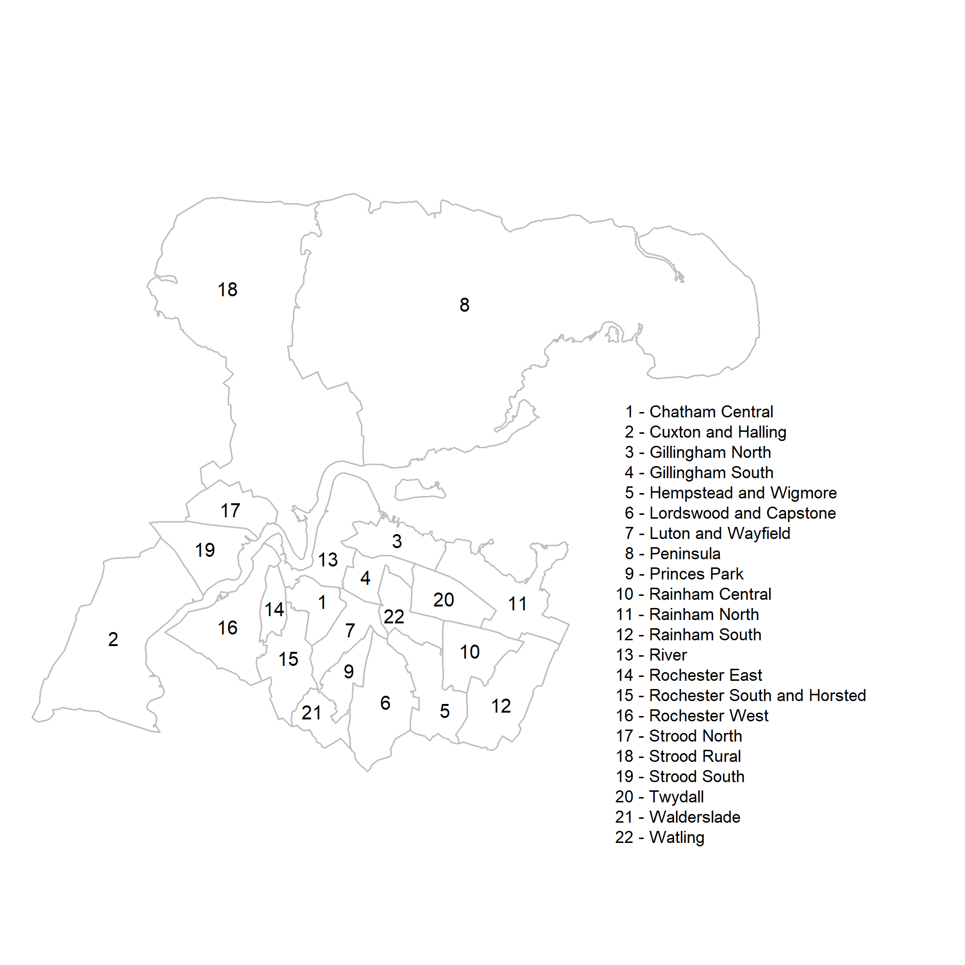
Figure 1: Medway ward map
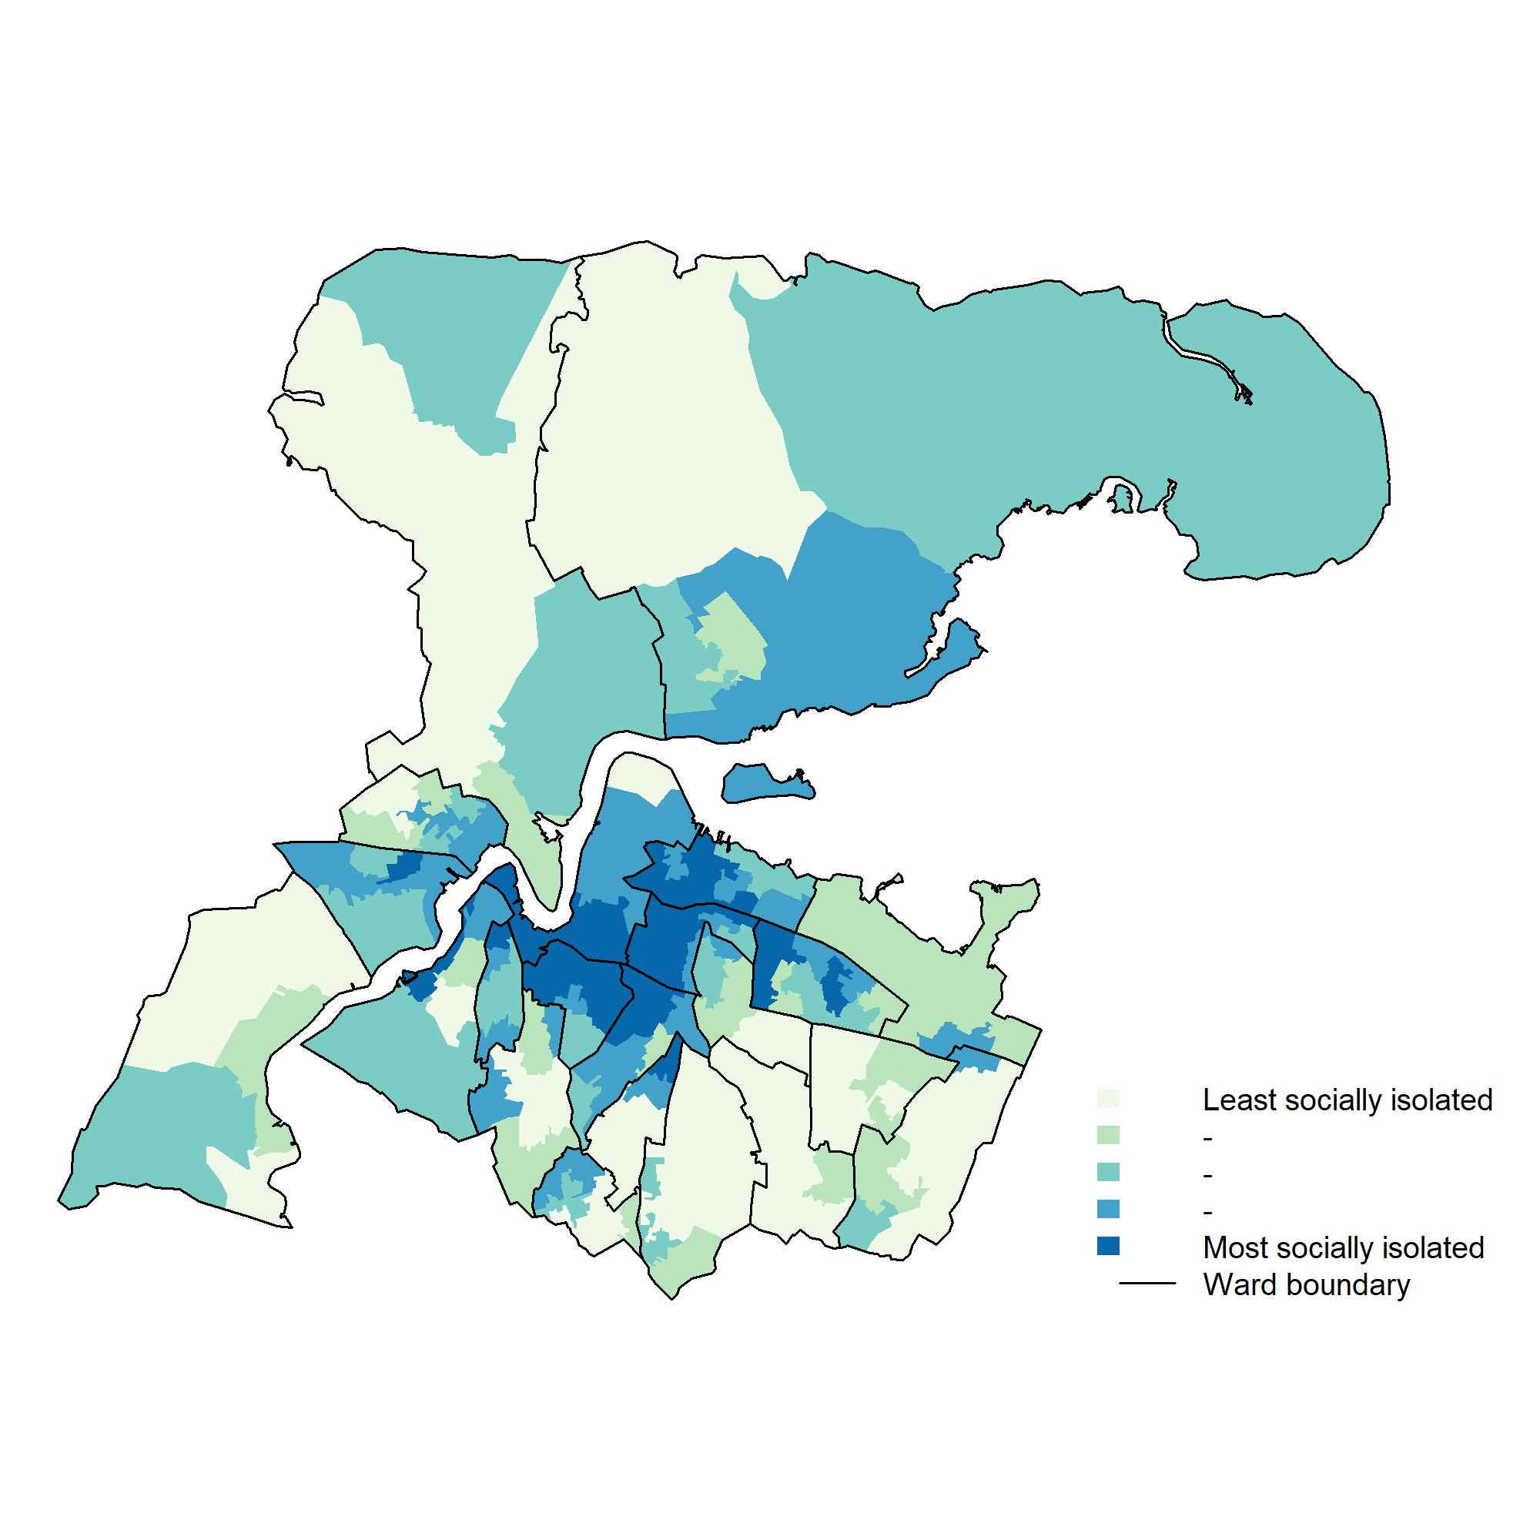
Figure 2: Relative social isolation per household at lower super output area level of persons under 65.
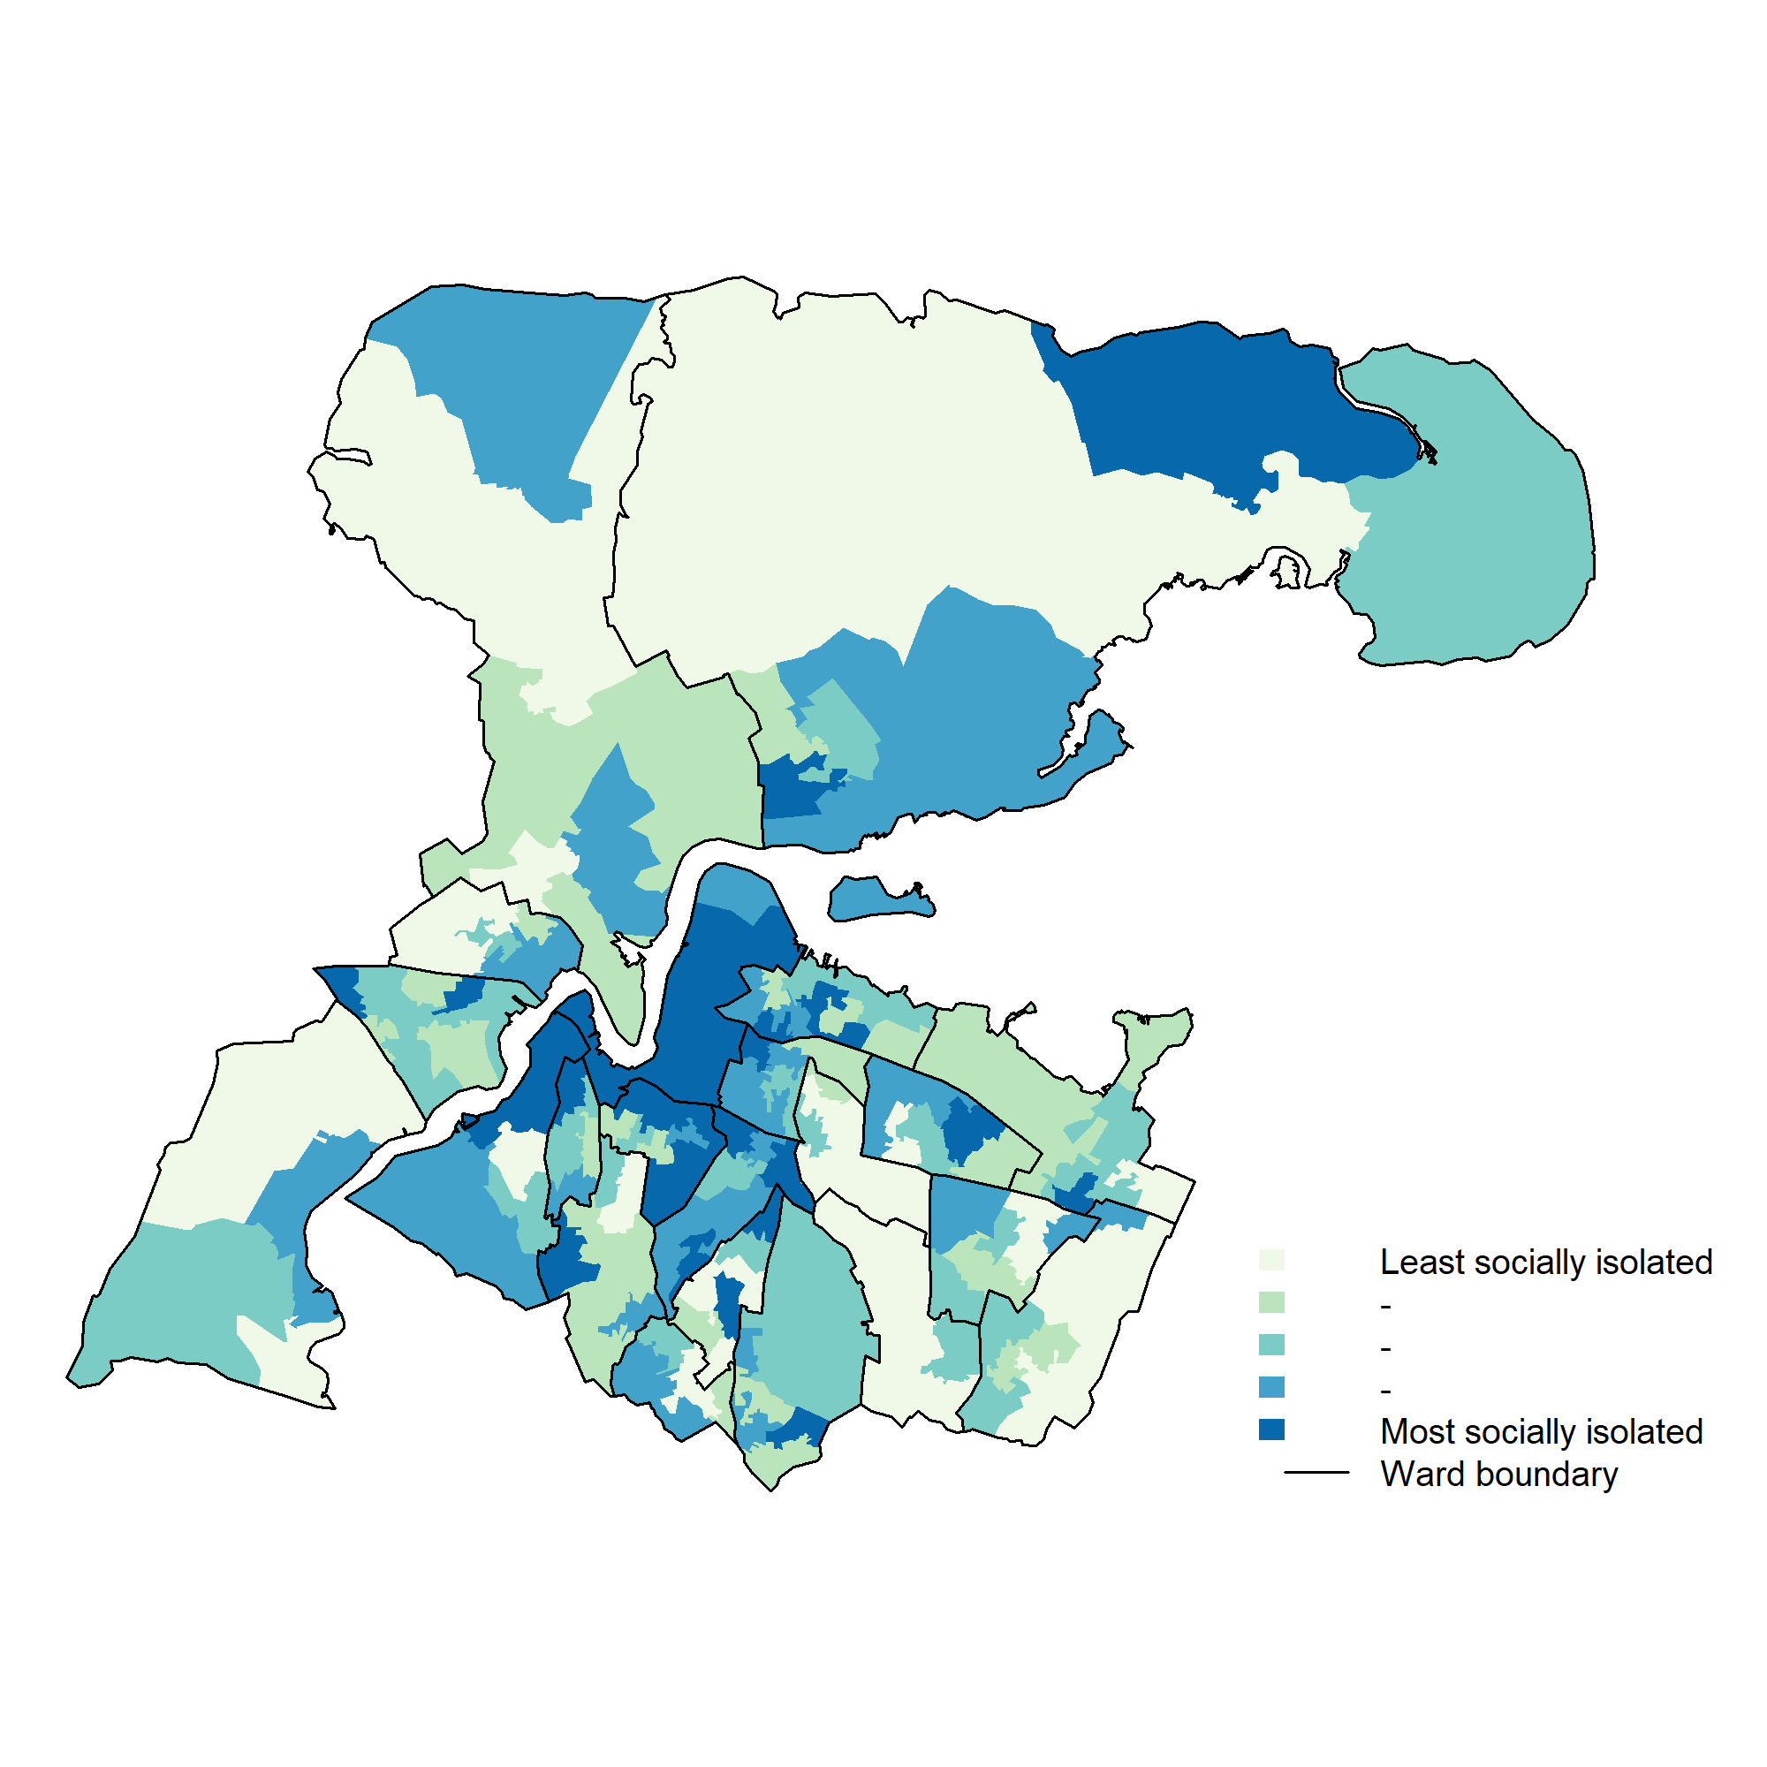
Figure 3: Relative social isolation per household at lower super output area level of persons aged 65 and over.

Figure 3 shows the estimated proportion of households for people aged 65 years old or over in Medway who are estimated to be socially isolated according to the developed composite index. Areas estimated to have the highest proportion of households that contain socially isolated people aged 65 years old or older include parts of Chatham Central, Peninsula, Princes Park, Rainham South, River, Rochester East, Rochester South and Horsted, Rochester West, Strood Rural, Strood South, Twydall and Walderslade. The map shows the specific communities where the highest proportion of households estimated to be socially isolated are located.
Figure 4 shows the distribution of a measure of health and disability for Medway. The measure includes reduced quality of life that is a result of poor mental and physical health. The areas that have the highest deprivation of health and disability are similar to ones that high levels of overall deprivation and those estimated to have relatively high levels of social isolation per for people aged below 65 years old.
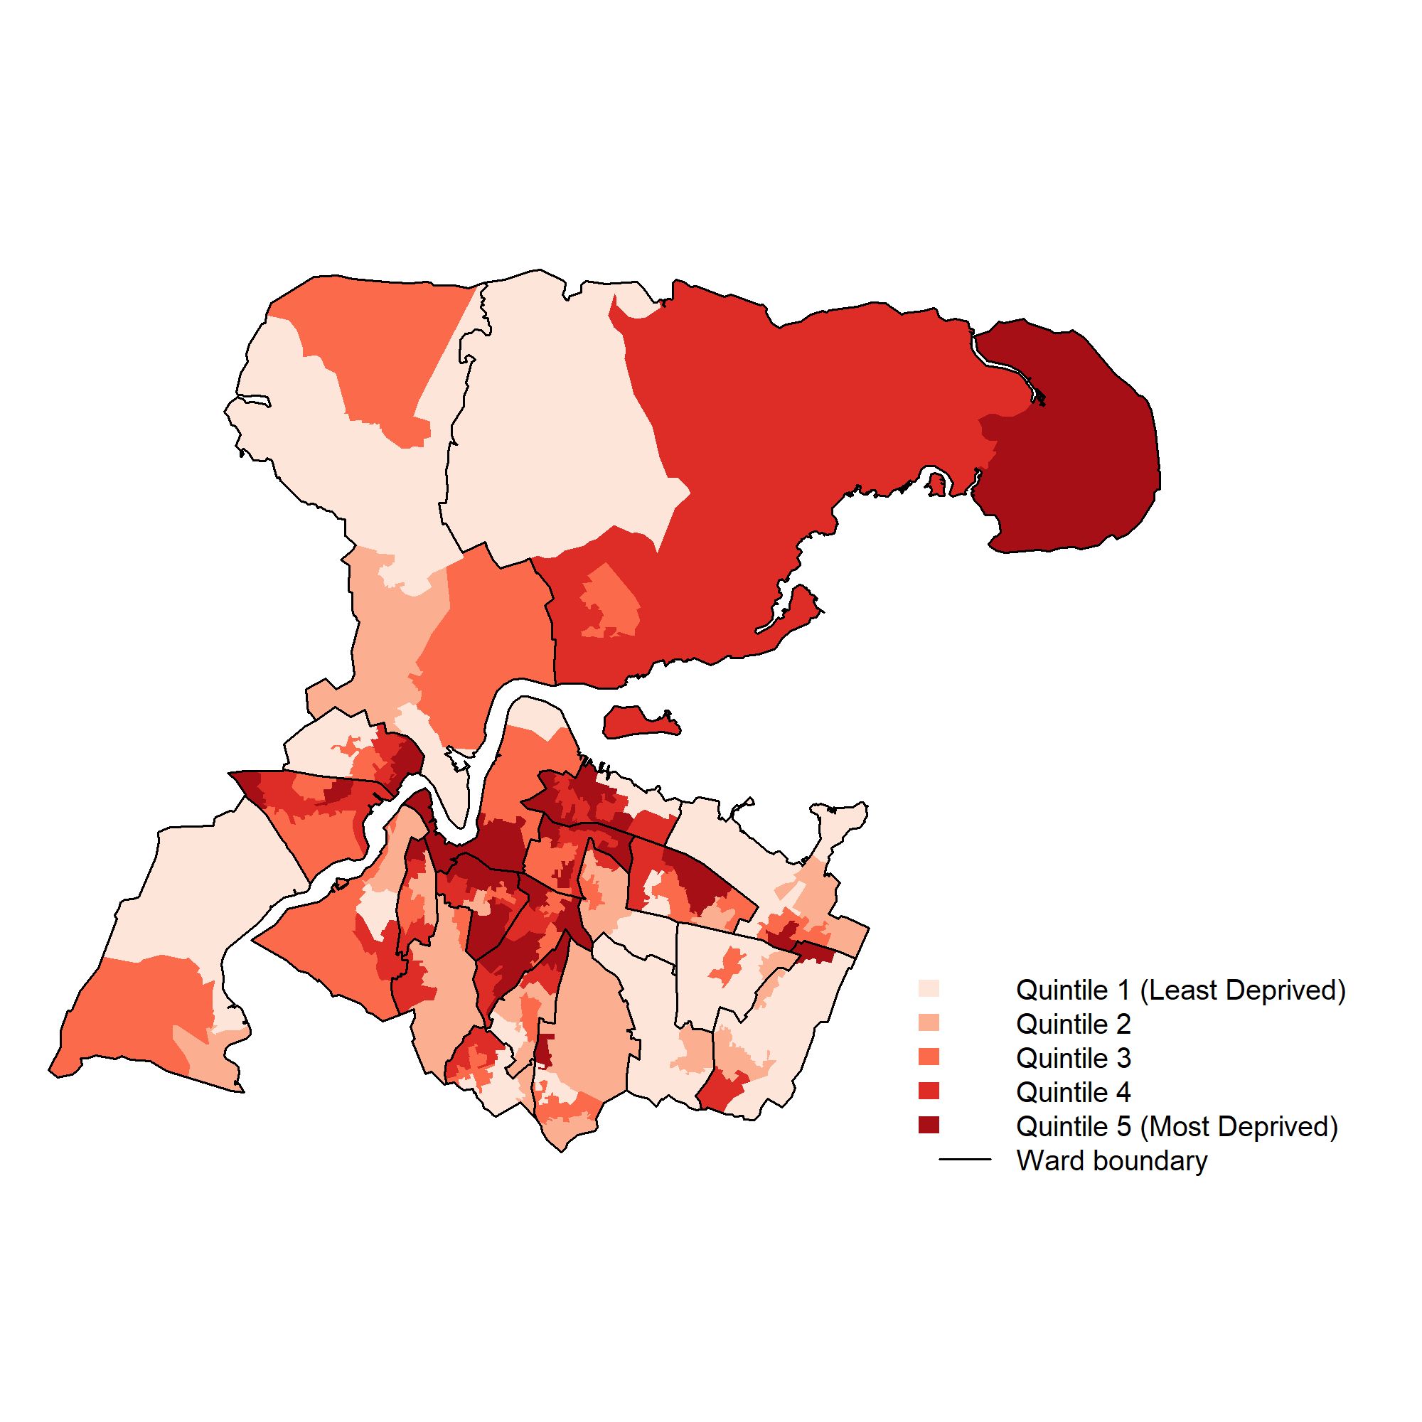
Figure 4: Health & Disability domain - IMD 2010 local quintiles for Medway using Lower Super Output Area (LSOA).

Current services in relation to need

Medway men’s health group
The focus of the group is on reducing the isolation of men. It was established in November 2013 and is supported and facilitated by Rethink. The group meets weekly at the Sunlight Centre, in Gillingham and usually over 20 men attend. The men attending the session feel that they are in a comfortable environment where they can discuss any problems or concerns that they have, receive peer support, and receive health promotion information.

Flexicare housing
Flexi-care housing in Medway is a model of supported accommodation which provides 24 hour care on site and allows older people to live as independently as possible. Flexi-care housing provides an opportunity to preserve or rebuild independent living skills which makes independent living possible for people with a range of abilities. Flexi-care is available to older people aged 55 and over including those with sensory needs, mental disorder including dementia, short- or long-term illnesses, and those who require end of life care.

Befriending schemes
The Hands & Gillingham Volunteer Centre and Rochester Hands Volunteer Bureau offer befriending schemes to provide support and information to the community and to develop the involvement of other voluntary and statutory organisations. It is offered primarily to elderly or disabled people who have difficulty leaving the house to due to their infirmity, and therefore can become isolated.
Suitable befrienders are matched to clients and visit them at home. During the visit, they can chat about everyday issues, enjoy a game of cards or encourage the client to contact old friends again. Befrienders are also able to take clients on days out to local amenities, such as the park or shops, giving them the opportunity to meet others and enjoy the fresh air. Regular contact between the client and befriender can establish a strong bond and encourage participation in community activities to encourage independence.

Leisure, arts and cultural activities delivered by Medway Council
There is currently a wealth of activities being offered across Medway including leisure (including physical activity) and education sessions delivered by Medway Adult and Community Learning Service. Medway Sport is working with partner organisations to launch initiatives such as boccia coaching for care home staff and afternoon tea dances. Medway Sport provide the Sports centre senior offer. The over 60s can enjoy a comprehensive timetable of activities at sport and leisure sites ranging from badminton, short tennis and table tennis to short mat bowls, chairobics, walking football and senior step. Most sites also offer a friendly social element with external trips and activities. The Senior Sports programme is also offered to help older people to live better, healthier lives.
Medway Libraries’ host regular groups which bring together a wide range of people who enjoy reading and talking about books

Activities delivered by volunteer organisations in Medway
Medway Voluntary Action provides a range of support to help not-for-profit organisations in Medway to assist them to be sustainable and connected. Both the voluntary sector and Medway Council offer a wide range of volunteering opportunities in local communities. Many other voluntary sector organisations such as Carers First and Age UK also support the reduction of social isolation.
The Women’s Royal Voluntary Service (WRVS) has recently opened an information centre for people over 55 in Medway. This is funded mainly by Medway Council, with a contribution from WRVS, the centre offers information and signposting on a range of issues that older people identify as being important to them. The centre is based in Central Chatham and is staffed by a team of local volunteers, led by a centre manager. In addition to the provision of information, the centre also provides the opportunity for older people to learn how to use computers. It has a small community cafe and will provide the opportunity for other organisations to hold regular ‘surgeries’ when older people can get expert advice on specific issues.

Evidence of what works
Reducing social isolation and loneliness can reduce the demand for health and social care interventions and the evidence shows that there are a number of interventions that can have a positive impact on reducing social isolation or loneliness, although the quality of the relationships in the interventions is a vital component. Also, some caution is needed when interpreting the research outcomes because there are a variety of populations that may have a different response to interventions (ie those who are very frail, those from different cultural backgrounds).

1. Befriending schemes
Butler (2006) found that befriending schemes can have a positive impact on reducing loneliness.[7] Befriending schemes are an intervention, that introduce an individual to one or more individuals, with the aim of increasing additional social support through the development of sustaining an emotion-focused relationship over time. They can include home visits by volunteers or paid workers or telephone or group support and often provided by community or voluntary organisations such as Age UK.

2. Community Navigators
Community Navigators are usually volunteers who provide ‘hard-to-reach’ or vulnerable people with emotional, practical and social support, acting as an interface between the community and public services and helping individuals to find appropriate interventions. There is evidence that people who used community navigator schemes became less lonely and socially isolated following such contact (Windle et al 2008).[8]

3. Supportive group services
Supportive group services (such as lunch clubs, bereavement support groups), and social group schemes which aim to help people widen their social circles can be effective in reducing loneliness and social isolation. A study by Savikko et al. (2010) showed a support group that offered social group activities (‘art and inspiring activities’, ‘group exercise and discussion’ and ‘therapeutic writing and group therapy’) reported that 95 per cent of the participants (mean age 80) felt that their feelings of loneliness had been alleviated during the intervention.[9] Pitkala et al. (2009) found that group based interventions that included art and cultural activities (eg music sessions, cultural events and sights, and production of their own art) and exercise and health discussion groups, (eg walking, strength training, swimming, or senior dancing) had a significant reduction in measured hospital bed days, physician visits and outpatient appointments.[10] A systematic review by Dickens et al (2011) found that sessions offering social activity and/or support within a group format were effective in alleviating social isolation.[11]

4. Mentoring schemes
Mentoring schemes involve working with people with the goal of providing clients with the necessary skills and abilities to ensure that they are able to continue and sustain any achieved change following withdrawal of the service. There is evidence that mentoring schemes can have a positive impact in improving symptoms of depression and after 12 months follow-up.[6]
There is very limited evidence on the cost-effectiveness of interventions to reduce social isolation or loneliness and it is relatively complex to measure accurately. Knapp et al (2010) demonstrated the economic impact of Befriending Interventions and Community Navigators, compared with what might have happened in the absence of any such service.[12] Along with the costs of ‘formal’ service provision, those unpaid ‘resources’ and ‘opportunity costs’ provided by family and/or informal carers were included. They found that a typical service for befriending would cost around £80 per older person within the first year and provides about £35 in ‘savings’ due to the reduced need for treatment and support for mental health needs. Pitkala et al. (2009) estimated cost-savings of supportive closed groups and found that there was a saving of €62 per person due to a reduction of hospital bed days, physician visits and outpatient appointments.[10] This saving took the cost of the intervention into account.

User views
A total of seven focus groups were undertaken to find out more about the views of population groups in Medway at risk of social isolation. Focus groups were undertaken with older people (Age UK day centre in Gillingham), carers (Carers First support group), mental health service users (MEGAN support group), black and minority ethnic communities (two groups were undertaken, one with the Medway BME Forum and the other with the Medway African and Caribbean Association), residents from Peninsula ward (parents at Grain Sure Start group) and a men’s health support group (weekly group, based at the Sunlight Centre, Gillingham facilitated by Rethink Mental Illness).
A number of key themes emerged from the focus groups that included access barriers influencing isolation, transport, involvement of communities, information, what works well currently and solutions. Key points from these themes were utilised in the development of the first social isolation strategy for Medway 2014-2018.

Unmet needs and service gaps
- Identifying people at risk of loneliness can be difficult, but targeting those disproportionately affected by loneliness – lower socio-economic groups, the widowed, the physically isolated, people who have recently stopped driving, those with sensory impairment and the very old – has proven most effective.
- Individuals within local communities should be encouraged to take some responsibility for identifying, ‘reaching out’ and supporting potentially isolated people within their own area. In order to achieve this, statutory, voluntary and community organisations need to work in partnership to build greater community capacity and better social outcomes for risk populations. The DERIC project which is being piloted in Medway and looks to do this should be supported.
- Reducing social Isolation needs to be built in to care pathways for a range of different conditions. Health professionals should be mindful of the effects that social isolation have on health and refer into a befriending group or community group.
- We will ensure that we will continue to offer the wide range of high quality services that are currently available across Medway in leisure centres, libraries and adult education centres.
- Ensuring that social isolation is embedded in any relevant future strategies and JSNA chapters.
- There is a need to undertake marketing and promotional work to raise the profile of social isolation in the Medway population.
- There is a need to improve awareness of social isolation via training among frontline professionals that include; health professionals, social care workers, community safety wardens, housing officers, community development workers and floating support staff. The increased knowledge will help them to have an increased awareness of the risks of social isolation and knowledge of how to address it.
- It is important to ensure we utilise opportunities to work with faith groups as partners to identify and support people at risk of being isolated.
- There is a need to utilise the opportunity from public health programmes to target raising awareness for social isolation and signpost people to support and activities. Examples of programmes include health checks, stop smoking, substance misuse.
- It is important to improve the availability of information and advice on existing services and activities that reduce loneliness and isolation. Local authority websites, book and social network groups, sports clubs, art groups, transport links and volunteering opportunities can all help reduce social isolation. It is important to ensure that information on these activities are available in day centres, health centres, schools, youth projects, housing offices and other settings within the local community.
- Evaluation is a key component of any future programmes in Medway. Self-reporting is regarded as the best means of measuring social isolation and loneliness amongst older people. Measurements using valid scales such the Friendship Scale should be utilised. In order to assess whether specific programmes are able to change individuals’ quality of life, or impact on their care pathway, participants need to be asked their views before the start of the intervention as well as following it.

Recommendations
- Interventions that have an evidence base of being effective to reduce social isolation, such as befriending programmes, should be considered for further commissioning support.
- Frontline health and social care workers should receive training and information that will help them to have an increased awareness of the risks of social isolation and find ways to connect people to activities or organisations that can help.
- There should be an emphasis to support people to engage with the wide range of opportunities (i.e. leisure facilities, drama groups) in Medway which would address social isolation. A greater understanding of people’s behaviour in terms of what would make them utilise facilities is needed. This could be undertaken via action research.
- To ensure the development of the care navigator programme appropriately signposts the population in Medway to improve the interface between the community and public services in helping socially isolated individuals to find appropriate interventions.
- There is a need to increase the number of supportive groups in Medway, such as the men’s health group operating at the Sunlight Centre to support vulnerable populations at risk of being socially isolated.

References
1 Biordi DL, Nicholson NR. Social isolation in: Larsen, p.d. And lubkin, i.m. (Eds) chronic illness: Impact and intervention (7th ed). London:Jones; Bartlett Publishers 2008.
2 Coyle CE, Dugan E. Social isolation, loneliness and health among older adults. Journal of aging and health 2012;24 (8):1346–63.
3 Holt-Lunstead S J., Layton JB. Social relationships and mortality risk: A meta-analytic review. PLoS Medicine 2010;7 (7):doi:10.1371/journal.pmed. 1000316.
4 Excellence SCI for. Research briefing 39. Preventing loneliness and social isolation: Interventions and outcomes. 2011.http://www.scie.org.uk/publications/briefings/files/briefing39.pdf
5 O’Luanaigh C, Lawlor BA. Loneliness and the health of older people. International Journal of Geriatric Psychiatry 2008;(23):1213–21.
6 Greaves CJ, Farbus L. Effects of creative and social activity on the health and well-being of socially isolated older people: Outcomes from a mulit-method observational study. The Journal of the Royal Society for the Promotion of Health 2006;126 (3):136–42.
7 Butler SS. Evaluating the senior-companion program: A mixed-method approach. Journal of Gerontological Social Work 2006;47 (1-2):45–70.
8 Windle G, Hughes D, Linck P, et al. Public health interventions to promote mental well-being in people aged 65 and over: Systematic review of effectiveness and cost-effectiveness. University of Wales Bangor: Institute of Medical; Social Care Research 2007.
9 N. Savikko RT P. Routasalo, Pitkala K. Psychosocial group rehabilitation for lonely older people: Favourable processes and mediating factors of the intervention leading to alleviated loneliness. International Journal of Older People Nursing 2010;5 (1):16–24.
10 Pitkala R K. H., Tilvis RS. Effects of pyschosocial group rehabiliation on health, use of health care services, and mortality of older persons suffering from loneliness: A randomised, controlled trial. Journal of Gerontolgy: Medical Sciences 2009;64A (7):792–800.
11 Dickens R A. P., Campbell JL. Interventions targeting social isolation in older people: A systematic review. BMC Public Health 2011;11:647.
12 Knapp B M., Snell T. Building community capacity: Making an economic case, PSSRU discussion paper 2772. London: PSSRU 2010.

