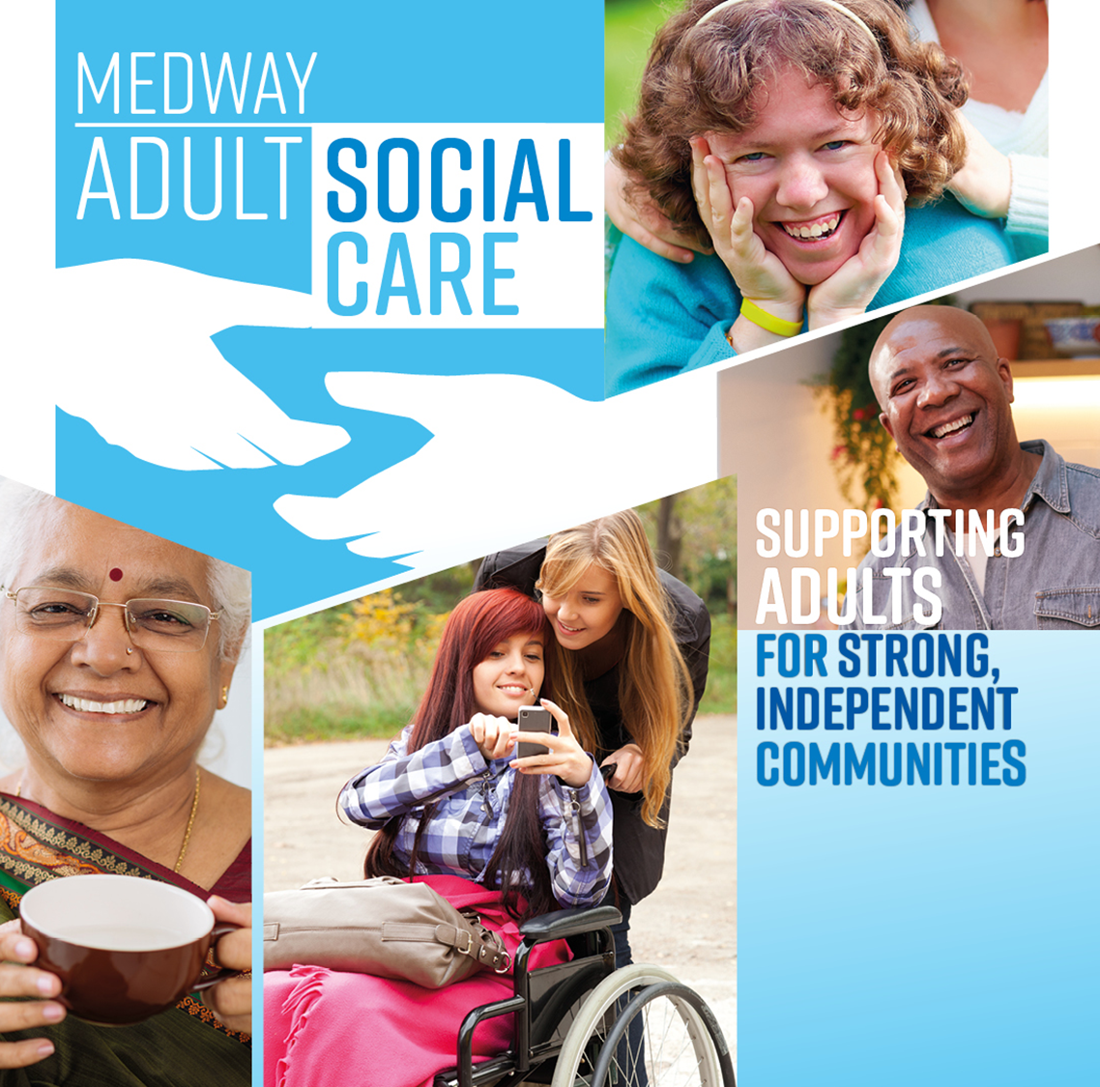
Adult social care
Eligibility criteria for individuals and carers
March 2023

Eligibility criteria for adult social care and support
The national eligibility criteria ensure that all local authorities meet the same minimum level of needs. If an adult meets the three elements of the criteria detailed below and is ordinarily resident in Medway, we have a duty to ensure their needs are met:
- The adult’s needs arise from or are related to a physical or mental impairment or illness.
- As a result of the needs, they are unable to achieve two or more specified outcomes (see Appendix A).
- As a consequence, there is or is likely to be, a significant impact on their wellbeing.
The Care Act does not require that individuals have a formal diagnosis of a physical or mental impairment or illness. Instead, local authorities must make a judgement based on the assessment process.
However, assessors will need to be assured that an individual’s needs are not caused by circumstantial factors, but by a physical or mental impairment.

Carer’s eligibility criteria
The Care Act introduces national eligibility criteria for carers. Eligibility is based on the impact a carer’s needs for support has on their wellbeing. A carer will have eligible needs if:
- their needs arise as a consequence of providing necessary care for an adult
- as a result of their needs, their health is deteriorating or is at risk or they are unable to achieve specified outcomes (see Appendix A)
- as a consequence, there is or likely to be, a significant impact on a carer’s wellbeing
Eligibility determination is made regardless of whether or not the adult who the carer cares for has eligible needs.
The carer must, however, be providing ‘necessary’ care. If the carer is providing care and support for needs which the adult is capable of meeting themselves, the carer may not be providing necessary support.

How do I arrange an assessment?
An assessment must be provided to all people and carers who appear to need care and support, regardless of their finances or whether the local authority thinks their needs will be eligible.
To get a social care assessment email us on ss.accessandinfo@medway.gov.uk or call 01634 334 466.

If you’re in hospital
If you are in hospital, you can get your social care needs assessed while you are there by asking to speak to your hospital social worker about support when you return home.
You can also get support from:
- reablement care which can help you relearn your everyday skills, mobility and independence. Call 01634 334 466 for an assessment
- a care home if you think you can no longer manage at home.
An assessment could be an individual assessment or a combined assessment with a carer and the person for whom they care.
Where relevant, it could be undertaken jointly with contribution from others, including the NHS.
A copy of the assessment will be sent to you. This will clearly indicate whether you are eligible for support.

What if my needs do not meet the eligibility criteria?
If you do not meet the eligibility criteria, we may look at what can be suggested or is on offer to meet your needs. For example, this may include suggesting services available to you in your community.
We may encourage an individual to seek medical diagnosis or support from healthcare services where appropriate. In exceptional circumstances, we may offer funded support.
We are not under any legal duty to meet non-eligible needs.

What can I do if I don’t agree with the assessment?
We should always discuss with you if you do not agree with the assessment, and we must record any differences of view.
Both you or your representative must always be informed of your right to make a complaint using our complaints procedure if you remain unhappy with our assessment and decision.
Section 13 of the Care Act 2014; The Care and Support (Eligibility Criteria) Regulation 2014 and Section 6 of Care Act Statutory Guidance provide further details on eligibility and the eligibility criteria.

Appendix A: The Care and Support (Eligibility Criteria) Regulations 2014

Needs which meet the eligibility criteria: adults who need care and support
An adult’s needs meet the eligibility criteria if:
- they arise from or are related to a physical or mental impairment or illness
- as a result of them, he or she is unable to achieve two or more of the outcomes specified below
- as a consequence, there is or is likely to be, a significant impact on the adult’s wellbeing.
The specified outcomes are:
- managing and maintaining nutrition
- maintaining personal hygiene
- managing toilet needs
- being appropriately clothed
- being able to make use of the adult’s home safely
- maintaining a habitable home environment
- developing and maintaining family or other personal relationships
- accessing and engaging in work, training, education or volunteering
- making use of necessary facilities or services in the local community including public transport, and recreational facilities or services
- carrying out any caring responsibilities the adult has for a child
For the purposes of this regulation, an adult is to be regarded as being unable to achieve an outcome if he or she is:
- unable to achieve the outcome without assistance
- able to achieve it without assistance, but doing so causes the adult significant pain, distress or anxiety
- able to achieve the outcome without assistance, but doing so endangers or is likely to endanger the health or safety of the adult, or of others
- able to achieve it without assistance but this takes significantly longer than would normally be expected
In determining whether the adult’s needs meet the eligibility criteria, and where the level of an adult’s needs fluctuates, we must take into account the adult’s circumstances over such period as we consider necessary to establish accurately the adult’s level of need.

Needs which meet the eligibility criteria: carers
A carer’s needs meet the eligibility criteria if:
- they arise as a consequence of providing necessary care for an adult
- the effect of them is that any of the circumstances specified below apply to the carer
- as a consequence of the above, there is or is likely to be, a significant impact on the carer’s well-being
The circumstances specified are as follows:
- The carer’s physical or mental health is or is at risk of, deteriorating.
- The carer is unable to:
  - carry out any caring responsibilities the carer has for a child
  - provide care to other persons for whom the carer provides care
  - maintain a habitable home environment in the carer’s home (whether or not this is also the home of the adult needing care)
  - manage and maintain nutrition
  - develop and maintain family or other personal relationships
  - engage in work, training, education or volunteering
  - make use of necessary facilities or services in the local community, including recreational facilities or services
  - engage in recreational activities
For the purposes of the circumstances listed above a carer is to be regarded as being unable to achieve an outcome if they are:
- unable to achieve the outcome without assistance
- able to achieve it without assistance, but doing so causes the carer significant pain, distress or anxiety
- able to achieve the outcome without assistance, but doing so endangers or is likely to endanger the health or safety of the carer, or of others
In determining whether the carer’s needs meet the eligibility criteria, and where the level of a carer’s needs fluctuates, we must take into account the carer’s circumstances over such period as we consider necessary to establish accurately the carer’s level of need.

