Hoo St Werburgh and Chattenden
Local Green Space Assessment
July 2022
[Amended 01.12.2022]

Introduction

This report has been prepared as part of the evidence base for the Hoo St Werburgh and Chattenden Neighbourhood Plan. It considers potential spaces for Local Green Space (LGS) designation, against the context of national planning policy and guidance.

The report has been prepared by C Chester and A Wells on behalf of Hoo St Werburgh & Chattenden Parish Council Neighbourhood Plan Steering Group.

- National Policy

The National Planning Policy Framework 2021 sets out the criteria for designating Local Green Space, As follows:

101. The designation of land as Local Green Space through local and neighbourhood plans allows communities to identify and protect green areas of particular importance to them. Designating land as Local Green Space should be consistent with the local planning of sustainable development and complement investment in sufficient homes, jobs and other essential services. Local Green Spaces should only be designated when a plan is prepared or updated, and be capable of enduring beyond the end of the plan period.

102. The Local Green Space designation should only be used where the green space is:
a) in reasonably close proximity to the community it serves;
b) demonstrably special to a local community and holds a particular local significance, for example because of its beauty, historic significance, recreational value (including as a playing field), tranquillity or richness of its wildlife; and
c) local in character and is not an extensive tract of land.

103. Policies for managing development within a Local Green Space should be consistent with those for Green Belts.

This criteria has been used as the basis for the following analysis of potential Local Green Space designations.

Analysis of Sites

3.1 Village Green

Church Street, Hoo Grid Reference: TQ784721

Plan

Community Value

The Village Green is a small open space in the centre of Hoo St Werburgh adjacent to local shops, a supermarket and pub. The space is used for recreation, a meeting place and an occasional market. There are take-away outlets where lunch can be obtained and the area is landscaped with flowers and shrubs and has seating for the local community. The space is owned by Medway Council and maintained by Medway Norse. There is a bus stop nearby. The Village Green provides a visual and social focal point for Hoo.

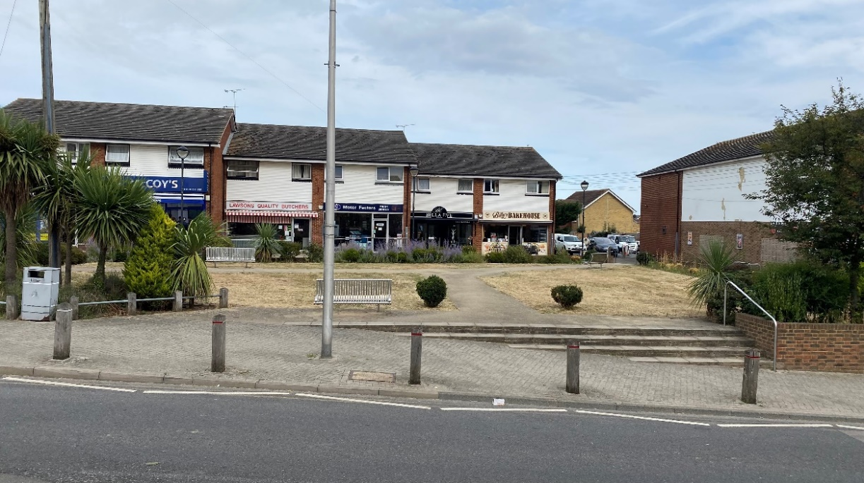
Looking across the Village Green toward the shops and food outlets.

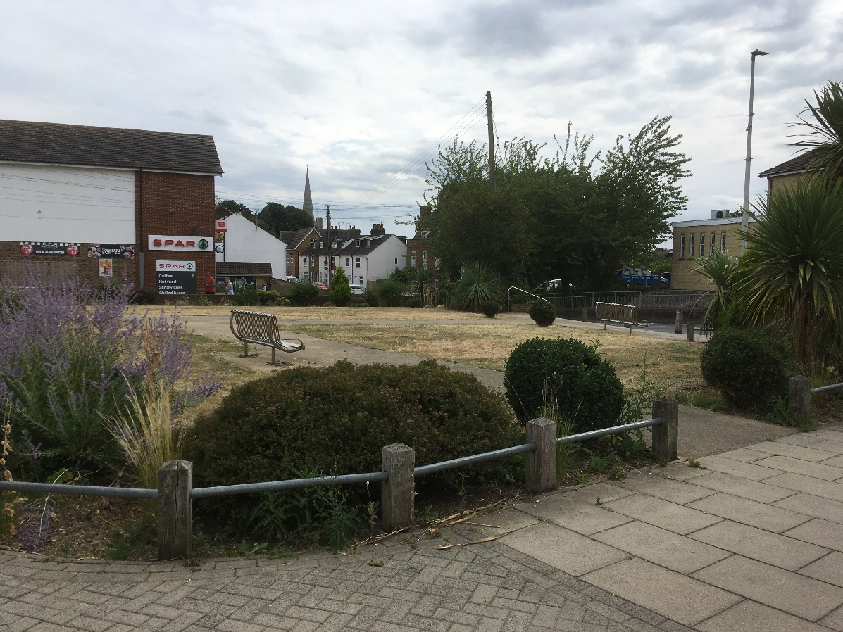
Looking south towards Church Street with the church spire in the background.

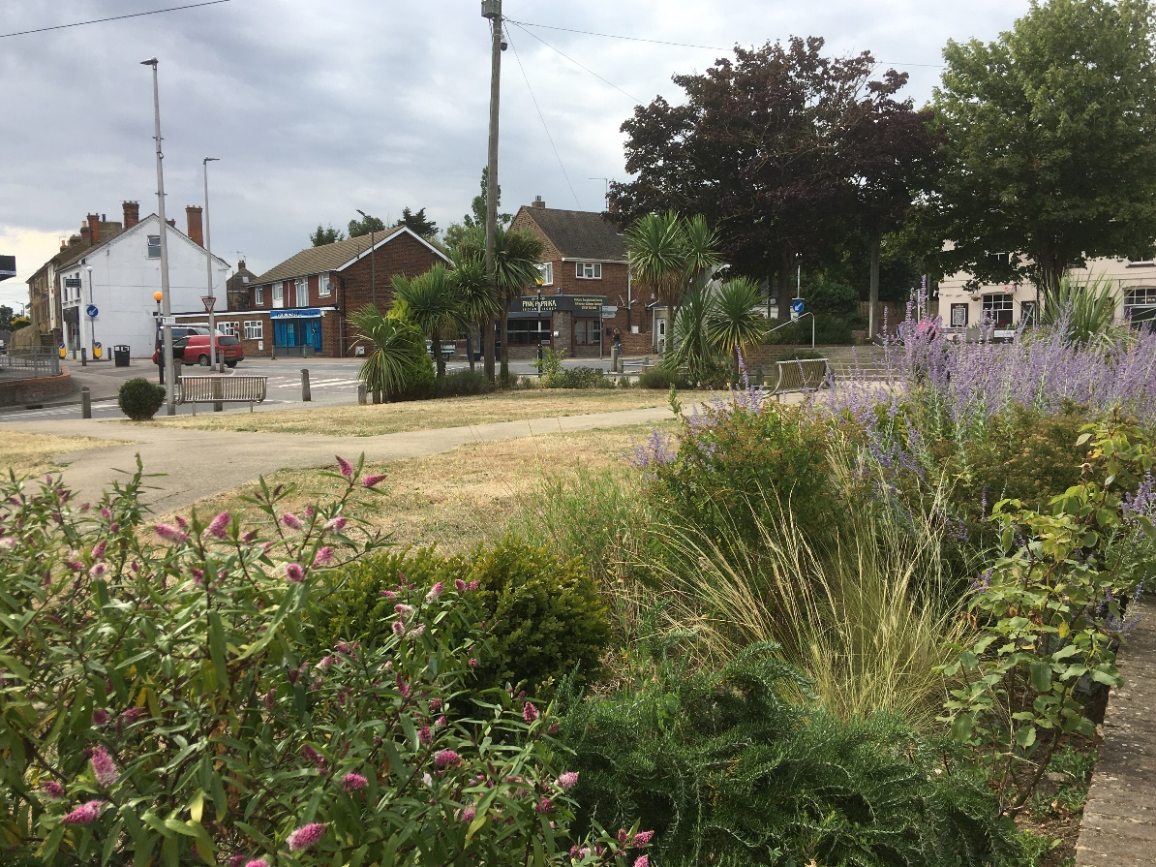
Looking across the area from the shops towards the crossroads and bus stop.
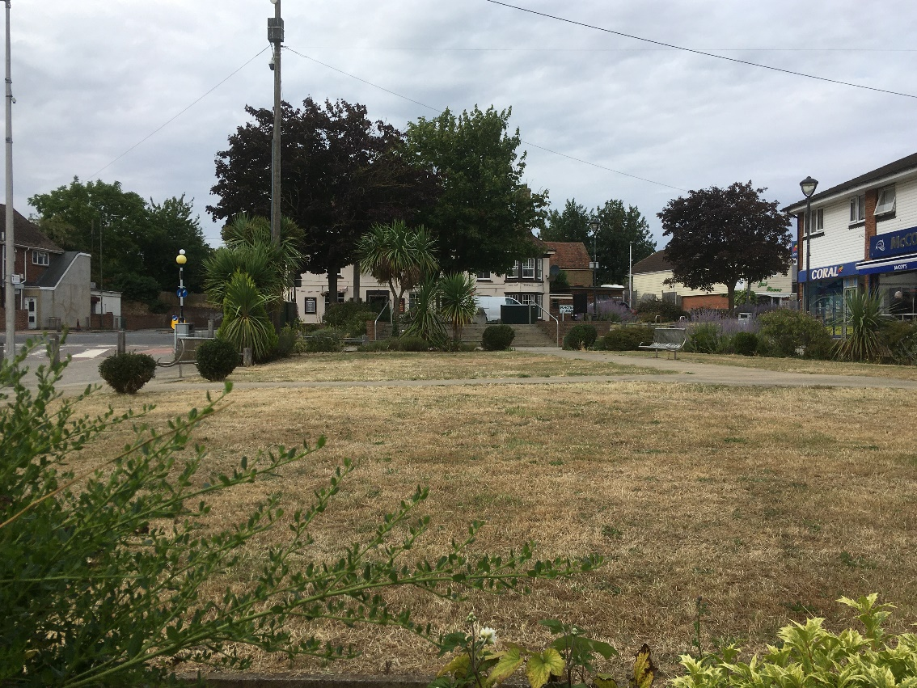
Looking north towards Bells Lane and Stoke Road. The Five Bells PH is behind the trees.

Suitability for LGS Designation

Special Community Value | The space is of special community value, as described above.
Area of space (Ha) | 0.1 ha
Planning permissions or site allocations | None.
Other Designations | None.
Not an extensive tract of land | The area of the site is 0.1 hectares.
Close to the community it serves | This area is in the centre of Hoo Village at the crossroads of Main Road, Stoke Road, Bells Lane and Church Street. The main bus 191 stops close by.

3.2 Hoo Common

Chattenden. Grid Reference: TQ761714

Plan

Community Value

Hoo Common is a large open sloping grassland containing mixed woodland with mature trees and shrubs. Among the trees that are noted are oak, sycamore, Rowan, hawthorn and hornbeam with underlying brambles and other shrubs. The area is a green lung and important for ecology and a wide variety of wildlife, including various insects common to grassland: ants; bees; wasps and butterflies. Commonly seen mammals are rabbits, foxes, hedgehogs, rats and mice. Bats have also been sighted in this location. Walkers have spotted many species of birds: crows, magpies and jays; blackbirds, sparrows and robins; greater spotted and green woodpeckers, various finches, pigeons and collared doves.

Hoo Common has a variety of uses including, walking, recreation and a place for picnics. There are viewpoints which give a vista across the river Medway and two fixed seats have been installed here. The site is owned by the Parish Council and maintained by Medway Norse.

Hoo Common, Title No. K152571 was transferred and covenanted “not to use the land for any purpose other than as recreational open space and woodland”.

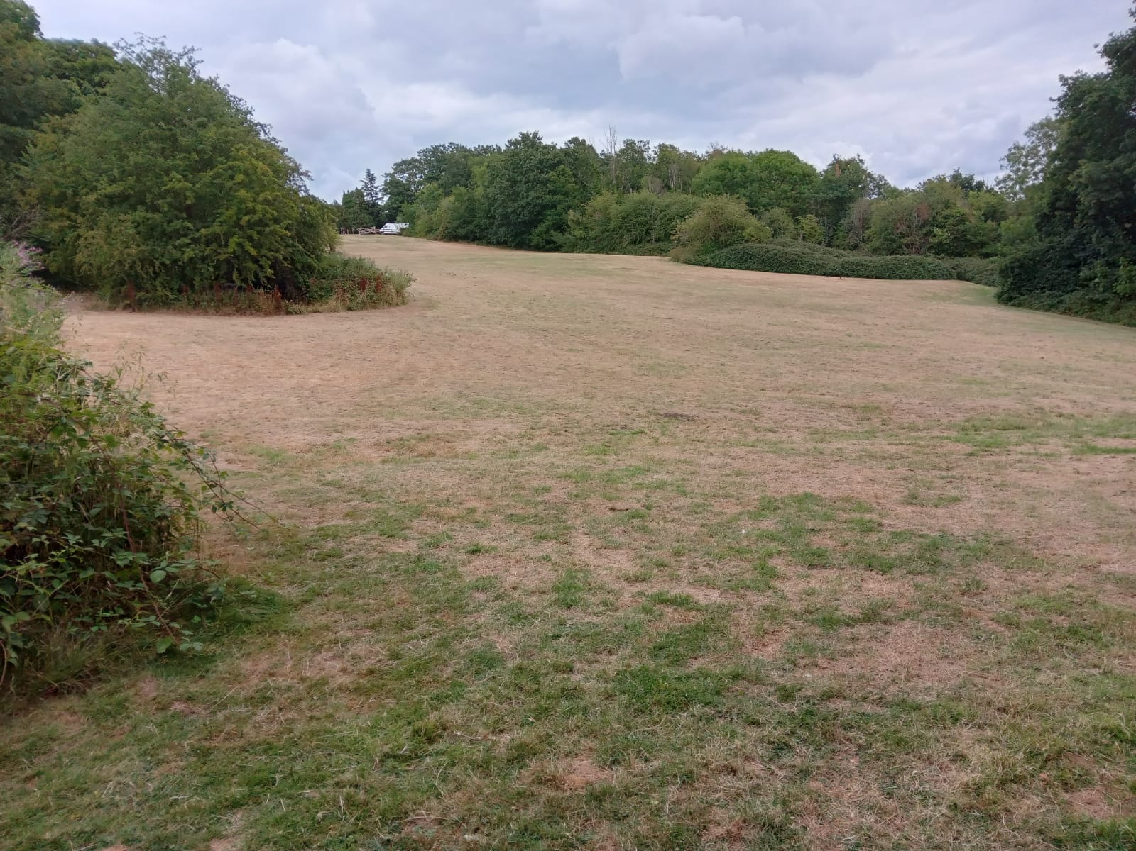
From the south entrance looking east.

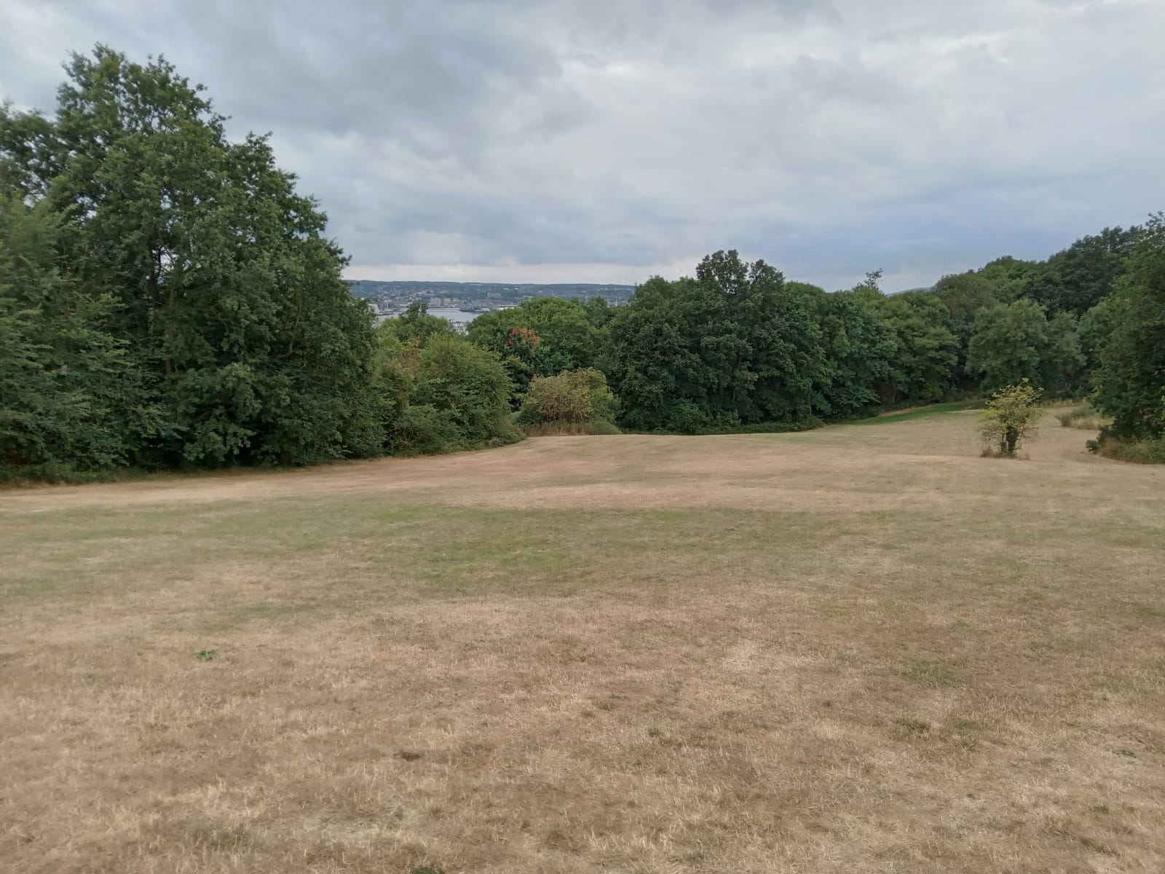
Looking south from the top east entrance (River Medway in distance)

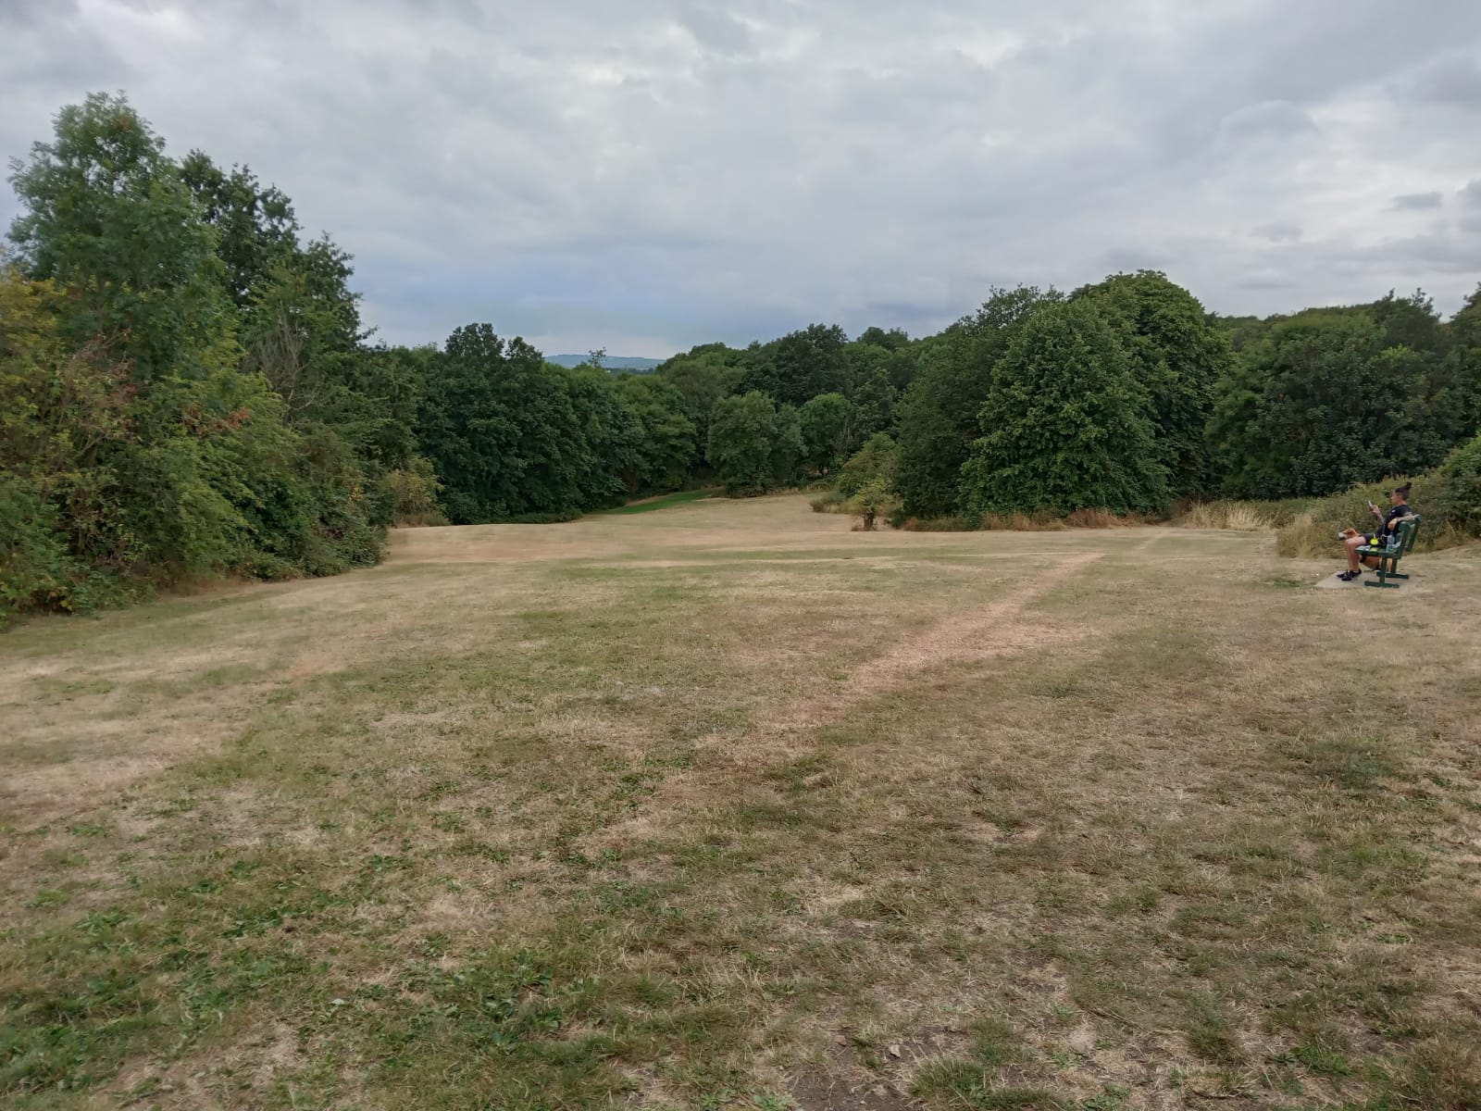
Looking southeast from the top west entrance.
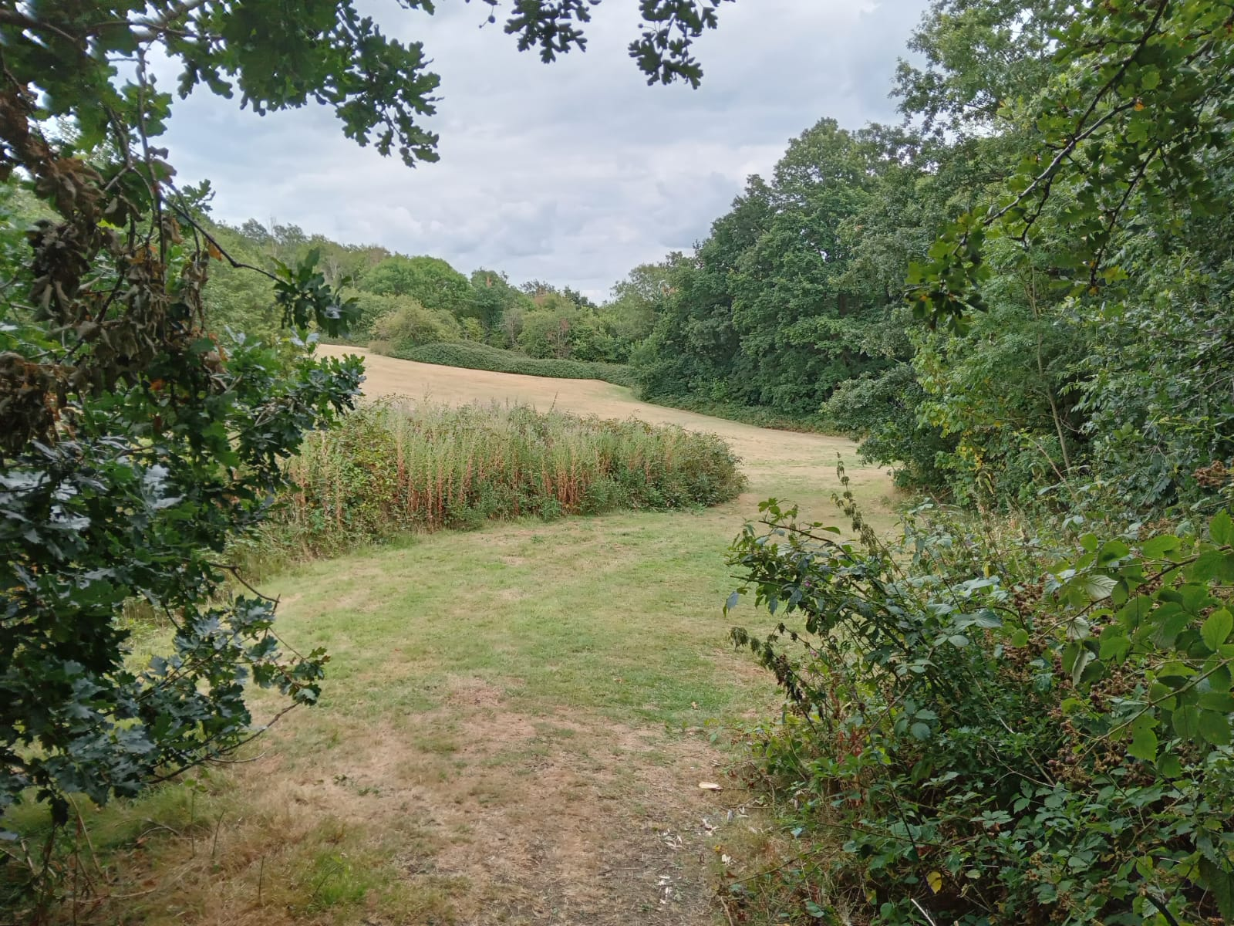
Looking south from the top west entrance and showing the mixed flora.

Suitability for LGS Designation

Special Community Value | The space is of special community value, as described above.  It incorporates a track for the Coastal Path and an alternative route for the Saxon Shore Way (upper) which is a long-distance path around the South East coast from Gravesend to Hastings.
Area of space (Ha) | The area of the site is 3.25 hectares.
Planning permissions or site allocations | None.
Other Designations | Hoo Common is adjacent to Ancient Woodland and SSSI. It includes routes for the Coastal Path and Saxon Shore Way.
Not an extensive tract of land | The area measures 3.25 hectares.
Close to the community it serves | Hoo Common is approximately 5 minutes walk from residential Chattenden and 20 minutes walk from Hoo village centre. It is reached from footpath RS106 and from the top of Elm Avenue.

Conclusions and Recommendations

4.1 Conclusions

Both spaces considered by this report are of special community value and meet the criteria in the NPPF.

The Village Green has important recreational value and is a place for community activities including a market.

Hoo Common is a place of beauty and tranquillity with an important landscape and views.

4.2 Recommendations

That the emerging Hoo St Werburgh and Chattenden Neighbourhood Plan include a policy to designate Hoo Village Green and Hoo Common as Local Green Space.

- Contact

Hoo St Werburgh Parish Council.

