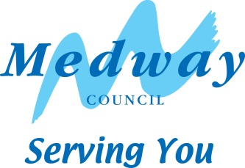
Self Build and Custom Housebuilding Register

Base Period 8 (31st October 2022 – 30 October 2023)

Number of individual applicants | 9
Number of association applicants | 0
Number of serviced plots required | 9
Preferred size of plot | Any size/no preference - 14%  0.01 – 0.05ha - 14%  0.06 – 0.1ha - 7%  0.11-0.49ha - 14%  0.5 – 0.99ha – 21%  1ha plus - 29%
Type of dwelling required  (some applicants may have specified more than one type of dwelling) | 80% House  10% Bungalow  0% house or bungalow  0% Mobile Home  10% Eco Home

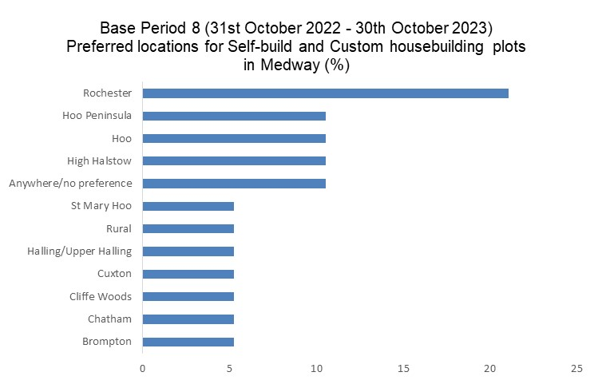

Please note: some applicants have given more than one location as a preferred area to self/custom build.

