Joint Local Health and Wellbeing Strategy Organisations Survey Analysis
Medway Council, Public Health Intelligence Team

Contributors:
- Emmanuella Uwaifo - Public Health Intelligence Analyst
- Dr Natalie Goldring - Senior Public Health Intelligence Manager
- Dr Eluned Broom - Senior Public Health Intelligence Analyst

Introduction
The Medway ‘Better Health Survey’ 2023 was conducted to better understand which aspects of life Medway residents thought were important to their health and wellbeing. The responses also offered insights into what people thought the barriers to achieving this were. Three versions of the survey were developed and tailored to a different group within the Medway population. These groups consisted of adults (aged 18 years and older) and children (aged 13-18 years) who were asked to provide responses about themselves. The third version was designed for organisations, specifically targeting their interactions with individuals they engage with.
This report relates to the ‘Organisations’ survey results which includes insights from representatives of organisations within Medway. It provides an overview of the perceived health needs and obstacles to good health and wellbeing faced by the individuals that these organisations interact with. It will inform actions needed to improve health and wellbeing. These will be set out in Medway’s ‘Joint Local Health and Wellbeing Strategy’ which is being refreshed from the current Medway Joint Health and Wellbeing Strategy (2018-2023).

Summary
The survey had a total of seven questions. It began by seeking the participants’ consent and gathering basic information about the type of organisation they represent. The remaining questions focused on the participants’ perspectives on what is important for achieving good health and wellbeing among the individuals they engage with, as well as the obstacles these individuals may face in maintaining good health. These health and wellbeing questions resulted in a mixture of quantitative (numerical) and qualitative (descriptive) responses. This report will initially summarise the type of organisations represented before focusing on the two quantitative response questions. Each question is examined first for the entire group of respondents, and then the analysis is further broken down by the type of organisation.

Types of organisations that responded
In this survey, 86% of the organisations that responded were from the Voluntary, Community and Social Enterprise (VCSE) sector, whilst the rest were public sector organisations.

What organisations believe the Medway residents they interact with want when considering their health and wellbeing
Question: When thinking about the health and wellbeing of the people you interact with through your role within your organisation, what would you say are the most important things people would want for themselves? Please number in order of importance, with 1 being ‘most important’.
Answer options:
- Feeling happy
- Less worry
- Getting help when feeling stressed
- Sleeping well
- Healthy and affordable food
- Getting enough exercise or being more physically active
- Healthy habits around food and eating
- Drinking alcohol within safe limits
- Being without illness or pain
- Giving up smoking
- Looking after their sexual health.
The designated respondent from each organisation taking part in the survey was asked to think about the people they interact with during their role within their organisation, specifically in terms of their health and wellbeing. They were then asked to rank what they would say were the most important things those people would want for themselves. They were instructed to assign a number for the eleven response options from 1 to 11 to indicate the level of importance, with 1 representing the most important priority for them.
To analyse this question, the top five responses were selected for each participant and assigned a score ranging from one to five, with five indicating the highest-ranked response. These scores were then combined to calculate a total score for each response. To determine the importance of each response within the top five, the total score for each response was divided by the sum of the total scores for all the responses in the top five. This calculation produced a proportion. The higher the proportion, the more likely the response was consistently placed and/or frequently ranked highly within the top five responses.
In figures 1 to 2 all the responses shown appear in the top five for at least one participant. A higher proportion indicates that the respondents from organisations think that response is more important to what Medway residents want when considering their health and wellbeing.
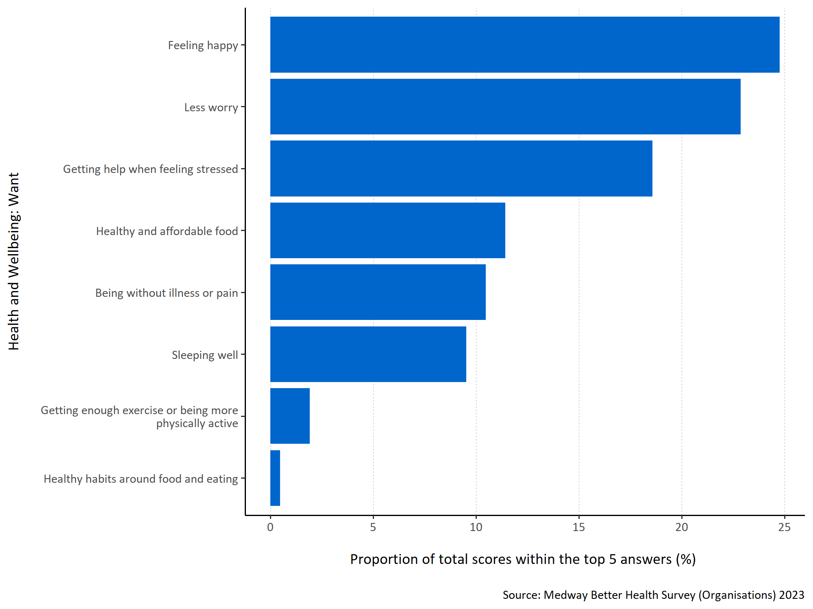
Figure 1: Proportion of total scores within the top 5 answers for each specified health and wellbeing want.
Figure 1 shows organisations considered ‘feeling happy’ to be most important to the Medway residents they interacted with when considering what they want for their health and wellbeing. ‘Getting help when feeling stressed’, ‘healthy and affordable food’ and ‘less worry’ were also considered important. ‘Drinking alcohol within safe limits’, ‘giving up smoking’ and ‘looking after their sexual health’ where not ranked in the top five options by any organisation representatives.
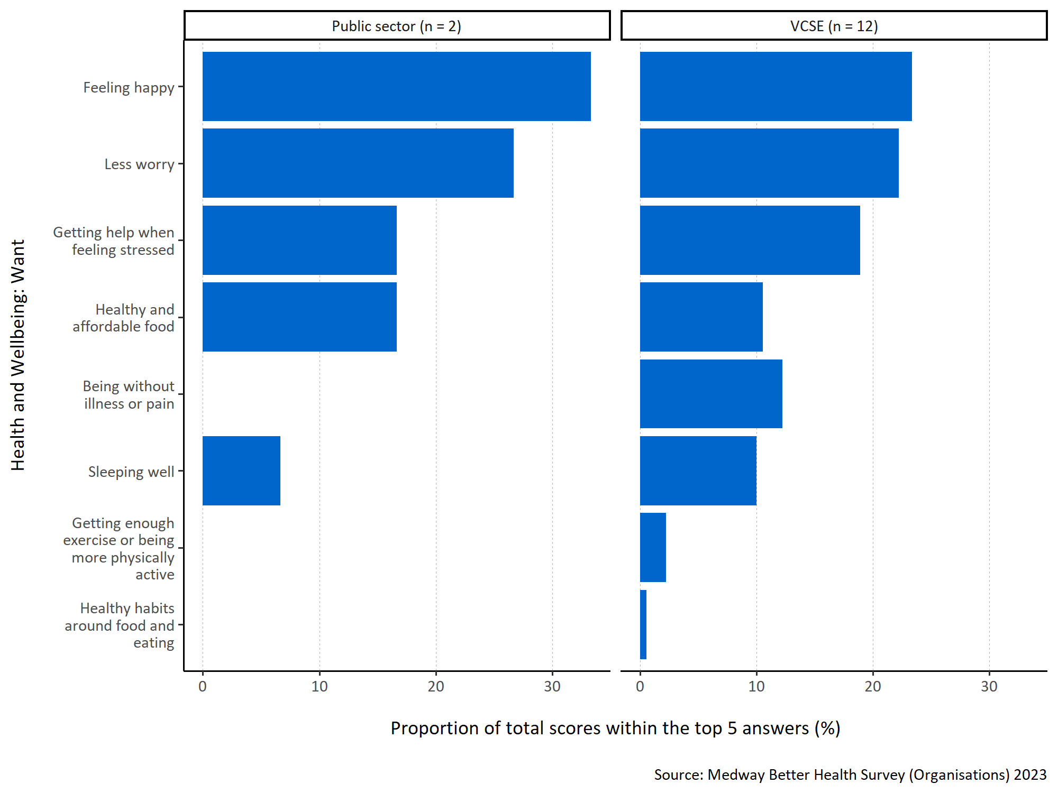
Figure 2: Proportion of total scores within the top 5 answers for each specified health and wellbeing want by organisation type.
Both types of organisation (public sector and VCSE) thought ‘feeling happy’ was the most important response. ‘Less worry’ was also important. ‘Being without illness or pain’, ‘getting enough exercise or being more physically active’ and ‘healthy habits around food and eating’ were not included in the top five rankings for the respondents from the public sector organisations. It is important to note that the number of respondents is low for both organisational groups and so any data must be interpreted with caution.

What organisations believe the Medway residents they interact with want to improve the health and wellbeing of everyone in Medway
Question: Thinking about the people you interact with through your role within your organisation, what do you think they would say are the most important things that can be done to improve the health and wellbeing of everyone living in Medway? Please number in order of importance, with 1 being ‘most important’.
Answer options:
- Affordable, good quality housing
- Having enough money to provide for their/their family’s needs
- Better access to GP services
- Better access to other health and care services (for example, mental health services, social care, hospital care, services that help manage conditions like diabetes, high blood pressure, breathing difficulties)
- Better access to the internet
- Affordable leisure activities
- Being able to spend time socially with other people
- Good-quality, affordable childcare
- Improved job security
- Feeling safe in the neighbourhood
- Support with caring responsibilities
- Better access to green spaces, (like open green spaces and water in urban areas, including parks, playing fields, play areas, allotments and community gardens, woodland and more natural areas, canal paths and riversides)
- Good local schools
- Adult education and training opportunities
- For society to tackle environmental issues (like climate change, pollution, traffic congestion)
- Support with parenting skills.
The participating organisations were also asked what they think the people they interact with would consider the most important things that can be done to improve the health and wellbeing of everyone living in Medway. They were instructed to assign a number for the sixteen response options from 1 to 16 to indicate the level of importance, with 1 representing the most important priority for them.
To analyse this question, the top five responses were selected for each participant and assigned a score ranging from one to five, with five indicating the highest-ranked response. These scores were then combined to calculate a total score for each response. To determine the importance of each response within the top five, the total score for each response was divided by the sum of the total scores for all the responses in the top five. This calculation produced a proportion. The higher the proportion, the more likely the response was consistently placed and/or frequently ranked highly within the top five responses.
In figures 3 to 4, all the responses shown appear in the top five for at least one participant. A higher proportion indicates that the respondents from organisations think that response is more important to what Medway residents want when considering how health and wellbeing can be improved for everyone living in Medway.
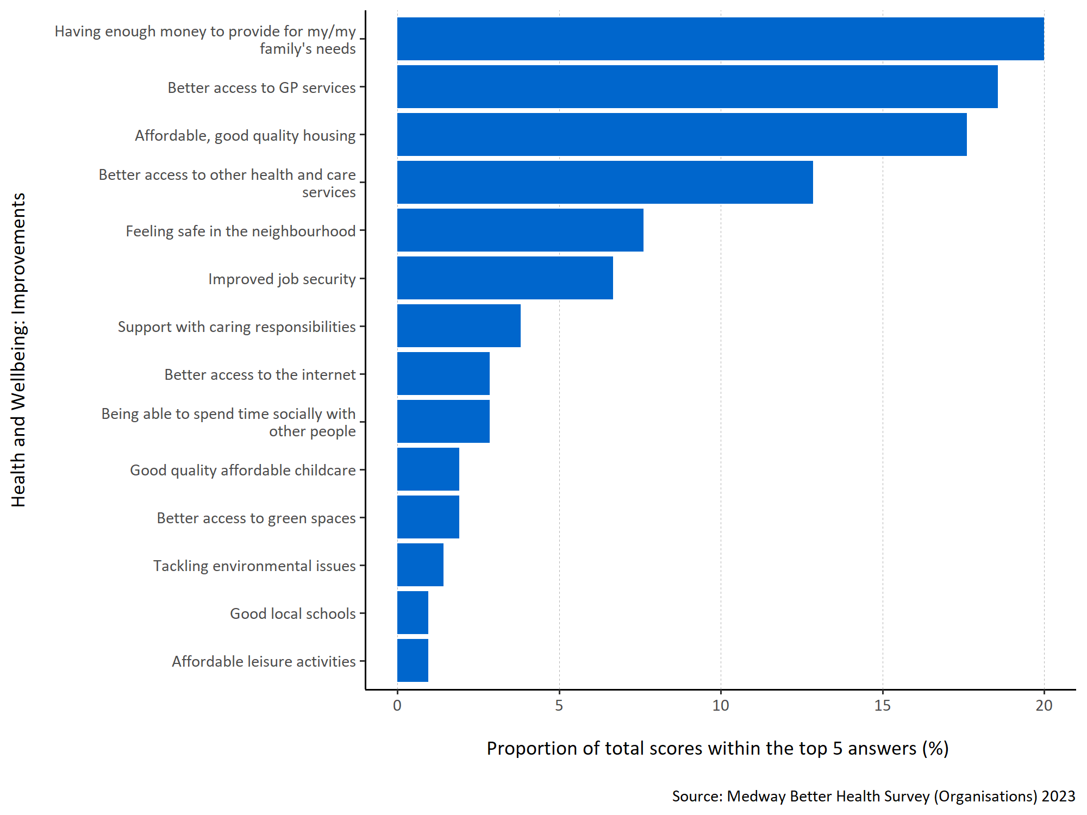
Figure 3: Proportion of total scores within the top 5 answers for each specified health and wellbeing improvement.
Figure 3 shows that representatives of organisations consider ‘having enough money to provide for my/ my family’s needs’ to be most important to the people they interact with in terms of improving health and wellbeing within Medway. ‘Better access to GP services’, ‘affordable, good quality housing’ and ‘better access to other health and care services’ were also thought to be important. No organisations included ‘for society to tackle environmental issues (like climate change, pollution, traffic congestion)’ or ‘support with parenting skills’ in their top five rankings.
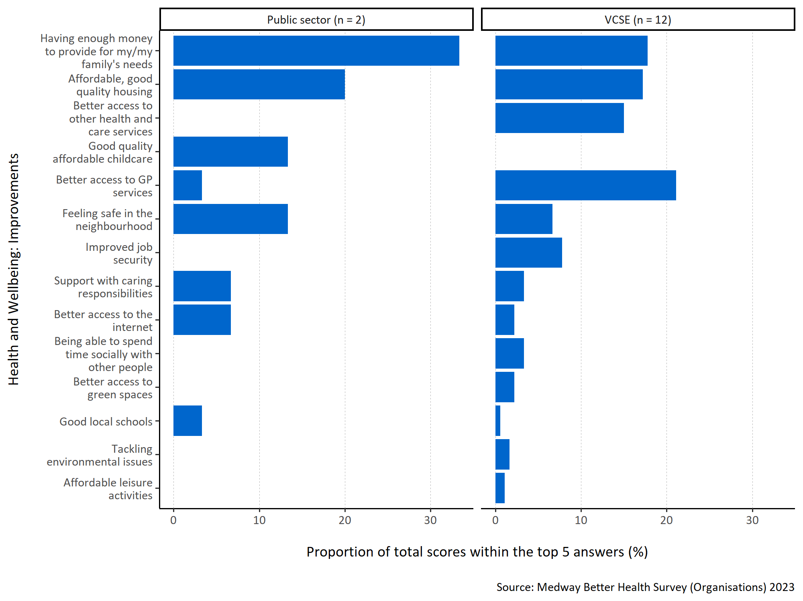
Figure 4: Proportion of total scores within the top 5 answers for each specified health and wellbeing improvement by organisation type.
Public sector respondents thought ‘having enough money to provide for my/my family’s needs’ was most important to the people they interacted with, whereas VCSE organisations believed ‘better access to GP surgeries’ was more important. Both considered ‘affordable, good quality housing’ to be important. VCSE organisations also thought ‘better access to other health and care services’ was important whereas this was not placed in the top five by any of the public sector respondents. Public sector organisations also never ranked ‘improved job security’, ‘being able to spend time socially with other people’, ‘better access to green spaces’, ‘tackling environmental issues’, and ‘affordable leisure activities’ in their top five.

