Joint Local Health and Wellbeing Strategy Adult Survey Analysis
Medway Council, Public Health Intelligence Team

Contributors:
- Emmanuella Uwaifo - Public Health Intelligence Analyst
- Dr Natalie Goldring - Senior Public Health Intelligence Manager
- Dr Eluned Broom - Senior Public Health Intelligence Analyst

Introduction
The Medway ‘Better Health Survey’ 2023 was conducted to better understand which aspects of life Medway residents thought were important to their health and wellbeing. The responses also offered insights into what people thought the barriers to achieving this were. Three versions of the survey were developed and tailored to a different group within the Medway population. These groups consisted of adults (aged 18 years and older) and children (aged 13-18 years) who were asked to provide responses about themselves. The third version was designed for organisations, specifically targeting their interactions with individuals they engage with.
This report relates to the ‘Adults’ survey results which includes insights from Medway residents aged 18 years and over. It gives an overview of the perceived health needs and barriers to health for the survey participants and will inform actions needed to improve health and wellbeing. These will be set out in Medway’s ‘Joint Local Health and Wellbeing Strategy’ which is being refreshed from the current Medway Joint Health and Wellbeing Strategy (2018-2023).

Summary
The survey had a total of ten questions. It began by seeking the particpants’ consent and collecting basic demographic information such as age, gender, ethnicity and whether they had any long-term physical or mental health conditions. The remaining five questions in the survey focused on what each participant considered important for achieving good health and wellbeing, as well as any obstacles they faced in being healthy and well. These health and wellbeing questions resulted in a mixture of quantitative (numerical) and qualitative (descriptive) responses. This report will initially analyse the demographic information before focusing on the two quantitative response questions. Each question is examined first for the entire group of respondents, and then the analysis is further broken down by age, gender, ethnicity, and whether the participants have any long term physical or mental health conditions.

Demographics of the survey participants compared with the Medway population
The total population of Medway in the most recent census (2021) was 279,827. This survey had 526 respondents and so provides a useful estimate of local views on health and wellbeing.
This following section shows comparisons of the demographic breakdowns from the ‘Better Health Survey’ sample and the latest census data for Medway (2021) for adults aged 18 years and older.
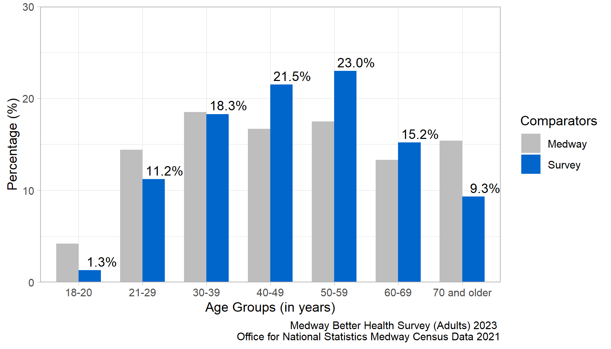
Figure 1: Age comparison between the local Medway population and the survey participants.
Figure 1 shows the age distribution for the survey participants compared to the Medway population. The distribution of survey responses by age group was similar to the 2021 Census, although the 18-20, 21-29 and 70 years and older age groups were slightly under-represented whereas the 40-49 and 50-59 year age groups were slightly over-represented.
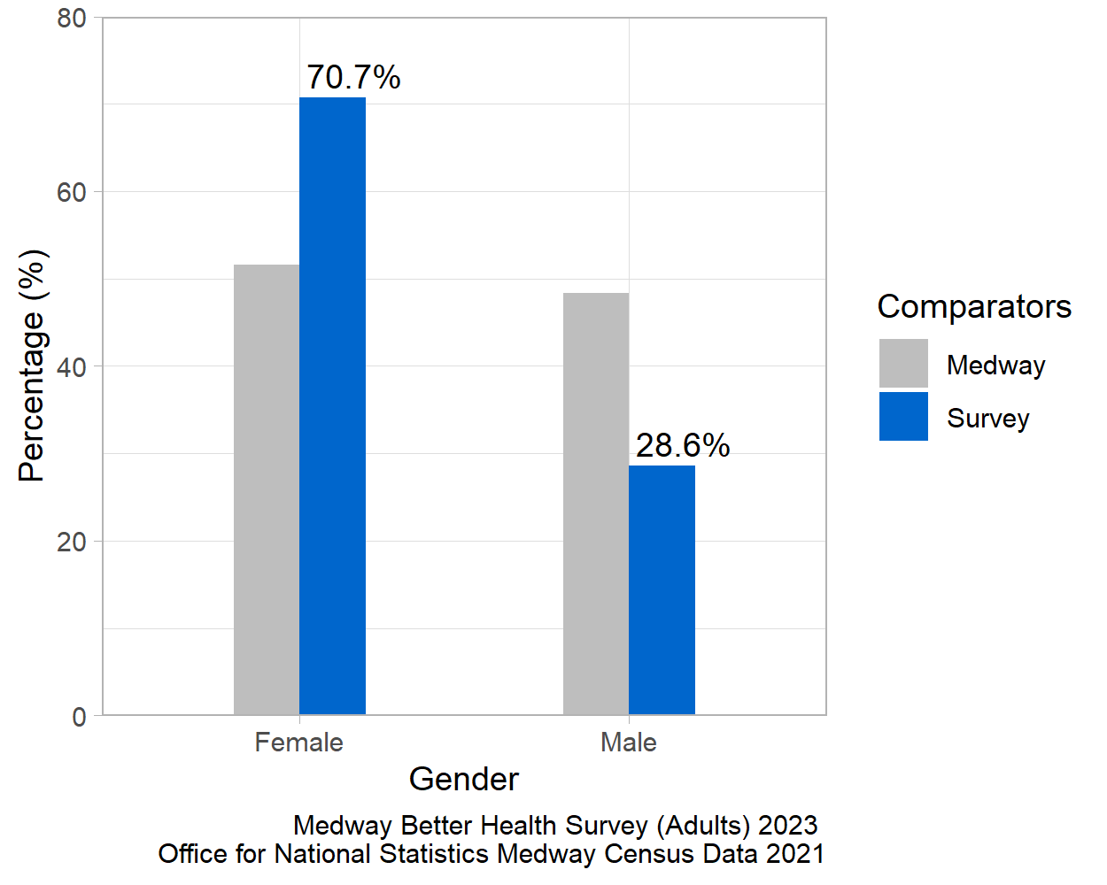
Figure 2: Gender comparison between the local Medway population and the survey participants.
Figure 2 shows the proportion of female and male respondents compared to the proportion in the Medway population as a whole. The female population was over-represented in the survey and the male population under-represented. A low number of individuals in the survey identified as non-binary or transgender male/female. These were suppressed to ensure respondents were not identifiable.
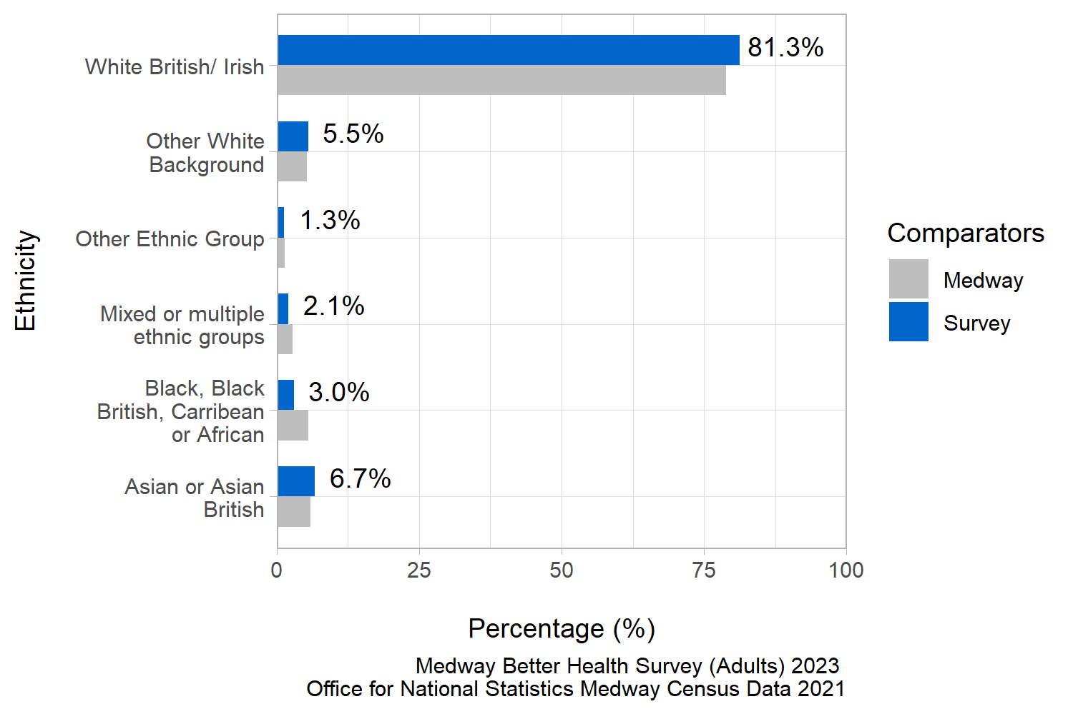
Figure 3: Ethnicity comparison between the local Medway population and the survey participants.
Figure 3 shows the ethnic group diversity in the survey compared with the local Medway population. The distribution of survey responses by ethnic group was similar to the 2021 Census.
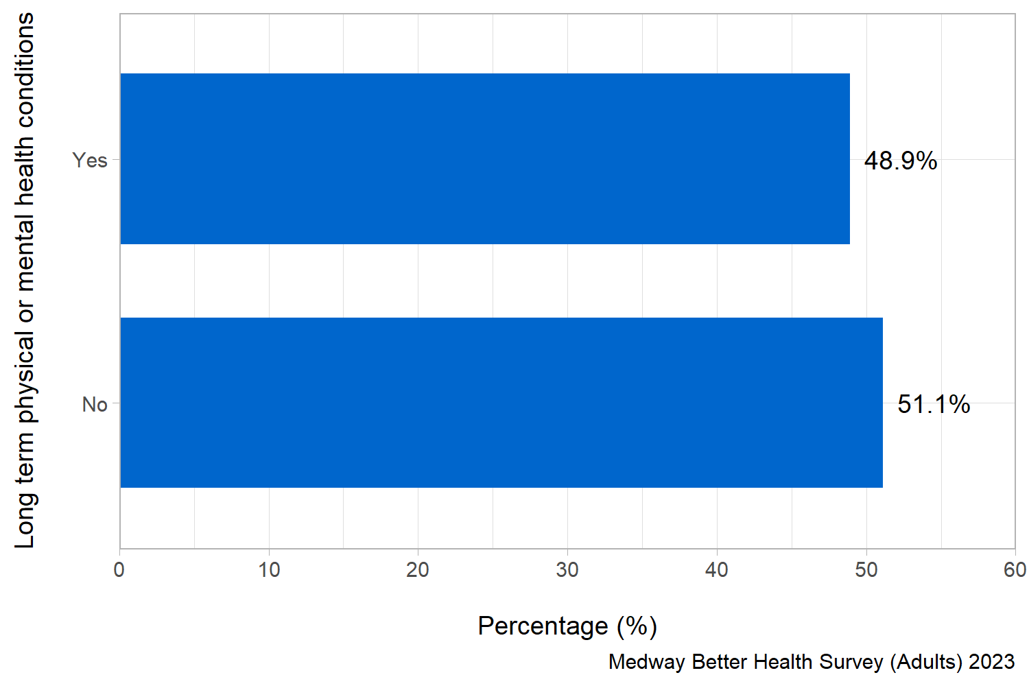
Figure 4: Proportion of survey respondents with long term physical or mental health conditions.
Figure 4 shows that just under half of the survey respondents reported a long term physical or mental health condition.
Taken together, this analysis indicates that the survey respondents are a good representation of the Medway population as a whole.

What Medway residents want when considering their health and wellbeing
Question: When thinking about your health and wellbeing, what are the things you would most want for yourself? Please number in order of importance, with 1 being most important.
Answer options:
- Feeling happy
- Less worry
- Getting help when feeling stressed
- Getting enough exercise or physical activity
- Sleeping well
- Healthy and affordable food
- Healthy habits around food and eating
- Drinking alcohol within safe limits
- Giving up smoking
- Looking after your sexual health
- Being without illness or pain.
Survey participants were asked to prioritise and rank the things they wanted most for their overall health and wellbeing. They were instructed to assign a number for the eleven response options from 1 to 11 to indicate the level of importance, with 1 representing the most significant priority.
To analyse this question, the top five responses were selected for each participant and assigned a score ranging from one to five, with five indicating the highest-ranked response. These scores were then combined to calculate a total score for each response. To determine the importance of each response within the top five, the total score for each response was divided by the sum of the total scores for all the responses in the top five. This calculation produced a proportion. The higher the proportion, the more likely the response was consistently placed and/or frequently ranked highly within the top five responses.
In figures 5 to 9 all the responses shown appear in the top five for at least one participant. A higher proportion indicates that response is more important to what Medway residents want when considering their health and wellbeing.
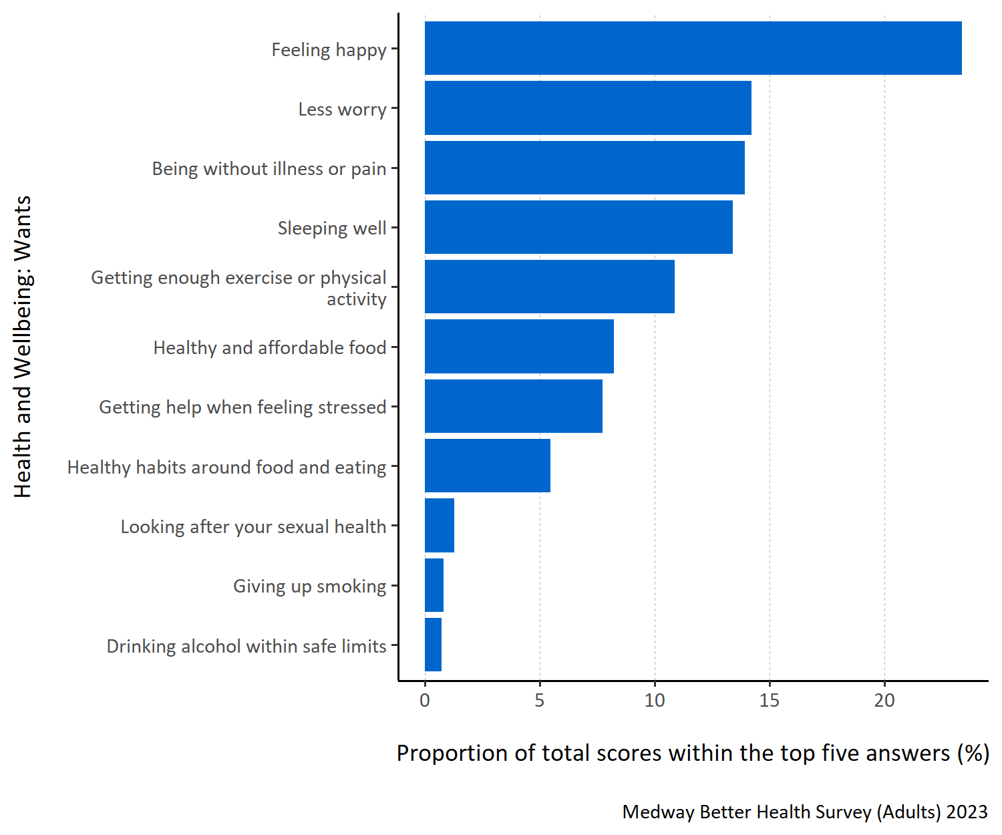
Figure 5: Proportion of total scores within the top five answers for each specified health and wellbeing want.
Figure 5 shows that survey respondents most wanted to be ‘feeling happy’ when considering their health and wellbeing. Respondents also thought ‘less worry’, ‘being without illness or pain’ and ‘sleeping well’ were important. When thinking about their wellbeing, respondents were less inclined to want to ‘look after their sexual health, ’give up smoking’ or ‘drink alcohol within safe limits’.
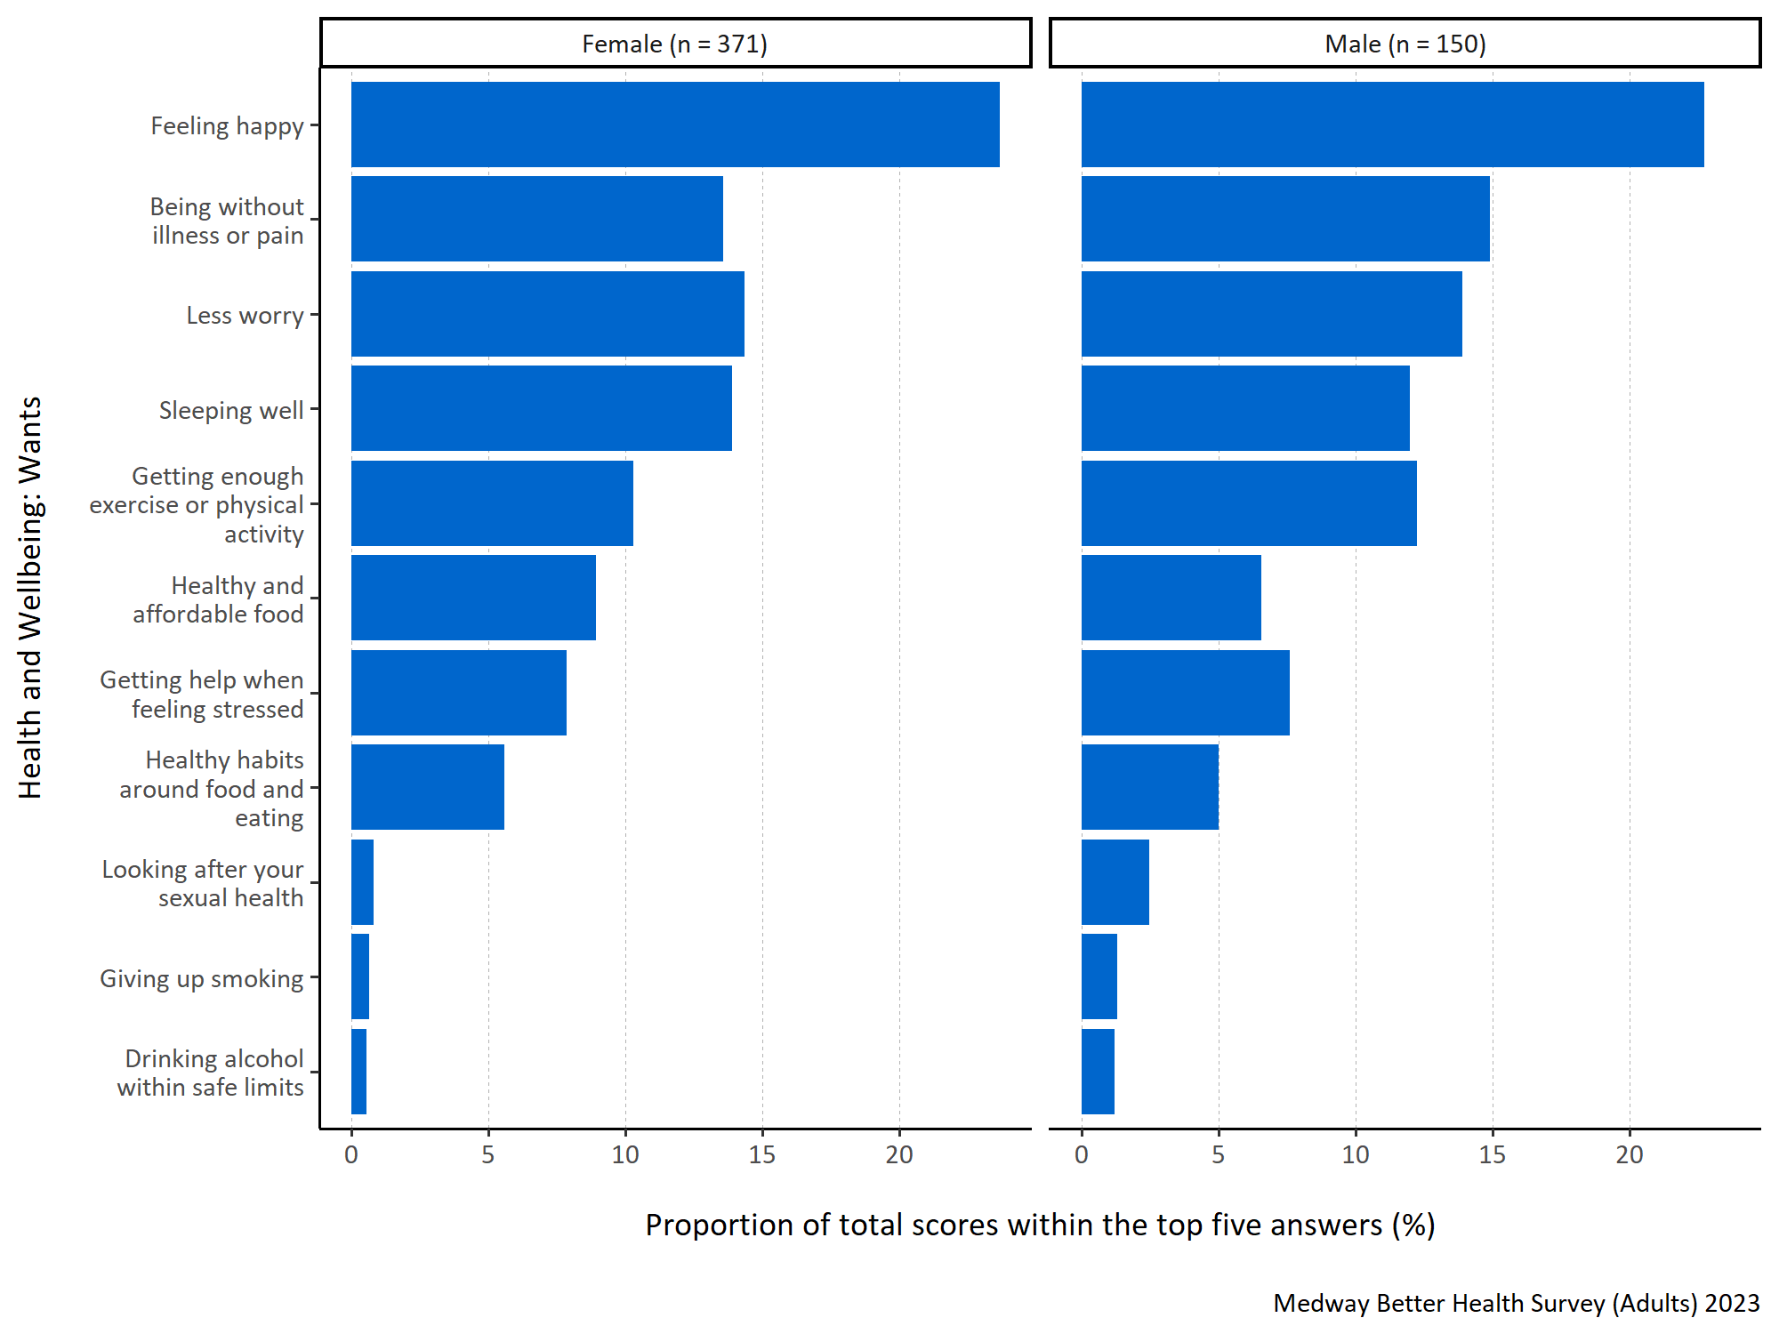
Figure 6: Proportion of total scores within the top five answers for each specified health and wellbeing want by gender.
Figure 6 shows that both male and female Medway residents wanted the most to be ‘feeling happy’ when considering their health and wellbeing. ‘Being without illness or pain’, ‘less worry’, ‘sleeping well’ and ‘getting enough exercise or physical activity’ were also important for both males and females.
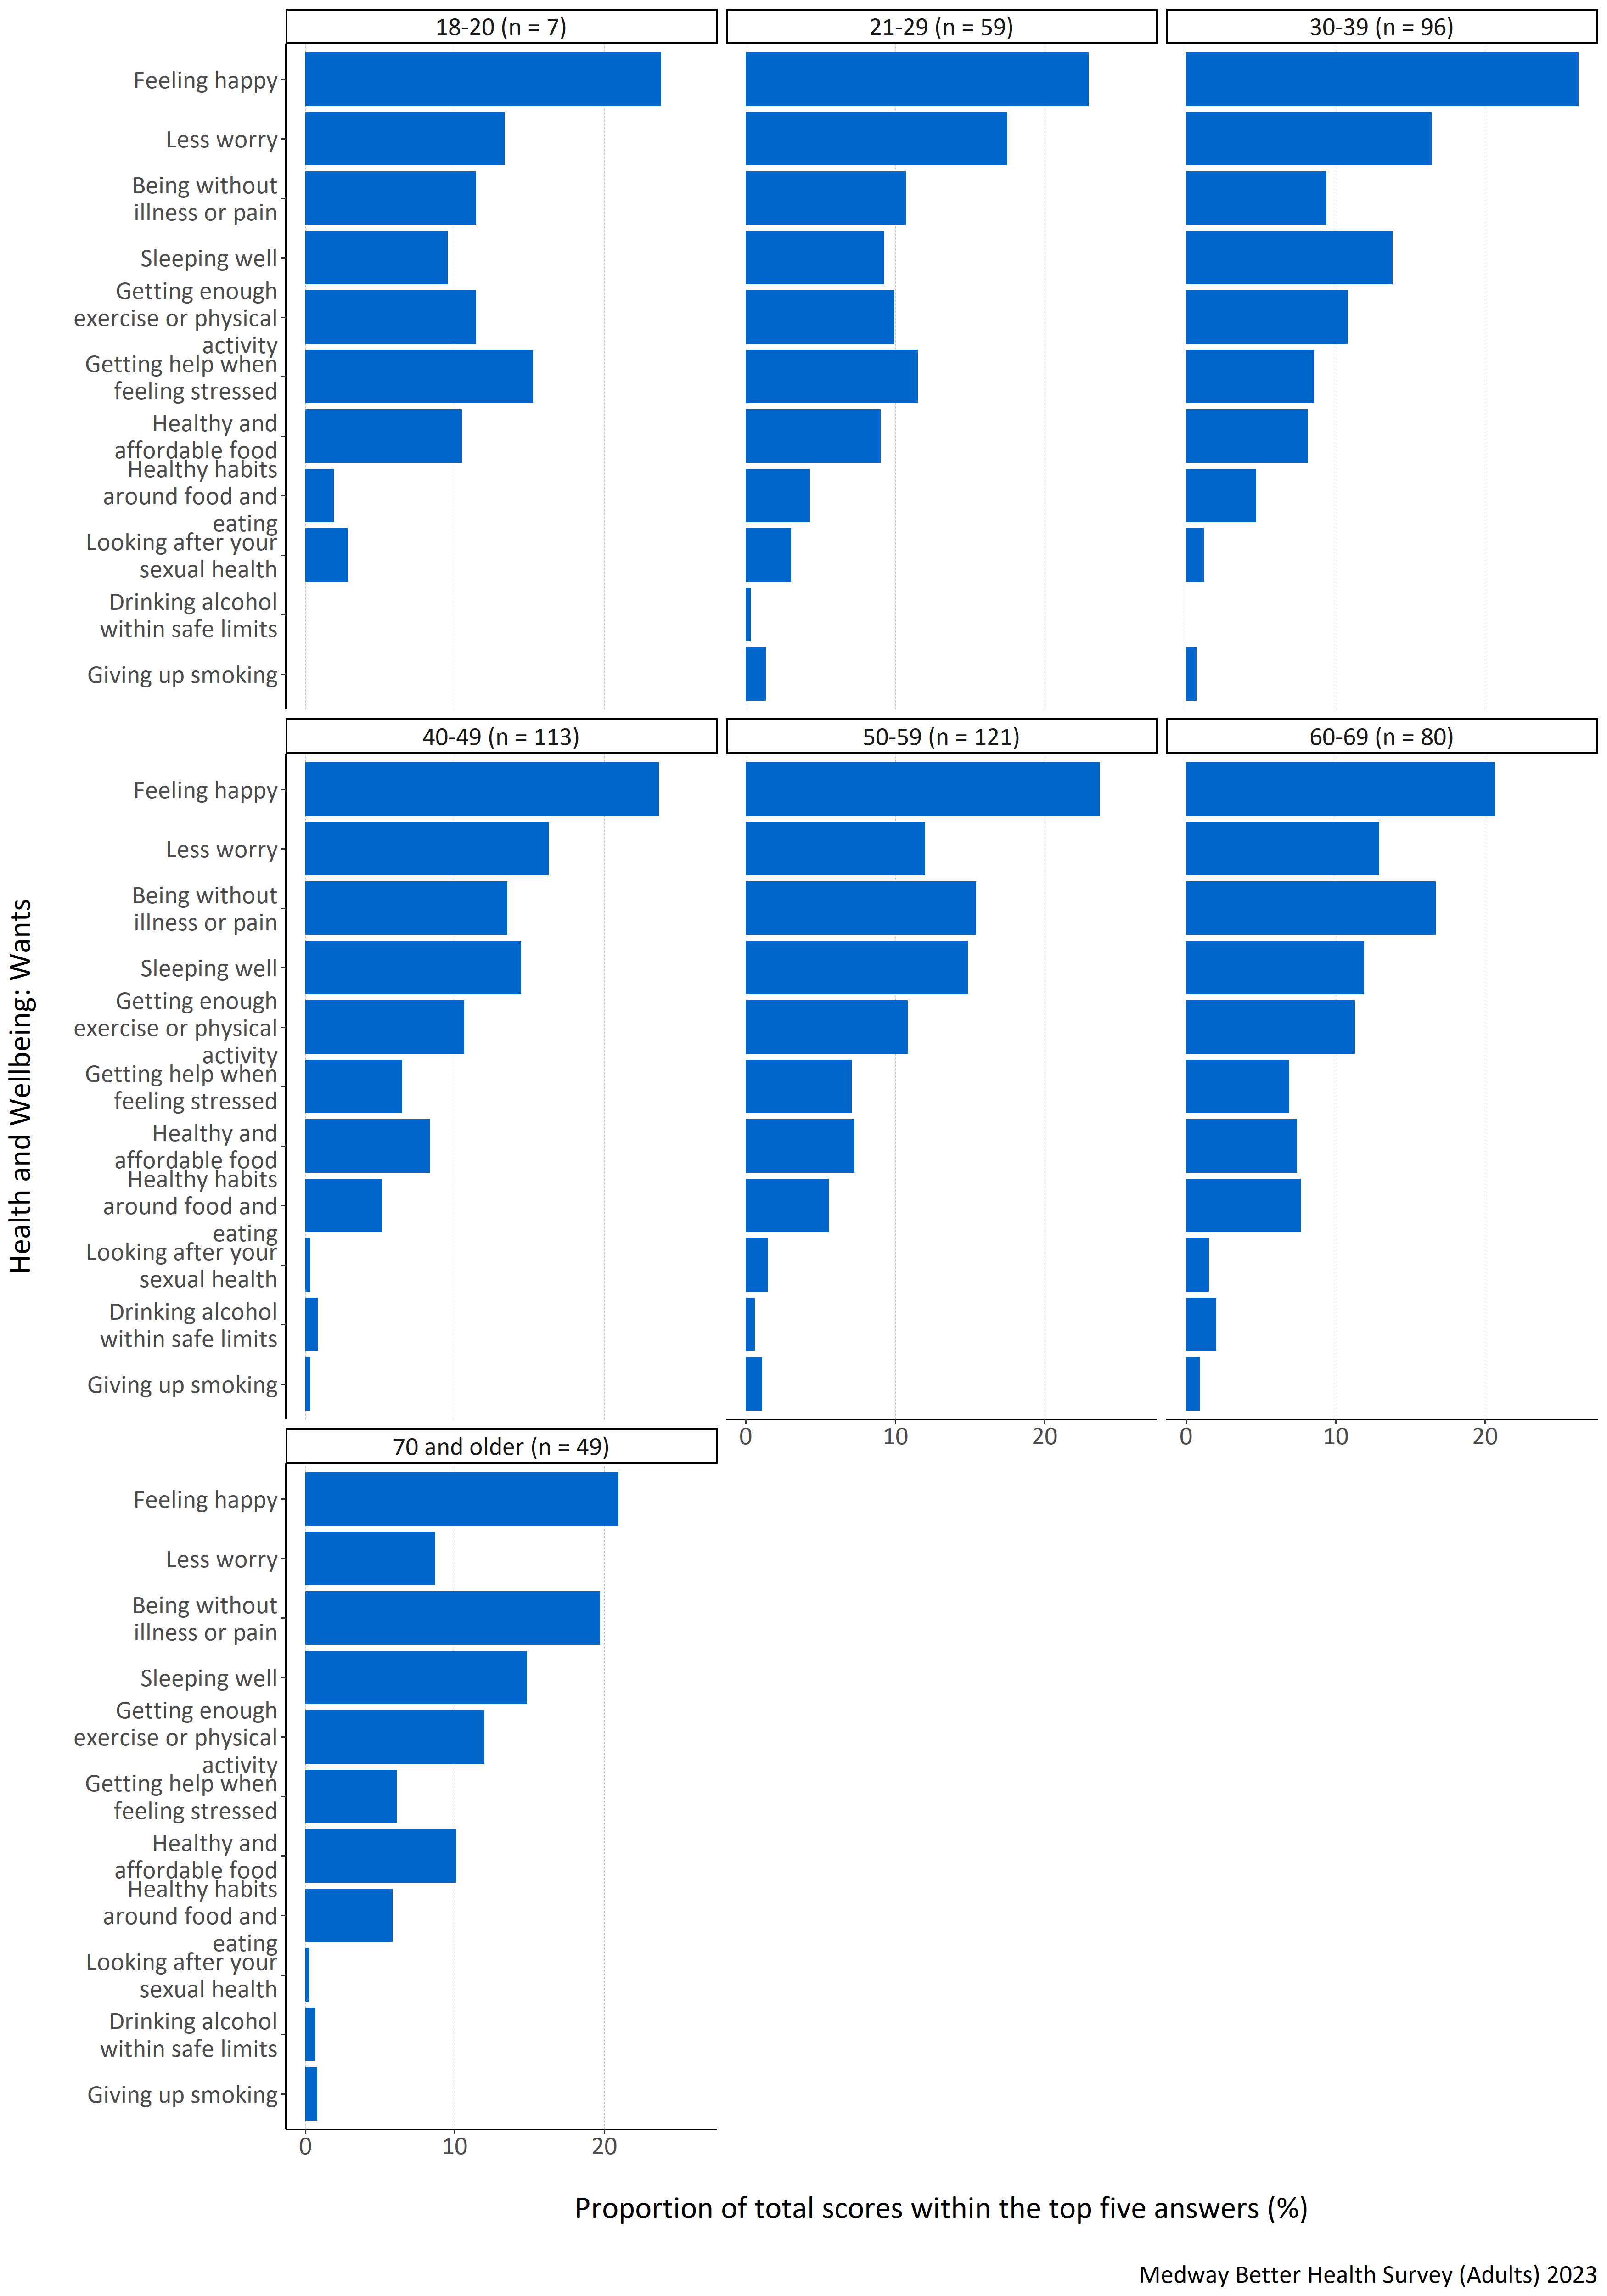
Figure 7: Proportion of total scores within the top five answers for each specified health and wellbeing want by age group (years).
Figure 7 shows that ‘feeling happy’ was important for all age groups. There was, however, variation between the importance assigned to other responses among different age groups. For example, in the age groups below 50 years old the response option ‘less worry’ had a high proportion. In the age groups above 50, greater importance was given to the responses ‘being without illness or pain’ and ‘sleeping well’. Interestingly, ‘drinking alcohol within safe limits’ was not placed in the top five rankings for any of the respondents in the 18-20 and 30-39 year old age groups.
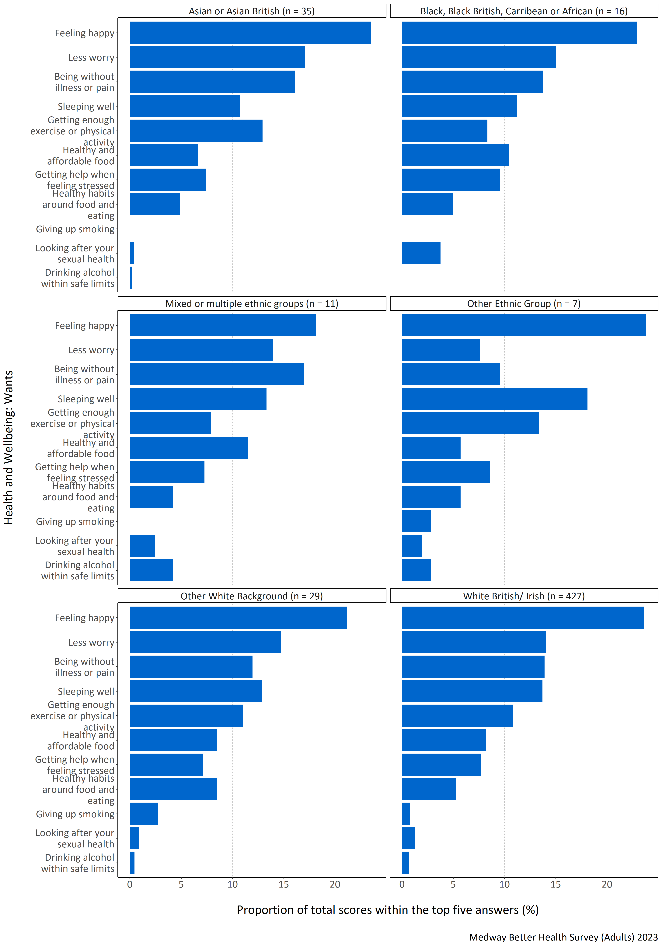
Figure 8: Proportion of total scores within the top five answers for each specified health and wellbeing want by ethnic group.
Figure 8 shows that respondents from all ethnic groups wanted most to be ‘feeling happy’ when considering their health and wellbeing. All ethnic groups, except for other ethnic groups, also ranked ‘less worry’, ‘being without illness or pain’ and ‘sleeping well’ highly. Respondents identifying as being from other ethnic groups ranked ‘sleeping well’ and ‘getting enough exercise or physical activity’ highly. ‘Giving up smoking’ was not placed in the top five most important health and wellbeing wants for those respondents identifying as Asian or Asian British, Black, Black British, Caribbean or African, or mixed or multiple ethnic groups. Black, Black British, Caribbean or African respondents also did not include ‘drinking alcohol within safe limits’ in their top five wants. It is important to note that there were low respondent numbers in some groups and so care must be taken when interpreting the results.
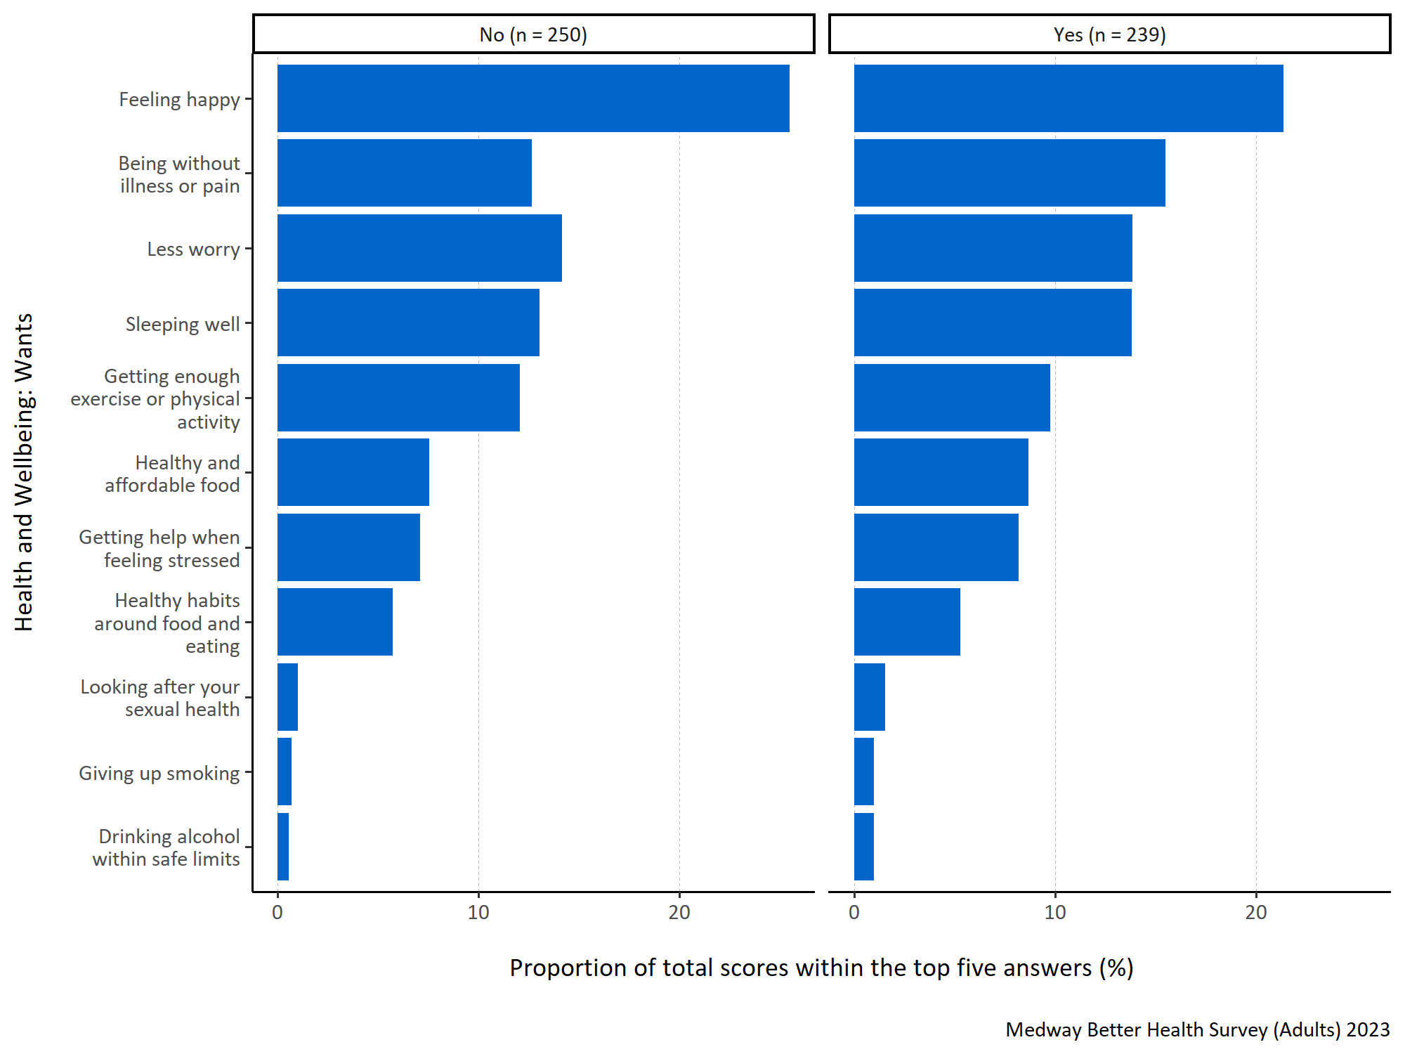
Figure 9: Proportion of total scores within the top five answers for each specified health and wellbeing want by long term physical or mental health conditions.
Figure 9 shows that for both respondents with and without a long term physical or mental health condition ‘feeling happy’ was considered most important for what people wanted when considering their health and wellbeing. Both groups also frequently ranked ‘being without illness or pain’, ‘less worry’, ‘sleeping well’ and ‘getting enough exercise or physical activity’ high, although those with a long term health condition prioritised ‘feeling happy’ less and ‘being without illness or pain’ more than those who did not report one.

What Medway residents think would improve their health and wellbeing
Question: What do you think are the most important things that can be done to improve health and wellbeing for everyone living in Medway? Please number in order of importance, with 1 being most important.
Answer options:
- Improved job security
- Having enough money to provide for my/my family’s needs
- Affordable, good quality housing
- Better access to GP services
- Better access to other health and care services (for example, mental health services, social care, hospital care, services that help manage conditions like diabetes, high blood pressure, breathing difficulties)
- Better access to green spaces (like open green spaces and water in urban areas, including parks, playing fields, play areas, allotments and community gardens, woodland and more natural areas, canal paths and riversides)
- Tackling environmental issues (like climate change, pollution, traffic congestion)
- Affordable leisure activities
- Being able to spend time socially with other people
- Better access to the internet
- Good-quality, affordable childcare
- Support with parenting skills
- Support with caring responsibilities
- Good local schools
- More adult education and training opportunities
- Feeling safe in the neighbourhood.
Survey participants were asked to prioritise and rank what they thought to be the most important things that can be done to improve health and wellbeing for everyone living in Medway. They were asked to assign a number for the sixteen response options from 1 to 16 to indicate the level of importance, with 1 representing the most significant priority.
To analyse this question, the top five responses were selected for each participant and assigned a score ranging from one to five, with five indicating the highest-ranked response. These scores were then combined to calculate a total score for each response. To determine the importance of each response within the top five, the total score for each response was divided by the sum of the total scores for all the responses in the top five. This calculation produced a proportion. The higher the proportion, the more likely the response was consistently placed and/or frequently ranked highly within the top five responses.
In figures 10 to 14 all the responses shown appear in the top five for at least one participant. A higher proportion indicates that response is more important to what Medway residents want when considering what could be done to improve health and wellbeing of residents in Medway.
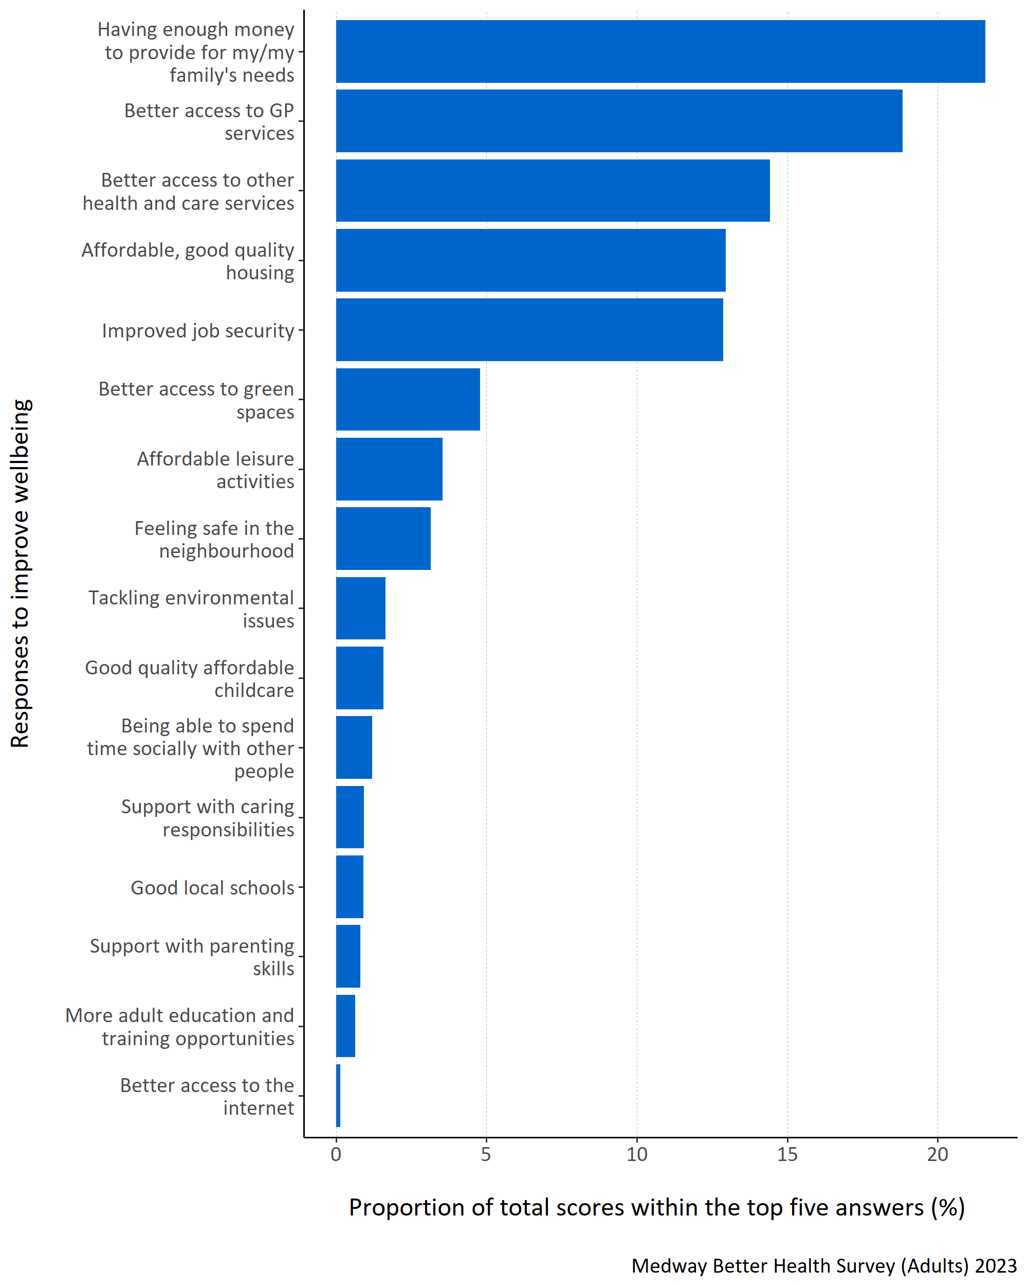
Figure 10: Proportion of total scores within the top five answers for each specified health and wellbeing improvement need.
Figure 10 shows that Medway residents thought ‘having enough money to provide for my/my family’s needs’ was most important to improving health and wellbeing for everyone in Medway. ‘Better access to GP services’, ‘better access to other health and care services’, ‘affordable, good quality housing’ and ‘improved job security’ were also thought to be important.
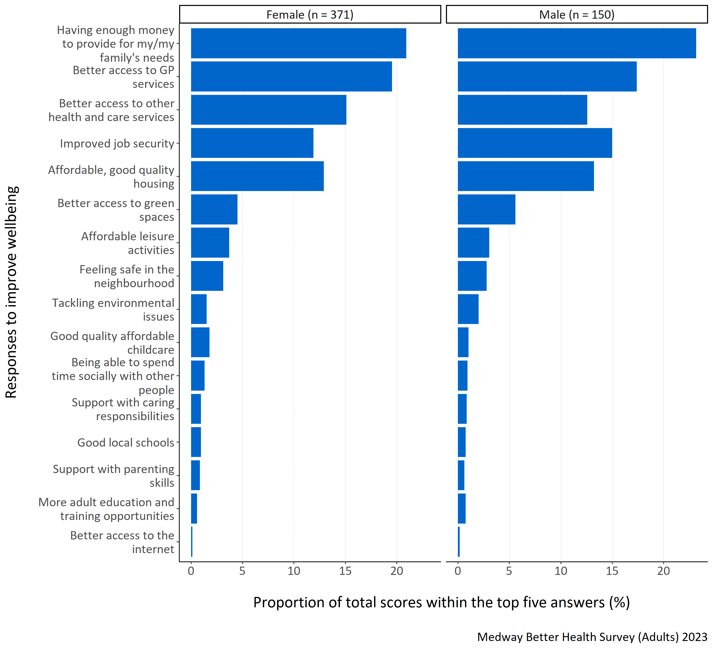
Figure 11: Proportion of total scores within the top five answers for each specified health and wellbeing improvement need by gender.
Figure 11 shows that ‘having enough money to provide for my/my family’s needs’ was considered most important for both male and female respondents when considering improving health and wellbeing. ‘Better access to GP services’, ‘better access to other health and care services’, ‘affordable, good quality housing’ and ‘improved job security’ were also considered important, however males considered ‘improved job security’ more important than females did.
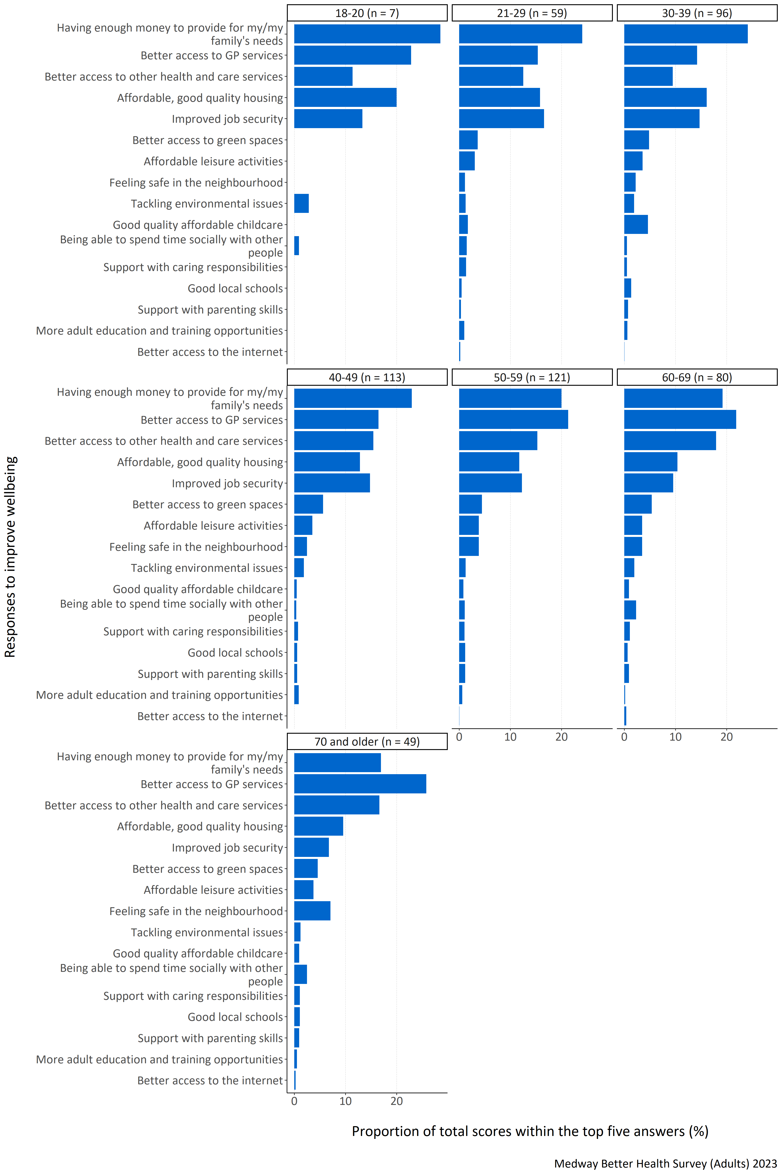
Figure 12: Proportion of total scores within the top five answers for each specified health and wellbeing improvement need by age group (years).
Figure 12 shows that ‘having enough money to provide for my/my family’s needs’ was most important to respondents aged below 50 years. For those aged over 50 ‘better access to GP services’ became more important. Younger age groups also thought that ‘affordable, good quality housing’ was more important.
For respondents in the 18-20 and 40-49 year old age groups, ‘better access to the internet’ was not placed in the top five rankings at all. Furthermore, for the 18-20 year old respondents, ‘better access to green spaces’, ‘affordable leisure activities’, ‘feeling safe in the neighbourhood’, ‘good quality affordable childcare’, ‘support with caring responsibilities’, ‘good local schools’, ‘support with parenting skills’, and ‘more adult education and training opportunities’ were not placed in the top five rankings.
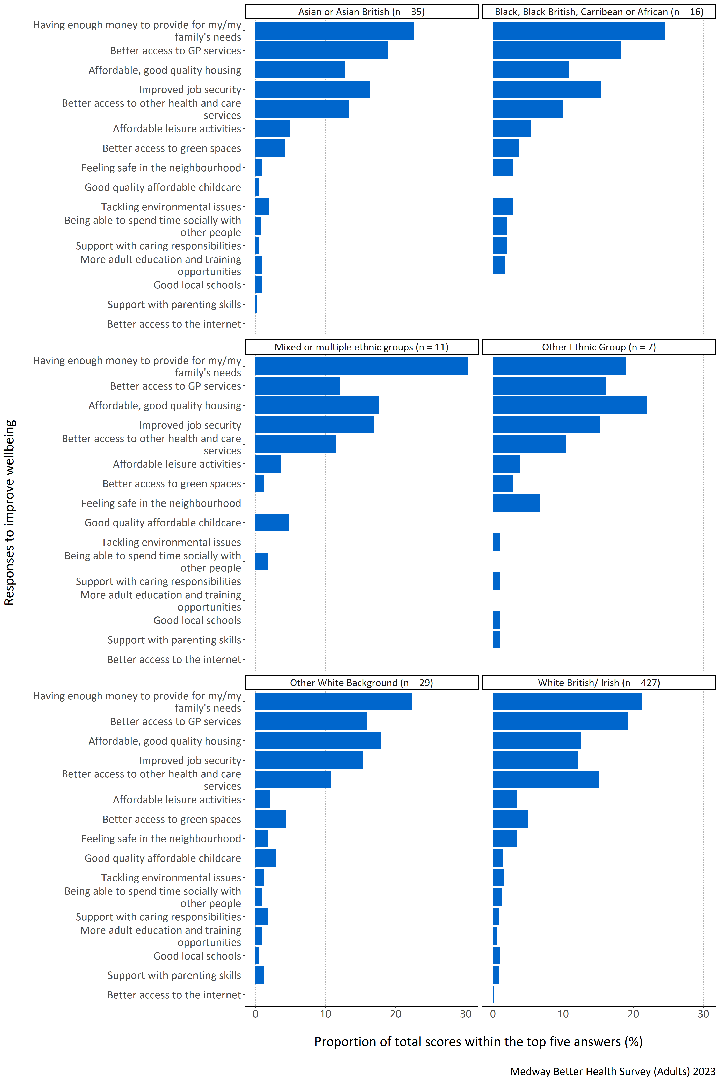
Figure 13: Proportion of total scores within the top five answers for each specified health and wellbeing improvement need by ethnic group.
Figure 13 shows that respondents from all ethnic groups, except for those in the other ethnic group, thought ‘having enough money to provide for my/my family’s needs’ was most important for improving health and wellbeing. Respondents from the other ethnic group category highlighted ‘affordable, good quality housing’ as important. White British/ Irish respondents also considered ‘better access to GP services’ and ‘better access to other health and care services’ to be important. Respondents from Asian or Asian British, Black, Black British, Caribbean or African and Other White Background groups thought ‘better access to GP services’ and ‘improved job security’ were important.
No respondent from any ethnic group except White British/Irish ranked ‘better access to the internet’ in their top five most important improvements when considering health and wellbeing. Additionally, for Black, Black British, Caribbean or African respondents, ‘good quality affordable childcare’, ‘good local schools’, and ‘support with parenting skills’ were not ranked in their top five. For mixed or multiple ethnic groups, no respondents placed ‘feeling safe in the neighbourhood’, ‘tackling environmental issues’, ’support with caring responsibilities’, ‘more adult education opportunities’, ‘good local schools’, and ‘support with parenting skills’ in their top five responses. For the other ethnic group, no respondents included ‘good quality affordable childcare’, ‘being able to spend time socially with other people’, and ‘more adult education and training opportunities’ within their top five responses. It should be noted that the number of respondents from Black, Black British, Caribbean or African, mixed or multiple ethnic group and other ethnic group were small and so data should be interpreted with caution.
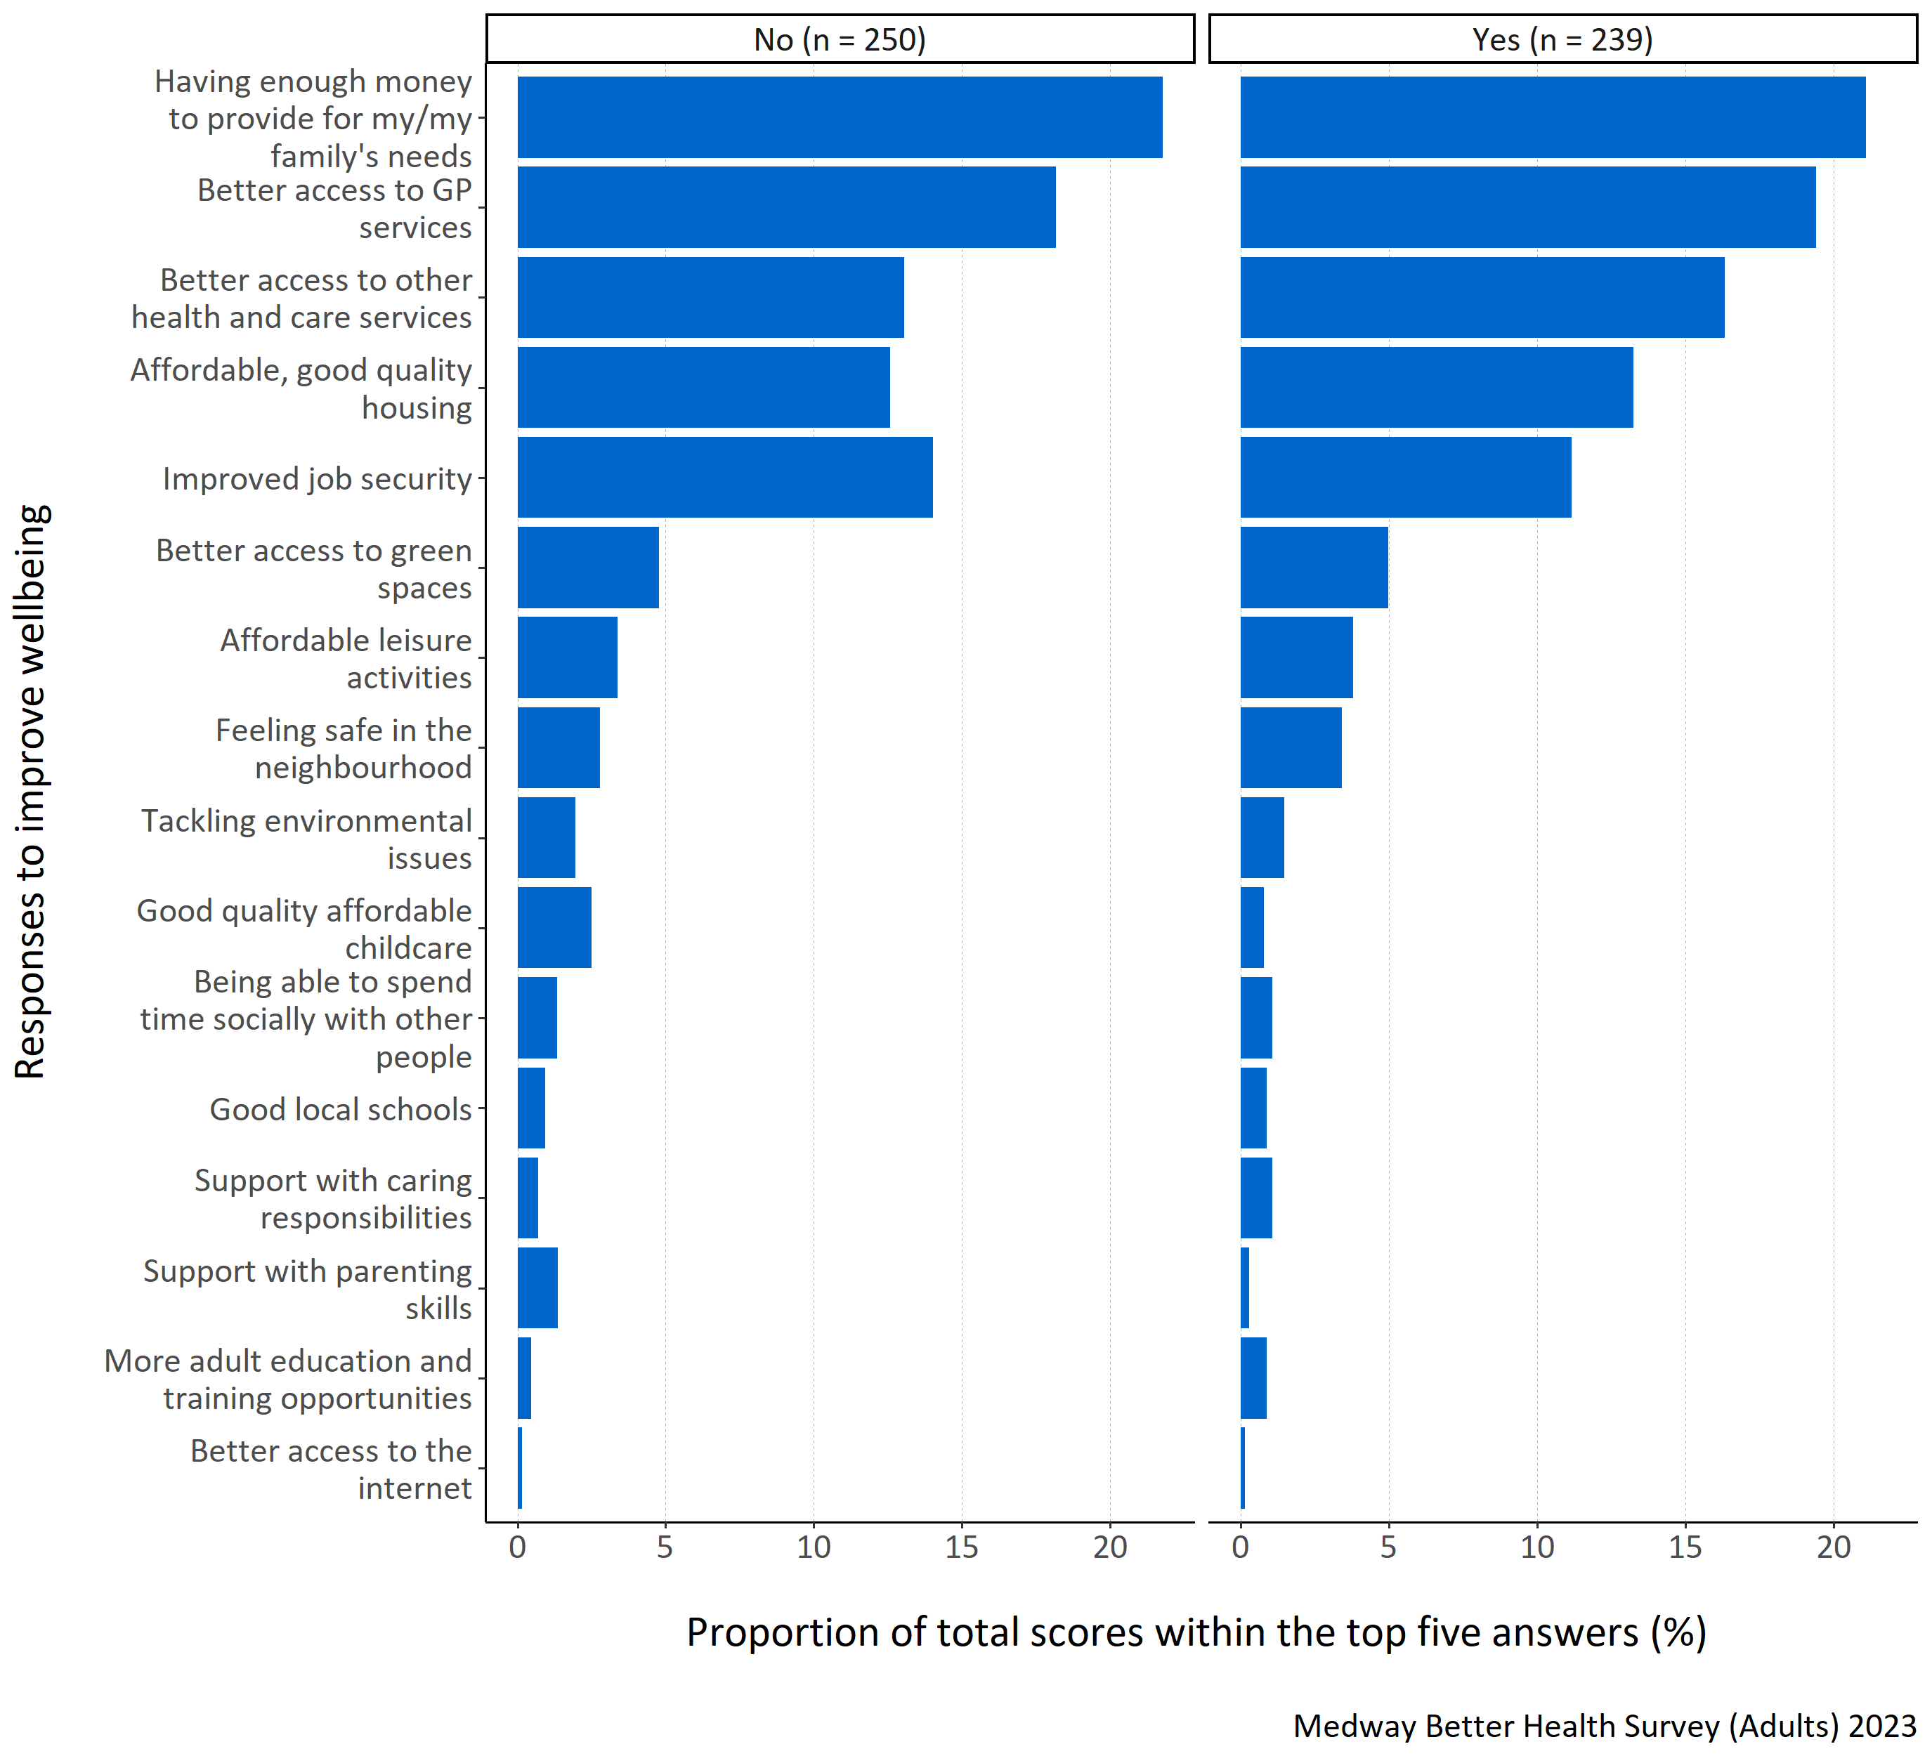
Figure 14: Proportion of total scores within the top five answers for each specified health and wellbeing improvement need by long term physical or mental health conditions.
Figure 14 shows that respondents considered ‘having enough money to provide for my/my family’s needs’ and ‘better access to GP services’ most important regardless of whether they reported a long term physical or mental health condition. Respondents with a long term physical or mental health condition also reported ‘better access to other health services’ as being important. Those without long term physical or mental health conditions thought ‘improved job security’ was also important.

