Joint Local Health and Wellbeing Strategy Children and Young People Survey Analysis
Medway Council, Public Health Intelligence Team

Contributors:
- Emmanuella Uwaifo - Public Health Intelligence Analyst
- Dr Natalie Goldring - Senior Public Health Intelligence Manager
- Dr Eluned Broom - Senior Public Health Intelligence Analyst

Introduction
The Medway ‘Better Health Survey’ 2023 was conducted to better understand which aspects of life Medway residents thought were important to their health and wellbeing. The responses also offered insights into what people thought the barriers to achieving this were. Three versions of the survey were developed and tailored to a different group within the Medway population. These groups consisted of adults (aged 18 years and older) and children (aged 13-18 years) who were asked to provide responses about themselves. The third version was designed for organisations, specifically targeting their interactions with individuals they engage with.
This report relates to the ‘Children and Young People’ survey results which includes insights from Medway residents aged 13-18 years old. It gives an overview of the perceived health needs and barriers to health for the survey participants and will inform actions needed to improve health and wellbeing. These will be set out in Medway’s ‘Joint Local Health and Wellbeing Strategy’ which is being refreshed from the current Medway Joint Health and Wellbeing Strategy (2018-2023).

Summary
The survey had a total of nine questions. It began by seeking the participants’ consent and collecting basic demographic information such as age, gender, ethnicity and whether they had any long-term physical or mental health conditions. The remaining questions in the survey focused on what each participant considered important for achieving good health and wellbeing, as well as any obstacles they faced in being healthy and well. These health and wellbeing questions resulted in a mixture of quantitative (numerical) and qualitative (descriptive) responses. This report will initially analyse the demographic information before focusing on the four quantitative response questions. Each question is examined first for the entire group of respondents, and then the analysis is further broken down by age, gender, ethnicity, and whether the participants have any long term physical or mental health conditions.

Demographics of the survey participants compared with the Medway population
The total population of Medway aged 13-18 years old in the most recent census (2021) was 20,491. This survey had 148 respondents, which provides a useful estimate of local views on health and wellbeing.
The following section shows comparisons of the demographic breakdowns from the ‘Better Health Survey’ survey sample and the latest census data for Medway (2021) for children and young people aged 13-18 years old.
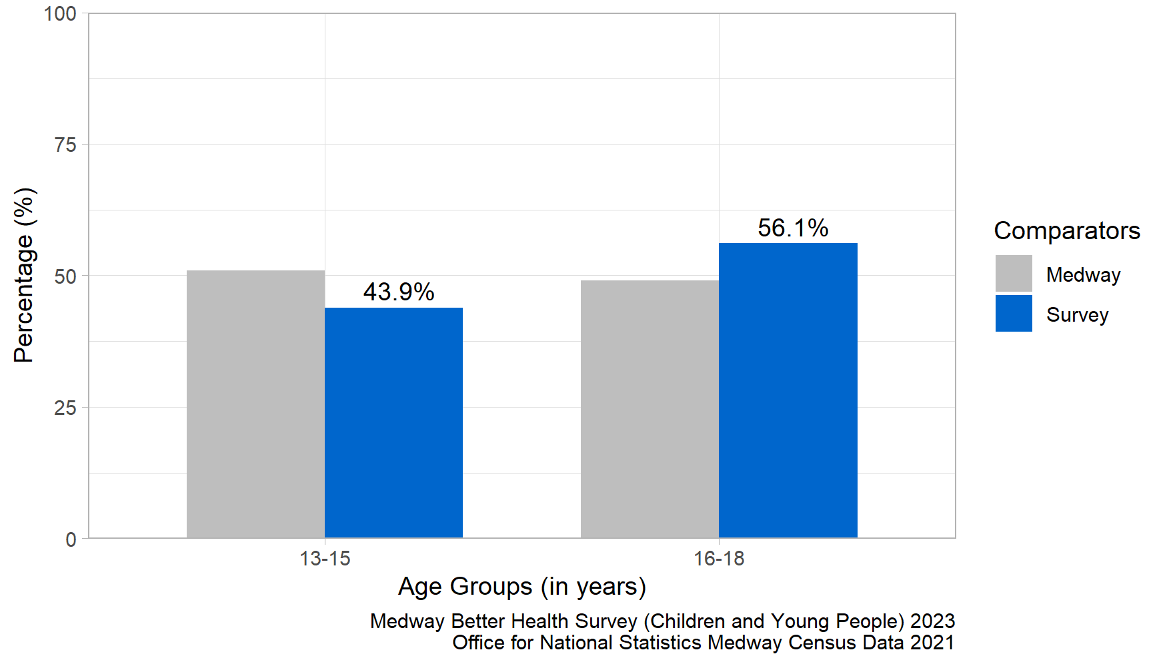
Figure 1 : Age Comparison between the local Medway population and the survey participants.
Figure 1 shows the age distribution for the survey participants and the local Medway population. The distribution of survey responses by age group was similar to the 2021 Census.
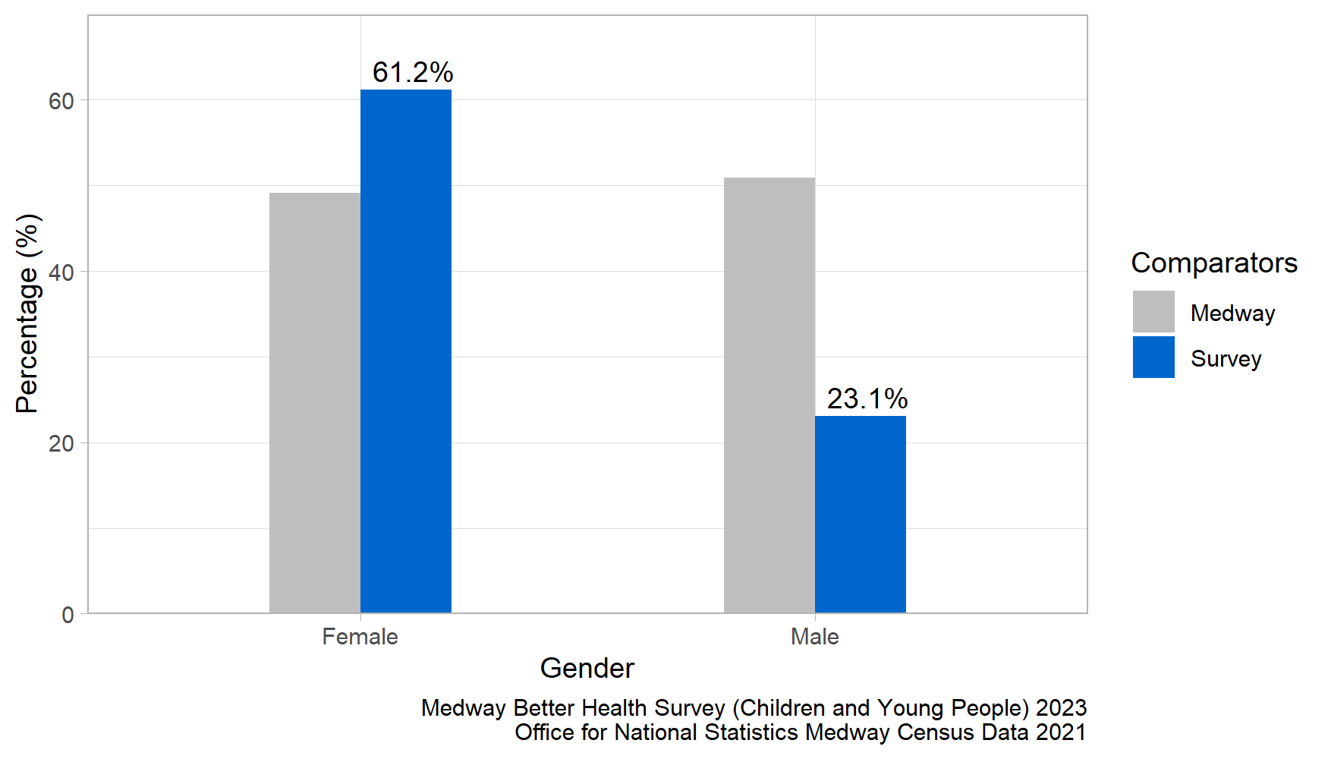
Figure 2: Gender Comparison between the Local Medway Population and the Survey Participants.
Figure 2 shows the gender division in Medway (aged 13-18 years old) compared with the survey participants. The distribution of survey responses by gender differs from the 2021 Census data. In the survey there is a much greater proportion of female respondents to male respondents, whereas in the local Medway population the split between male and female is nearly equal.
A small number of individuals in the survey identified with a gender identity other than male or female. Due to the low numbers, their responses were mostly suppressed to prevent the possibility of identification. However, non-binary individuals were included in the analysis as there were enough participants who identified as non-binary, reducing the risk of identification. In Figure 2, the data for non-binary individuals was suppressed because the census data provided negligible statistics for meaningful comparison.
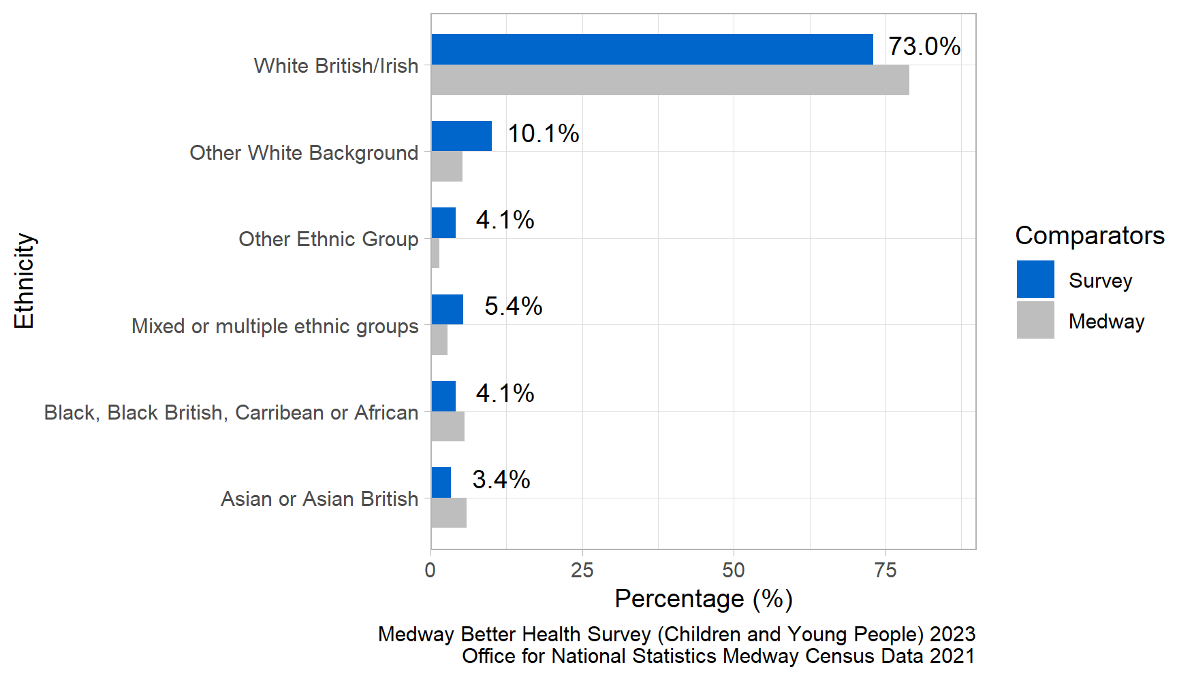
Figure 3: Ethnicity Comparison between the local Medway population and the survey participants.
Figure 3 shows the ethnic group diversity in the survey respondents (age 13 - 18 years) compared with the local Medway Population (all ages). The distribution of survey responses by ethnic group was similar to the 2021 Census.
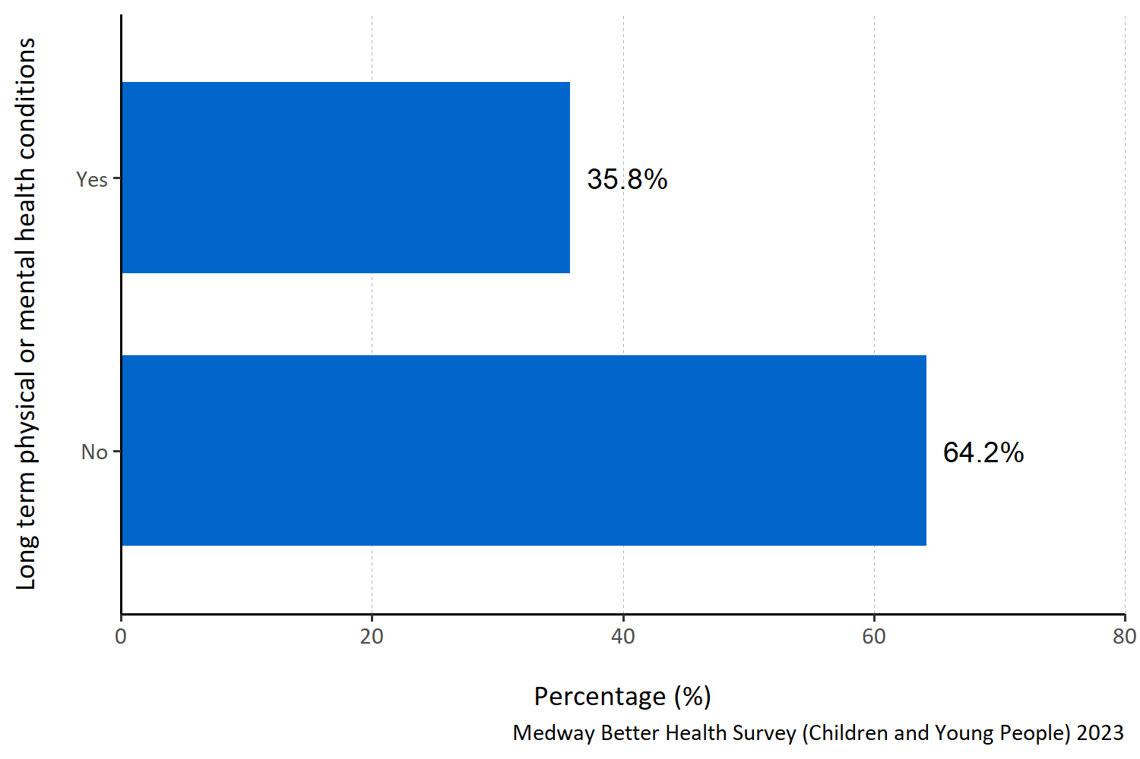
Figure 4: Proportion of survey respondents with long term physical or mental health conditions.
Figure 4 shows that about 35% of the survey respondents reported a long term physical or mental health condition.
Taken together, this analysis indicates that the survey respondents are a good representation of the Medway population aged 13- 18 years old as a whole.

Defining what being healthy means to children and young people in Medway
Question: What does being healthy mean to you? Please number in order of importance, with 1 being ‘most important’.
Answer options:
- Feeling happy
- Feeling calm and relaxed
- Sleeping well
- Being without illness or pain
- Less worry
- Dealing well with stress when it happens
- Getting enough exercise
- Healthy habits around food and eating
- Having supportive friends and family.
Survey participants were asked to prioritise and rank the response options for what they would personally define as being healthy in order of importance. They were instructed to assign a number for the nine response options from 1 to 9 to indicate the level of importance, with 1 representing the most important priority for them.
To analyse this question, the top five responses were selected for each participant and assigned a score ranging from one to five, with five indicating the highest-ranked response. These scores were then combined to calculate a total score for each response. To determine the importance of each response within the top five, the total score for each response was divided by the sum of the total scores for all the responses in the top five. This calculation produced a proportion. The higher the proportion, the more likely the response was consistently placed and/or frequently ranked highly within the top five responses.
In figure 5 to 9 all the responses shown appear in the top five for at least one participant. A higher proportion indicates that response is more important to children and young people in Medway when defining what being healthy means to them.
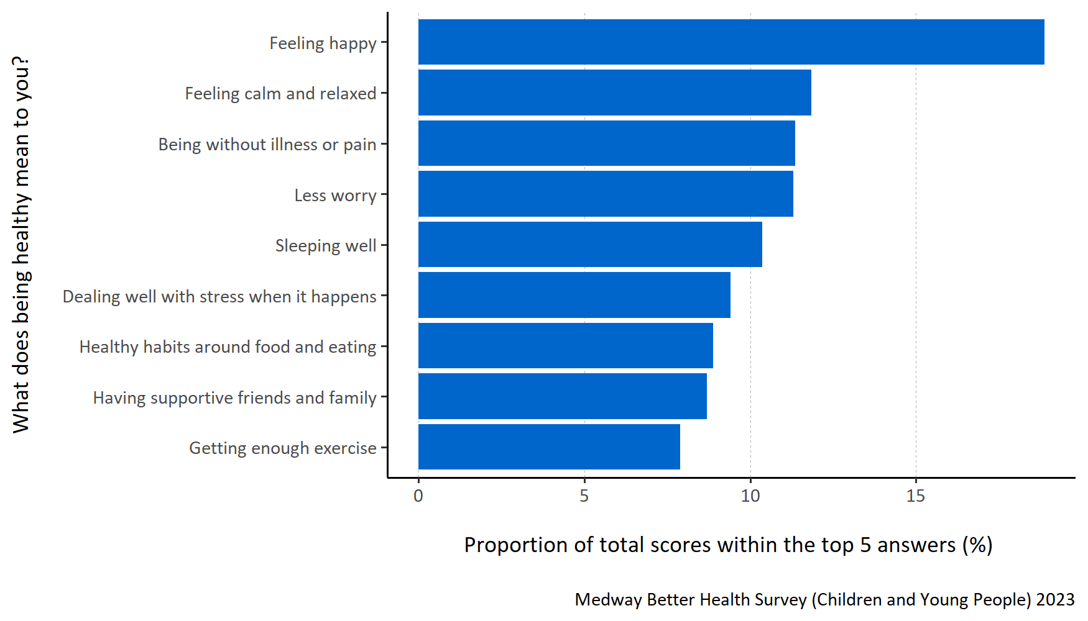
Figure 5: Proportion of total scores within the top 5 answers for each specified healthy lifestyle factor.
Figure 5 shows that children and young people in Medway consider ‘feeling happy’ to be most important when defining being healthy. They also thought ‘feeling calm and relaxed’, ‘being without illness or pain’ and ‘less worry’ were important.
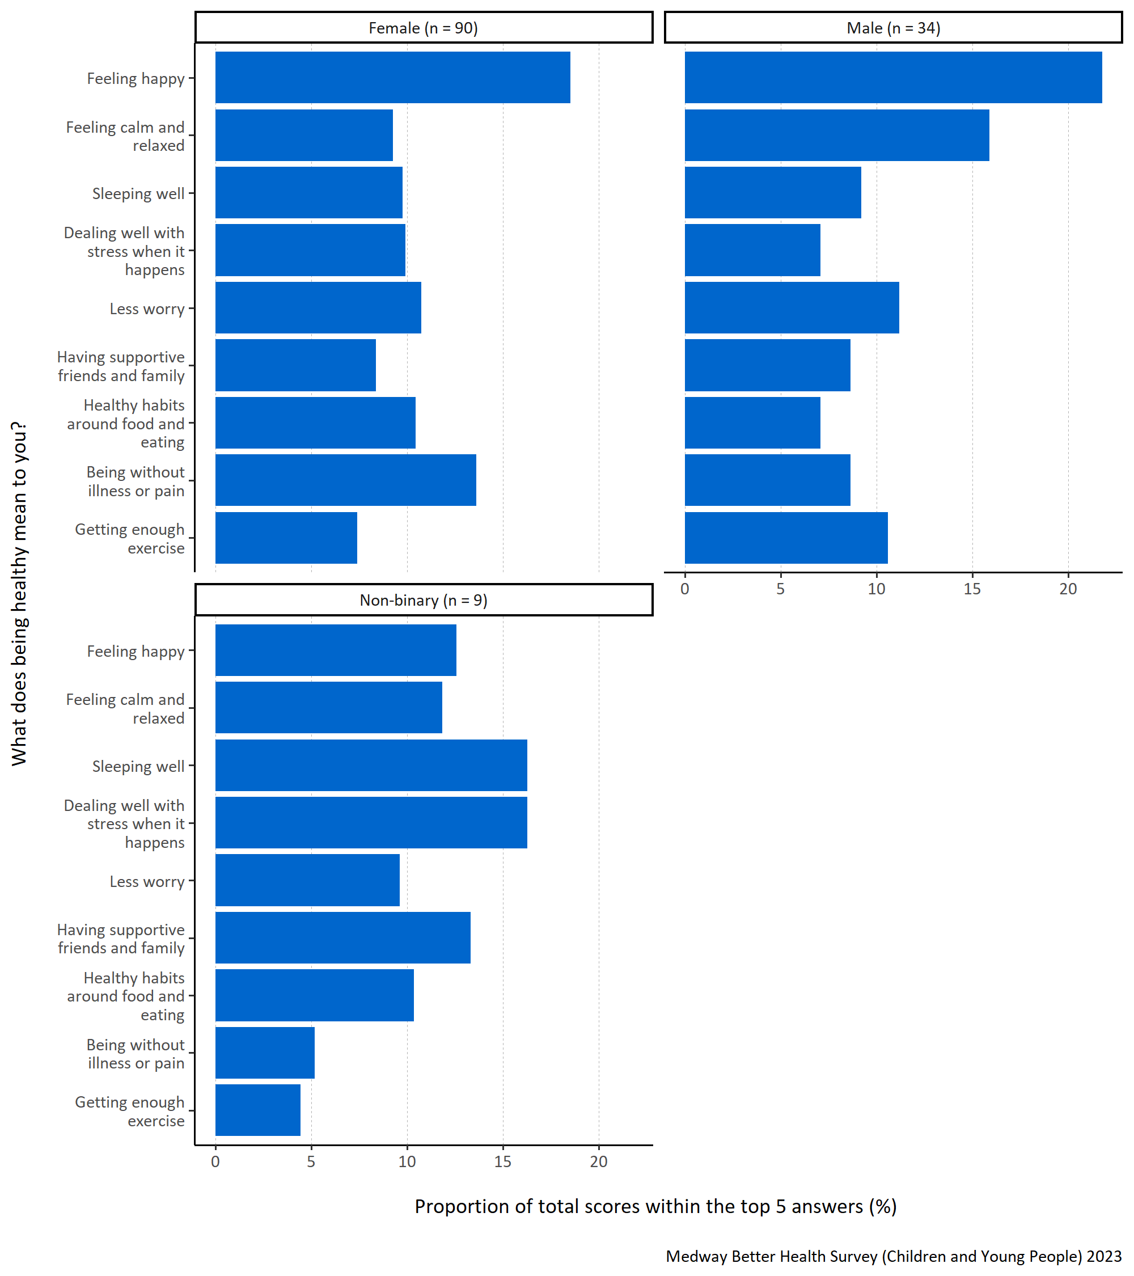
Figure 6: Proportion of total scores within the top 5 answers for each specified healthy lifestyle factor by gender.
Figure 6 shows that ‘feeling happy’ was most important for males and females who completed the survey. This was not the case for non-binary respondents, who favoured ‘sleeping well’ and ‘dealing well with stress when it happens’. Females also regarded ‘being without pain or illness’ as important whereas males favoured ‘feeling calm and relaxed’ and non-binary respondents favoured ‘having supportive friends and family’.
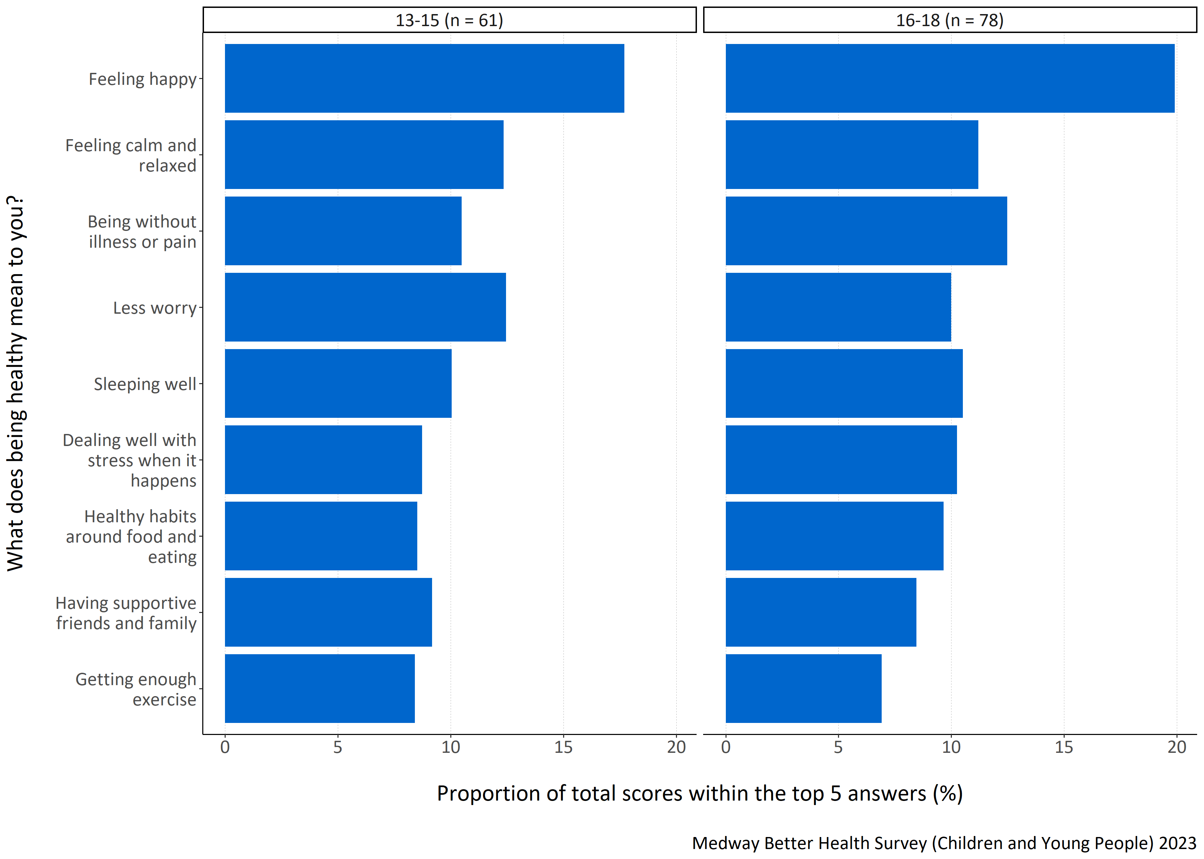
Figure 7: Proportion of total scores within the top 5 answers for each specified for each specified healthy lifestyle factor by age group in years.
Figure 7 shows that ‘feeling happy’ was considered most important when defining good health regardless of age. Younger age groups (13-15 years old) also thought ‘feeling calm and relaxed’ and ‘less worry’ to be important whereas older age groups (16-18 years old) favoured ‘being without illness or pain’.
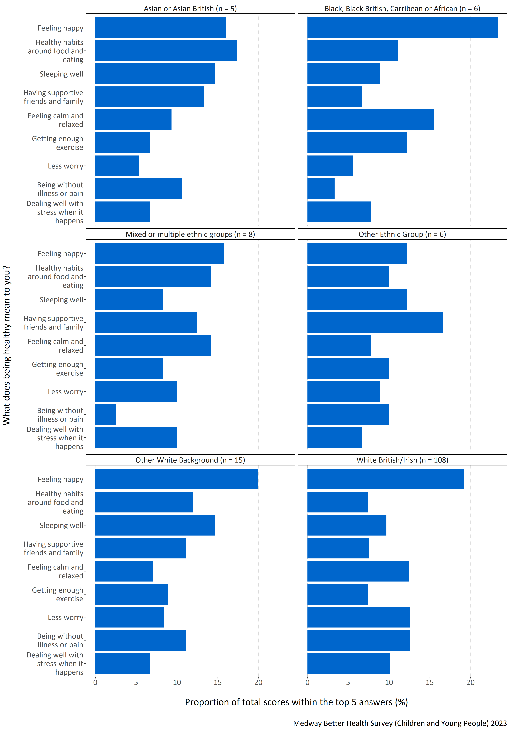
Figure 8: Proportion of total scores within the top 5 answers for each specified healthy lifestyle factor by ethnicity.
Figure 8 shows that respondents identifying as Black, Black British, Caribbean or African, mixed or multiple ethnic groups, White British/Irish, and other White background, considered ‘feeling happy’ to be most important when defining good health. For respondents identifying with other ethnic groups, ‘having supportive friends and family’ was most important, while Asian or Asian British respondents most favoured ‘healthy habits around food and eating’. That said, ‘feeling happy’ was also thought of as important to Asian or Asian British respondents. The responses ‘healthy habits around food and eating’ and ‘sleeping well’ were considered important for respondents in the other White background’ and other ethnic group categories. For White British/Irish respondents, ‘less worry’, ‘being without illness or pain’ and ‘feeling calm and relaxed’ were also favoured.
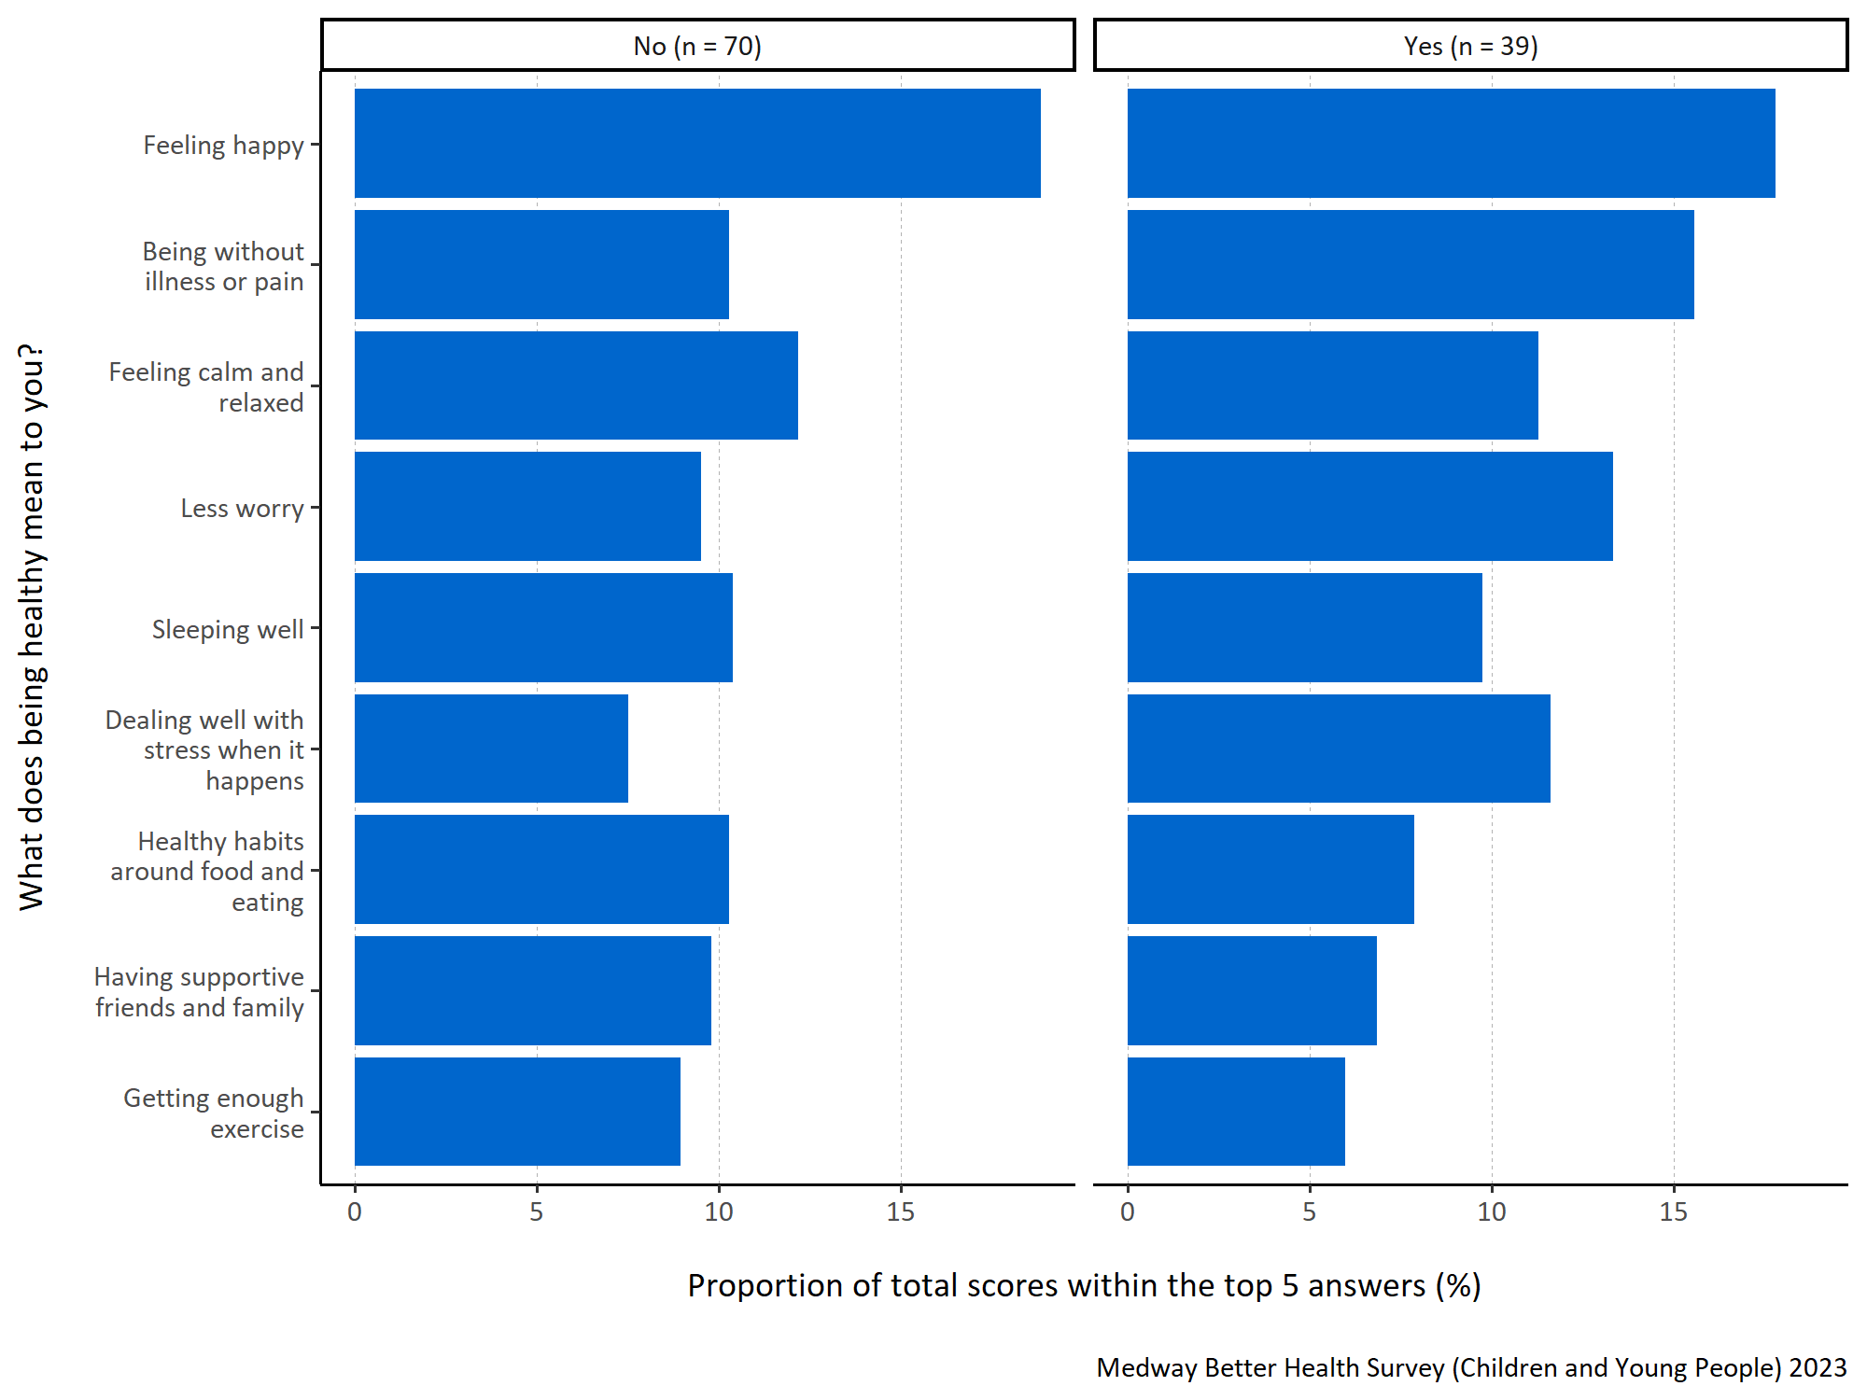
Figure 9: Proportion of total scores within the top 5 answers for each specified healthy lifestyle factor by long term physical or mental health conditions.
Figure 9 shows that ‘feeling happy’ was considered most important when defining good health regardless of whether the child or young person had a long term physical or mental health condition.
Additionally, the responses ‘being without illness or pain’, ‘less worry’, ‘dealing well with stress when it happens’ and ‘feeling calm and relaxed’ were deemed important.

How do children and young people in Medway manage difficult emotions
Question: What helps you to manage difficult emotions (things like low mood, worry, anger, stress, sadness, fear, jealousy, feeling anxious)? Please number in order of importance, with 1 being ‘most important’.
- Listening to music
- Sleeping
- Socialising
- Participating in sport or other physical activity
- Doing something create (for example, art, writing, poetry, drama, playing music, etc.)
- Watching TV or films
- Chatting to friends or family
- Eating
- Using social media
- Using technology (like playing computer games)
- Using online self-help Apps
- Practising mindfulness meditation
- I don’t usually do anything.
Survey participants were asked to prioritise and rank what they thought to be the most important things that they do to manage their ‘difficult emotions’. They were instructed to assign a number for the thirteen response options from 1 to 13 to indicate the level of importance, with 1 representing the most significant priority.
To analyse this question, the top five responses were selected for each participant and assigned a score ranging from one to five, with five indicating the highest-ranked response. These scores were then combined to calculate a total score for each response. To determine the importance of each response within the top five, the total score for each response was divided by the sum of the total scores for all the responses in the top five. This calculation produced a proportion. The higher the proportion, the more likely the response was consistently placed and/or frequently ranked highly within the top five responses.
In figures 10 to 14 all the responses shown appear in the top five for at least one participant. A higher proportion indicates that response is more important to children and young people in Medway when asked to consider what helps them manage difficult emotions.
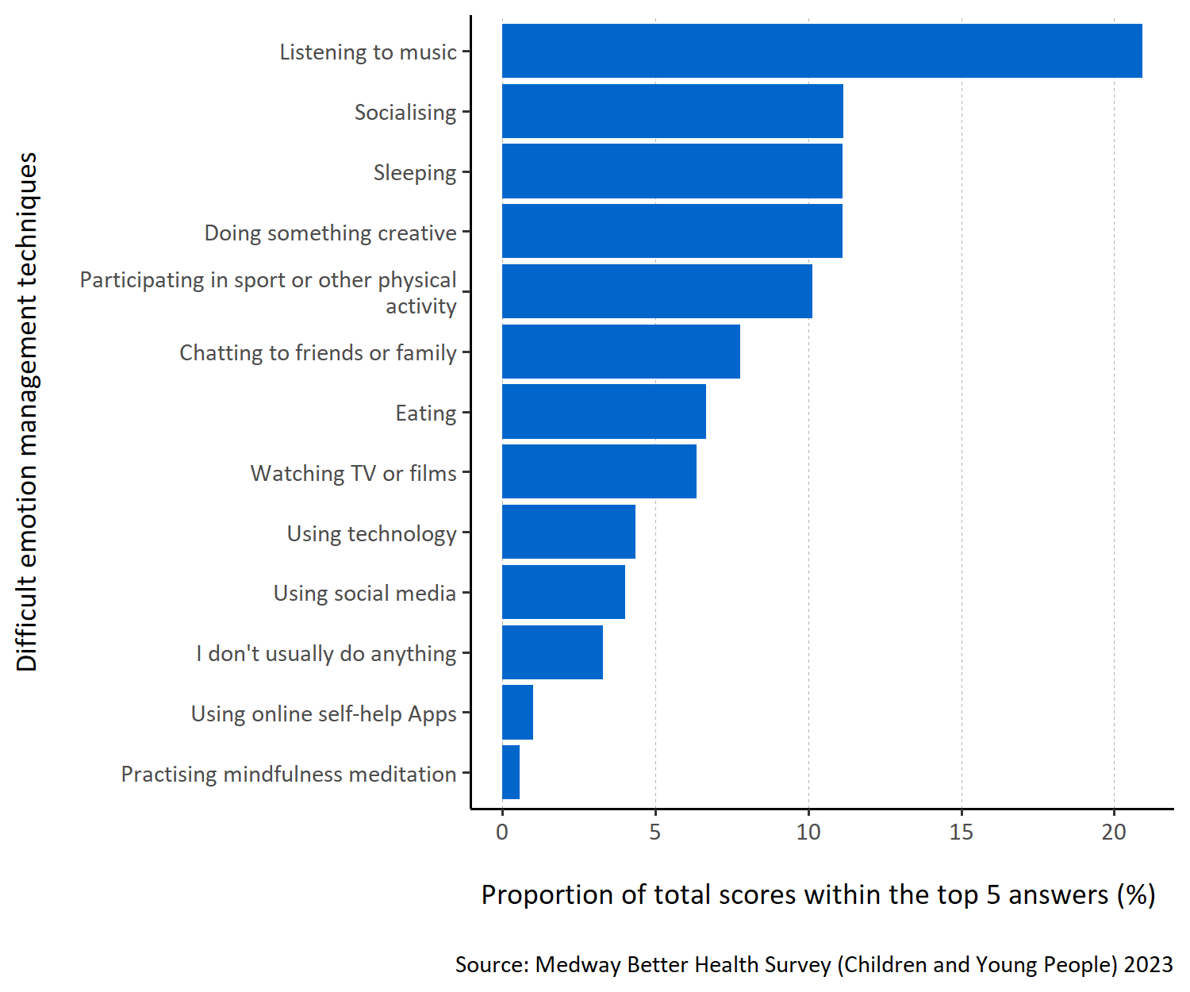
Figure 10: Proportion of total scores within the top 5 answers for each specified difficult emotion management technique.
Figure 10 shows that children and young people in Medway report ‘listening to music’ most helps them manage difficult emotions. Respondents also considered ‘socialising’, ‘participating in sport or other physical activity’, ‘sleeping’ and ‘doing something creative’ to be important methods.
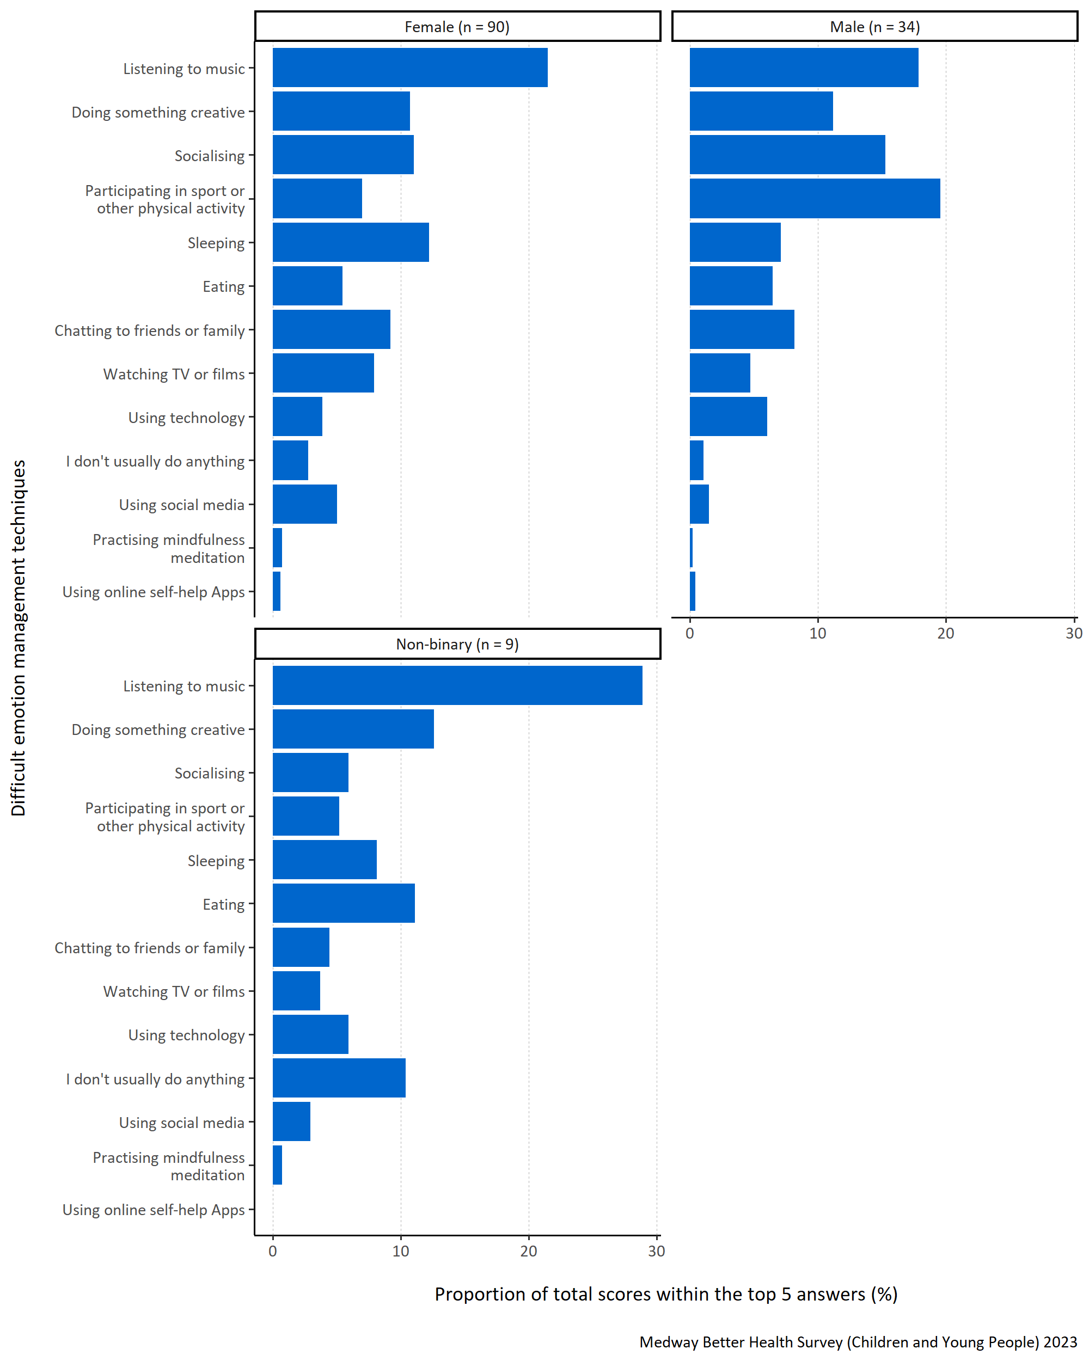
Figure 11: Proportion of total scores within the top 5 answers for each specified difficult emotion management technique by gender.
Figure 11 shows that ‘listening to music’ was used by non-binary and female respondents to manage difficult emotions. Although male respondents also favoured ‘listening to music’, they considered ‘participating in sport or other physical activity’ to be most important. ‘Using online self-help Apps’ was not placed in the top five rankings by any respondents identifying as non-binary.
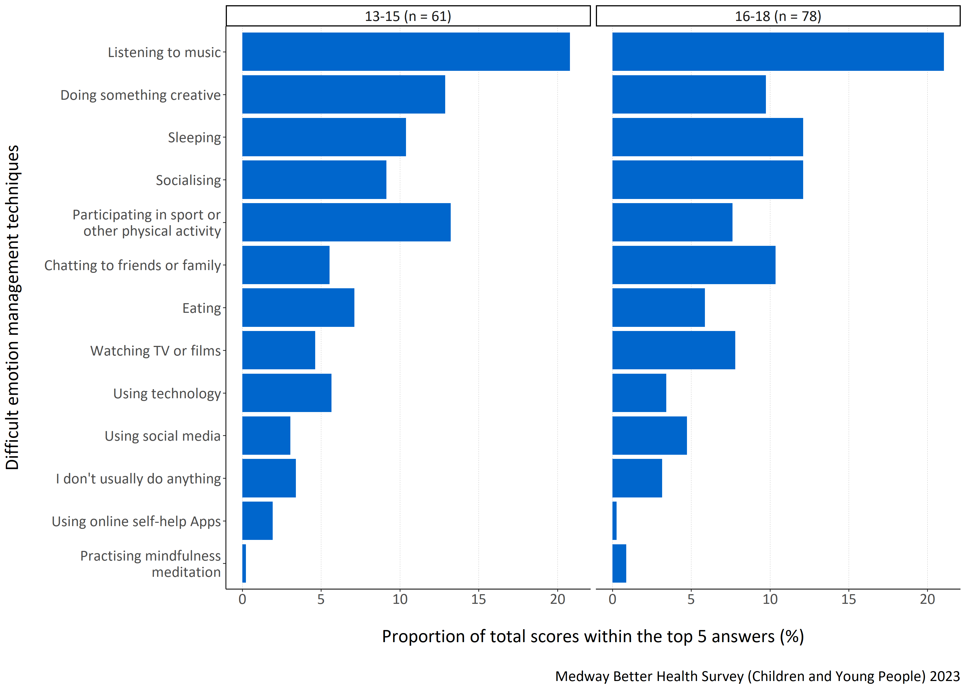
Figure 12: Proportion of total scores within the top 5 answers for each specified difficult emotion management technique by age group in years.
Figure 12 shows that ‘listening to music’ was the best way of managing difficult emotions for both the 13-15 and 16-18 year old respondents. For respondents aged 13-15 years old, ‘participating in sport or other physical activity’ and ‘doing something creative’ were also considered important. For respondents aged 16-18 years old, ‘sleeping’, ‘socialising’, and ‘chatting to friends or family’ were favoured.
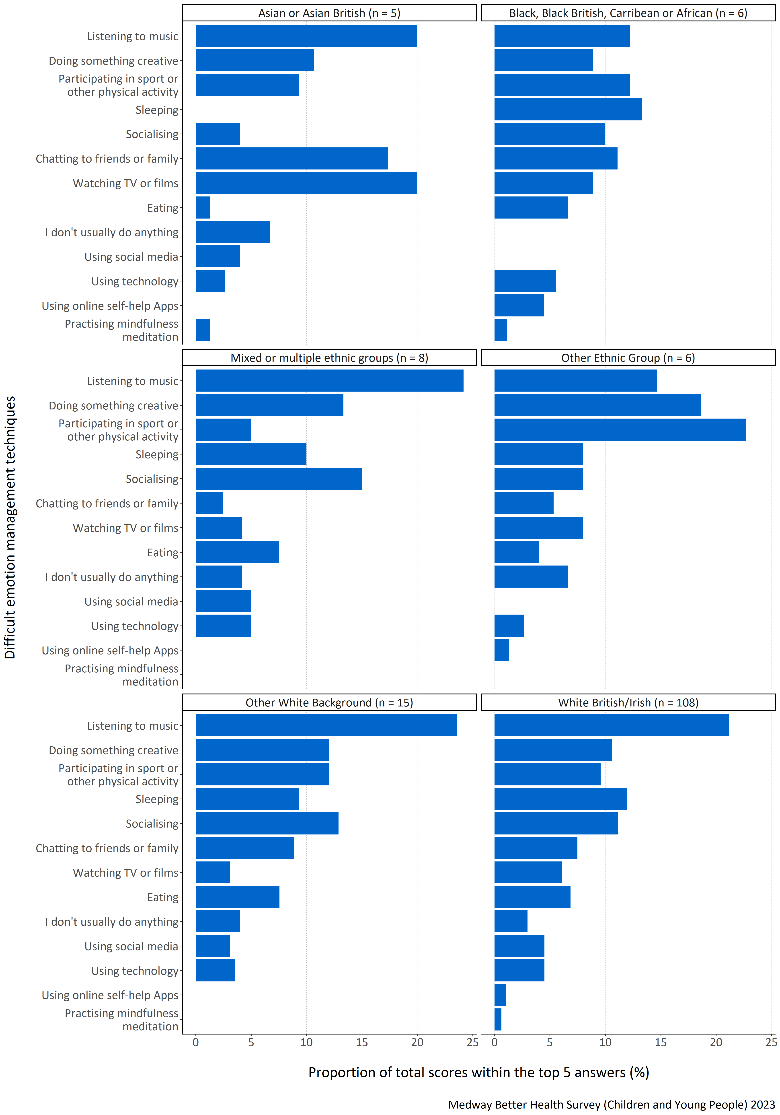
Figure 13: Proportion of total scores within the top 5 answers for each specified difficult emotion management technique by ethnicity.
Figure 13 presents the scores for respondents in the survey grouped up by ethnic background. ‘Listening to music’ was considered most important when managing difficult emotions amongst mixed or multiple backgrounds, other White backgrounds, White British/Irish, and Asian or Asian British ethnic groups. Respondents identifying as from another ethnic group in this survey most commonly placed ‘participating in a sport or other physical activity’ as most important.
The response option given lowest importance also varied by ethnic group. For example, ‘practising mindfulness meditation’ was given the lowest importance or not ranked at all in the top five choices by mixed or multiple ethnic groups, other ethnic groups, people from White British/Irish background and people from other White backgrounds. No respondents from Asian or Asian British backgrounds picked ‘sleeping’ or ‘using self-help Apps’ in their top five methods of managing difficult emotions, and no respondents from Black, Black British, Caribbean or African ethnic backgrounds picked ‘I don’t usually do anything’ or ‘using social media’. It is important to note that the number of respondents in all groups except White British/Irish was low and so these results must be interpreted with caution.
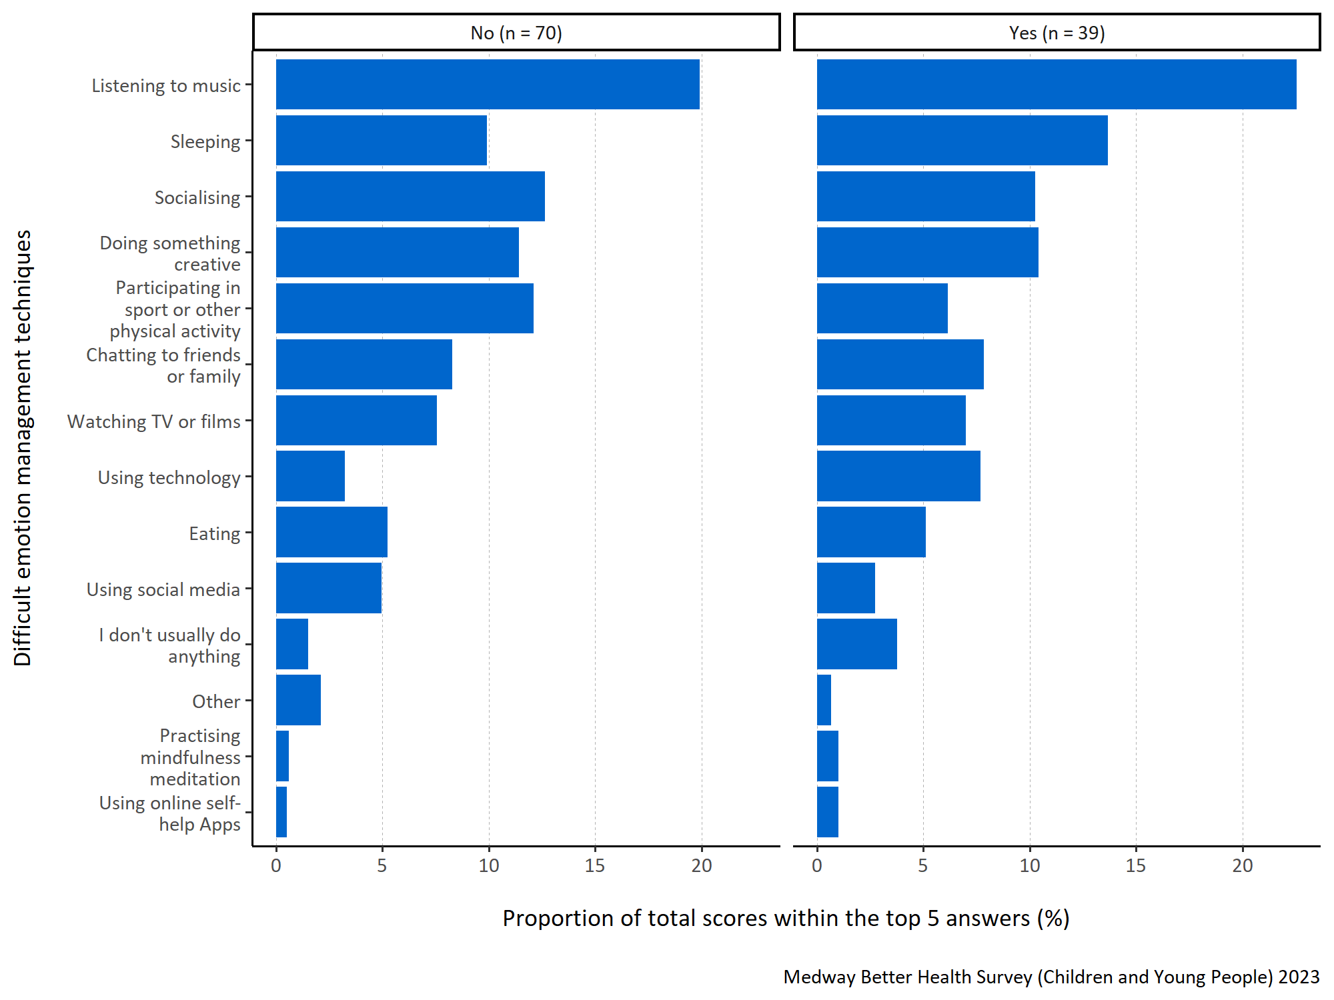
Figure 14: Proportion of total scores within the top 5 answers for each specified difficult emotion management technique by long term physical or mental health conditions.
Figure 14 shows that ‘listening to music is most important to respondents regardless of whether they report a long term physical or mental health condition. For respondents with a long term physical or mental health condition, ’sleeping’ was also considered important. Although those without a long term health condition also considered ‘sleeping’ important, they reported that ‘socialising’, ‘doing something creative’ and ‘participating in sport or other physical activity’ as more important.

Who would children and young people in Medway go to if they needed support with difficult emotions
Question: Who would you go to if you felt you needed support with these emotions? Please number in order of importance, with 1 being ‘most important’.
Answer options:
- Friends
- Parent/care giver
- Other relative (for example, brother, sister, aunt, uncle, grandparent)
- Boyfriend/girlfriend
- Teacher
- Doctor/GP
- Extra-curricular activity teacher (for example, music teacher, sports coach, drama teacher)
- School Nurse
- Online/social media information or support
- Mentor or counsellor
- Scout or Guide leader
- Youth worker
- I don’t have anyone to go to.
Survey participants were asked to prioritise and rank who they thought to be the most important people in their lives to go to, to get support with managing their ‘difficult emotions’. They were instructed to assign a number for the thirteen response options from 1 to 13 to indicate the level of importance, with 1 representing the most significant priority.
To analyse this question, the top five responses were selected for each participant and assigned a score ranging from one to five, with five indicating the highest-ranked response. These scores were then combined to calculate a total score for each response. To determine the importance of each response within the top five, the total score for each response was divided by the sum of the total scores for all the responses in the top five. This calculation produced a proportion. The higher the proportion, the more likely the response was consistently placed and/or frequently ranked highly within the top five responses.
In figures 15 to 19 all the responses shown appear in the top five for at least one participant. A higher proportion indicates that children and young people in Medway are more likely to go to that option if they felt they needed support with difficult emotions.
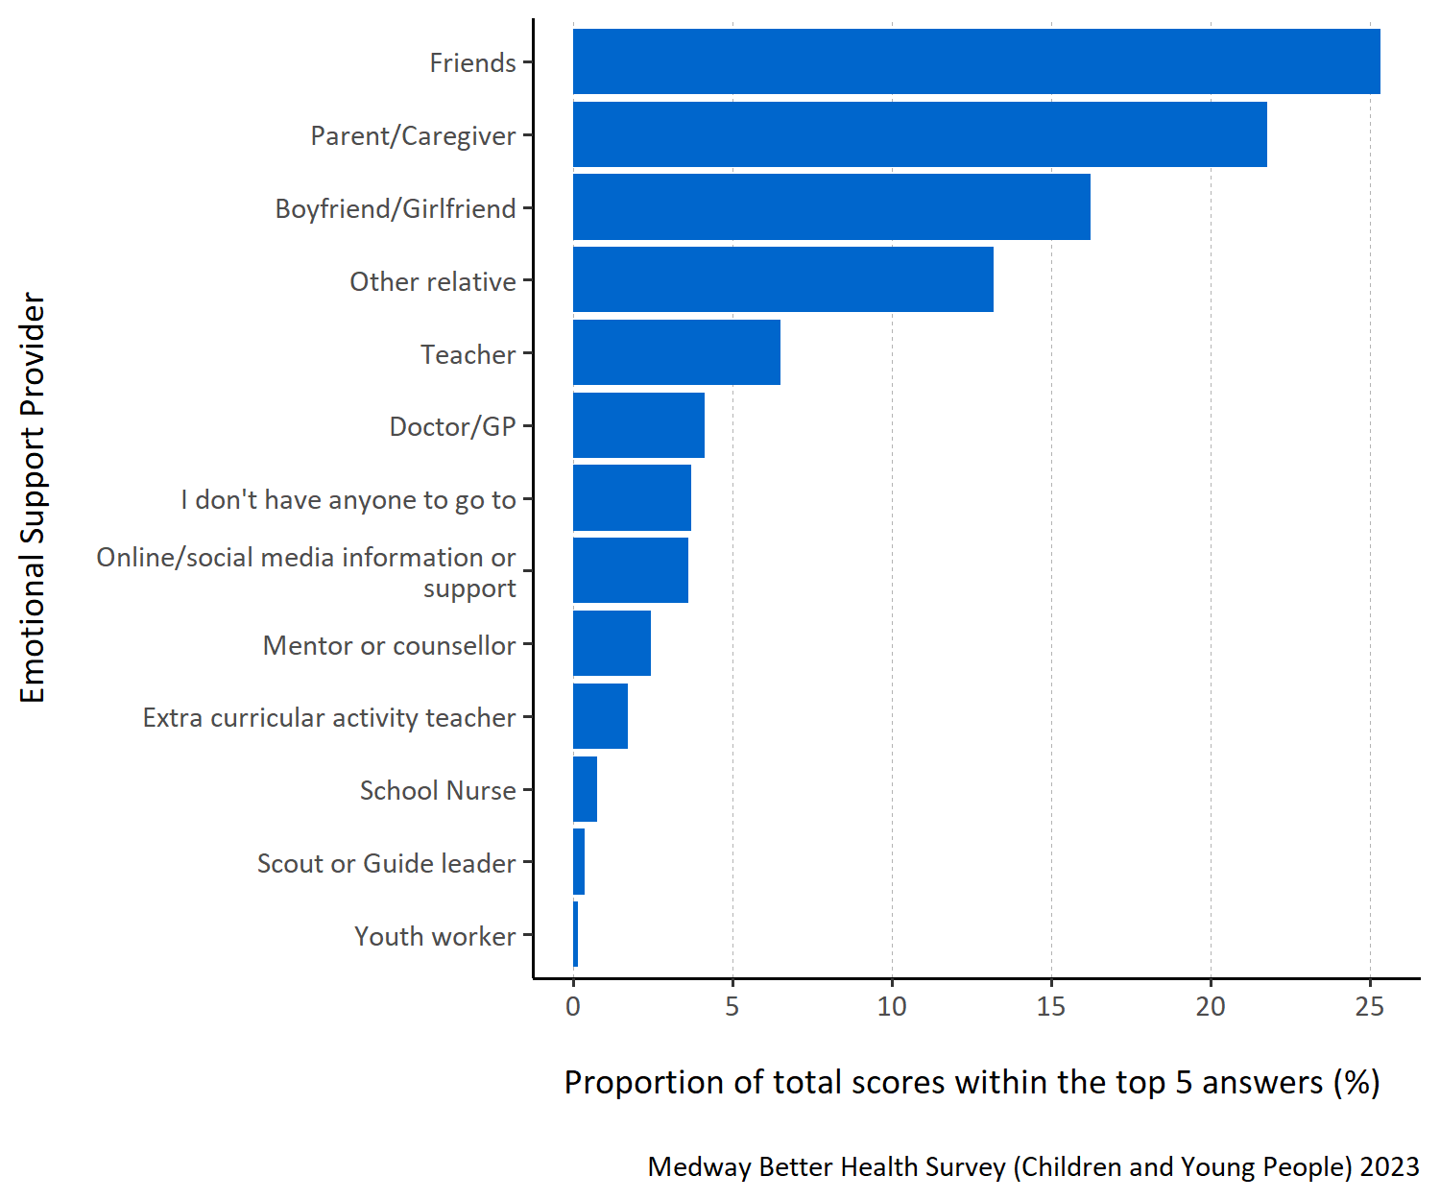
Figure 15: Proportion of total scores within the top 5 answers for each specified emotional support provider.
Figure 15 shows that children and young people in Medway are most likely to go to ‘friends’ if they feel like they need support with their emotions. They also favoured going to a ‘parent/caregiver’ their ‘boyfriend/girlfriend’ and an ‘other relative’.
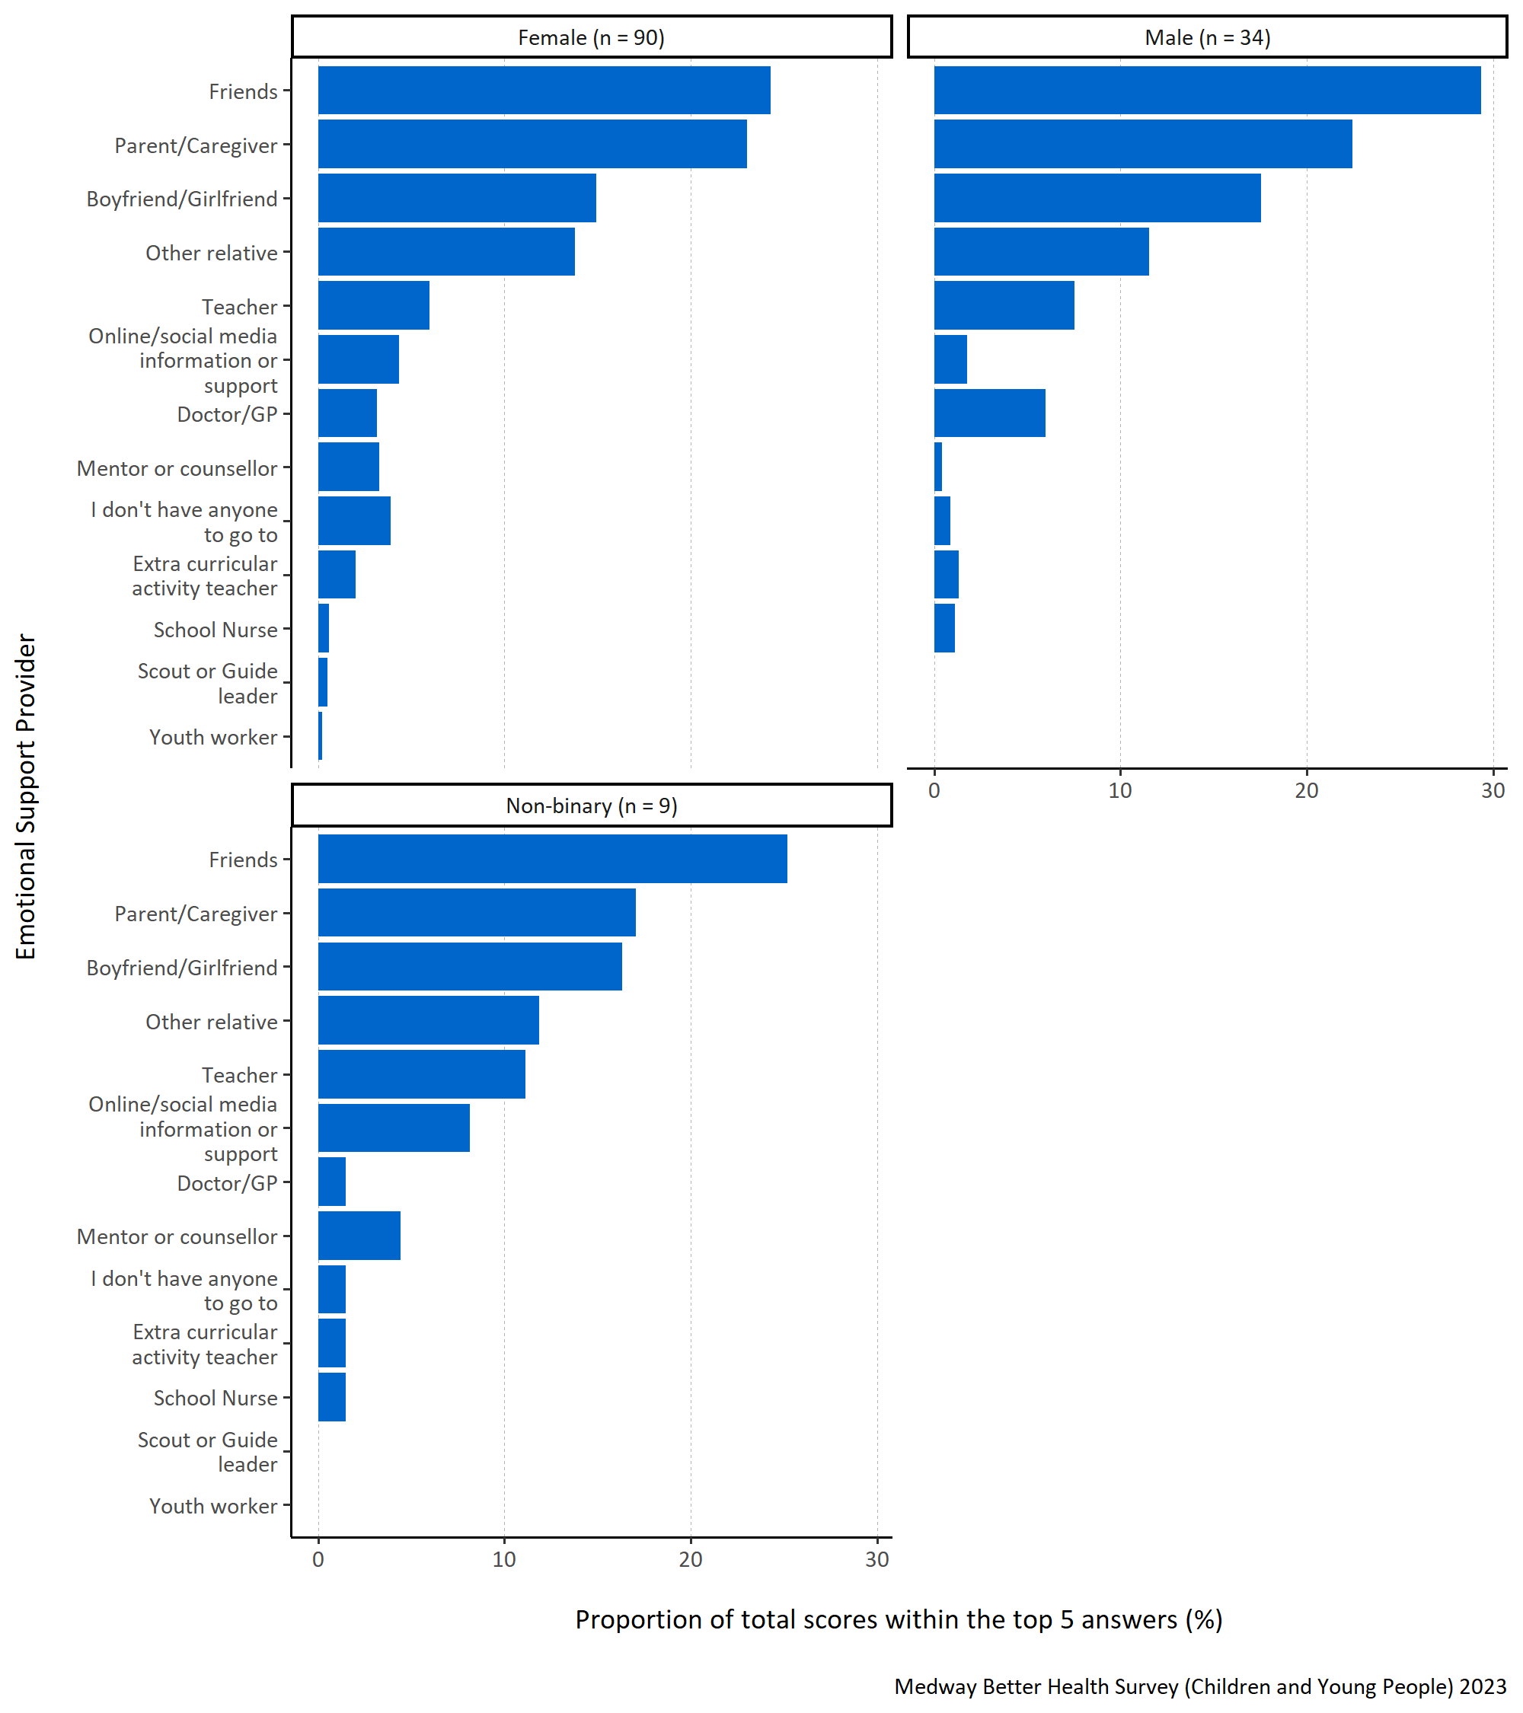
Figure 16: Proportion of total scores within the top 5 answers for each specified emotional support provider by gender.
Figure 16 shows that male, non-binary, and female respondents are most likely to seek out ‘friends’. Additionally, respondents were likely to go to a ‘parent/caregiver’ or ‘boyfriend/girlfriend’. ‘Scout or Guide leader’ and ‘youth worker’ were not placed in the top five rankings by any male respondents or by any respondents that identified as non-binary. It should be noted that there are a small number of non-binary respondents and so caution must be taken when interpreting these data.
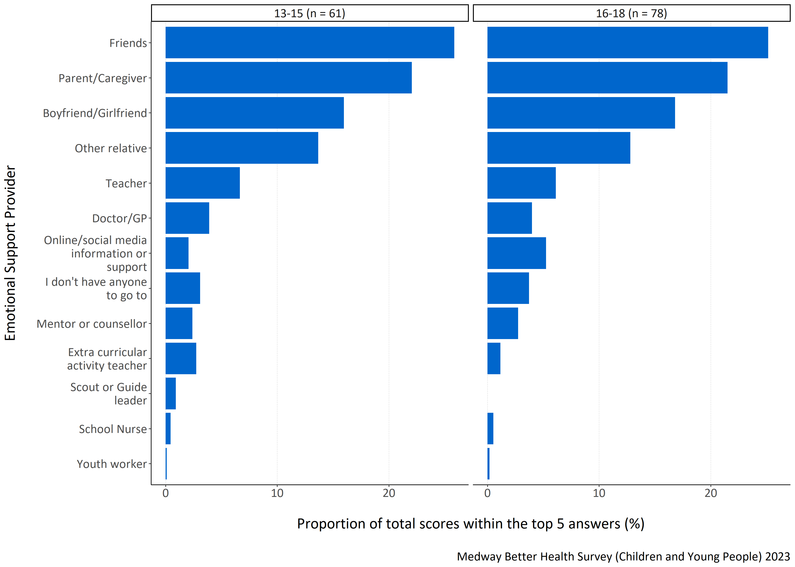
Figure 17: Proportion of total scores within the top 5 answers for each specified emotional support provider by age group in years.
Figure 17 shows that both 13-15 and 16-18 year old respondents are most likely to go to ‘friends’ when they feel they need support with difficult emotions. They are also likely to go to a ‘parent/caregiver’, ‘boyfriend/girlfriend’ or an ‘other relative’. No respondent aged 16-18 years old would go to a ‘Scout or Guide leader’.
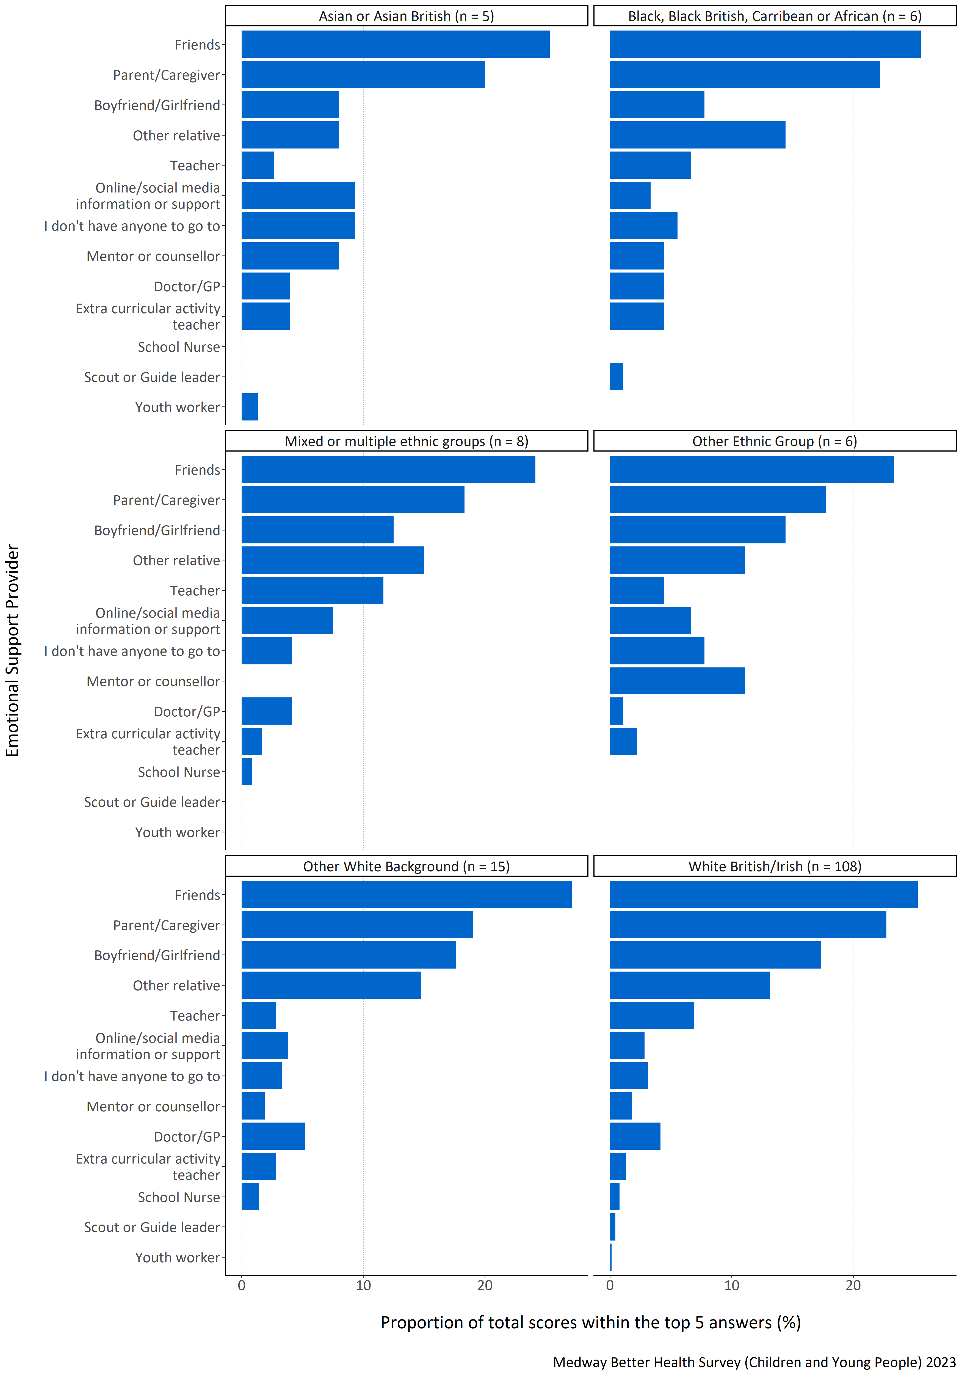
Figure 18: Proportion of total scores within the top 5 answers for each specified emotional support provider by ethnicity.
Figure 18 shows that respondents from all ethnic groups were most likely to go to ‘friends’ if they felt they needed support with difficult emotions with the next most likely being their ‘parent/caregiver’. White British/Irish, other White background, mixed or multiple ethnic groups, and other ethnic group respondents were also likely to go to their ‘boyfriend/girlfriend’, or an ‘other relative’. ‘Scout or Guide leader’ and ‘Youth Worker’ responses weren’t included in the top 5 most important emotional support providers by respondents identifying with mixed or multiple ethnic groups, other ethnic groups and other White backgrounds. Additionally, other ethnic group respondents did not include ‘school nurse’ in their top five, and mixed or multiple ethnic group respondents did not include ‘mentor or counselor’ in their top five. Asian or Asian British respondents did not include ‘school nurse’ and ‘scout or guide leader’ in their top five, whilst Black, Black British, Caribbean or African respondents did not include ‘school nurse’ and ‘youth worker’.
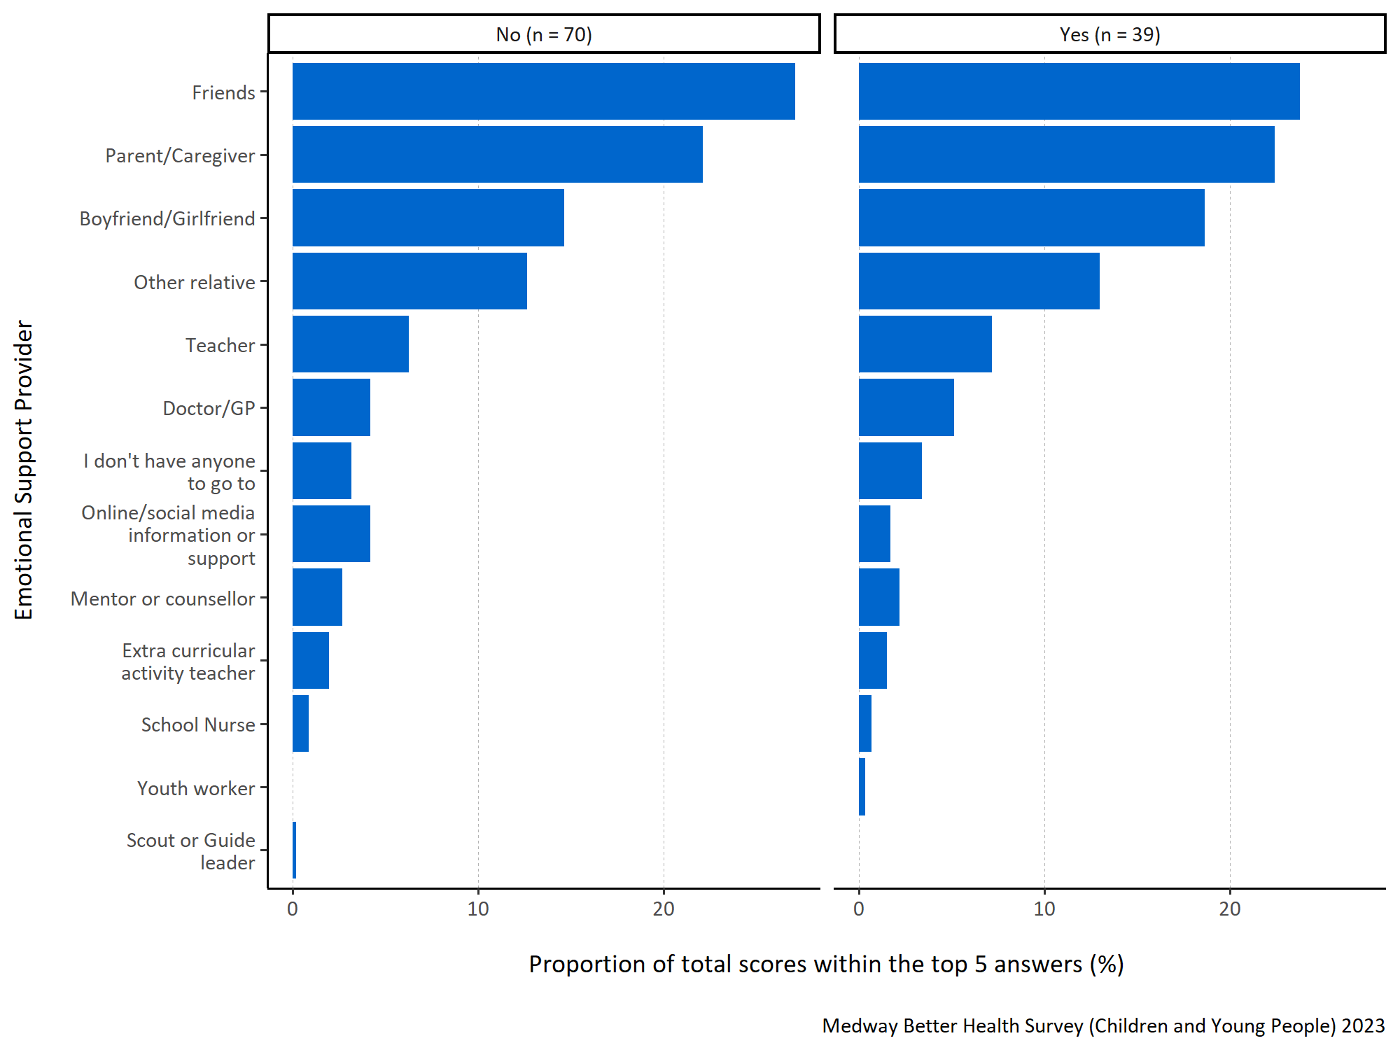
Figure 19: Proportion of total scores within the top 5 answers for each specified emotional support provider by long term physical or mental health conditions.
Figure 19 shows that regardless of whether the child or young person reported a long term physical or mental health condition, they were most likely to go to ‘friends’ for support with difficult emotions. This was also true for other likely options including a ‘parent/caregiver’, their ‘boyfriend/girlfriend’, or an ‘other relative’. ‘Scout or Guide leader’ was not included in the top five rankings by any respondents with a long term physical or mental health condition.

What children and young people in Medway think would improve their health and wellbeing
Question: In your opinion, which of the things listed below would help you to improve your health and wellbeing? Please tick all that apply.
Answer options:
- Doing more physical activities
- My family knowing more about how to cook healthy food
- Being able to spend more time socially with other people
- Better access to the internet
- Better access to public green spaces (like open green spaces and water in urban areas, including parks, playing fields, play areas, allotments and community gardens, woodland and more natural areas, canal paths and riversides).
- For society to tackle environmental issues (like climate change, pollution, traffic congestion)
- Help with managing things like asthma, diabetes, autism, attention deficit hyperactivity disorder (ADHD)
- Help with mental health needs, including anxiety and worry
- Help with managing physical disabilities
- Parenting support for my parent or care-giver
- Support for young people who are providing care for adults
- Support for young people who are providing care for their sibling(s) with special needs
- Better sexual health advice and support within school and the wider community.
Survey participants were asked to prioritise and rank what they thought to be the most important things that can be done to improve their health and wellbeing. They were instructed to assign a number for the thirteen response options from 1 to 13 to indicate the level of importance, with 1 representing the most significant priority.
The respondents were asked to identify what things (out of the answer options above) could help them improve their health and wellbeing. In this question, they could tick as many or as little response options as they wanted and the answers are presented here in Figures 20-23 as proportions of respondents selecting said answers.
A higher proportion indicates that response is more important to what children and young people in Medway think is important when considering what could be done to improve their health and wellbeing.
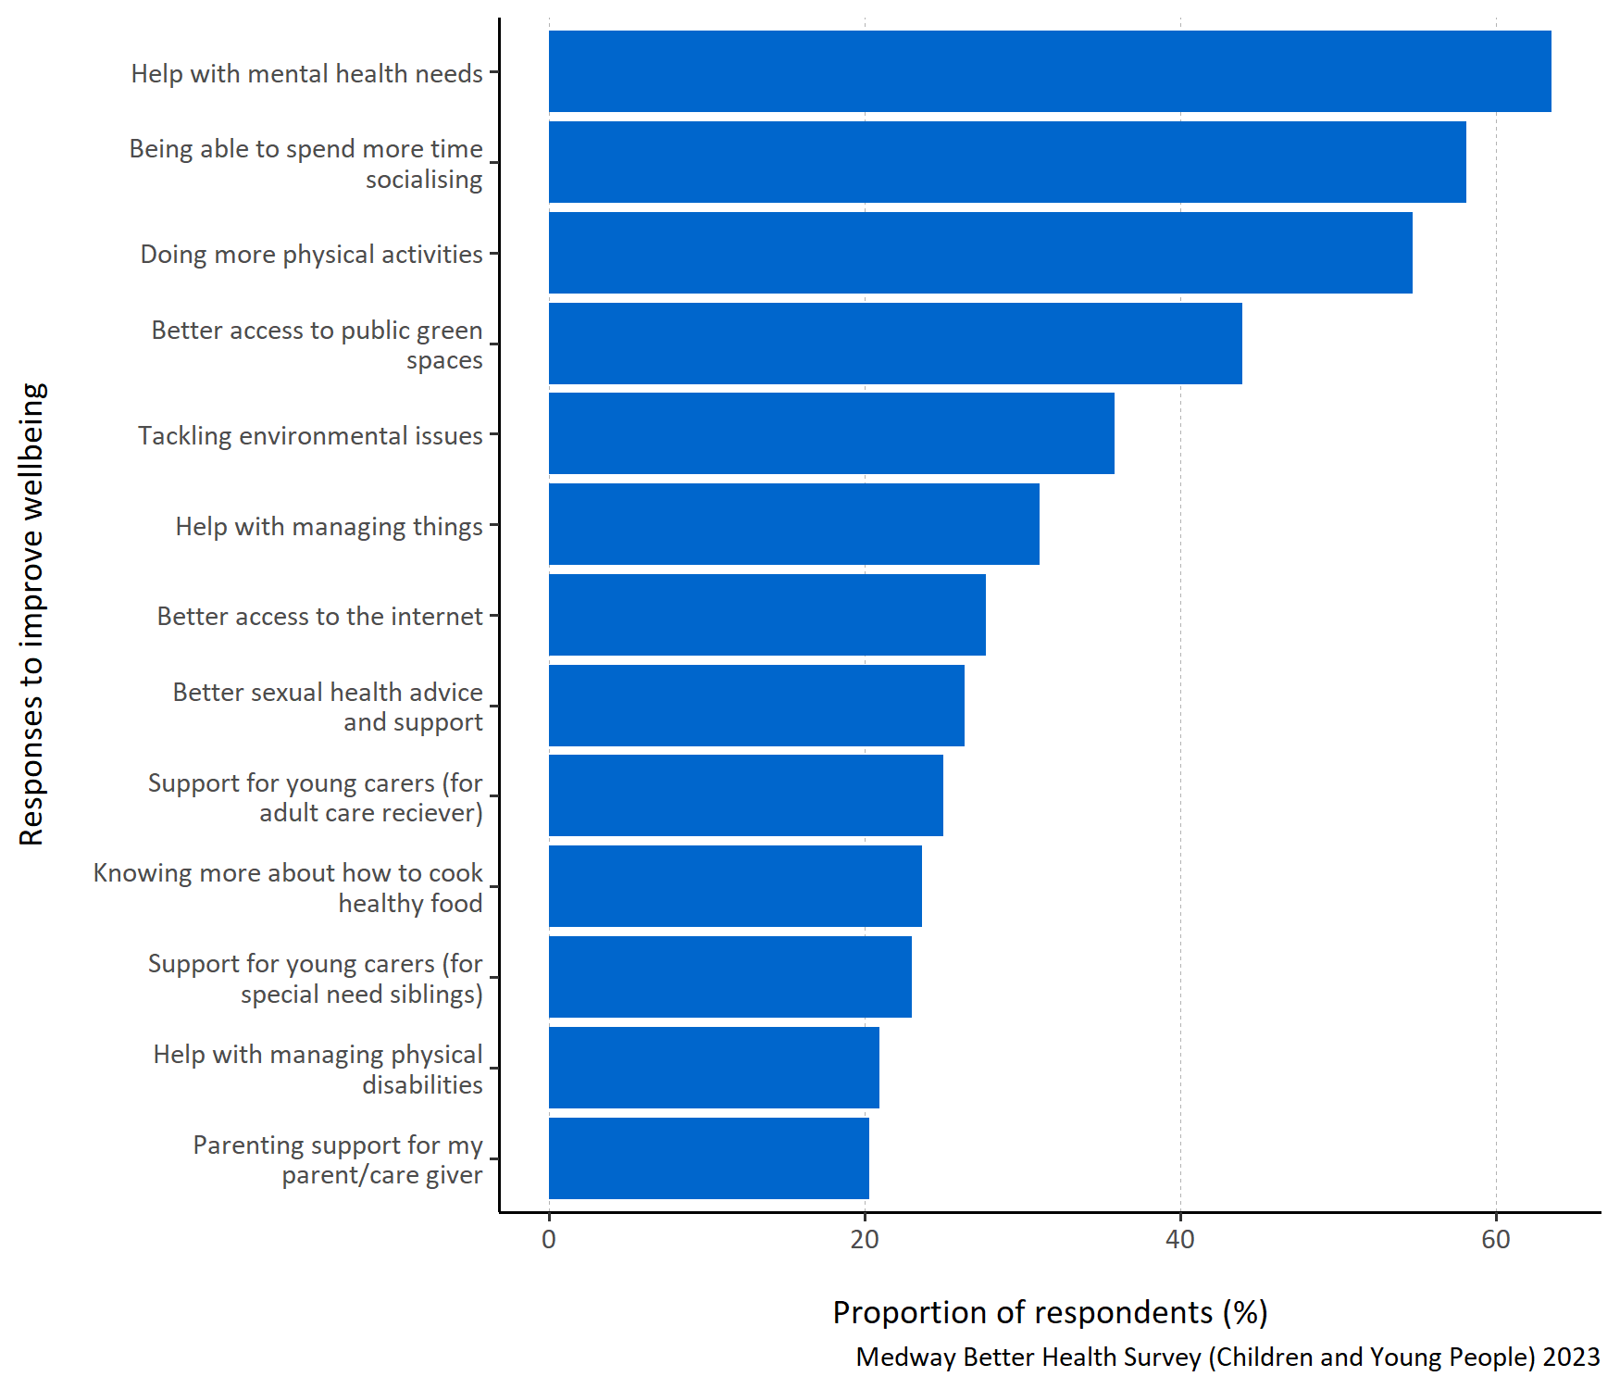
Figure 20: Proportion of respondents selecting each specified way to improve health and wellbeing.
Figure 20 shows that ‘Help with mental health needs’ was most commonly ticked by participants as being important for improving their health and wellbeing. ‘Being able to spend more time socialising’, ‘doing more physical activities’ and ‘better access to public green spaces’ were also commonly ticked by participants. ‘Parenting support for my parent/care giver’ is shown here to have received the lowest proportion of ticks from respondents.
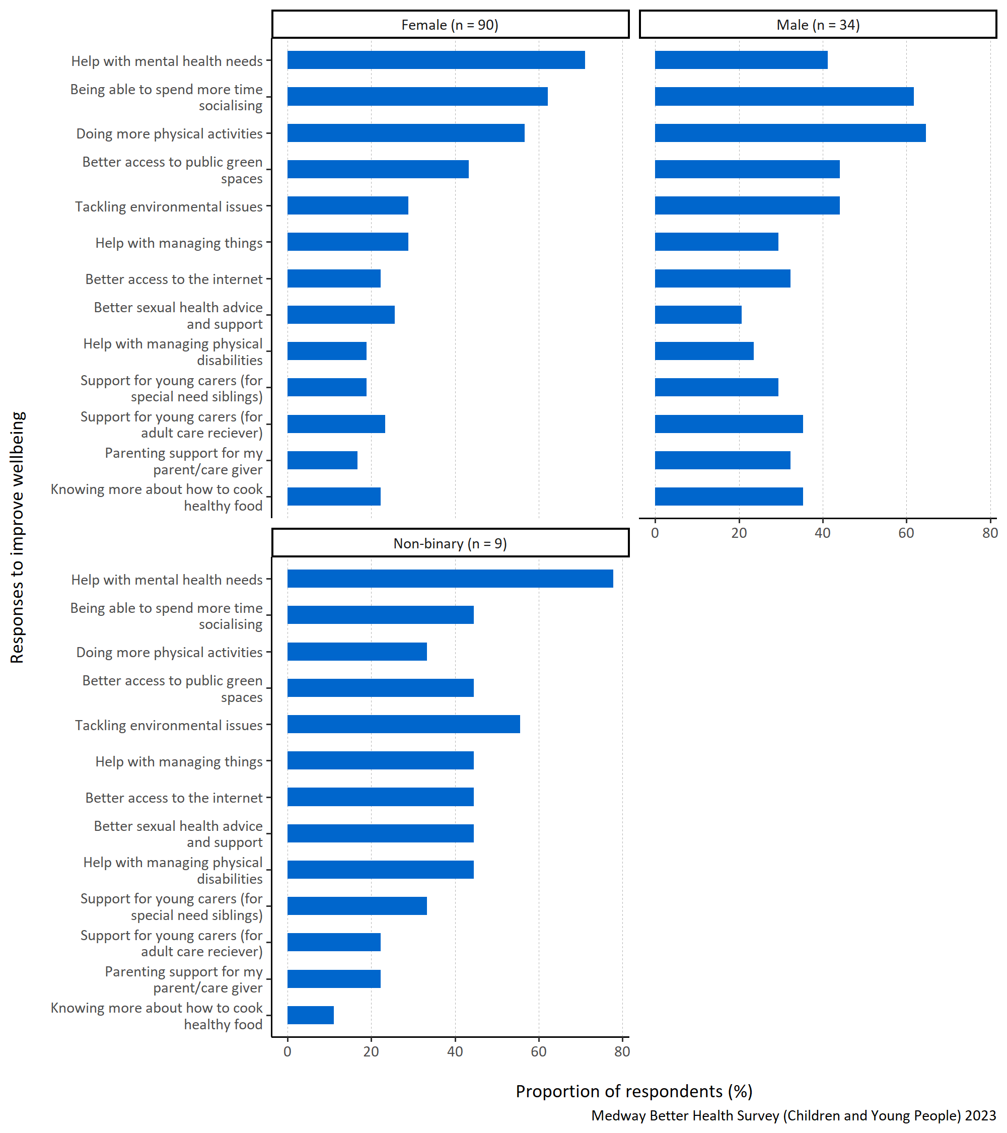
Figure 21: Proportion of respondents selecting each specified way to improve health and wellbeing by gender.
Figure 21 presents the proportions of respondents that selected each response option, split up by specified gender. Each proportion here was calculated based on the total number of respondents from each gender.
Female and non-binary respondents most commonly selected ‘Help with mental health needs’ as being something that could improve their health and wellbeing, with 71% and 77% respectively. In comparison, only 41% of male respondents selected this as being something they perceived that could improve their health and wellbeing.
Male respondents selected ‘Doing more physical activities’ as being something that could improve their health and wellbeing the most, with 65% of male survey participants selecting this as an option. They also commonly selected ‘being able to spend more time socialising’ and ‘doing more physical activities’.
Non-binary respondents frequently selected ‘tackling environmental issues’ as something that could improve their health and wellbeing.
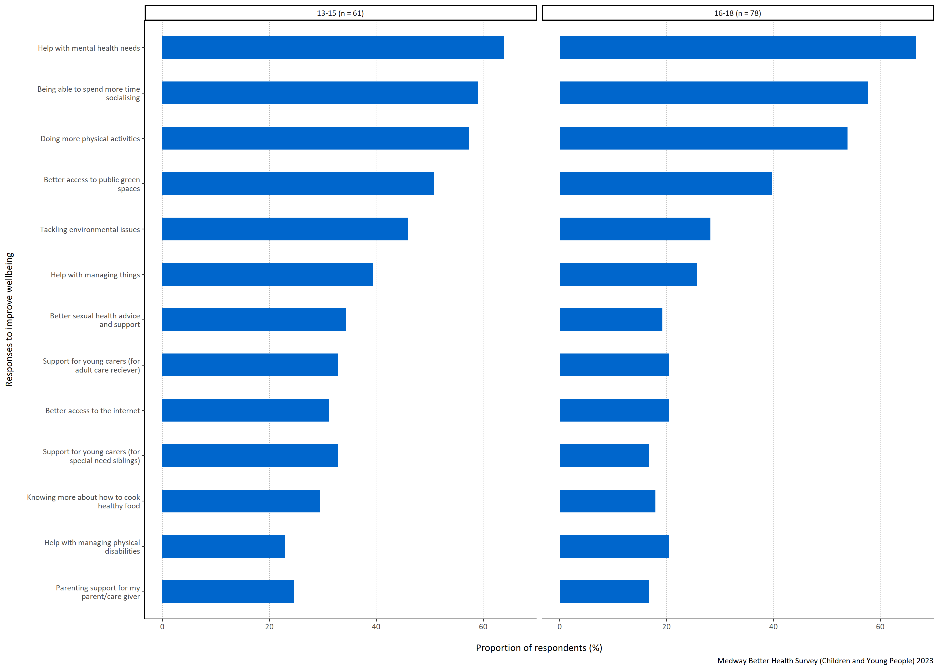
Figure 22: Proportion of respondents selecting each specified way to improve health and wellbeing by age group in years.
Figure 22 presents the proportions of respondents that selected each response option, split up by specified age group (in years). Each proportion here was calculated based on the total number of respondents from each age grouping.
For respondents both aged 13-15 and 16-18 years old, ‘Help with mental health needs’ was the response option selected most commonly with 64% and 67% choosing this, respectively. They both also commonly selected ‘being able to spend more time socialising’, ‘doing more physical activities’, and ‘better access to public green spaces’ as things that they thought could improve their health and wellbeing.
The least selected answer options for those aged 13-15 years old was ‘Help with managing physical disabilities’, and for those aged 16-18 years old was ‘parenting support for my parent/care giver and support for young carers (for special need siblings)’.
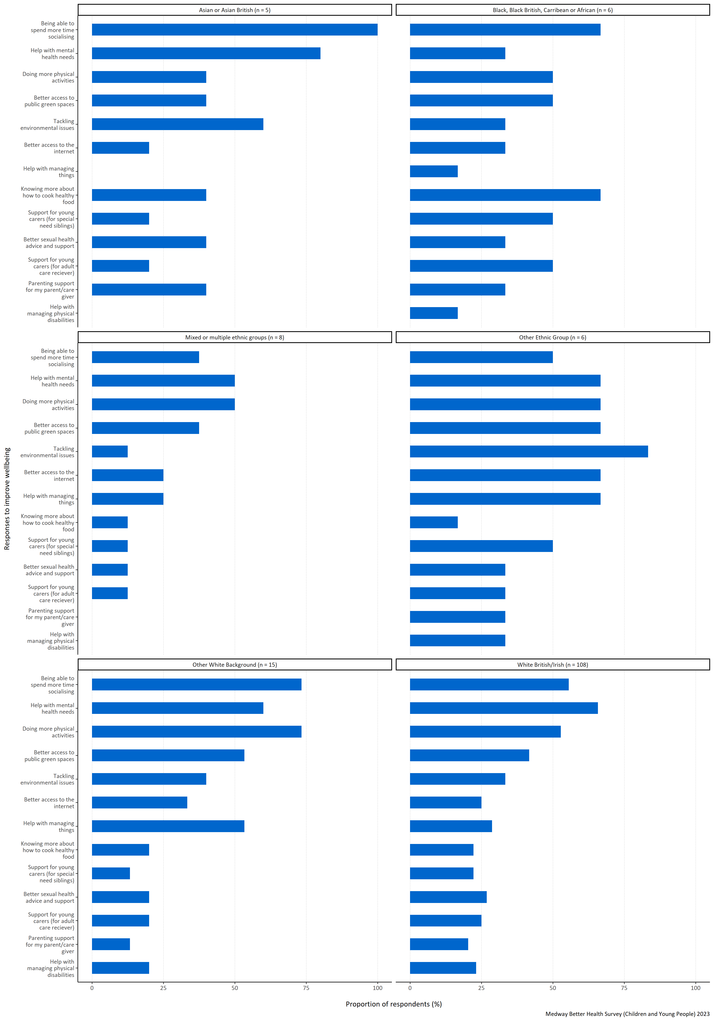
Figure 23: Proportion of respondents selecting each specified way to improve health and wellbeing by ethnicity.
Figure 23 presents the proportions of respondents that selected each response option, split up by ethnic group. Each proportion here was calculated based on the total number of respondents from each specified ethnic grouping.
There is much variation between the proportion of respondents selecting each answer option and their respective ethnic groupings. For example, survey participants identifying as Asian or Asian British, other White background and Black, Black British, Caribbean or African all selected ‘Being able to spend more time socialising’ most commonly. Black, Black British, Caribbean or African respondents also commonly selected ‘knowing more about how to cook healthy food’, ‘doing more physical activities’ and ‘better access to public green spaces’.
Participants identifying with other ethnic groups most commonly selected ‘Tackling environmental issues’ as being something that could improve their health and wellbeing. This group of respondents also commonly selected ‘better access to public green spaces’, ‘help with mental health needs’ and ‘doing more physical activities’. White British/Irish respondents reported ‘help with mental health needs’ as most important to improving their health and wellbeing.
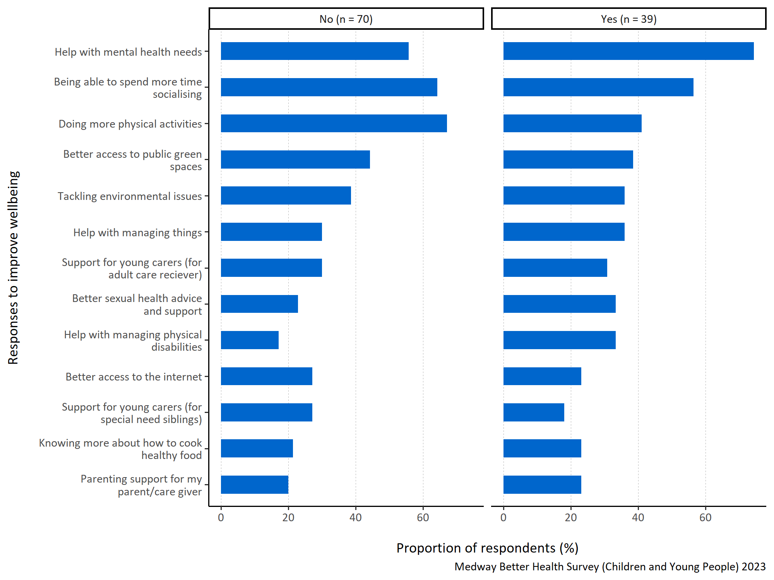
Figure 24: Proportion of respondents selecting each specified way to improve health and wellbeing by long term physical or mental health conditions.
Figure 24 presents the proportions of respondents that selected each response option, split up by whether they have or have not got a long term physical or mental health condition. Each proportion here was calculated based on the total number of respondents from each category.
Participants with a long term physical or mental health condition considered ‘help with mental health needs’ most important when asked about improving their health and wellbeing, with 75% of respondents in that category ticking this answer.
Respondents without a long term physical or mental health condition thought ‘doing more physical activities’ was most important for improving their health and wellbeing.

