Medway’s Joint Local Health and Wellbeing Strategy 2024 - 2028

Creating a healthier Medway

Contents
Foreword 3
Introduction 5
Who will deliver the strategy? 5
The building blocks of health and wellbeing 7
An overview of the health and wellbeing of our residents 9
Medway’s Joint Local Health and Wellbeing Strategy 2024 - 2028 11
Our Vision 13
Who we spoke to 14
Priorities and Actions 18
Priority Theme 1: Healthier, longer lives for everyone 18
Priority Theme 2: Reduce poverty and inequality 22
Priority Theme 3: Safe, connected, and sustainable places 26
Priority Theme 4: Connected communities and cohesive services 29
Using research to reduce health inequalities 35
Acknowledgements 36
References 37
Appendix A: Better Health Survey for Adults - Quantitative Analysis 39
Appendix B: Better Health Survey for Children & Young People – Quantitative Analysis 63
Appendix C: Better Health Survey for Organisations – Quantitative Analysis 99
Appendix D: Better Health Survey, Focus Groups, and one-to-one discussions – Qualitative Analysis 109

Foreword
With its rich and exciting blend of history, diversity, and culture, Medway offers a unique experience to both residents and visitors. The continued growth and development of our area brings new opportunities for everyone and the ability to enjoy these opportunities rests upon the health and wellbeing of our people. This Joint Health and Wellbeing Strategy builds on our commitment to enhance health and wellbeing across all stages of life by recognising and tackling the things that get in the way of people living well, enjoying life, and feeling happy and fulfilled.
Much has changed and new challenges have emerged since our last strategy was adopted in 2018. The COVID-19 pandemic has highlighted stark differences in health outcomes between different groups of people. We have seen an increase in living costs and an escalation of the effects of climate change. We have also seen a shift in people’s needs. There is now greater awareness and demand for services that support people’s emotional wellbeing, especially when they feel lonely and isolated. We have heard our residents tell us how much they value happiness, wellbeing, and social connections.
We have a lot to be proud of since adopting our previous strategy. Our work on smoking has contributed to fewer women smoking during pregnancy and more babies being born healthy. Increased numbers of people have taken advantage of the NHS Health Checks screening programme to reduce their risks of getting diseases like diabetes, dementia, and circulatory problems. We have worked hand-in-hand with families and educational settings to provide the Holiday Activities and Food Programme, making sure children enjoy a nutritious meal, are active and safe, and not socially isolated during the school holidays.
As our residents’ needs change, so too must our approach. Our new strategy enhances the focus on tackling inequalities and injustices and on creating the conditions that make it easier for people to thrive and achieve their potential. This means recognising that the environment in which we live, work, and grow is a vital component of our wellbeing. Over the next five years, we will aim to put in place the building blocks of a happy and healthy life, such as a safe and secure home environment, good education, stable employment, affordable housing, and access to support when it is needed.
We can only do this by working in partnership as members of the Health and Wellbeing Board, with a shared health and care agenda. This strategy’s ambition to tackle inequalities and create healthy and fulfilling lives for everyone sits alongside the ambitions of NHS Kent and Medway’s Integrated Care Strategy: to work together to reduce economic and health inequalities, support social and economic development, improve public service outcomes, and ensure services for citizens are of excellent quality and good value for money.
Good health and wellbeing is a collective endeavour and having the right strategy is an important first step. COVID-19 demonstrated the power of togetherness and the incredible strengths that prevail in our community when people come together with a shared sense of purpose. We have a vibrant range of voluntary and community organisations who play a vital role in supporting the health and wellbeing of our residents. This strategy is an invitation to all sectors, organisations, and communities to build on our great foundations and strive towards a healthier, happier, and more equitable Medway.
Cllr Teresa Murray, Deputy Leader for Medway Council and Portfolio Holder for Public Health Chair Medway Health and Wellbeing Board

Introduction

Who will deliver the strategy?

The Medway Joint Health and Wellbeing Strategy is our blueprint for improving health and wellbeing for everyone living, working, and studying in Medway.
In this document we describe:
- The current health and care landscape in Medway and what residents have told us about their health and wellbeing.
- A comprehensive set of priorities to inform what we all need to do together over the next five years to meet the needs of local people.
- How this strategy was developed through a combination of looking at what the data tells us are important causes of illness and early death in Medway, and by listening to what people in Medway told us is important to them.
This strategy is overseen by the Medway Health and Wellbeing Board (HWB) which includes the NHS, Healthwatch, Medway Council officers, and elected members (councillors). It is not owned by any single organisation but aims to develop a common purpose across health and care services, the voluntary sector, and the people of Medway. The HWB will use this strategy to develop and agree annual priorities and leadership around programmes of work. All organisations in the HWB are collectively accountable for delivering this strategy.

Health and Wellbeing Board Membership
Statutory Members
- Healthwatch Medway
- Director of Children and Adult Services (Medway Council)
- Director of Public Health (Medway Council)
- NHS Kent & Medway Integrated Care Board
Non-Statutory Members
- Medway Voluntary Action
- Kent Local Medical Committee
- Kent & Medway NHS & Social Care Partnership Trust
- Medway NHS Foundation Trust
- Medway Community Healthcare
- Medway and Swale Health & Care Partnership
- Elected members

NHS Kent & Medway Integrated Care System Strategy
Medway is part of the Kent and Medway Integrated Care System (ICS), which has its own strategy developed closely alongside the Medway Joint Local Health and Wellbeing Strategy. The focus of the ICS is on the whole of Kent and Medway, while this strategy focuses on Medway alone.

What is the Kent and Medway Integrated Care System (ICS)
The ICS brings partner organisations together across Kent and Medway to improve outcomes in health and care, tackle inequalities, improve experiences of and access to health and care services, enhance productivity and value for money, and help the NHS support social and economic development.
The three statutory organisations in Kent and Medway ICS are Medway Council, Kent County Council, and the NHS Kent & Medway Integrated Care Board (ICB).
This new system allows for a more unified and collaborative approach across organisations over a larger geographical area. It is a means of using our combined strengths and resources to make a difference to people’s lives.
The Kent & Medway Integrated Care System Strategy sets out six priority areas for local authorities, health and care organisations and other partners to focus on that will bring improvements to the lives of people living in Kent & Medway.
Scan the QR code to go to the Integrated Care Strategy:

Health and Care Partnership
Health and Care Partnerships and Primary Care Networks sit within the ICS and are made up of several types of care providers. They serve the needs of people living within a smaller, defined geographical area and are well-placed to understand and respond to the needs and challenges faced by people in that area. Their remit extends beyond looking after the medical health needs of people and includes things like education, housing, environmental health, and leisure. Medway is part of the Medway and Swale Health and Care Partnership.

The building blocks of health and wellbeing

Good health is about much more than health care services. A long and healthy life comes from a strong foundation supporting all the building blocks, such as good education and employment; good quality, affordable housing; access to healthy food; and strong social and community networks. When one or more of these blocks are missing, lives can be cut short leading people to spend more time in poor health. For example, housing with steep stairs that is poorly adapted for a frail older person can lead to falls and injury, with longer-term impacts on mobility and social isolation.
This Joint Local Health and Wellbeing Strategy looks at these aspects of our everyday lives and calls on all of us to come together and play our part in improving lives and the environment in which we live.

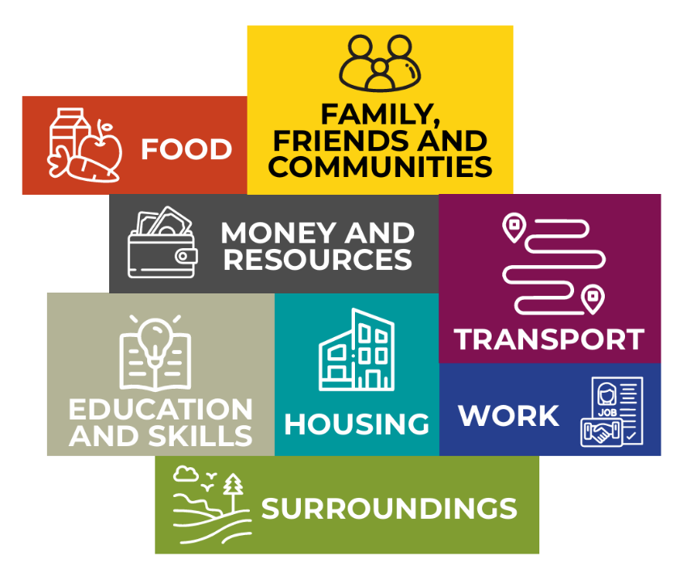

Image based on The Health Foundation’s 'The Building Blocks of Health'..

An overview of the health and wellbeing of our residents
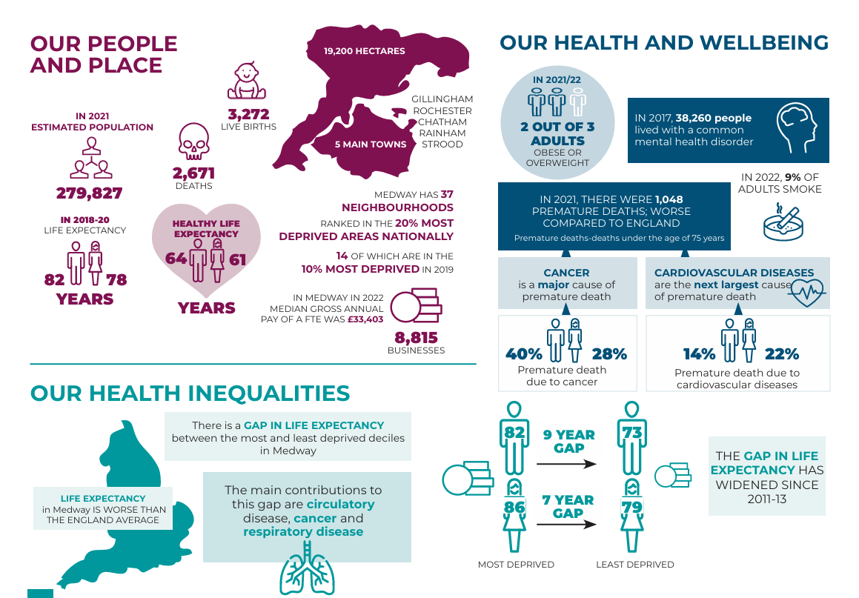
View an accessible version of this infographic on the Medway JSNA infographic summary page

Medway’s Joint Local Health and Wellbeing Strategy 2024 - 2028

Goal
Improve the physical and mental health and wellbeing of Medway residents and reduce inequalities.

Purpose
To ensure everyone in Medway lives a long, healthy, and happy life, with people valuing self-care and helping others. Opportunities are available to all throughout life to help people grow and create a brighter future. Medway is a place where help is easily available, places are connected, and when people move between services, their journey is seamless. People are proud to live in Medway and feel part of their community.

Priority Theme 1: Healthier and longer lives for everyone
- Babies and children are healthy, happy, and safe. They develop well and are ready to start school.
- People in Medway are supported to live healthy, long, and happy lives, and value self-care.
- Vulnerable adults lead fulfilling lives in a secure and caring environment that ensures their wellbeing and safety.
- Older people live with dignity and stay independent for as long as possible.
- Good mental health is enjoyed by everyone. People can cope with life’s challenges, sleep well, have positive relationships, and experience a sense of purpose and fulfilment.

Priority Theme 2: Reduce poverty and inequality
- All children achieve a good level of education leading to secure employment in adulthood.
- Outcomes are improved for those in vulnerable and disadvantaged groups, such as children in care and care leavers.
- People and families can access healthy food, have steady jobs, and live in affordable, good quality homes.
- People in Medway are supported in managing the cost of living.

Priority Theme 3: Safe, connected, and sustainable places
- Services are close to where people live and accessible by active transport such as walking, cycling, or using public transport.
- People and organisations work together to create a sustainable, clean and green environment.
- Green spaces can be accessed and used by all.
- People feel safe in their neighbourhood.

Priority Theme 4: Connected communities and cohesive services
- People feel connected with their community, have a sense of belonging, and strong support networks.
- Everyone can find and access services and information easily, with support to ensure digital inclusion.
- Organisations work together so when people move between services, their journey is seamless.
- There is trust and respect between services, organisations, and users, regardless of their differences; diversity is recognised and embraced.

Our Vision
Medway will be a place where people care for themselves and others, and where help is easily available when it’s most needed. Our community will work together to create equal opportunities and a brighter future, making Medway a place where wellbeing is valued by everyone and pathways to personal growth are open to all.

Who we spoke to
- 526 adults completed the Medway Better Health Survey for Adults
- 148 children and young people completed the Medway Better Health Survey for Children & Young People
- 14 organisations completed the Medway Better Health Survey for Organisations
- 7 focus groups carried out with groups impacted by health inequalities
- 7 one-to-one interviews carried out with people less likely to respond to surveys and engagement opportunities
- 20 organisations were represented at our system leaders’ workshop
People are at the heart of the Joint Health and Wellbeing Strategy. We made it our priority to better understand the experiences and health and wellbeing needs of people in Medway to develop this strategy. That meant speaking to children and adults who live and work in Medway, with a particular focus on residents who may be less likely to voice their needs, including:
- Those living in more deprived areas
- People experiencing homelessness
- Sex workers
- Older women and men
- People whose life experiences have made it more difficult for them to manage their own physical and mental wellbeing
- People living in rural areas (through Parish Councillors)
- People in the armed forces
- Ethnic minority groups
- The Gypsy Roma Traveller community
We also spoke to a range of health and care organisations and the voluntary and community sector.

What we heard; the things that are important to the people of Medway

Resident engagement – adults
- Better mental and physical health
- Having enough money to provide for their own and their family’s needs
- Better access to health and care services
- Affordable good quality housing
- Improved job security

Resident engagement – children and young people
- Help with mental health needs
- More social connections
- Doing more physical activities
- Better access to public green spaces
- Tackling environmental issues

Focus groups
- Social groups and places where people can connect with others
- Better access to health and care services, including alternatives to digital access
- To be treated with respect by health and care professionals
- Help with parenting skills, as their own experiences of being parented have had a detrimental impact on their adult life
- Support groups that last longer than 8 weeks.

Service providers and system leaders
- Access and barriers to services
- Help with mental health needs
- Communication and education
- Workforce pressures
- System cohesion

Priorities and Actions

Priority Theme 1: Healthier, longer lives for everyone
We will ensure that people in Medway have what they need throughout their lives to maintain good physical and mental health and wellbeing.

Why this is important
In Medway in 2022/23, over a third of children aged 10 to 11 years were overweight or obese (37.3%), which is similar to England (36.6%)[1]
Health is affected by a mix of social, economic, and environmental factors, the effects of which build up over an individual’s life. At each stage there are actions we can take to promote health, prevent diseases, and stop health gaps from opening up between groups of people: before birth; in infancy, childhood, and adolescence; during working age and through to old age.
Additional effort is also needed to ensure people who tend to have worse health outcomes than the general population, such as those with learning disabilities or severe mental illness, can lead happy and fulfilling lives.
We will maintain the focus of the 2018–23 health and wellbeing strategy on improving how well people live and how long they live. This includes valuing mental health just as much as physical health, which is a clear message coming out of our engagement with Medway residents.
Some people in Medway experience more health problems compared to others and die earlier. In our least well-off neighbourhoods, men are dying 10 years earlier than those in the most well-off. For women, the gap is 7 years [2]
Top five causes of death in Medway in 2021 [3]
Cause of death | Number of deaths
- Cancer | 663
- Cardiovascular diseases | 551
- COVID-19 | 441
- Respiratory diseases | 267
- Dementia, including Alzheimer’s | 217

Around 75% of residents in the Better Health Survey described some form of movement or regular exercise as being important to helping them stay healthy.

What residents see as health and wellbeing priorities
- Feeling happy
- Mental health
- Being without illness or pain
- Worrying less
- Sleeping well
- Physical activity
Help with parenting skills…I felt I couldn’t talk to my parents…If things had been different, I might not be suffering from anxiety and depression.’ [Focus Group]

What improvements residents want to see
- Timely access to reliable health and care services, including GPs
- Support to get physically active and eat healthily
- More accessible mental health and wellbeing services
- Services that are accessible for people such as sex workers, rough sleepers and those experiencing homelessness
- Making sure the building blocks for good health are in place, such as having enough money; affordable, good quality housing; access to green space; good quality jobs and job security

What we are building on
- A strong partnership of local agencies, organisations, and residents who provide core support to promote health, and prevent and treat disease from birth to old age. This includes the Kent and Medway Integrated Care System and Medway and Swale Health and Care Partnership, formed in 2022.
- An increase in the amount and strength of multidisciplinary working. For example, the Blue Light Project brings together a multi-disciplinary team to support people experiencing severe disadvantages such as substance misuse, homelessness, criminal justice system involvement, and mental health challenges. It prevents people from falling through service access gaps.
- Increased support to carers and measures to address fragmentation in care, enabling residents to navigate services and lead fulfilling lives independently within their homes.
- Innovative mental health initiatives, such as Medway Men in Sheds, that support men to get together and learn new skills, and a 24/7 ‘Reduce the Pressure’ helpline to provide mental wellbeing support, brief cognitive behavioural therapy, and signposting to other services.
- Targeted community-based interventions such as ‘Hypertension Heroes’ for early identification, treatment, and self-management of diseases in higher risk community groups.

What we will do next
We will work together with our residents to ensure that every person in Medway has what they need throughout their life to maintain good health and wellbeing. By working with residents in active partnership, we can increase the number of years we all spend in good physical and mental health, reduce the risk of dying early and make Medway a place where everyone can thrive.
- Give children the best start in life, so they are happy, healthy, and safe, and have a firm foundation for their future. We will provide an enhanced parenting support programme to address health and educational inequalities and help families get the help they need. We will continue to support children to develop well and be ready to start school.
- Prevent ill health, help people to value self-care and stop people dying early, so that people live healthy, long, and happy lives. We will work with residents to create the support and opportunities they need to get active and eat healthily, and act early to prevent ill health and diagnose disease.
- Support and protect vulnerable adults, so they can lead fulfilling lives with the right amount of care and support that ensures their wellbeing and safety.
- Make Medway a good place to grow older, enabling our residents to live well and with dignity, and stay independent for as long as possible.
- Promote mental health, emotional wellbeing, and resilience. We will build on and encourage community-based initiatives and facilitate social connections, recognising the importance of a robust support network for people’s resilience.

Priority Theme 2: Reduce poverty and inequality
We will enable all residents to achieve their full potential by reducing existing inequalities and creating the conditions where all residents can thrive.

Why this is important
Within Medway, in 2021/22, there were 11,364 (19.9%) children living in relative low-income families.[4]
In 2021, approximately 17.2% of Medway residents lived in areas with highest risk of food insecurity.[5]
In 2022/23, approximately 6.1% of 16-17 year olds in Medway were not in education, employment, or training.[6]
An individual’s social and economic conditions affect their behaviours—for example, their likelihood of smoking and eating unhealthy food. The variation in living conditions creates differences in health and wellbeing outcomes, disadvantaging some groups of people and leading to avoidable and unfair inequalities in health outcomes. In Medway, some of our most disadvantaged people include children in care, those with special educational needs and disabilities (SEND), and some migrant communities.
Poverty is a significant underlying reason for inequalities as it affects a person’s ability to access and obtain the things they need to stay healthy. Reducing health inequalities requires improvement in the key building blocks of health such as educational achievement, job security and the affordability and quality of housing.
We need to harness our strong partnerships to improve social and economic conditions and enable targeted support to those who are vulnerable and most disadvantaged. This will create systems where all residents have the opportunity to transform their lives and achieve their full potential.
Over a third of adult respondents to the Medway Better Health Survey (200 people), indicated the important of affordable and accessible activities for their health and wellbeing.

‘Much better and more accessible health centre [is needed] because at the moment my present one is overstretched, oversubscribed, and difficult to access.’ [Medway Better Health Survey for Adults]

What residents see as health and wellbeing priorities
- Having enough money to meet their needs
- Affordable, good quality housing
- Improved job security

What improvements residents want to see
‘More affordable and safe access to exercise and not just subsidising those who are unemployed or on benefits…some local council pools can be expensive for working people.’ [Focus Group]
- Low-cost health and wellbeing activities for all residents
- More support to access affordable physical activity and healthy eating, for example, healthy eating on a budget.
- More effective service provision to meet the needs of vulnerable and disadvantaged communities, including people experiencing homelessness.
- Greater promotion of available social and economic support published both online and in print.

What we are building on
We are building on a strong foundation of interconnected partnerships which work together to tackle the wider social, environmental, and economic conditions which lead to inequalities.
Provision of targeted access and support for vulnerable groups, including:
- Focused oral health assistance to Medway’s most vulnerable residents.
- Tailored physical activity programmes to those with long term-health conditions.
- Continued drive to increase the number of affordable homes by building on the average of 219 affordable homes constructed each year over the past 5 years.

Establishing networks that promote health and wellbeing while considering financial constraints.
- The creation of the Medway Food Partnership which collaboratively ensures access to healthy, affordable food.
- Setting up the Holiday Activities and Food Programme which provides a healthy hot meal during school holidays to children who are eligible for free school meals.
- Providing money management and budgeting courses to support residents with the cost of living.
Enhancing the connection between education and employment by creating pathways for people from disadvantaged groups to acquire new skills:
- Delivery of the Business Pledge programme which links business and education facilities to ensure opportunities for all, including care leavers, those with special educational needs and disabilities (SEND), veterans, and young people not in employment, education, or training (NEET).
- Digital Inclusion classes for disadvantaged groups, leading to participants being able to check own blood pressure, book GP appointments, apply for bus passes, use online banking services, and understand fraud prevention.
- Delivering life-skills training to support people to engage with services.

What we will do next
We will deliver a coordinated and comprehensive approach to addressing the social and economic conditions that influence health. We will do this by layering the support offered to communities whilst joining up our actions to transform the lives of Medway residents.
- Ensure all children achieve a good level of education, which will equip them with the knowledge and skills to widen their opportunities and lead to secure employment in adulthood. We will specifically focus on children who face existing educational inequalities, such as children in care and those who have free school meals.
- Improve outcomes for vulnerable and disadvantaged groups by bridging the gaps in social and economic circumstances to enable all residents to thrive. We will provide a targeted approach to ensure that those who need the most support can access it.
- Improve access to healthy food, steady jobs, and encourage economic development. We will plan, develop, and regenerate in a way that improves the quality of life for new and existing communities and makes Medway the area of choice for new businesses and anchor organisations, encouraging them to employ locally whilst enhancing social value.
- We will increase the supply of affordable homes ensuring that there is a mixture of property types and sizes to meet the needs of Medway residents.
- Support residents to manage the cost of living, which will improve their wellbeing and build stronger, more resilient, and equitable communities. We will focus on providing the building blocks and tools so that residents feel empowered to effectively manage their living expenses.

Priority Theme 3: Safe, connected, and sustainable places
We will make Medway a healthy place to live, work, and visit. We will preserve and improve the environment around us so that current and future generations can enjoy all that Medway has to offer.

Why this is important
There were 52 crimes involving violence against the person in Medway for every 1,000 people in 2022/23, which is higher than the Kent average rate of 41.[7]
It is estimated that one in every 18 deaths in Medway in 2021 were linked to particle air pollution.[8]
12.5% of adults walked for travel at least three days a week in 2019/20, which is similar to the England average of 15.1%.[9]
The places where we live and work affect our health, from the air we breathe to the streets we walk. When we build health into the fabric of daily life, we enable people to make healthy choices. Green space, leisure facilities, and opportunities for walking and cycling make physical activity easy and enjoyable, promoting health and happiness. Right now, some of the places we live in are causing us harm: air pollution is a major issue in Medway and is linked to heart disease, respiratory problems, and lung cancer, as well as making asthma worse. Often those living in highly polluted areas are less well-off, widening health inequalities.
Ensuring people are safe and free from mental and physical harm such as violence or domestic abuse is also essential for health and wellbeing. Safety, in turn, fosters a sense of security, which encourages physical activity, social engagement, and emotional wellbeing.
Services need to be in the right places so that they are easily accessible to residents when they are needed. This is especially important for groups who are often disadvantaged, such as those experiencing homelessness; migrants; and the Gypsy, Roma, and Traveller communities.
Achieving this and transforming Medway into a healthy place to live and work will require us to look outward and work in partnership with residents and the community.

What residents see as health and wellbeing priorities
- An environment that supports mental and physical health
- Services that are easily accessible for all members of the community
- Being able to move around for work, leisure and other day-to-day needs

What improvements residents want to see
- Better access to green spaces
- Low-cost and safe access to opportunities to exercise
- Measures to make public transport and active travel, such as walking and cycling easier, cheaper, and safer
‘I started cycling a bit more in the last couple of years, but you know, you don’t always feel safe on the roads.’ [Focus Group]
‘Things to tempt people away from the screen…include whole family in fitness…rebuild family social connections.’ [Medway Better Health Survey for Adults]

What we are building on
- An Active Travel Working Group that brings together multiple workstreams in a strategic way, supporting the development of the Council’s emerging Local Cycling & Walking Infrastructure Plan (LCWIP), including capital infrastructure and behavioural change interventions. The group also assists bidding opportunities for funding and initiatives related to active travel and public transport.
- A multi-agency Community Safety Partnership to develop and implement strategies to address issues like anti-social behaviour, drug or alcohol abuse and re-offending.
- Medway’s Climate Change Action Plan includes actions to reduce carbon emissions across Medway and build resilient communities. Initiatives include support for domestic retrofit and active travel.

What we will do next
We will take a place-based approach, working with the community and residents to ensure safety, security, and wellbeing for all.
Bring services closer to people
- We will ensure services are accessible by active transport such as walking or cycling, or using public transport​.
Create a sustainable, clean, and green environment
- We will do this by strengthening the partnership between individuals and organisations in Medway.
​Improve access to green spaces
- We will make it easier for people to use and enjoy green spaces.
Build safer communities
- We will work with our system partners and residents so that people feel secure in their neighbourhood.

Priority Theme 4: Connected communities and cohesive services
We will celebrate our communities and help them to feel empowered, placing them at the heart of all that we do, ensuring that no-one in Medway is left behind. People will feel more connected with one another. When support is needed, services will be accessed seamlessly.

Why this is important
In 2019/20, 14.9% of adults in Medway felt lonely.[10]
In 2021/22, 43.9% of adult social care users over the age of 18 years stated they had as much social contact as they would like.[11]
Relationships have a powerful influence on our health and wellbeing. Whether these connections are formed with friends, within the community or through interactions with services, their influence is profound. Positive relationships and meaningful connections create a sense of belonging and establish a support system which improves resilience. The benefits of these social connections extend beyond the individual, having a positive impact on the wider community. This in turn builds trust, creates a shared sense of purpose and fosters understanding and empathy among community members.
In Medway we are proud of the rich tapestry of cultures, backgrounds, and perspectives within our communities. Embracing inclusivity means we need to focus on valuing our communities whilst also proactively maximising opportunities for historically excluded groups to participate and flourish. This means enabling easy access to services across healthcare, education, and community settings.
‘The other day I got six questions from the surgery, and I can’t reply to it cuz I can’t get on the internet.’ [Focus Group]

What residents see as health and wellbeing priorities
- Services that are easier to access
- Trust and respect between service users and organisations
- Maintaining social connections
‘I think so many of us live alone or feel lonely; gathering places where you feel safe and can be with others might be a good thing to have, should you need it.’ [Medway Better Health Survey for Adults]

What improvements residents want to see
- Compassionate services where people feel valued and respected
- Support provided in ways that work for people, particularly for disadvantaged groups, such as communities experiencing homelessness, older people, and those with mobility issues
- Timely access to services
- Easier ways to get information about support that is available
‘Easy, accessible healthcare [is needed]. Not being able to get help, care, and advice when you need it is the most worrying and stressful part of my life.’ [Focus Group]

What we are building on
We are building on dedicated services which work alongside a robust community and voluntary sector to enhance the health and wellbeing of our area. Some of the areas we have developed in recent years include:
Harnessing the skills of the local community to improve health and wellbeing and to sustain community resilience.
- Launched the 5 Ways to Wellbeing campaign and rolled out the Connect 5 mental health intervention.
- Developed Hypertension Heroes — a community led approach to identify people with hypertension and promote self-management and understanding of the condition.
- Promoted the Better Medway Pledge to raise awareness of and reduce loneliness and social isolation by empowering individuals, groups, organisations, and businesses across Medway to make a pledge to increase connection and reduce loneliness.
Providing a range of services to improve community cohesion and awareness of services.
- Introduced the Peer Ambassador Programme to provide young people with the skills, knowledge, and confidence to act as a peer mentor and help eradicate the stigma of mental health and wellbeing conversations and signpost their peers to sources of support.
- Continued provision of A Better Medway Champions which delivers free high-quality training on public health topics and interpersonal skills. The training raises awareness of local support services and how to access them.
- Developed the Directory of Services for the social prescribing system across Medway and Swale. This directory contains details of many health and wellbeing services and activities to which Social Prescribing Link Workers can easily refer.
Developed innovative opportunities for groups to contribute to service development.
- Created the Children and Young People's Consultation and Engagement Framework and Toolkit to ensure that the voices of children are represented through Council plans and services.
- Implemented the Digital Inclusion Strategy so that everyone can access the information and services they need. One example is the work of Medway Diversity Forum who, in partnership with Kent Police, have delivered educational sessions so that people can learn how to use their own digital devices to access services whilst remaining vigilant to fraud.

What we will do next
We will work to ensure services are aligned and coordinated and build relationships with our communities that are grounded in trust and respect. We will recognise the strengths of our communities which provide a foundation for all residents.
Support people to feel connected with their communities.
- We will promote inclusivity, engage with communities in new ways and listen to feedback on how we can work together to improve health and wellbeing within Medway. This will help create a sense of belonging and build strong support networks.
Ensure easy access to service information and actively promote digital inclusion.
- This will enhance equality, promote inclusivity, and empower residents through better access to the information they need to make informed decisions about their health and wellbeing.
Work together so that when people move between services, their journey is seamless.
- We will work with system partners to improve the coordination of services.
Champion a focus on trust and respect between services, organisations, and users.
- We will recognise and embrace diversity and embed equity within our communities and service provision.

Using research to reduce health inequalities
In 2022, Medway Council was funded by the National Institute for Health and Care Research (NIHR) to set up a Health Determinants Research Collaboration (HDRC) with the University of Kent. The aim of the HDRC is to enable Medway Council to become more research-active, to conduct research and to use the results of research to improve health and wellbeing.
Up to 80% of what influences a person’s health and wellbeing happens outside of the NHS, for example housing, education, employment, and the physical environment, much of which is either directly or indirectly influenced by the council. The HDRC aims to find ways to improve health and wellbeing and reduce health inequalities by doing research on these building blocks of health.

Acknowledgements

We are grateful to Medway’s residents for their role in shaping the priorities set out in this Joint Local Health and Wellbeing Strategy. The experiences and perspectives shared by the people of Medway will underpin our plans and actions over the coming years. We extend our thanks to both individual residents who completed surveys, as well as community members and groups who took part in interviews and focus group discussions, including:
- Tywdall Library - Social Group
- Christ Church, Luton – Social Group
- One Big Family – Service Users’ Group
- 1 RSME Brompton Barracks
- Imago – Service Users
- Frindsbury Extra Parish Council
- Caring Hands – Ladies’ Night Social Group
- Kent Ramgarhia Darbar (Gurdwara)
- Cuxton Caravan Site
We would also like to thank our system partners across both public sector organisations, as well as those representing the voluntary, community, and social enterprise sector, for their contribution in creating this strategy.

References
[1] Office for Health Improvement, ‘Year 6 prevalence of overweight (including obesity)’, Public Health Outcomes Framework - Fingertips. Indicator ID 20602. Feb. 2023. [Online].
[2] Public Health Intelligence Team, ‘Medway summary ward profile’, Medway JSNA. Medway Council, 2023. [Online].
[3] Office for Health Improvement, ‘Mortality profile’, Public Health Profiles - Fingertips. Indicator ID 93823. 2021. [Online]..
[4] Office for Health Improvement, ‘Children living in relative low income families’, Public Health Profiles - Fingertips. Indicator ID 93700. Feb. 2023. [Online].
[5] Office for Health Improvement, ‘Percentage of residents living in areas at highest risk of food insecurity’, Public Health Profiles - Fingertips. Indicator ID 93864. Feb. 2023. [Online].
[6] Office for Health Improvement, ‘16-17 year olds not in education, employment, or training’, Public Health Profiles - Fingertips. Indicator ID 93203. Feb. 2023. [Online].
[7] Office for National Statistics, ‘Violence against the person’, Recorded crime data by Community Safety Partnership area. Feb. 2023. [Online].
[8] Office for Health Improvement, ‘Mortality attributable to particulate air pollution’, Public Health Profiles - Fingertips. Indicator ID 93861. Feb. 2023. [Online].
[9] Office for Health Improvement, ‘Percentage of adults walking for travel at least three days per week’, Public Health Profiles - Fingertips. Indicator ID 93439. Feb. 2021. [Online].

[10] Office for Health Improvement, ‘Percentage of adults who feel lonely often or some of the time’, Public Health Profiles - Fingertips. Indicator ID 93758. Feb. 2021. [Online].
[11] Office for Health Improvement, ‘Social Isolation: percentage of adult social care users who have as much social contact as they would like’, Public Health Profiles - Fingertips. Indicator ID 90280. Feb. 2023. [Online].

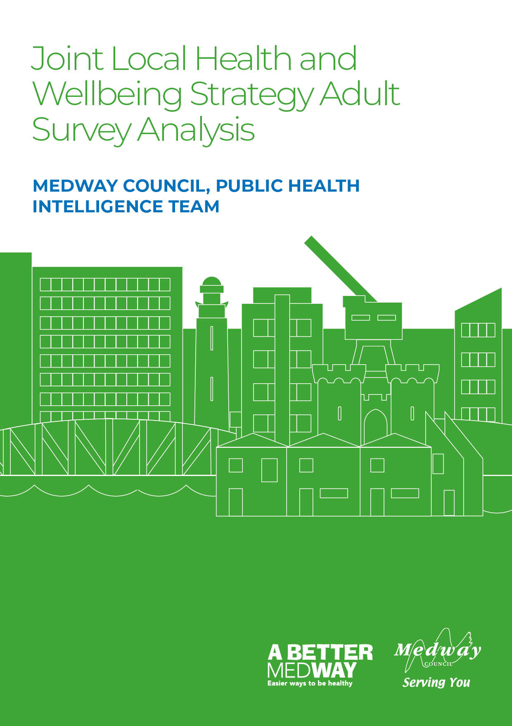

Appendix A: Better Health Survey for Adults - Quantitative Analysis

Medway Council, Public Health Intelligence Team

Contributors:
- Emmanuella Uwaifo - Public Health Intelligence Analyst
- Dr Natalie Goldring - Senior Public Health Intelligence Manager
- Dr Eluned Broom - Senior Public Health Intelligence Analyst

Introduction
The Medway ‘Better Health Survey’ 2023 was conducted to better understand which aspects of life Medway residents thought were important to their health and wellbeing. The responses also offered insights into what people thought the barriers to achieving this were. Three versions of the survey were developed and tailored to a different group within the Medway population. These groups consisted of adults (aged 18 years and older) and children (aged 13-18 years) who were asked to provide responses about themselves. The third version was designed for organisations, specifically targeting their interactions with individuals they engage with.
This report relates to the ‘Adults’ survey results which includes insights from Medway residents aged 18 years and over. It gives an overview of the perceived health needs and barriers to health for the survey participants and will inform actions needed to improve health and wellbeing. These will be set out in Medway’s ‘Joint Local Health and Wellbeing Strategy’ which is being refreshed from the current Medway Joint Health and Wellbeing Strategy (2018-2023).

Summary
The survey had a total of ten questions. It began by seeking the particpants’ consent and collecting basic demographic information such as age, gender, ethnicity and whether they had any long-term physical or mental health conditions. The remaining five questions in the survey focused on what each participant considered important for achieving good health and wellbeing, as well as any obstacles they faced in being healthy and well. These health and wellbeing questions resulted in a mixture of quantitative (numerical) and qualitative (descriptive) responses. This report will initially analyse the demographic information before focusing on the two quantitative response questions. Each question is examined first for the entire group of respondents, and then the analysis is further broken down by age, gender, ethnicity, and whether the participants have any long term physical or mental health conditions.

Demographics of the survey participants compared with the Medway population
The total population of Medway in the most recent census (2021) was 279,827. This survey had 526 respondents and so provides a useful estimate of local views on health and wellbeing.
This following section shows comparisons of the demographic breakdowns from the ‘Better Health Survey’ sample and the latest census data for Medway (2021) for adults aged 18 years and older.
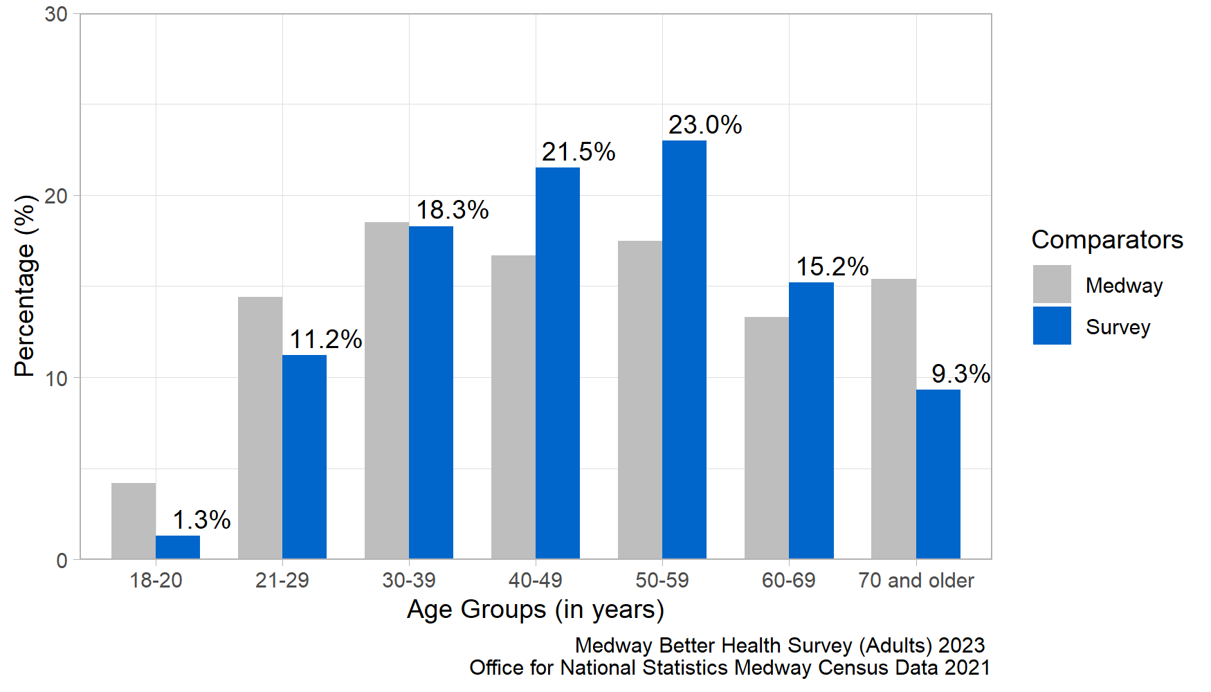
Figure 1: Age comparison between the local Medway population and the survey participants.
Figure 1 shows the age distribution for the survey participants compared to the Medway population. The distribution of survey responses by age group was similar to the 2021 Census, although the 18-20, 21-29 and 70 years and older age groups were slightly under-represented whereas the 40-49 and 50-59 year age groups were slightly over-represented.
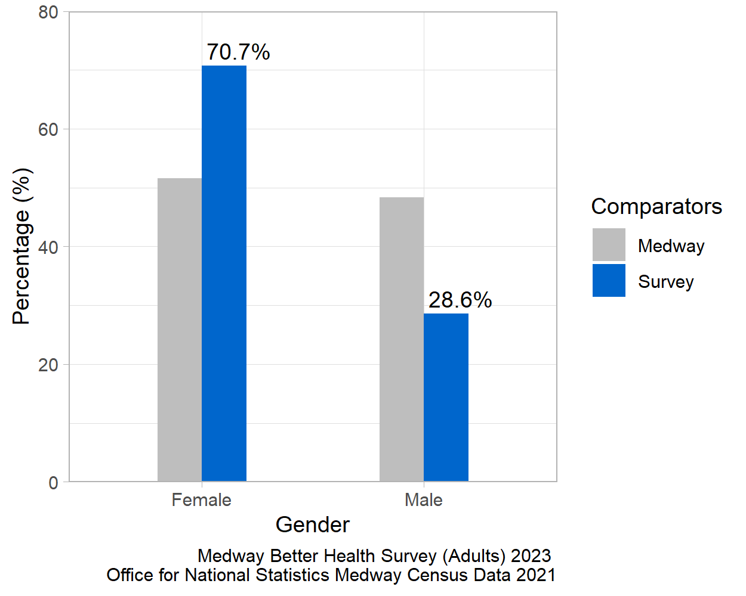
Figure 2: Gender comparison between the local Medway population and the survey participants.
Figure 2 shows the proportion of female and male respondents compared to the proportion in the Medway population as a whole. The female population was over-represented in the survey and the male population under-represented. A low number of individuals in the survey identified as non-binary or transgender male/female. These were suppressed to ensure respondents were not identifiable.
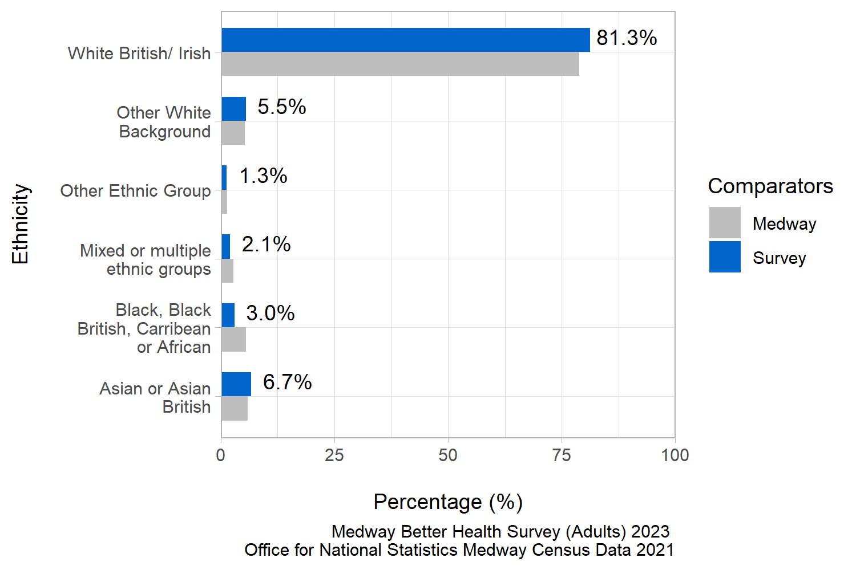
Figure 3: Ethnicity comparison between the local Medway population and the survey participants.
Figure 3 shows the ethnic group diversity in the survey compared with the local Medway population. The distribution of survey responses by ethnic group was similar to the 2021 Census.
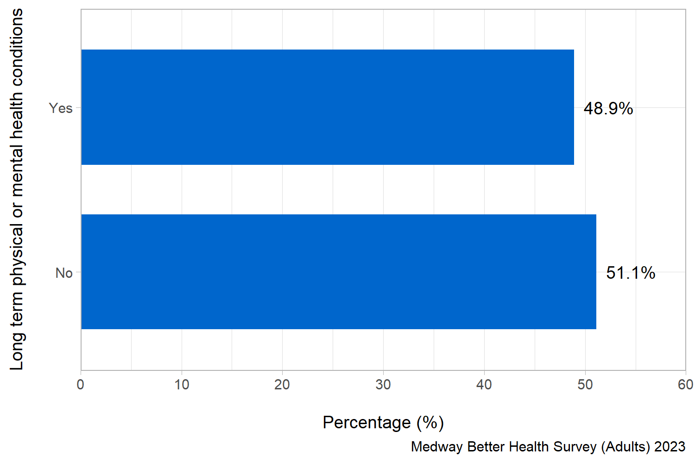
Figure 4: Proportion of survey respondents with long term physical or mental health conditions.
Figure 4 shows that just under half of the survey respondents reported a long term physical or mental health condition.
Taken together, this analysis indicates that the survey respondents are a good representation of the Medway population as a whole.

What Medway residents want when considering their health and wellbeing
Question: When thinking about your health and wellbeing, what are the things you would most want for yourself? Please number in order of importance, with 1 being most important.
Answer options:
- Feeling happy
- Less worry
- Getting help when feeling stressed
- Getting enough exercise or physical activity
- Sleeping well
- Healthy and affordable food
- Healthy habits around food and eating
- Drinking alcohol within safe limits
- Giving up smoking
- Looking after your sexual health
- Being without illness or pain.
Survey participants were asked to prioritise and rank the things they wanted most for their overall health and wellbeing. They were instructed to assign a number for the eleven response options from 1 to 11 to indicate the level of importance, with 1 representing the most significant priority.
To analyse this question, the top five responses were selected for each participant and assigned a score ranging from one to five, with five indicating the highest-ranked response. These scores were then combined to calculate a total score for each response. To determine the importance of each response within the top five, the total score for each response was divided by the sum of the total scores for all the responses in the top five. This calculation produced a proportion. The higher the proportion, the more likely the response was consistently placed and/or frequently ranked highly within the top five responses.
In figures 5 to 9 all the responses shown appear in the top five for at least one participant. A higher proportion indicates that response is more important to what Medway residents want when considering their health and wellbeing.
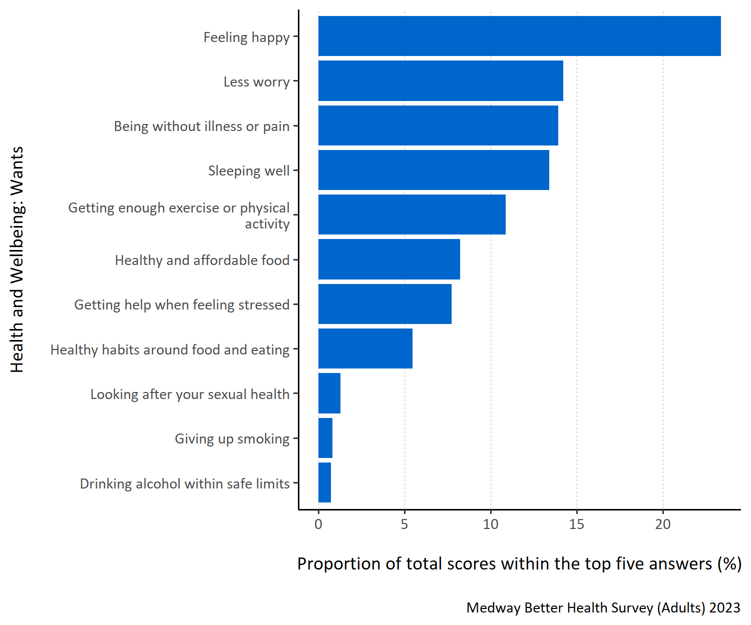
Figure 5: Proportion of total scores within the top five answers for each specified health and wellbeing want.
Figure 5 shows that survey respondents most wanted to be ‘feeling happy’ when considering their health and wellbeing. Respondents also thought ‘less worry’, ‘being without illness or pain’ and ‘sleeping well’ were important. When thinking about their wellbeing, respondents were less inclined to want to ‘look after their sexual health, ’give up smoking’ or ‘drink alcohol within safe limits’.
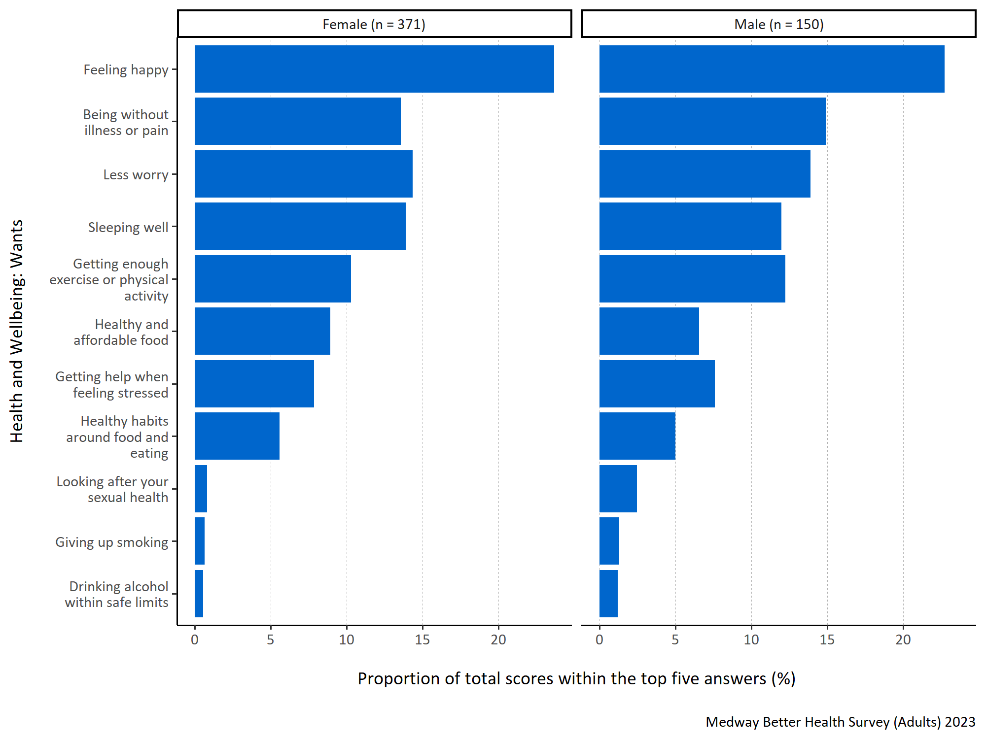
Figure 6: Proportion of total scores within the top five answers for each specified health and wellbeing want by gender.
Figure 6 shows that both male and female Medway residents wanted the most to be ‘feeling happy’ when considering their health and wellbeing. ‘Being without illness or pain’, ‘less worry’, ‘sleeping well’ and ‘getting enough exercise or physical activity’ were also important for both males and females.
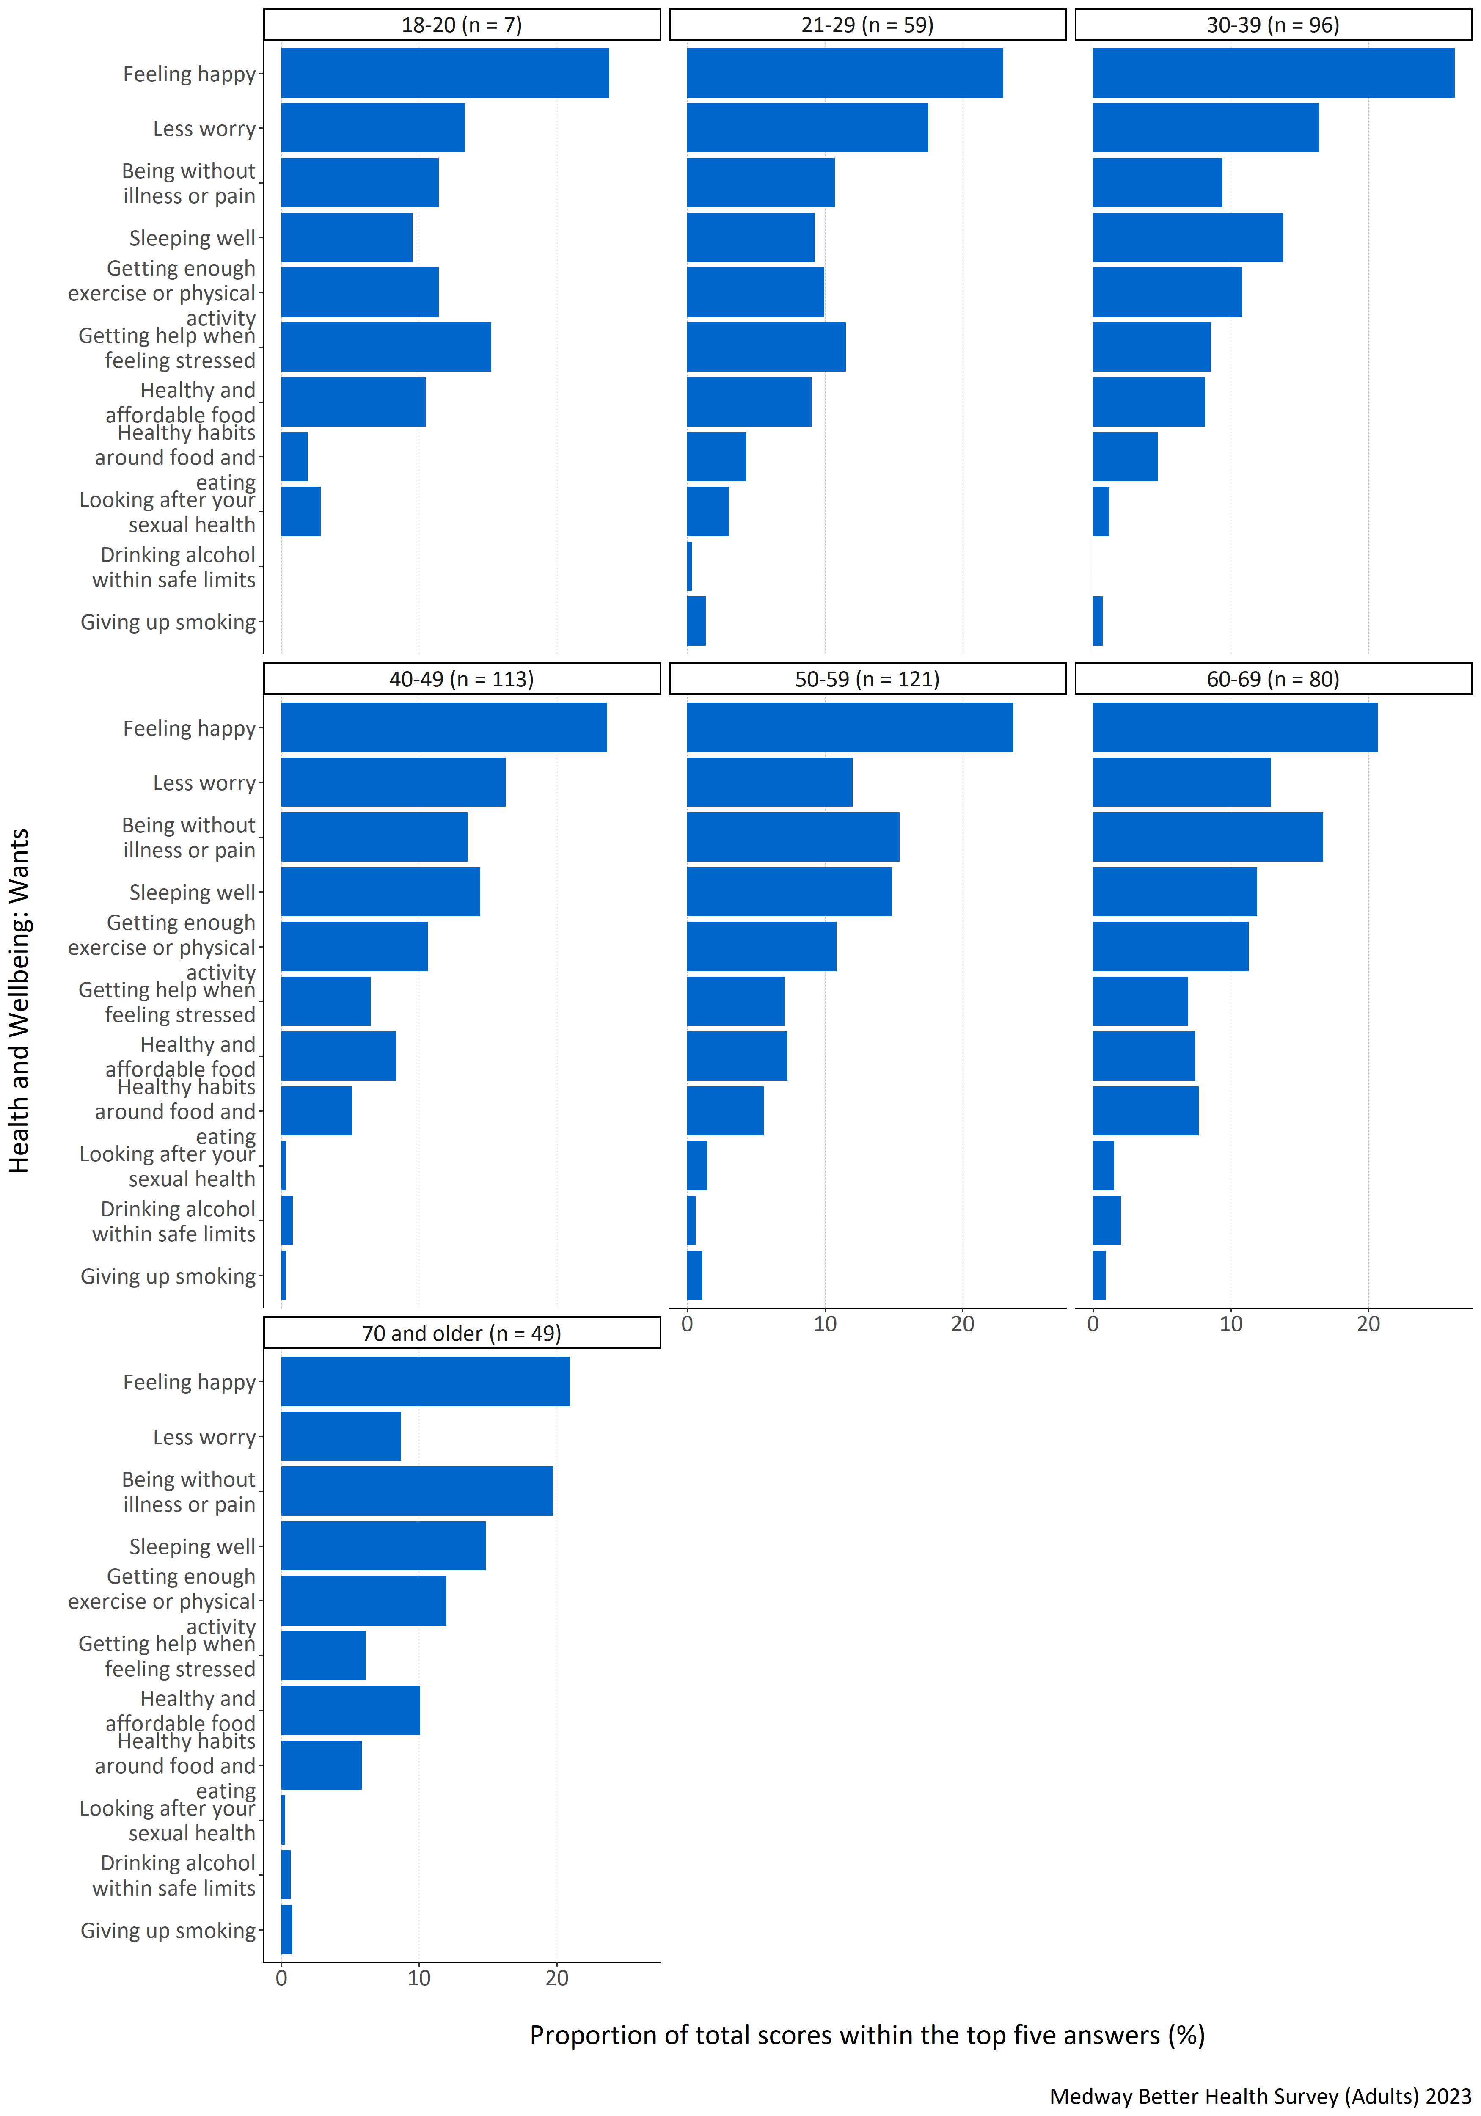
Figure 7: Proportion of total scores within the top five answers for each specified health and wellbeing want by age group (years).
Figure 7 shows that ‘feeling happy’ was important for all age groups. There was, however, variation between the importance assigned to other responses among different age groups. For example, in the age groups below 50 years old the response option ‘less worry’ had a high proportion. In the age groups above 50, greater importance was given to the responses ‘being without illness or pain’ and ‘sleeping well’. Interestingly, ‘drinking alcohol within safe limits’ was not placed in the top five rankings for any of the respondents in the 18-20 and 30-39 year old age groups.
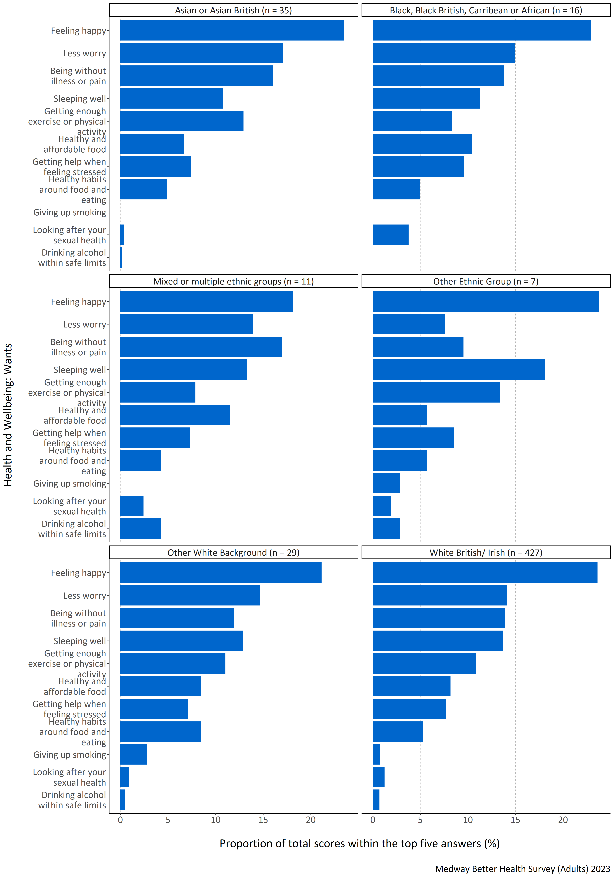
Figure 8: Proportion of total scores within the top five answers for each specified health and wellbeing want by ethnic group.
Figure 8 shows that respondents from all ethnic groups wanted most to be ‘feeling happy’ when considering their health and wellbeing. All ethnic groups, except for other ethnic groups, also ranked ‘less worry’, ‘being without illness or pain’ and ‘sleeping well’ highly. Respondents identifying as being from other ethnic groups ranked ‘sleeping well’ and ‘getting enough exercise or physical activity’ highly. ‘Giving up smoking’ was not placed in the top five most important health and wellbeing wants for those respondents identifying as Asian or Asian British, Black, Black British, Caribbean or African, or mixed or multiple ethnic groups. Black, Black British, Caribbean or African respondents also did not include ‘drinking alcohol within safe limits’ in their top five wants. It is important to note that there were low respondent numbers in some groups and so care must be taken when interpreting the results.
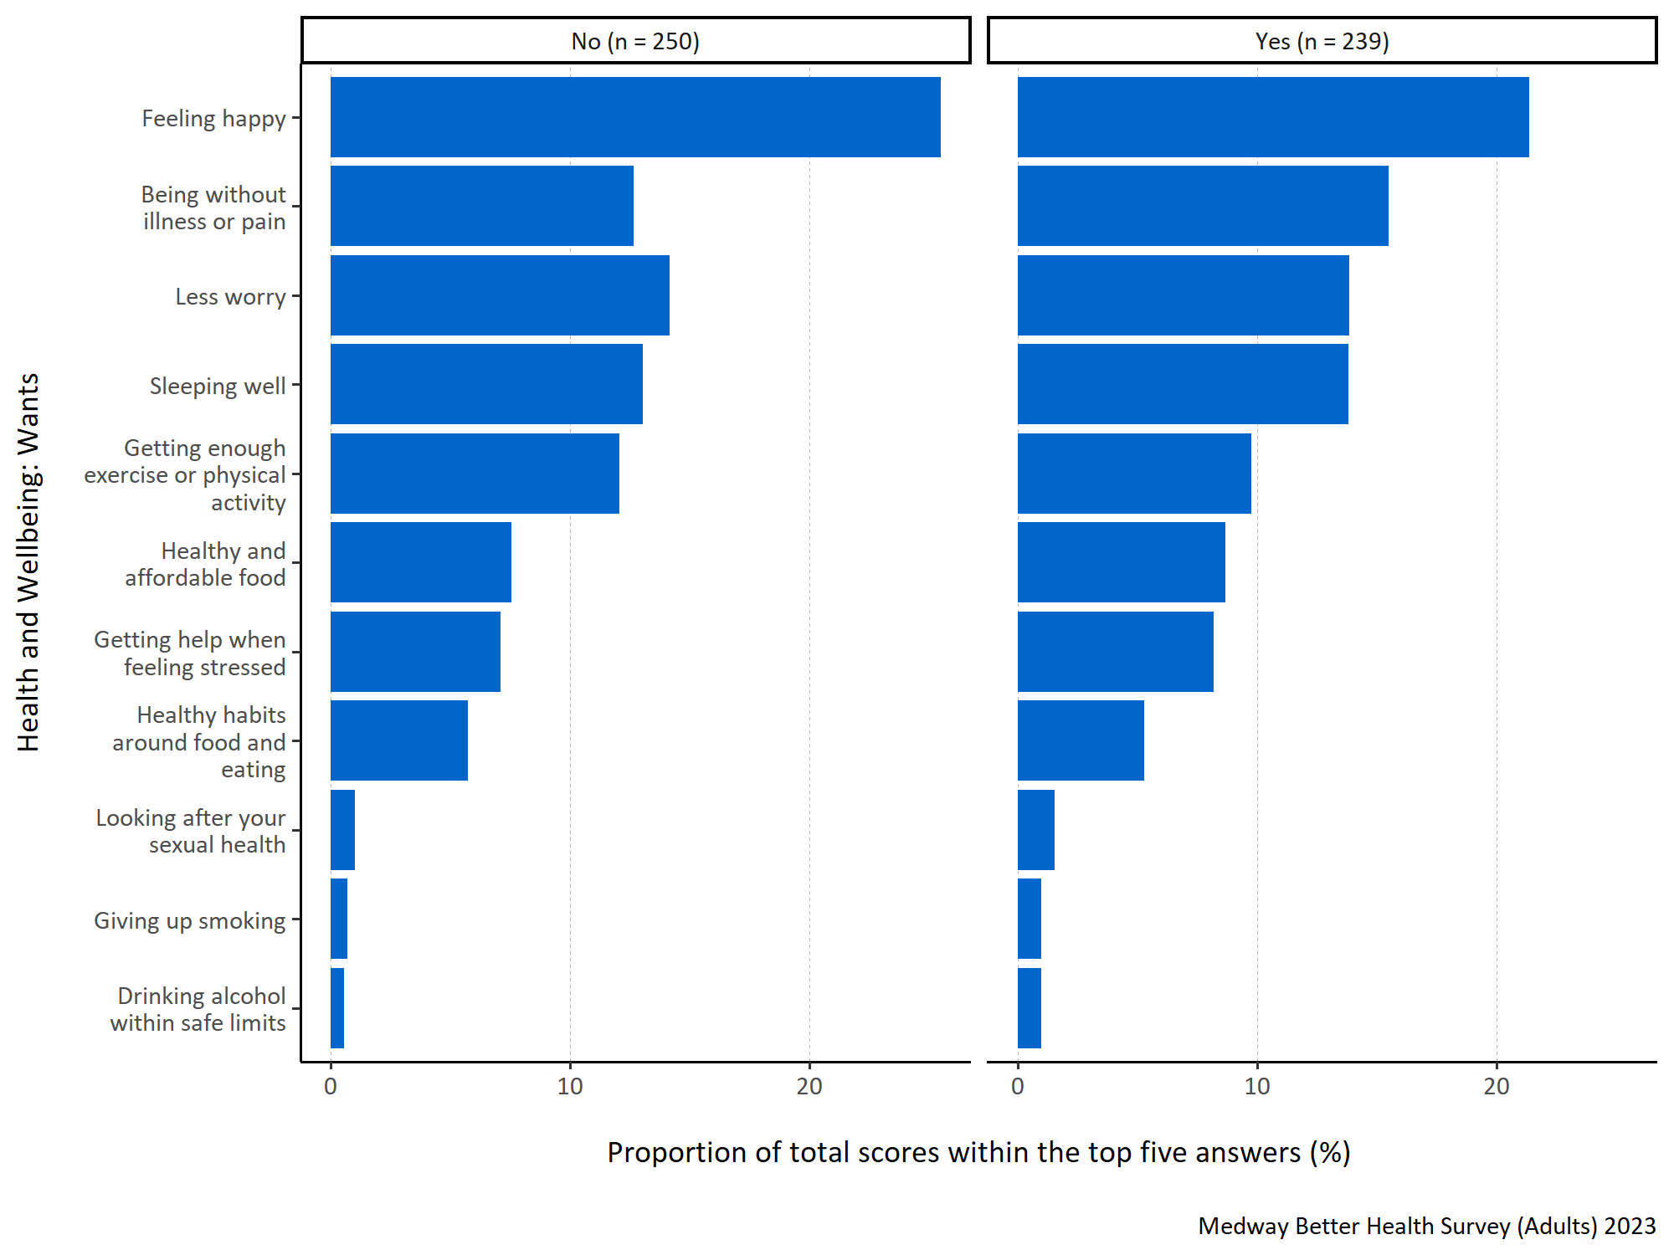
Figure 9: Proportion of total scores within the top five answers for each specified health and wellbeing want by long term physical or mental health conditions.
Figure 9 shows that for both respondents with and without a long term physical or mental health condition ‘feeling happy’ was considered most important for what people wanted when considering their health and wellbeing. Both groups also frequently ranked ‘being without illness or pain’, ‘less worry’, ‘sleeping well’ and ‘getting enough exercise or physical activity’ high, although those with a long term health condition prioritised ‘feeling happy’ less and ‘being without illness or pain’ more than those who did not report one.

What Medway residents think would improve their health and wellbeing
Question: What do you think are the most important things that can be done to improve health and wellbeing for everyone living in Medway? Please number in order of importance, with 1 being most important.
Answer options:
- Improved job security
- Having enough money to provide for my/my family’s needs
- Affordable, good quality housing
- Better access to GP services
- Better access to other health and care services (for example, mental health services, social care, hospital care, services that help manage conditions like diabetes, high blood pressure, breathing difficulties)
- Better access to green spaces (like open green spaces and water in urban areas, including parks, playing fields, play areas, allotments and community gardens, woodland and more natural areas, canal paths and riversides)
- Tackling environmental issues (like climate change, pollution, traffic congestion)
- Affordable leisure activities
- Being able to spend time socially with other people
- Better access to the internet
- Good-quality, affordable childcare
- Support with parenting skills
- Support with caring responsibilities
- Good local schools
- More adult education and training opportunities
- Feeling safe in the neighbourhood.
Survey participants were asked to prioritise and rank what they thought to be the most important things that can be done to improve health and wellbeing for everyone living in Medway. They were asked to assign a number for the sixteen response options from 1 to 16 to indicate the level of importance, with 1 representing the most significant priority.
To analyse this question, the top five responses were selected for each participant and assigned a score ranging from one to five, with five indicating the highest-ranked response. These scores were then combined to calculate a total score for each response. To determine the importance of each response within the top five, the total score for each response was divided by the sum of the total scores for all the responses in the top five. This calculation produced a proportion. The higher the proportion, the more likely the response was consistently placed and/or frequently ranked highly within the top five responses.
In figures 10 to 14 all the responses shown appear in the top five for at least one participant. A higher proportion indicates that response is more important to what Medway residents want when considering what could be done to improve health and wellbeing of residents in Medway.
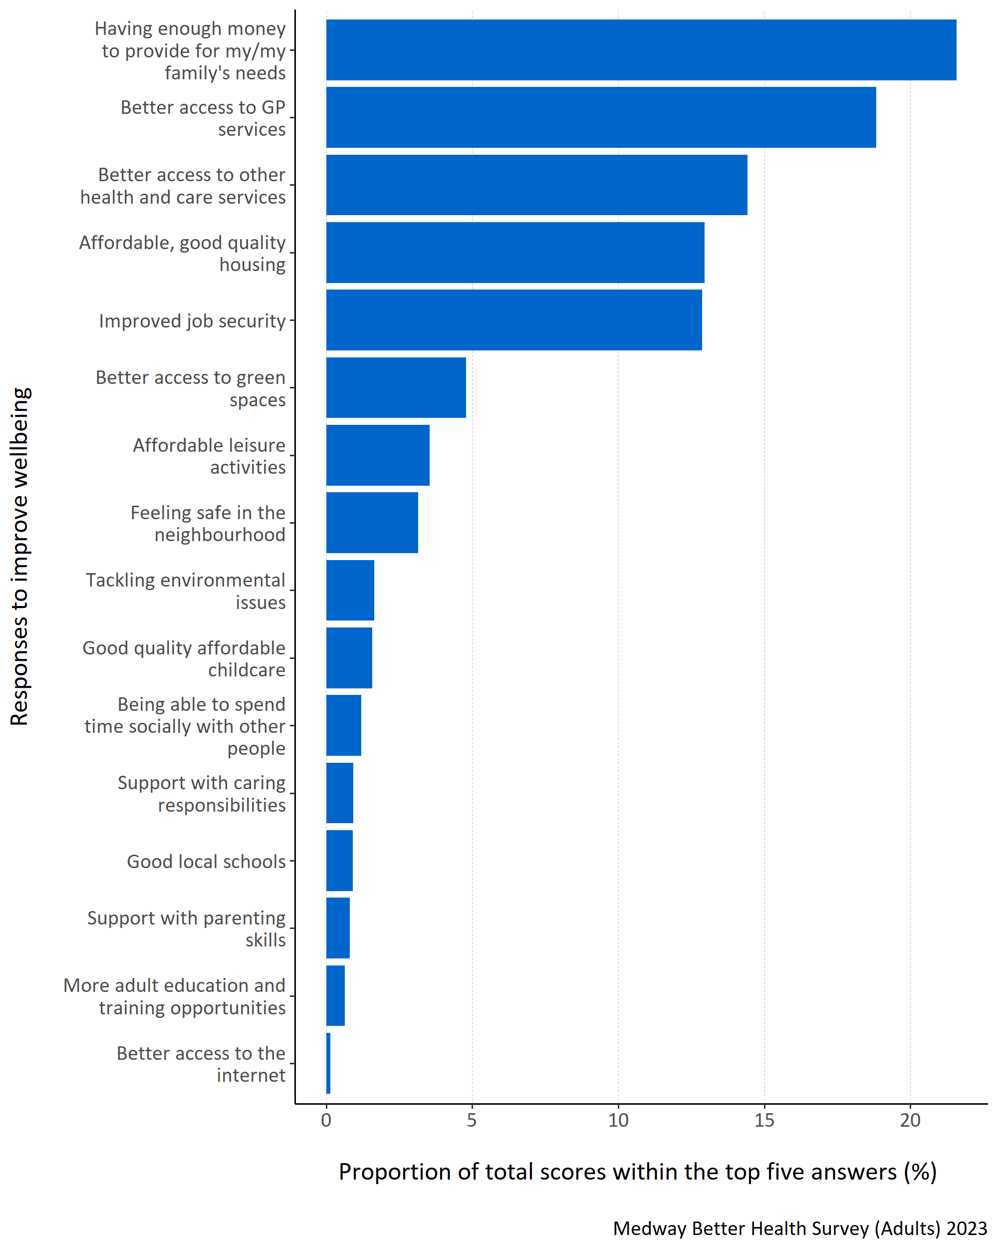
Figure 10: Proportion of total scores within the top five answers for each specified health and wellbeing improvement need.
Figure 10 shows that Medway residents thought ‘having enough money to provide for my/my family’s needs’ was most important to improving health and wellbeing for everyone in Medway. ‘Better access to GP services’, ‘better access to other health and care services’, ‘affordable, good quality housing’ and ‘improved job security’ were also thought to be important.
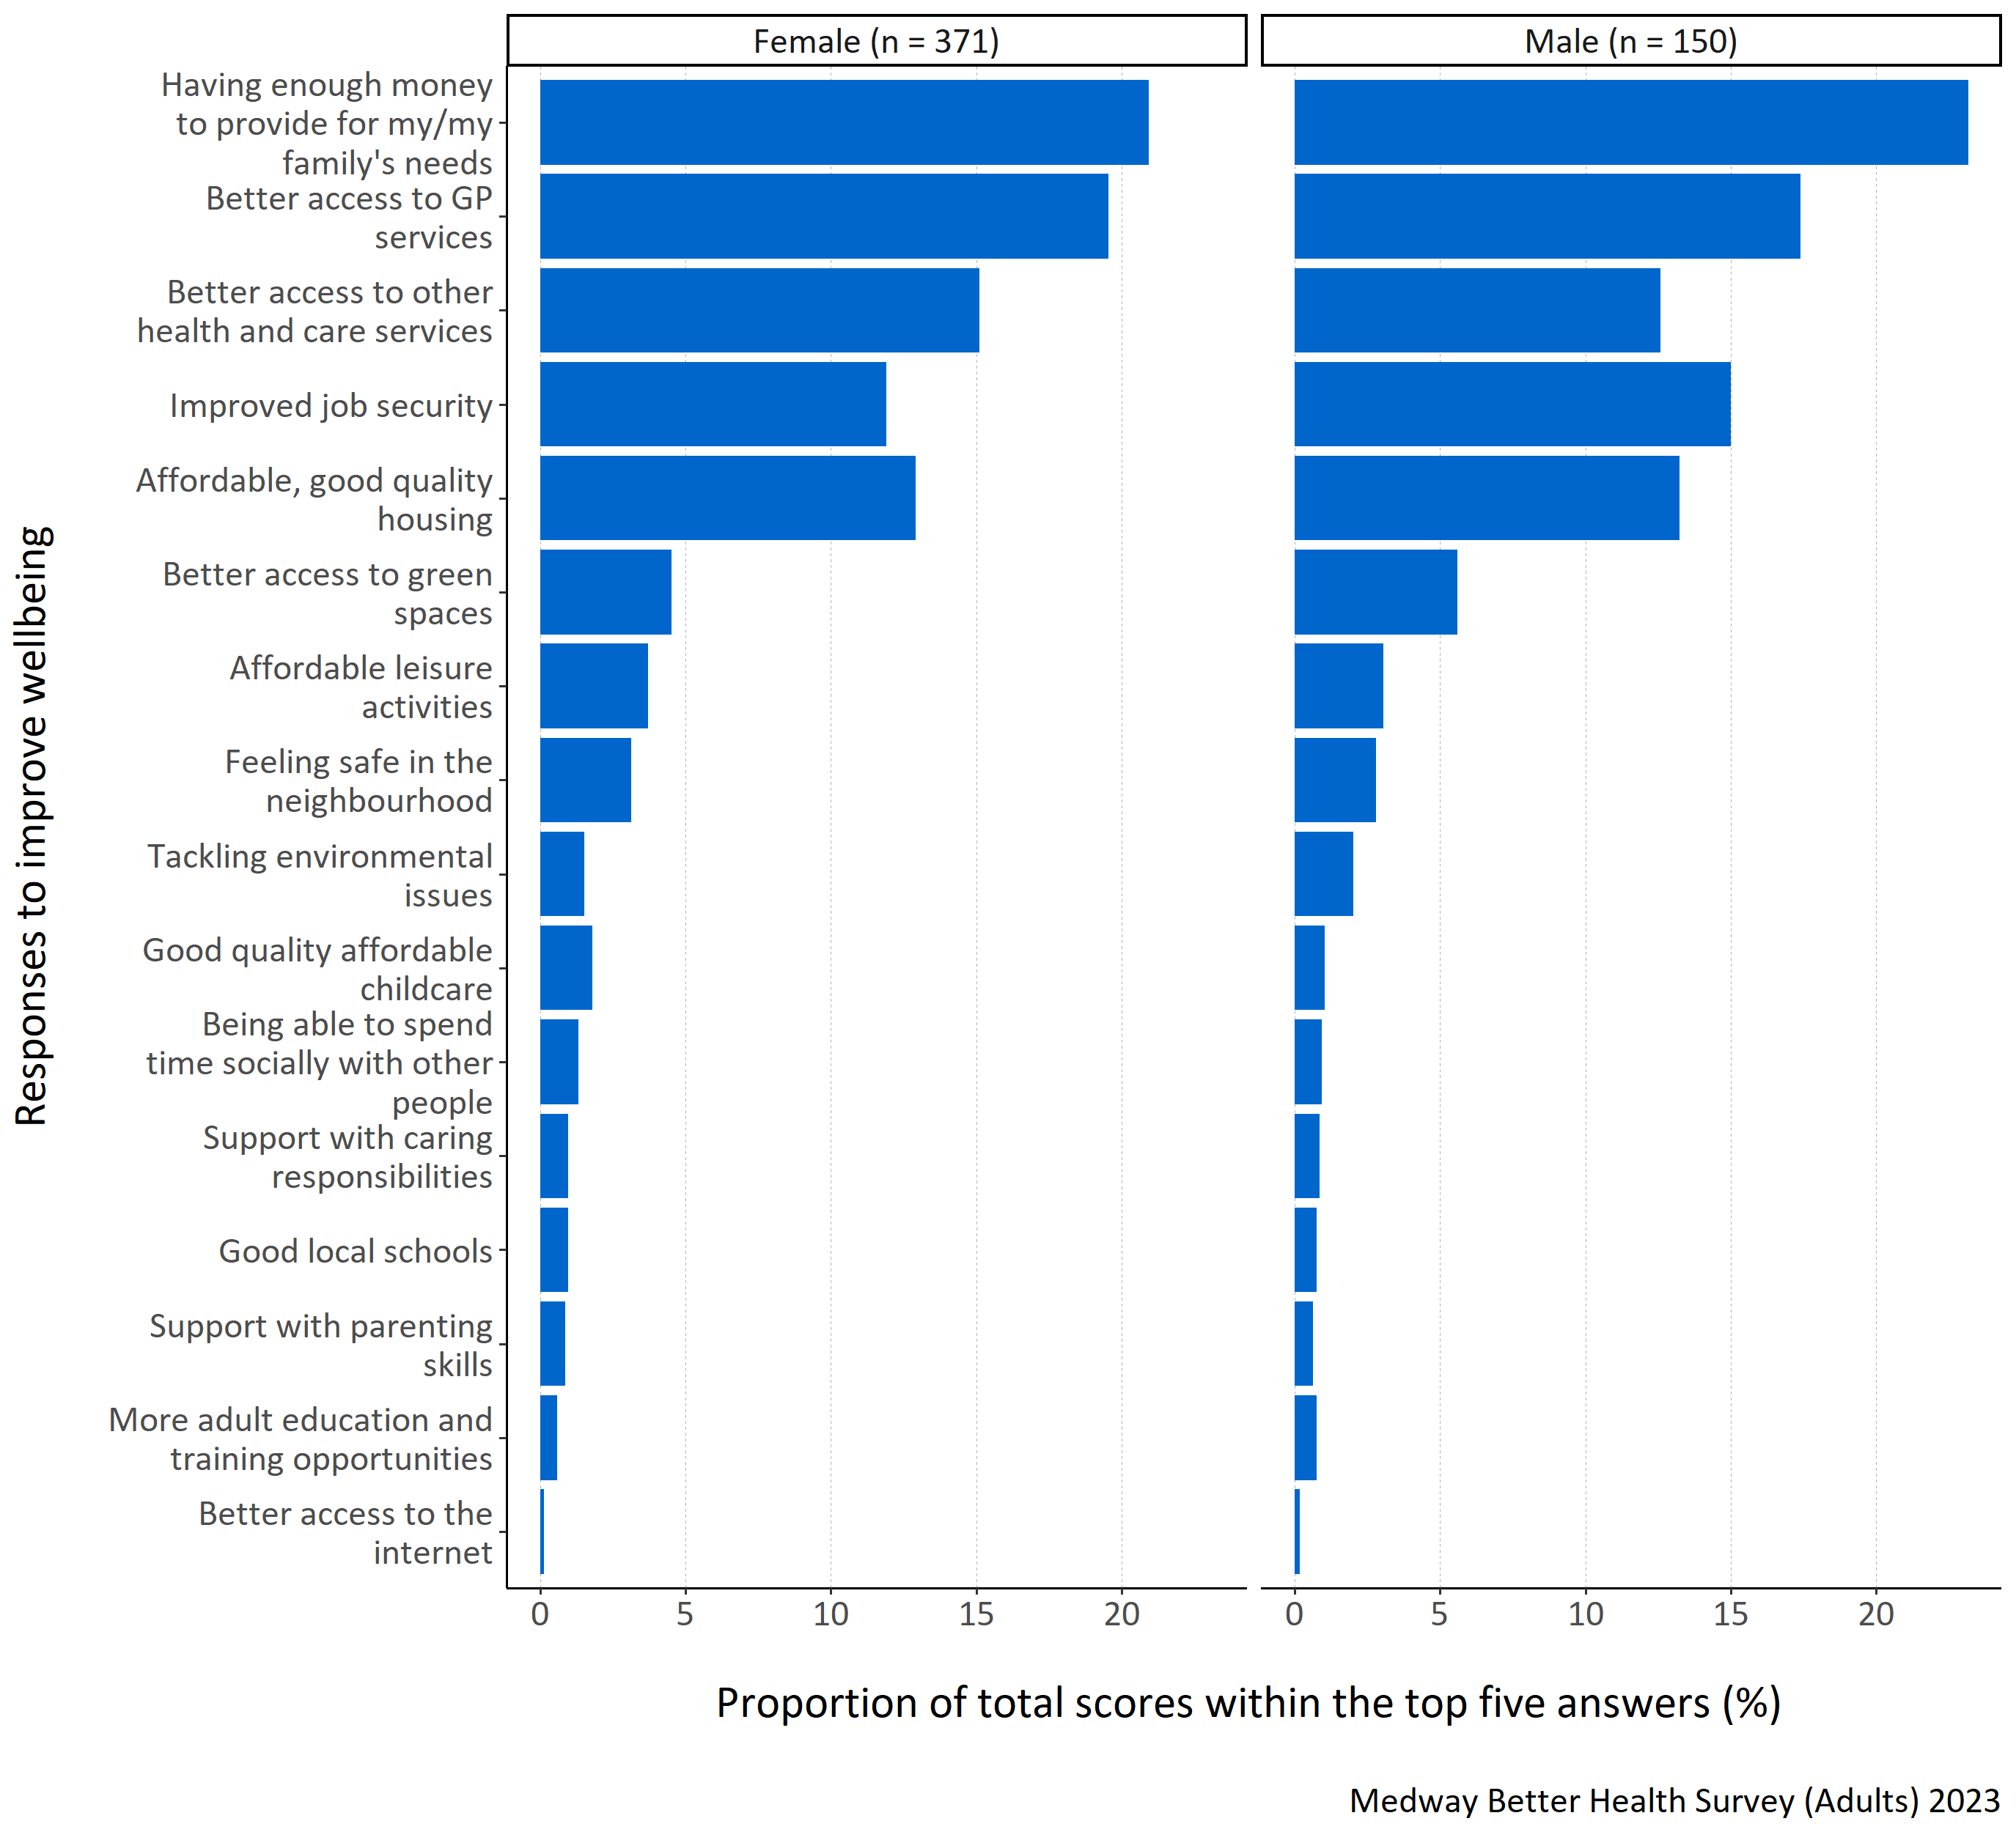
Figure 11: Proportion of total scores within the top five answers for each specified health and wellbeing improvement need by gender.
Figure 11 shows that ‘having enough money to provide for my/my family’s needs’ was considered most important for both male and female respondents when considering improving health and wellbeing. ‘Better access to GP services’, ‘better access to other health and care services’, ‘affordable, good quality housing’ and ‘improved job security’ were also considered important, however males considered ‘improved job security’ more important than females did.
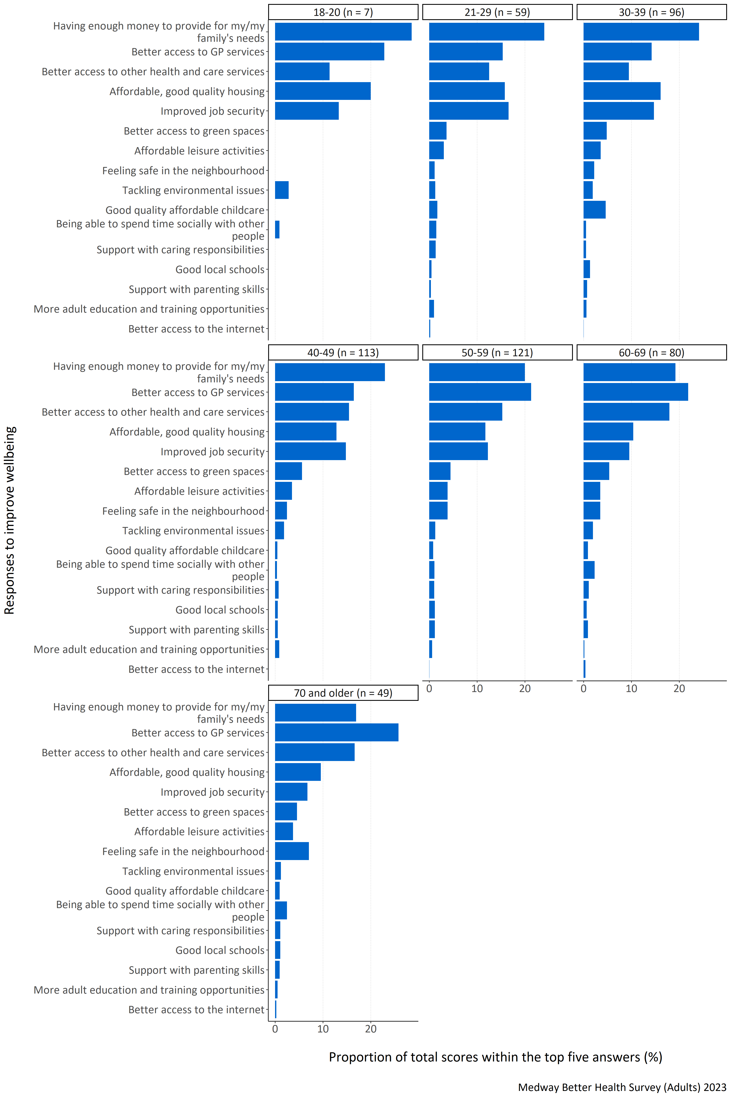
Figure 12: Proportion of total scores within the top five answers for each specified health and wellbeing improvement need by age group (years).
Figure 12 shows that ‘having enough money to provide for my/my family’s needs’ was most important to respondents aged below 50 years. For those aged over 50 ‘better access to GP services’ became more important. Younger age groups also thought that ‘affordable, good quality housing’ was more important.
For respondents in the 18-20 and 40-49 year old age groups, ‘better access to the internet’ was not placed in the top five rankings at all. Furthermore, for the 18-20 year old respondents, ‘better access to green spaces’, ‘affordable leisure activities’, ‘feeling safe in the neighbourhood’, ‘good quality affordable childcare’, ‘support with caring responsibilities’, ‘good local schools’, ‘support with parenting skills’, and ‘more adult education and training opportunities’ were not placed in the top five rankings.
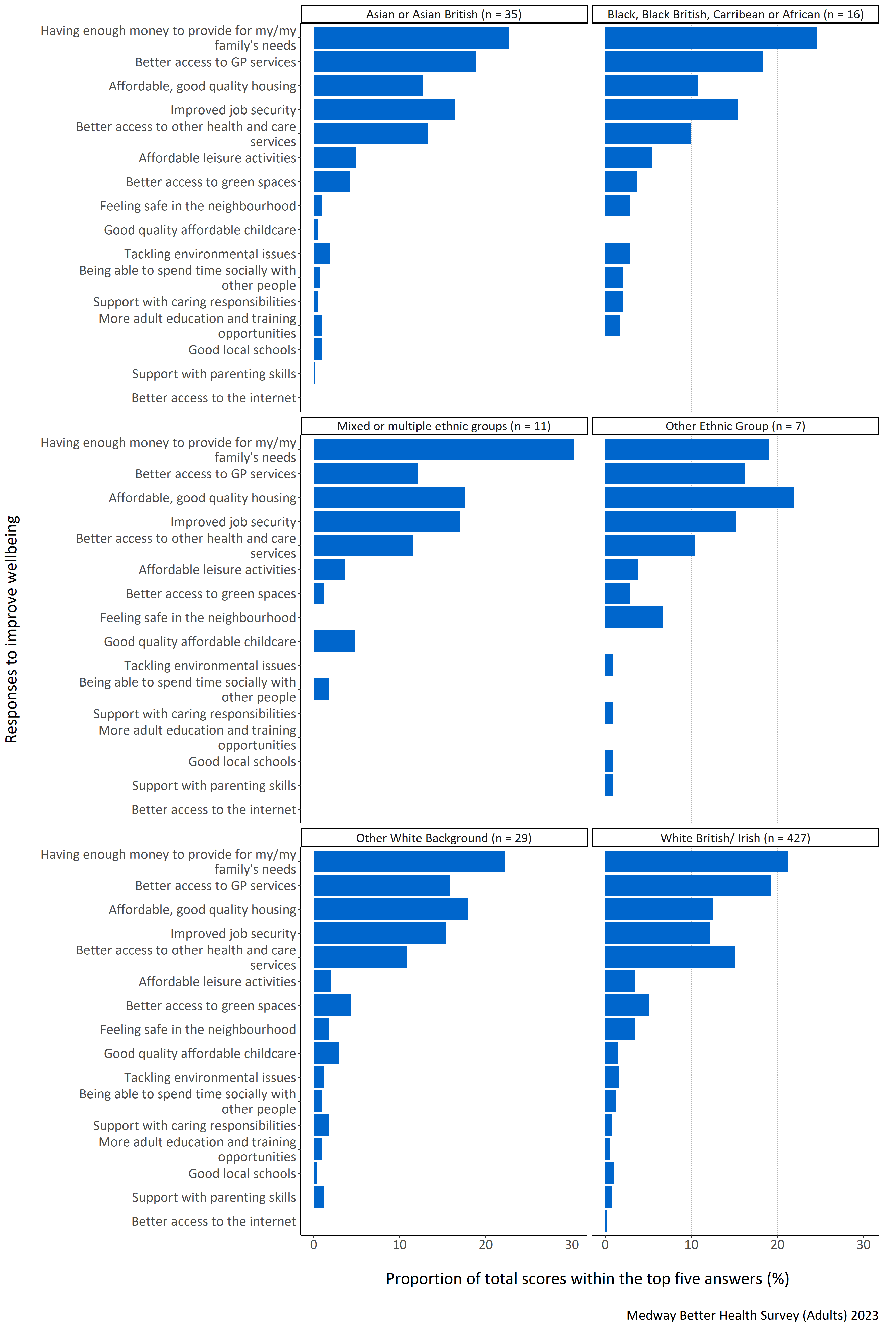
Figure 13: Proportion of total scores within the top five answers for each specified health and wellbeing improvement need by ethnic group.
Figure 13 shows that respondents from all ethnic groups, except for those in the other ethnic group, thought ‘having enough money to provide for my/my family’s needs’ was most important for improving health and wellbeing. Respondents from the other ethnic group category highlighted ‘affordable, good quality housing’ as important. White British/ Irish respondents also considered ‘better access to GP services’ and ‘better access to other health and care services’ to be important. Respondents from Asian or Asian British, Black, Black British, Caribbean or African and Other White Background groups thought ‘better access to GP services’ and ‘improved job security’ were important.
No respondent from any ethnic group except White British/Irish ranked ‘better access to the internet’ in their top five most important improvements when considering health and wellbeing. Additionally, for Black, Black British, Caribbean or African respondents, ‘good quality affordable childcare’, ‘good local schools’, and ‘support with parenting skills’ were not ranked in their top five. For mixed or multiple ethnic groups, no respondents placed ‘feeling safe in the neighbourhood’, ‘tackling environmental issues’, ’support with caring responsibilities’, ‘more adult education opportunities’, ‘good local schools’, and ‘support with parenting skills’ in their top five responses. For the other ethnic group, no respondents included ‘good quality affordable childcare’, ‘being able to spend time socially with other people’, and ‘more adult education and training opportunities’ within their top five responses. It should be noted that the number of respondents from Black, Black British, Caribbean or African, mixed or multiple ethnic group and other ethnic group were small and so data should be interpreted with caution.
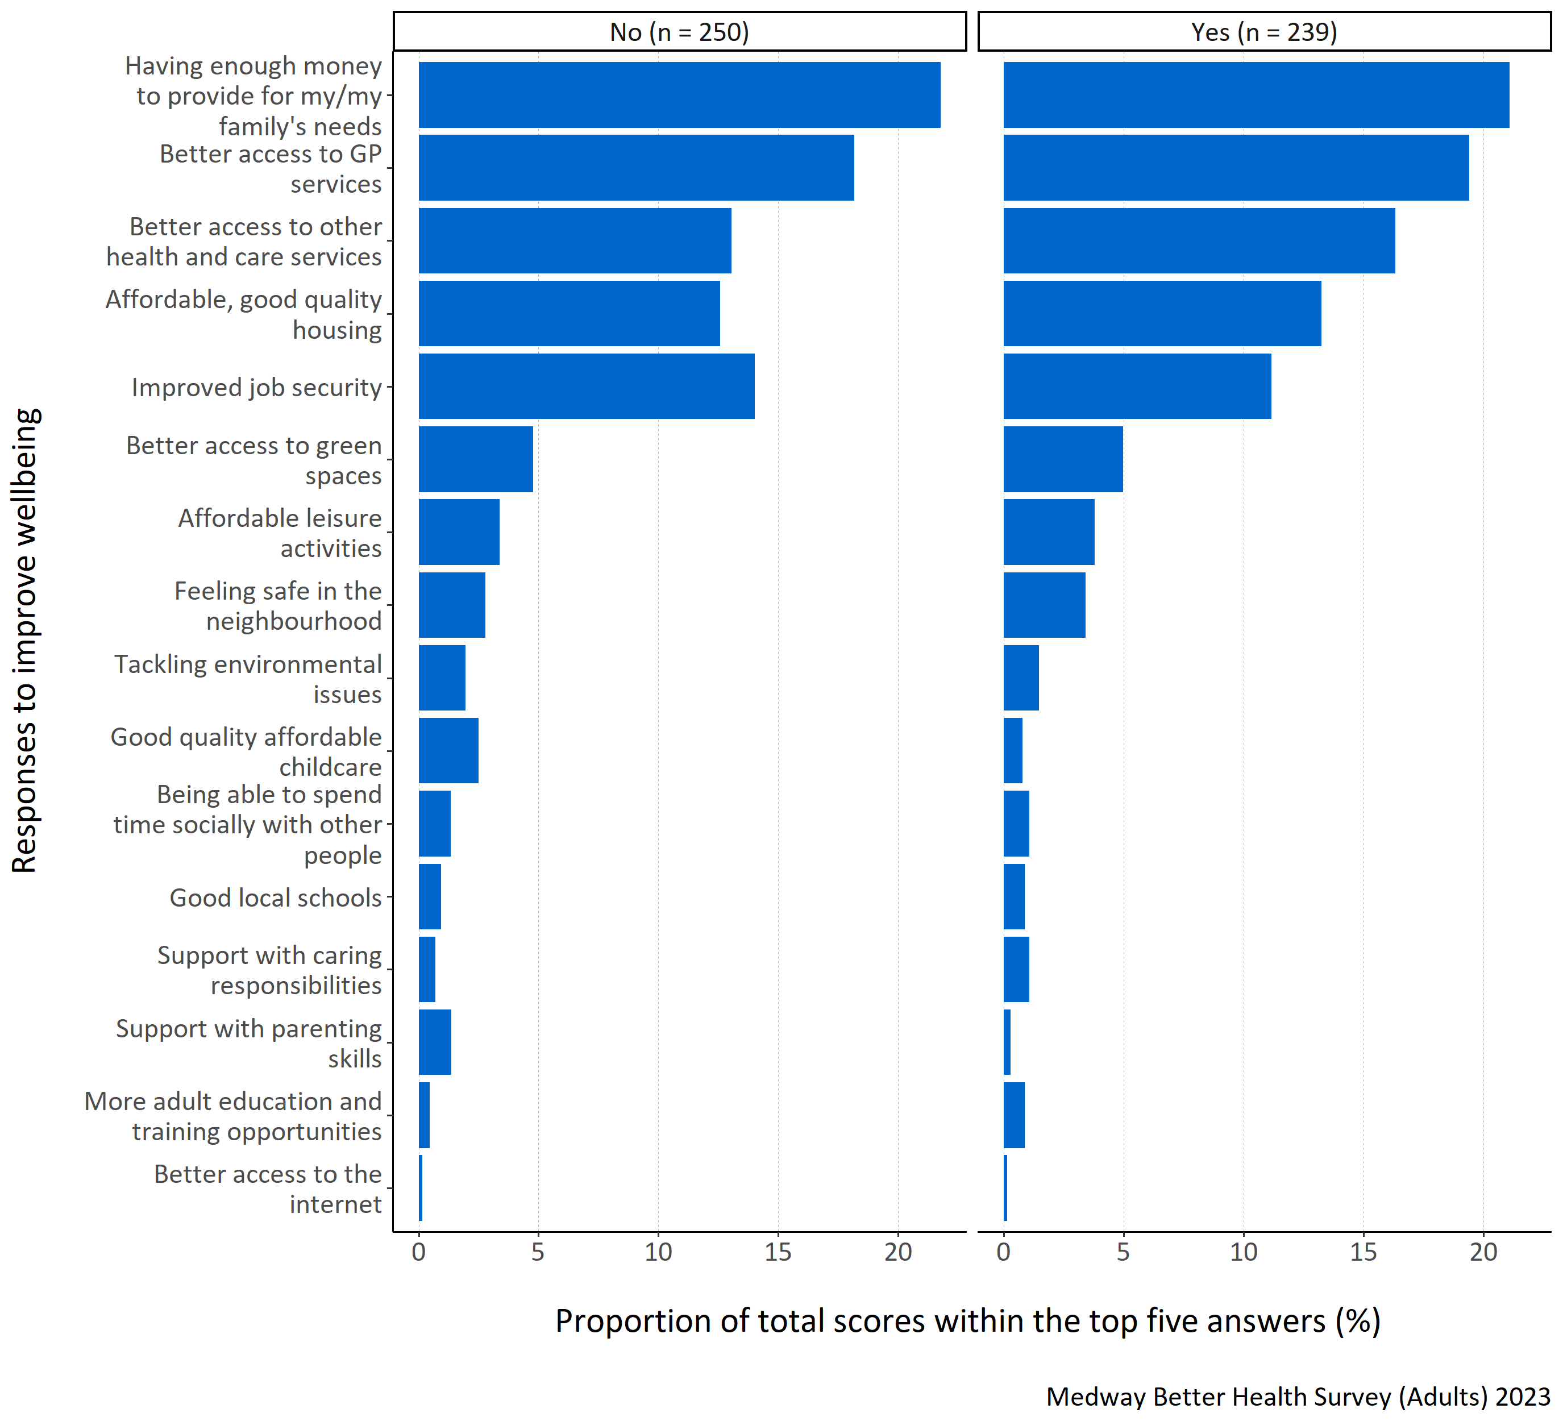
Figure 14: Proportion of total scores within the top five answers for each specified health and wellbeing improvement need by long term physical or mental health conditions.
Figure 14 shows that respondents considered ‘having enough money to provide for my/my family’s needs’ and ‘better access to GP services’ most important regardless of whether they reported a long term physical or mental health condition. Respondents with a long term physical or mental health condition also reported ‘better access to other health services’ as being important. Those without long term physical or mental health conditions thought ‘improved job security’ was also important.

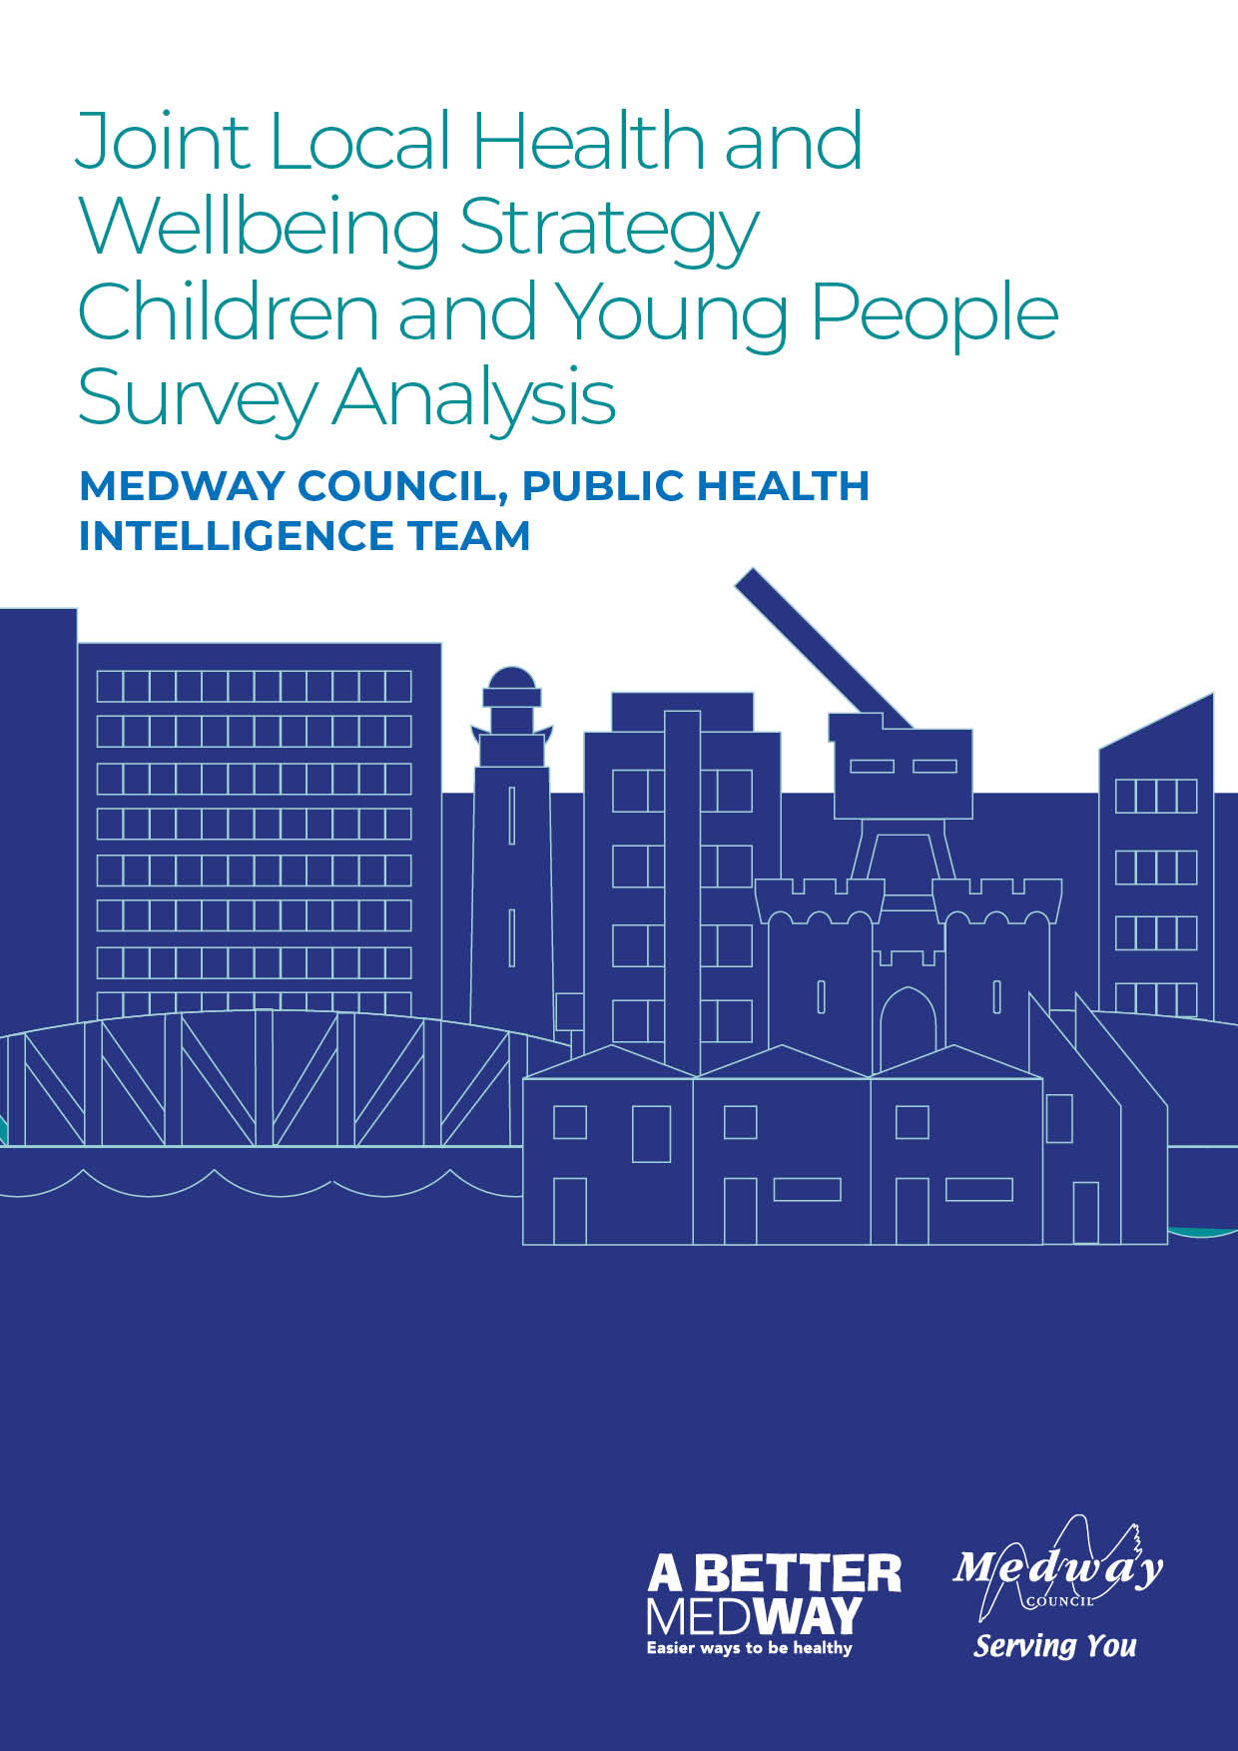

Appendix B: Better Health Survey for Children & Young People – Quantitative Analysis

Medway Council, Public Health Intelligence Team

Contributors:
- Emmanuella Uwaifo - Public Health Intelligence Analyst
- Dr Natalie Goldring - Senior Public Health Intelligence Manager
- Dr Eluned Broom - Senior Public Health Intelligence Analyst

Introduction
The Medway ‘Better Health Survey’ 2023 was conducted to better understand which aspects of life Medway residents thought were important to their health and wellbeing. The responses also offered insights into what people thought the barriers to achieving this were. Three versions of the survey were developed and tailored to a different group within the Medway population. These groups consisted of adults (aged 18 years and older) and children (aged 13-18 years) who were asked to provide responses about themselves. The third version was designed for organisations, specifically targeting their interactions with individuals they engage with.
This report relates to the ‘Children and Young People’ survey results which includes insights from Medway residents aged 13-18 years old. It gives an overview of the perceived health needs and barriers to health for the survey participants and will inform actions needed to improve health and wellbeing. These will be set out in Medway’s ‘Joint Local Health and Wellbeing Strategy’ which is being refreshed from the current Medway Joint Health and Wellbeing Strategy (2018-2023).

Summary
The survey had a total of nine questions. It began by seeking the participants’ consent and collecting basic demographic information such as age, gender, ethnicity and whether they had any long-term physical or mental health conditions. The remaining questions in the survey focused on what each participant considered important for achieving good health and wellbeing, as well as any obstacles they faced in being healthy and well. These health and wellbeing questions resulted in a mixture of quantitative (numerical) and qualitative (descriptive) responses. This report will initially analyse the demographic information before focusing on the four quantitative response questions. Each question is examined first for the entire group of respondents, and then the analysis is further broken down by age, gender, ethnicity, and whether the participants have any long term physical or mental health conditions.

Demographics of the survey participants compared with the Medway population
The total population of Medway aged 13-18 years old in the most recent census (2021) was 20,491. This survey had 148 respondents, which provides a useful estimate of local views on health and wellbeing.
The following section shows comparisons of the demographic breakdowns from the ‘Better Health Survey’ survey sample and the latest census data for Medway (2021) for children and young people aged 13-18 years old.
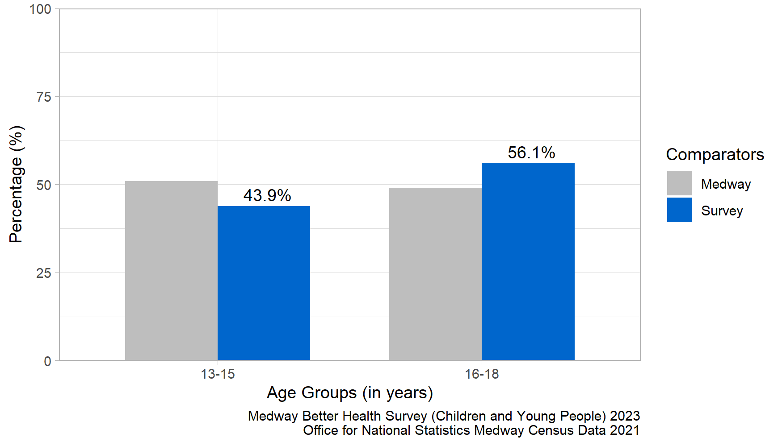
Figure 1 : Age Comparison between the local Medway population and the survey participants.
Figure 1 shows the age distribution for the survey participants and the local Medway population. The distribution of survey responses by age group was similar to the 2021 Census.
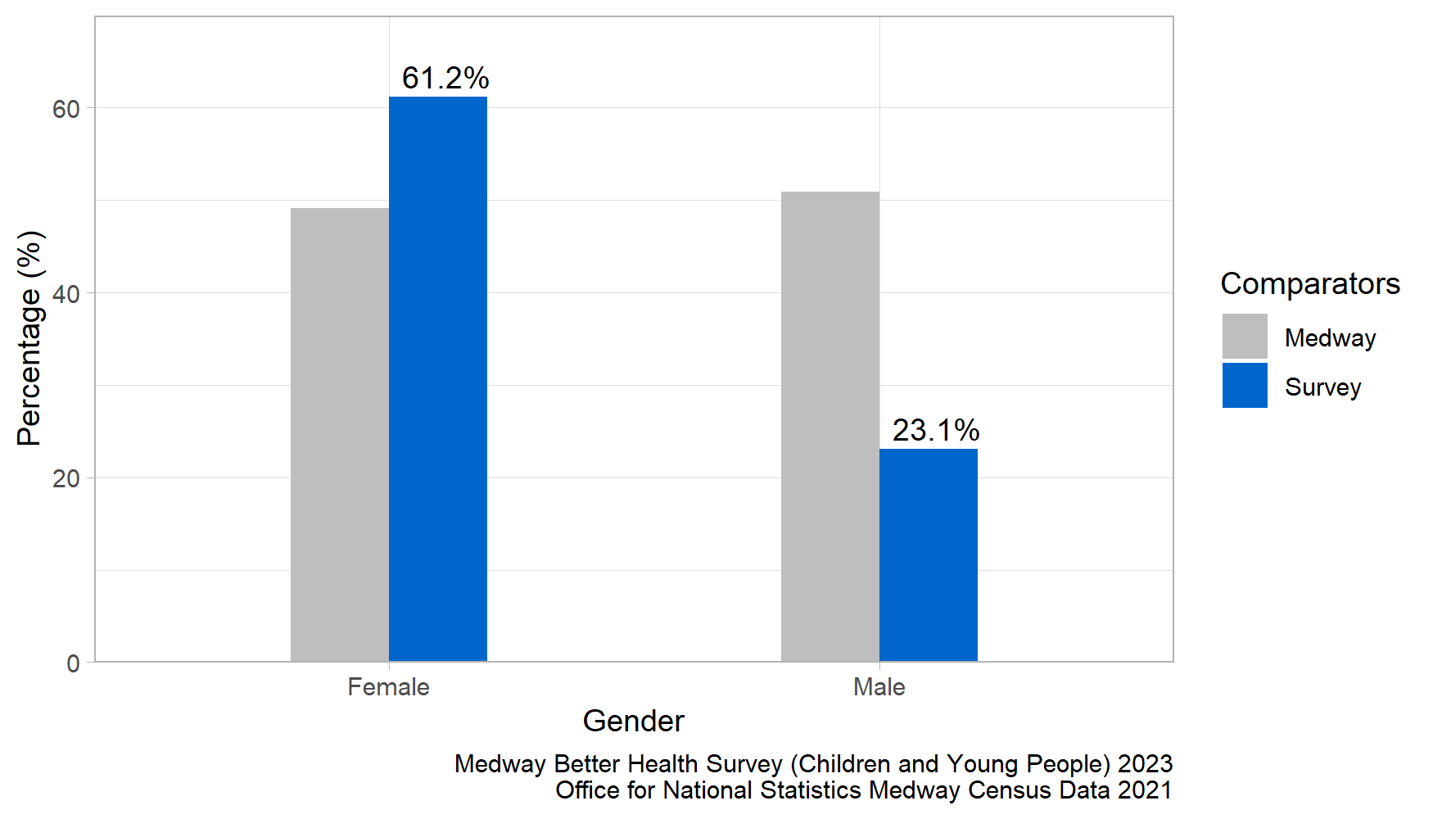
Figure 2: Gender Comparison between the Local Medway Population and the Survey Participants.
Figure 2 shows the gender division in Medway (aged 13-18 years old) compared with the survey participants. The distribution of survey responses by gender differs from the 2021 Census data. In the survey there is a much greater proportion of female respondents to male respondents, whereas in the local Medway population the split between male and female is nearly equal.
A small number of individuals in the survey identified with a gender identity other than male or female. Due to the low numbers, their responses were mostly suppressed to prevent the possibility of identification. However, non-binary individuals were included in the analysis as there were enough participants who identified as non-binary, reducing the risk of identification. In Figure 2, the data for non-binary individuals was suppressed because the census data provided negligible statistics for meaningful comparison.
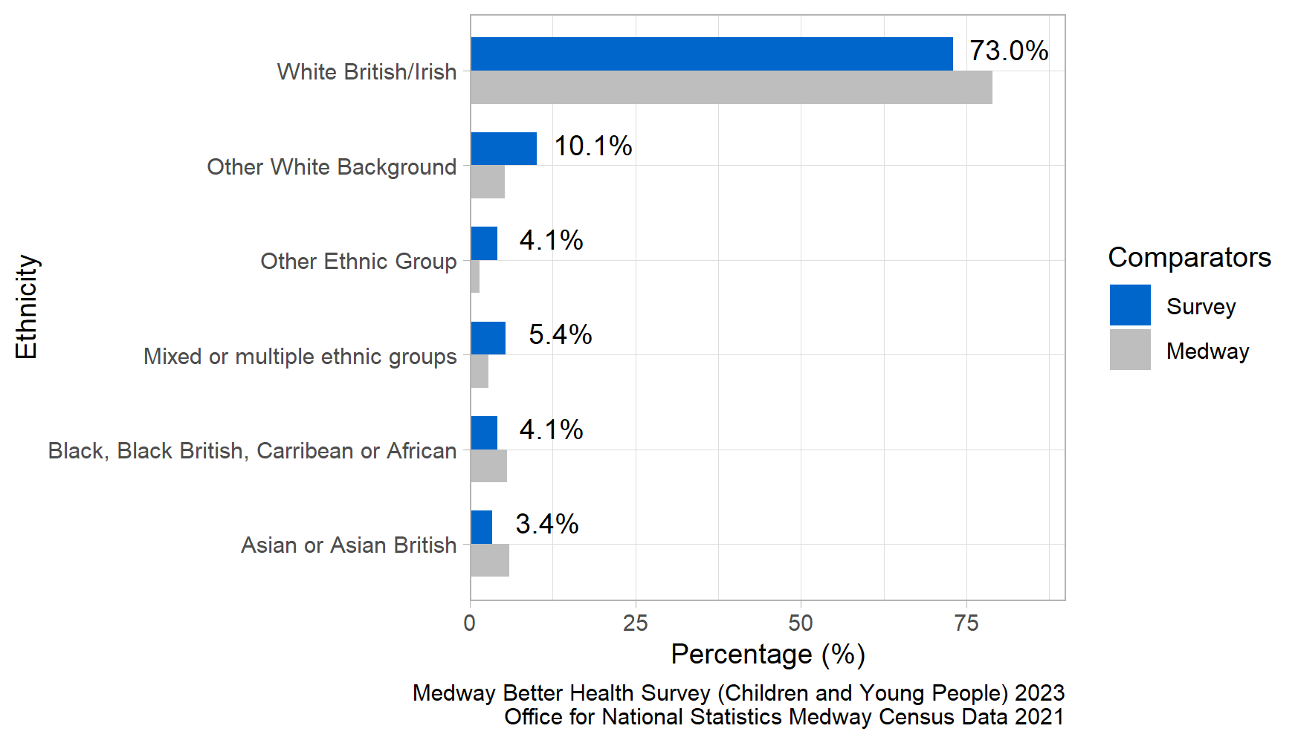
Figure 3: Ethnicity Comparison between the local Medway population and the survey participants.
Figure 3 shows the ethnic group diversity in the survey respondents (age 13 - 18 years) compared with the local Medway Population (all ages). The distribution of survey responses by ethnic group was similar to the 2021 Census.
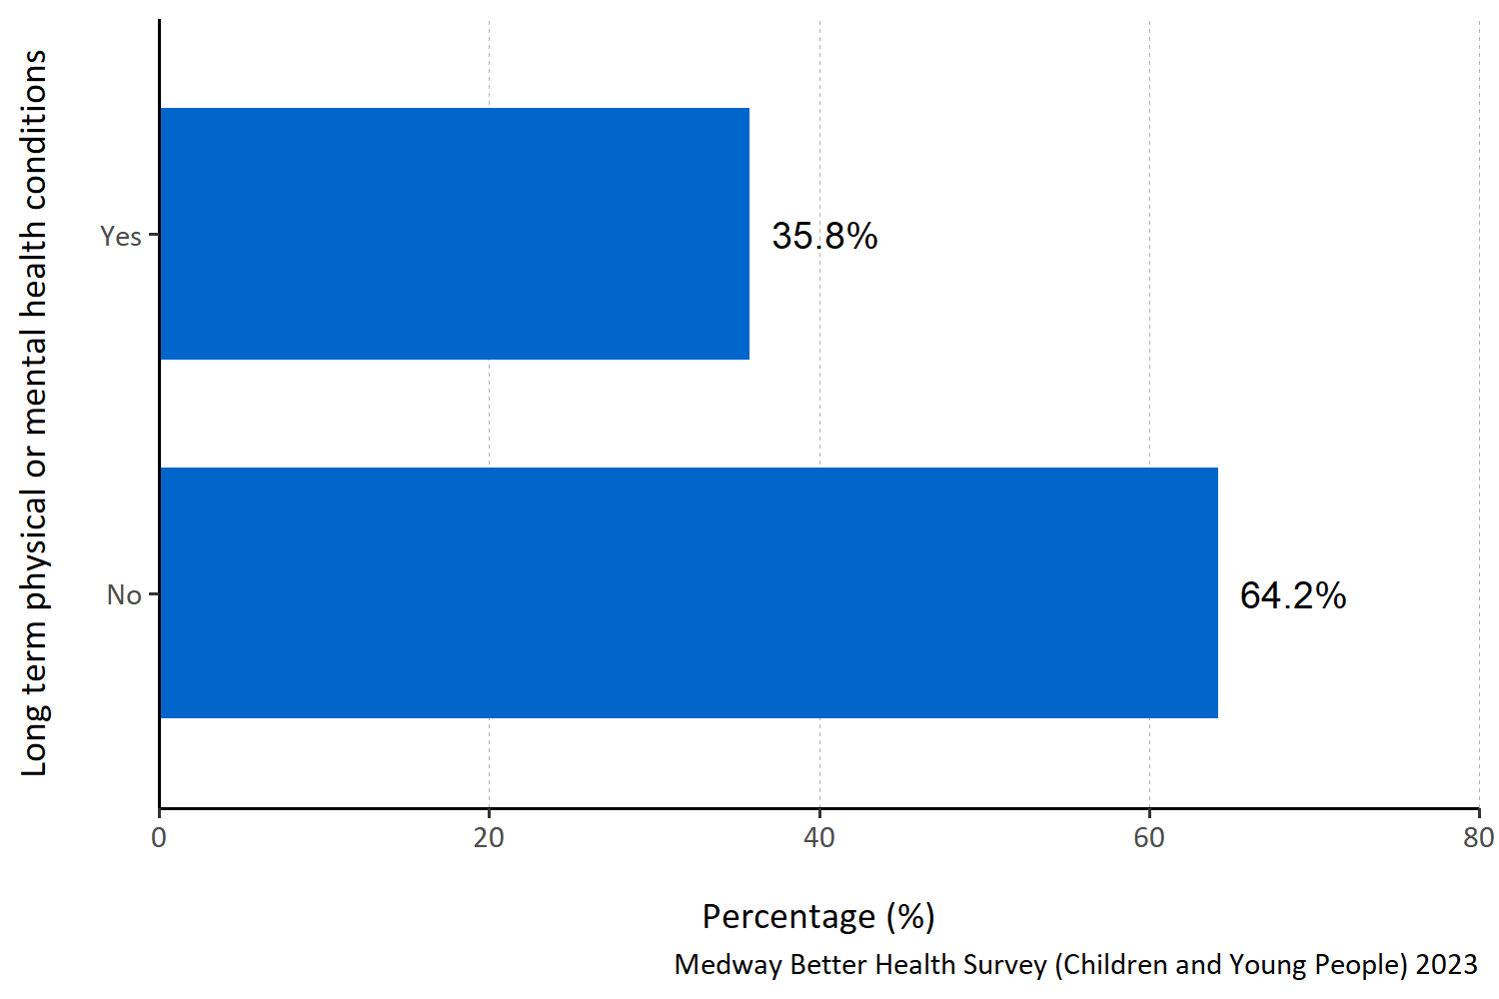
Figure 4: Proportion of survey respondents with long term physical or mental health conditions.
Figure 4 shows that about 35% of the survey respondents reported a long term physical or mental health condition.
Taken together, this analysis indicates that the survey respondents are a good representation of the Medway population aged 13- 18 years old as a whole.

Defining what being healthy means to children and young people in Medway
Question: What does being healthy mean to you? Please number in order of importance, with 1 being ‘most important’.
Answer options:
- Feeling happy
- Feeling calm and relaxed
- Sleeping well
- Being without illness or pain
- Less worry
- Dealing well with stress when it happens
- Getting enough exercise
- Healthy habits around food and eating
- Having supportive friends and family.
Survey participants were asked to prioritise and rank the response options for what they would personally define as being healthy in order of importance. They were instructed to assign a number for the nine response options from 1 to 9 to indicate the level of importance, with 1 representing the most important priority for them.
To analyse this question, the top five responses were selected for each participant and assigned a score ranging from one to five, with five indicating the highest-ranked response. These scores were then combined to calculate a total score for each response. To determine the importance of each response within the top five, the total score for each response was divided by the sum of the total scores for all the responses in the top five. This calculation produced a proportion. The higher the proportion, the more likely the response was consistently placed and/or frequently ranked highly within the top five responses.
In figure 5 to 9 all the responses shown appear in the top five for at least one participant. A higher proportion indicates that response is more important to children and young people in Medway when defining what being healthy means to them.
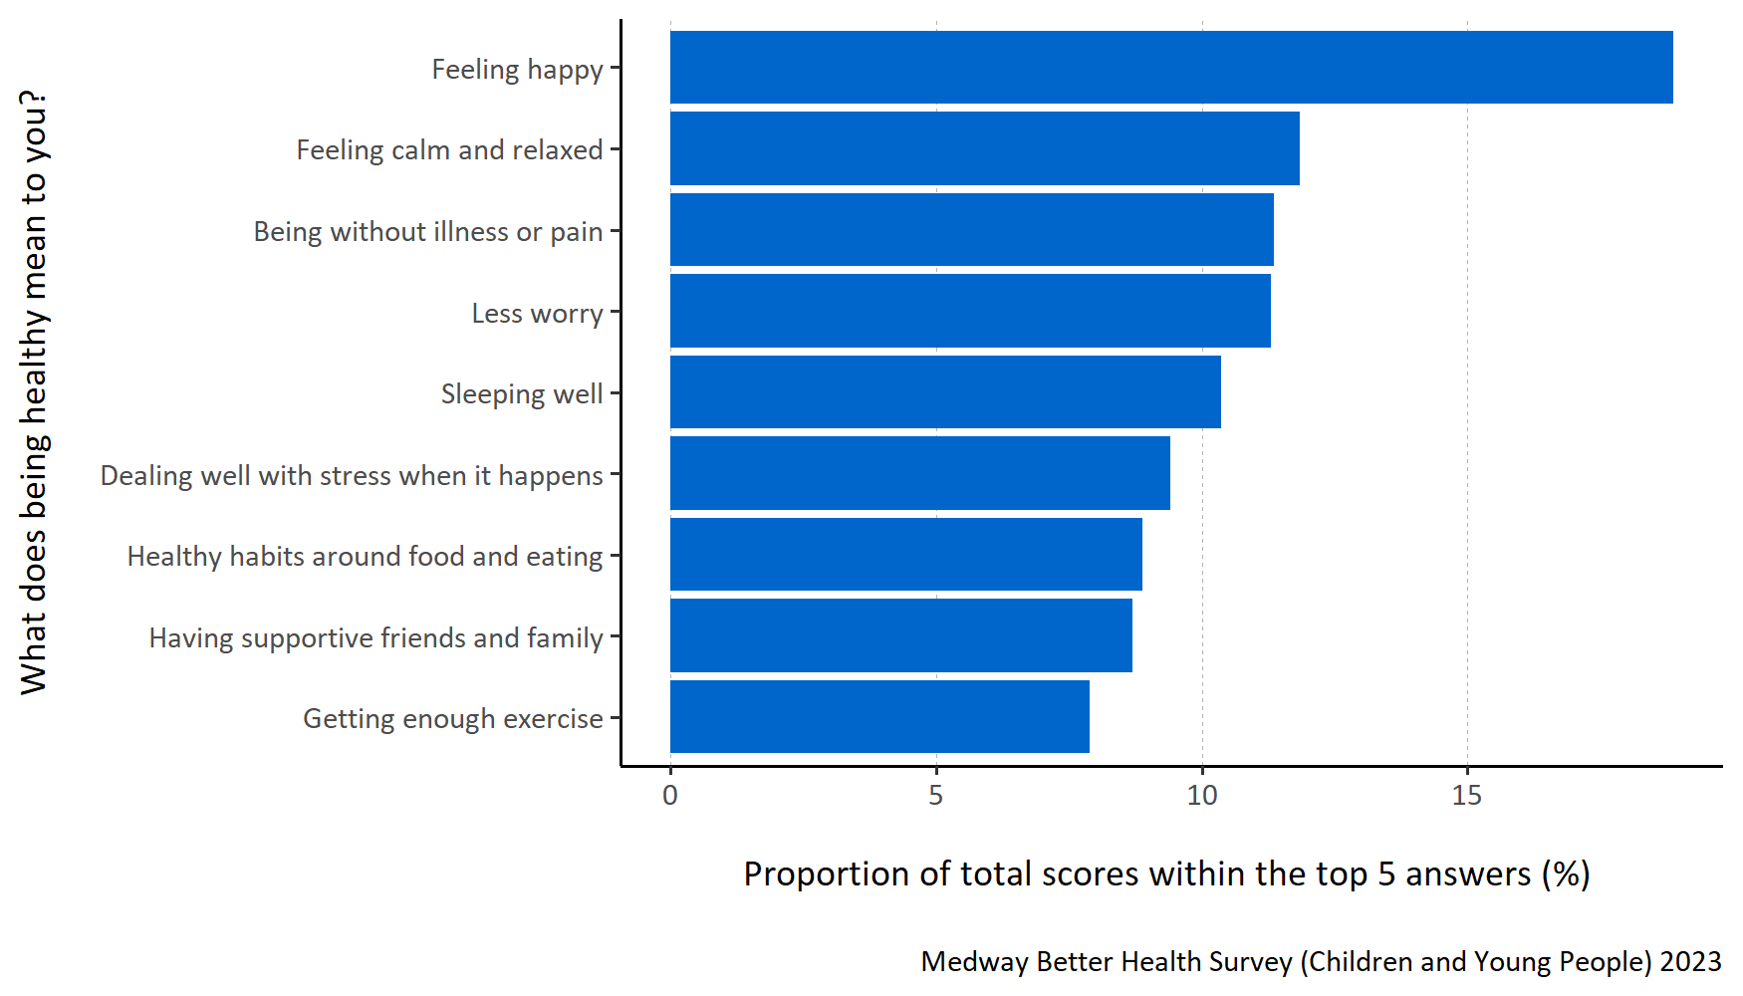
Figure 5: Proportion of total scores within the top 5 answers for each specified healthy lifestyle factor.
Figure 5 shows that children and young people in Medway consider ‘feeling happy’ to be most important when defining being healthy. They also thought ‘feeling calm and relaxed’, ‘being without illness or pain’ and ‘less worry’ were important.
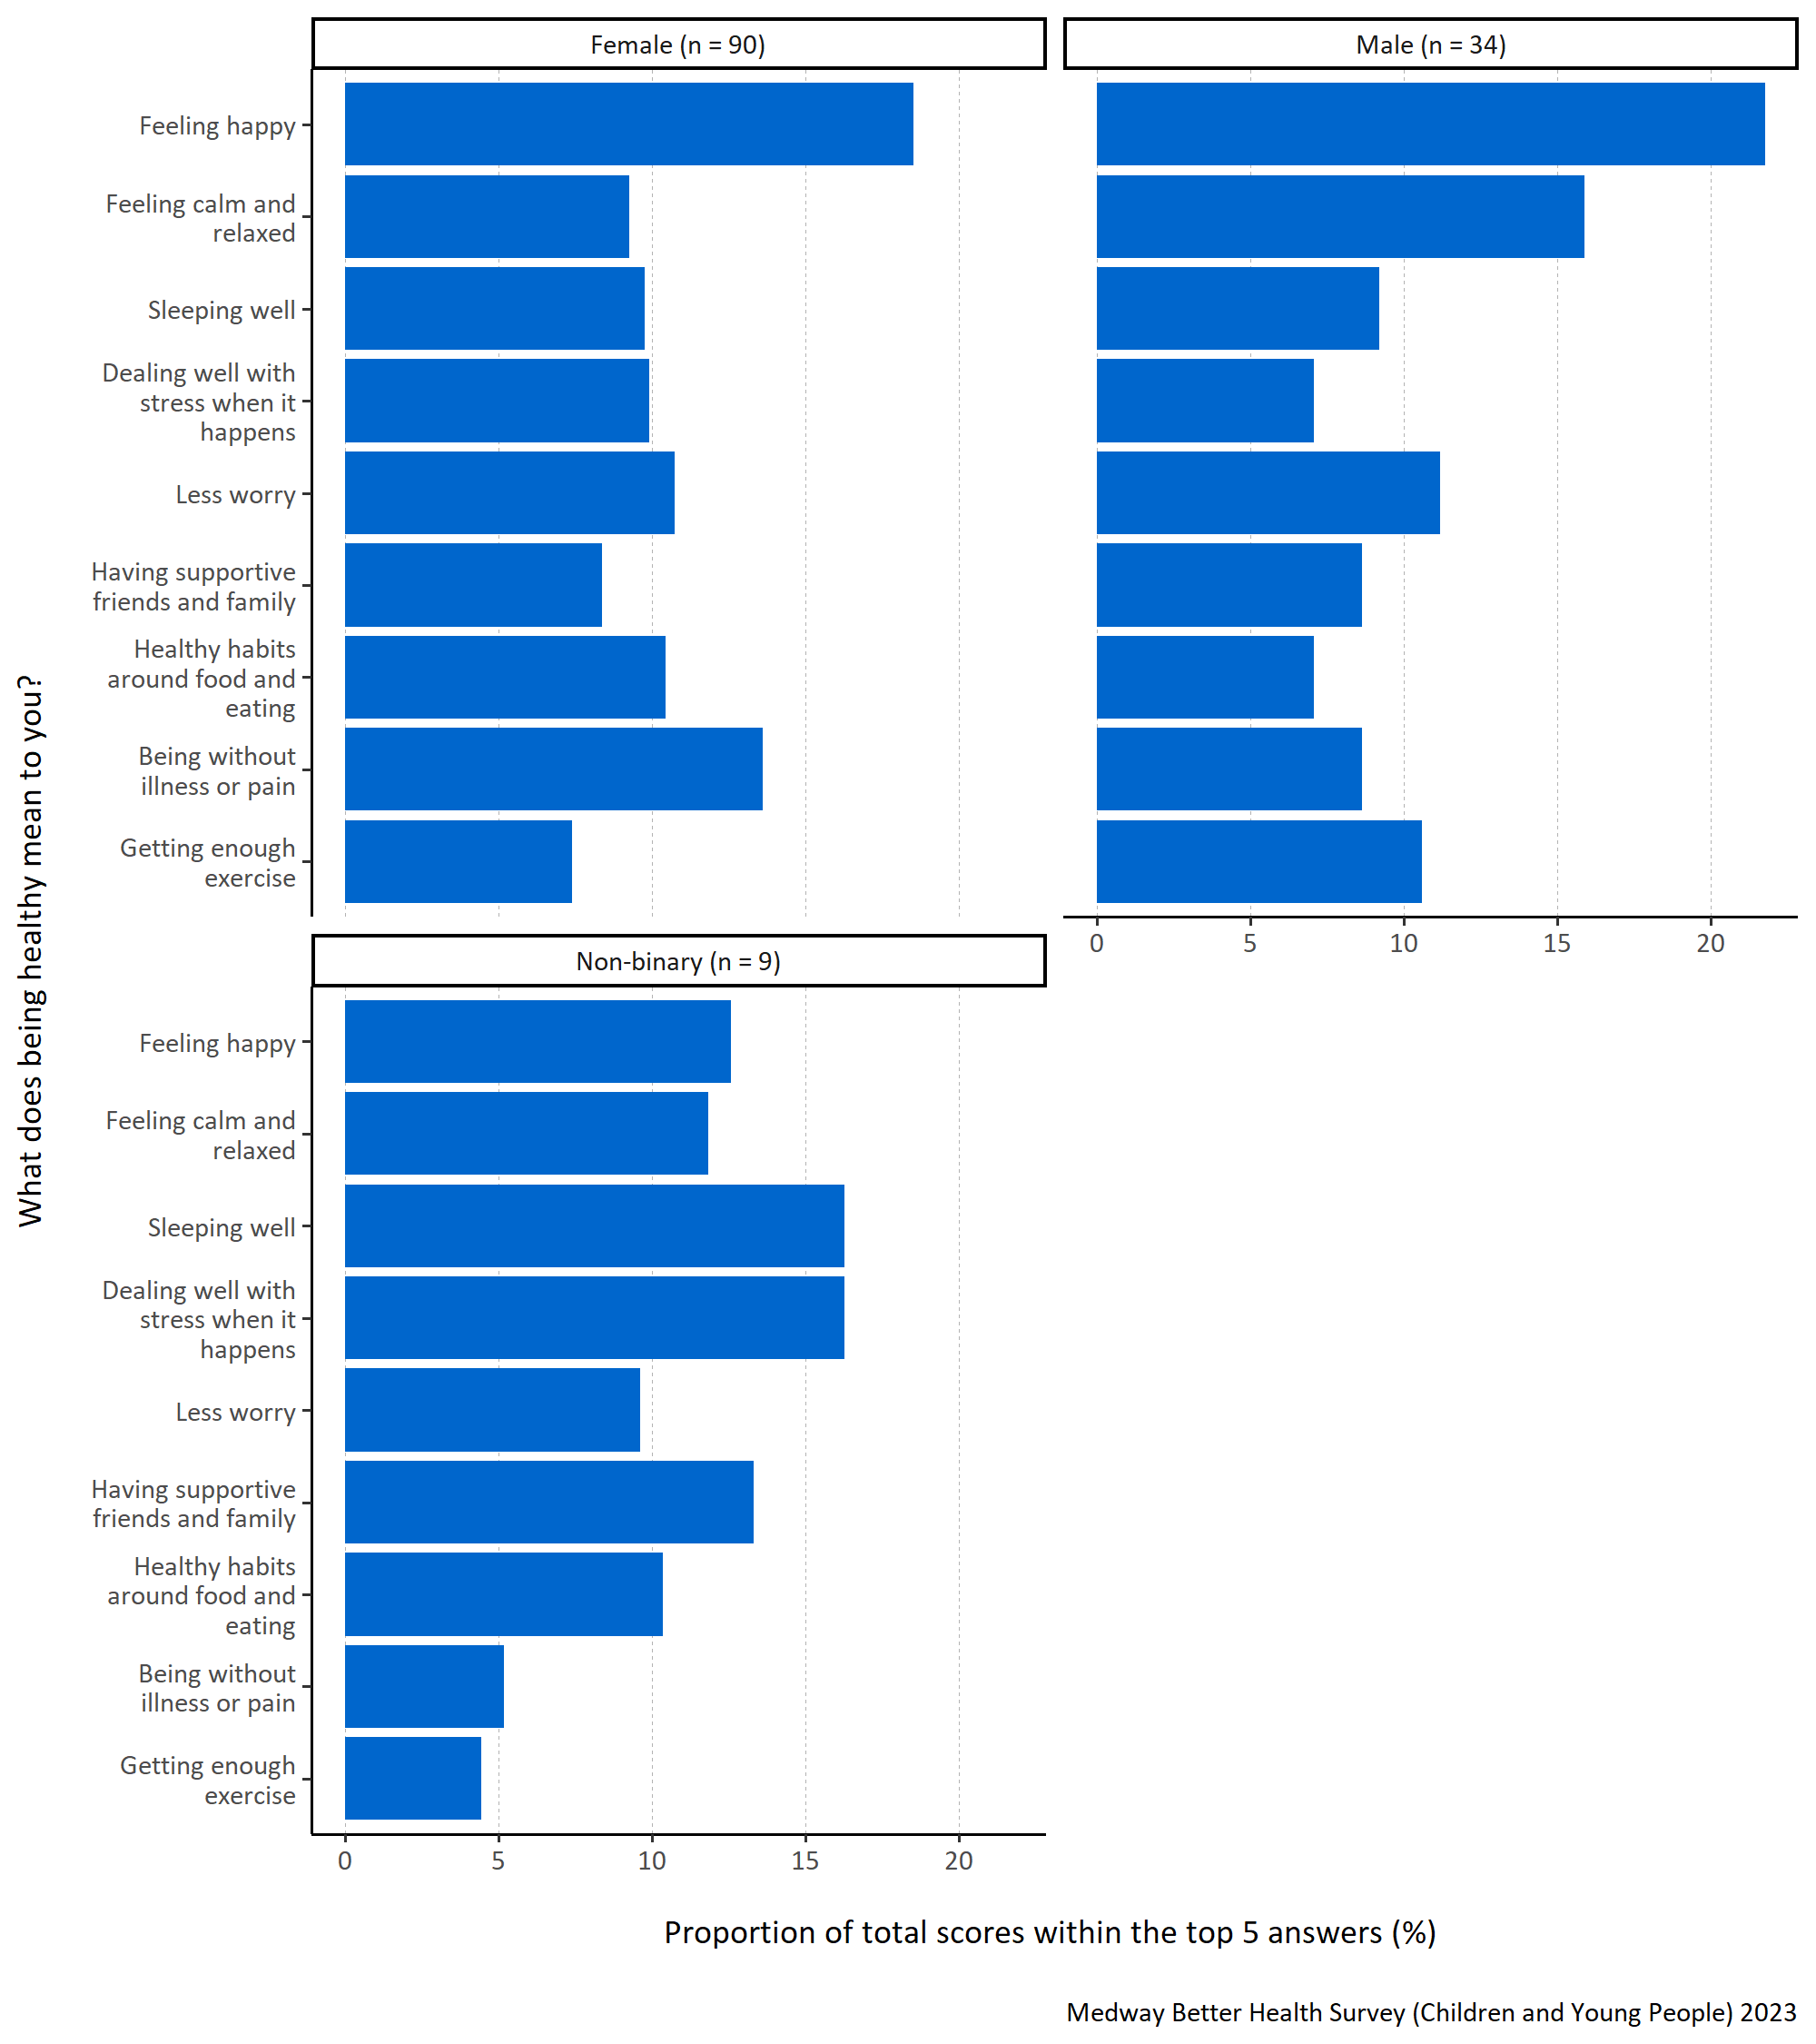
Figure 6: Proportion of total scores within the top 5 answers for each specified healthy lifestyle factor by gender.
Figure 6 shows that ‘feeling happy’ was most important for males and females who completed the survey. This was not the case for non-binary respondents, who favoured ‘sleeping well’ and ‘dealing well with stress when it happens’. Females also regarded ‘being without pain or illness’ as important whereas males favoured ‘feeling calm and relaxed’ and non-binary respondents favoured ‘having supportive friends and family’.
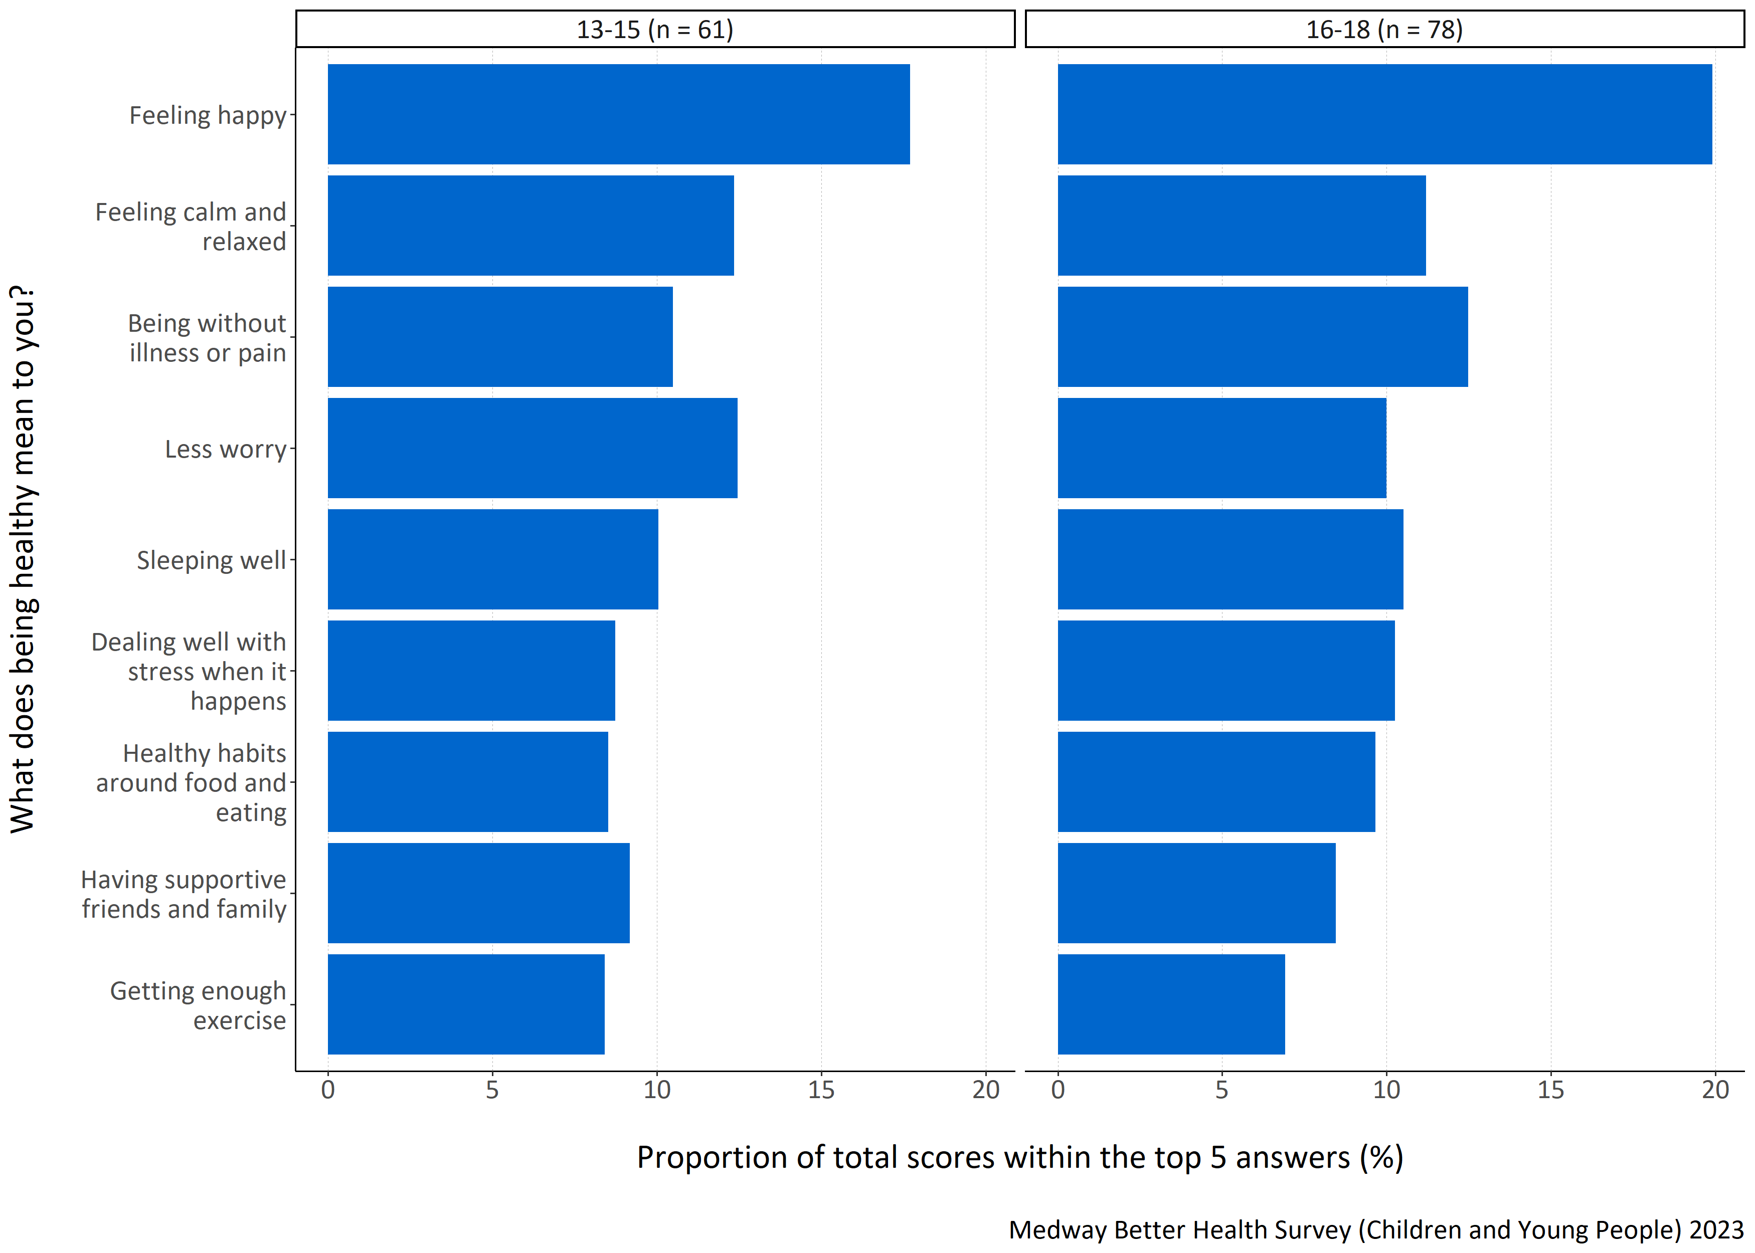
Figure 7: Proportion of total scores within the top 5 answers for each specified for each specified healthy lifestyle factor by age group in years.
Figure 7 shows that ‘feeling happy’ was considered most important when defining good health regardless of age. Younger age groups (13-15 years old) also thought ‘feeling calm and relaxed’ and ‘less worry’ to be important whereas older age groups (16-18 years old) favoured ‘being without illness or pain’.
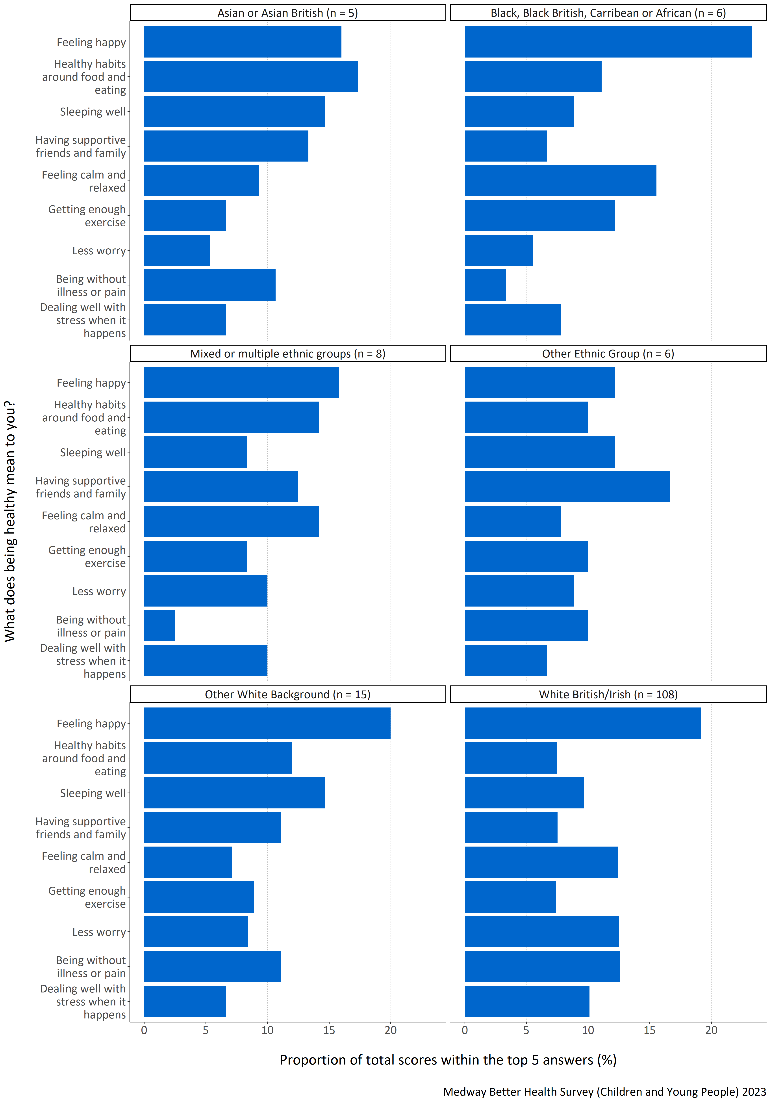
Figure 8: Proportion of total scores within the top 5 answers for each specified healthy lifestyle factor by ethnicity.
Figure 8 shows that respondents identifying as Black, Black British, Caribbean or African, mixed or multiple ethnic groups, White British/Irish, and other White background, considered ‘feeling happy’ to be most important when defining good health. For respondents identifying with other ethnic groups, ‘having supportive friends and family’ was most important, while Asian or Asian British respondents most favoured ‘healthy habits around food and eating’. That said, ‘feeling happy’ was also thought of as important to Asian or Asian British respondents. The responses ‘healthy habits around food and eating’ and ‘sleeping well’ were considered important for respondents in the other White background’ and other ethnic group categories. For White British/Irish respondents, ‘less worry’, ‘being without illness or pain’ and ‘feeling calm and relaxed’ were also favoured.
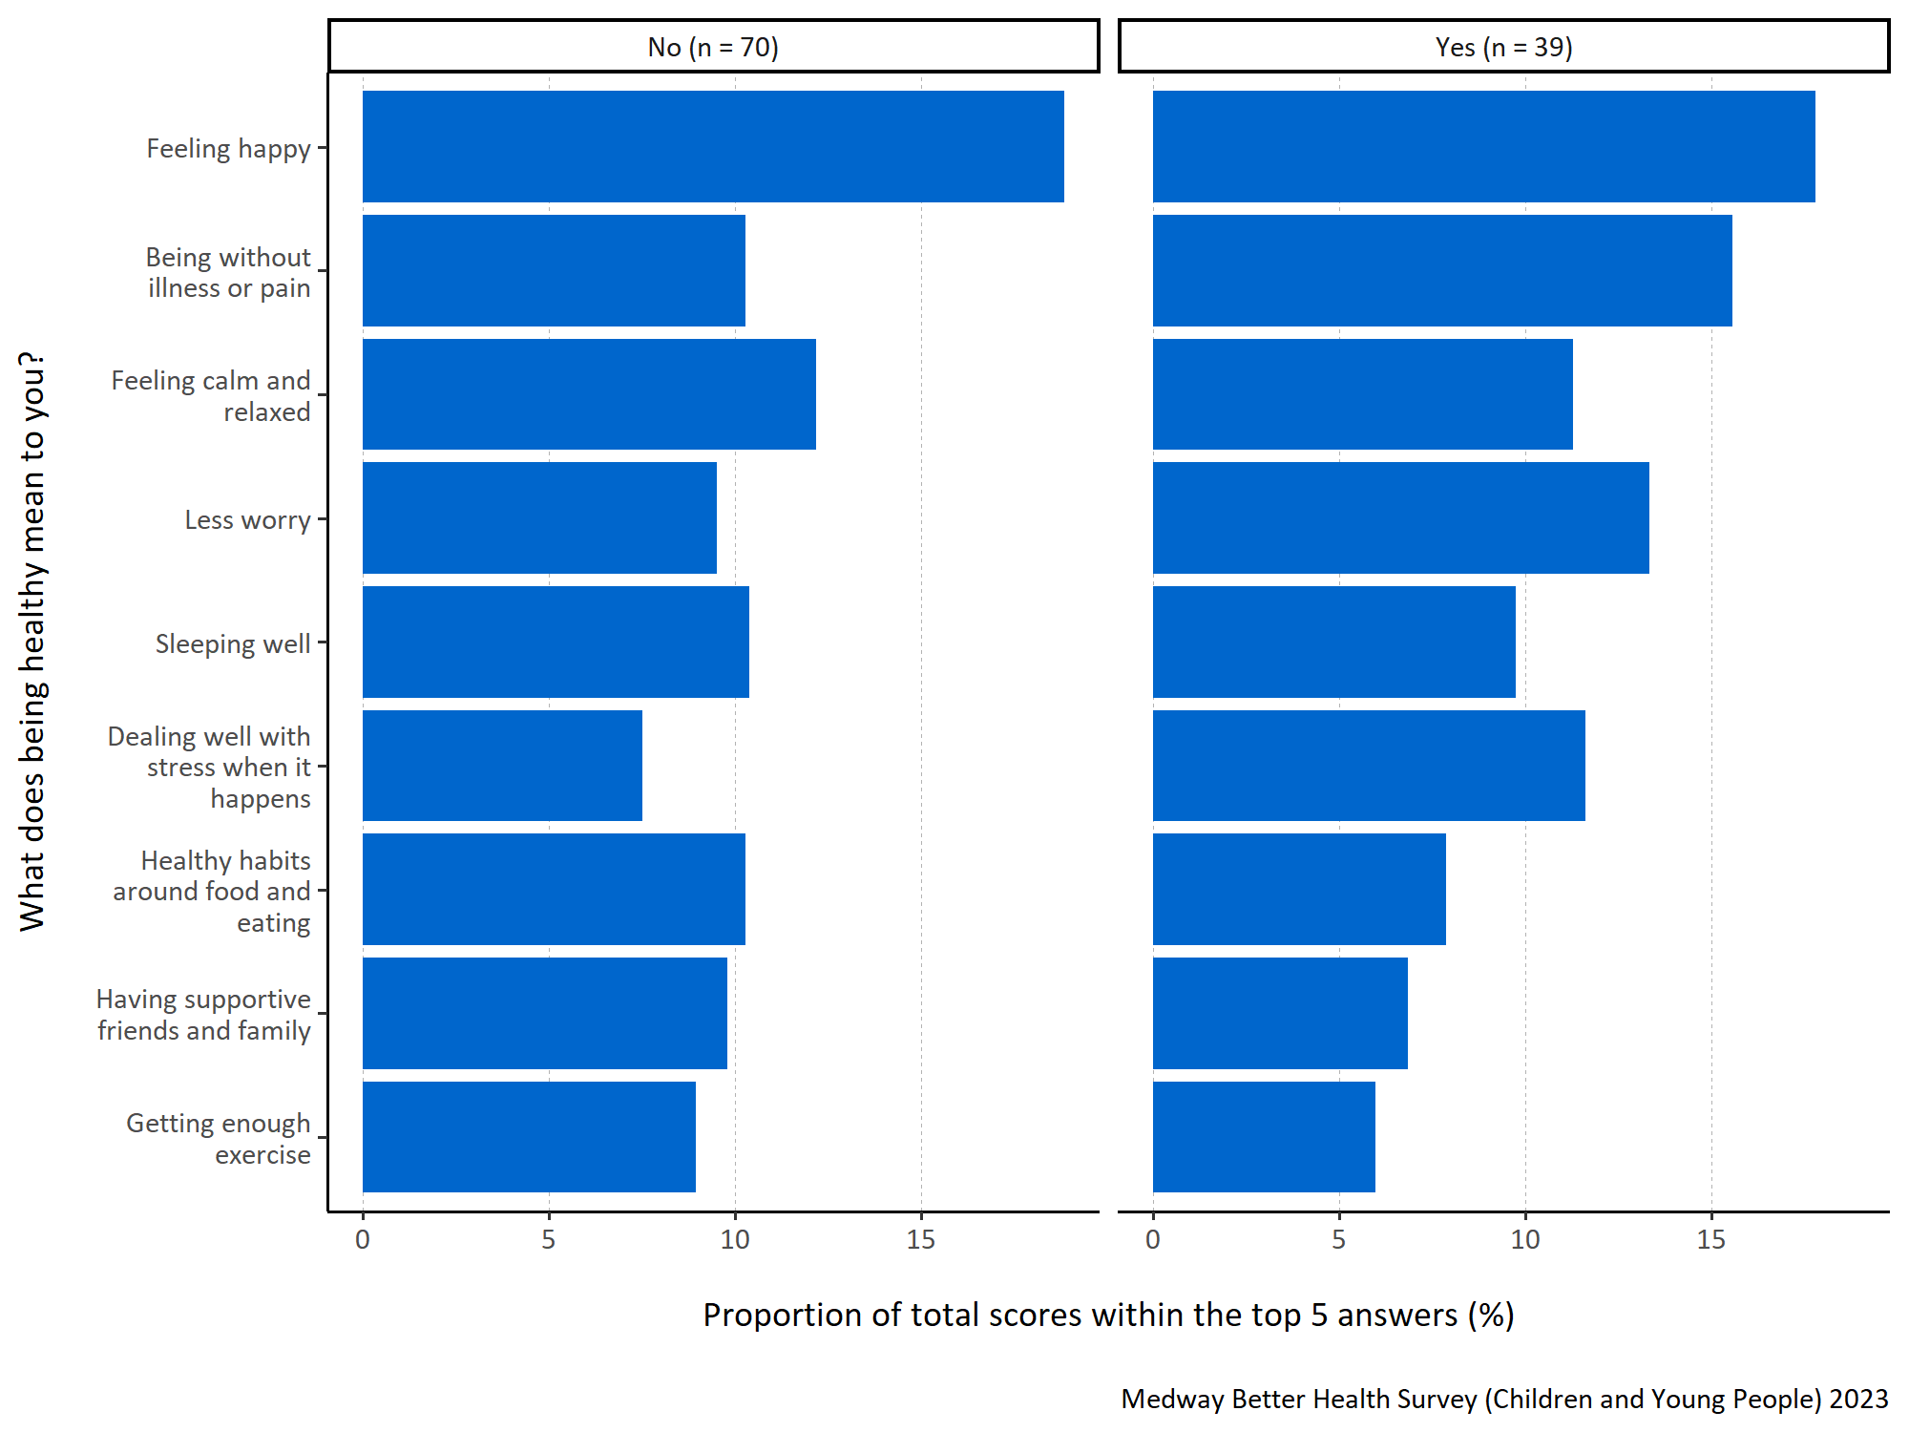
Figure 9: Proportion of total scores within the top 5 answers for each specified healthy lifestyle factor by long term physical or mental health conditions.
Figure 9 shows that ‘feeling happy’ was considered most important when defining good health regardless of whether the child or young person had a long term physical or mental health condition.
Additionally, the responses ‘being without illness or pain’, ‘less worry’, ‘dealing well with stress when it happens’ and ‘feeling calm and relaxed’ were deemed important.

How do children and young people in Medway manage difficult emotions
Question: What helps you to manage difficult emotions (things like low mood, worry, anger, stress, sadness, fear, jealousy, feeling anxious)? Please number in order of importance, with 1 being ‘most important’.
- Listening to music
- Sleeping
- Socialising
- Participating in sport or other physical activity
- Doing something create (for example, art, writing, poetry, drama, playing music, etc.)
- Watching TV or films
- Chatting to friends or family
- Eating
- Using social media
- Using technology (like playing computer games)
- Using online self-help Apps
- Practising mindfulness meditation
- I don’t usually do anything.
Survey participants were asked to prioritise and rank what they thought to be the most important things that they do to manage their ‘difficult emotions’. They were instructed to assign a number for the thirteen response options from 1 to 13 to indicate the level of importance, with 1 representing the most significant priority.
To analyse this question, the top five responses were selected for each participant and assigned a score ranging from one to five, with five indicating the highest-ranked response. These scores were then combined to calculate a total score for each response. To determine the importance of each response within the top five, the total score for each response was divided by the sum of the total scores for all the responses in the top five. This calculation produced a proportion. The higher the proportion, the more likely the response was consistently placed and/or frequently ranked highly within the top five responses.
In figures 10 to 14 all the responses shown appear in the top five for at least one participant. A higher proportion indicates that response is more important to children and young people in Medway when asked to consider what helps them manage difficult emotions.
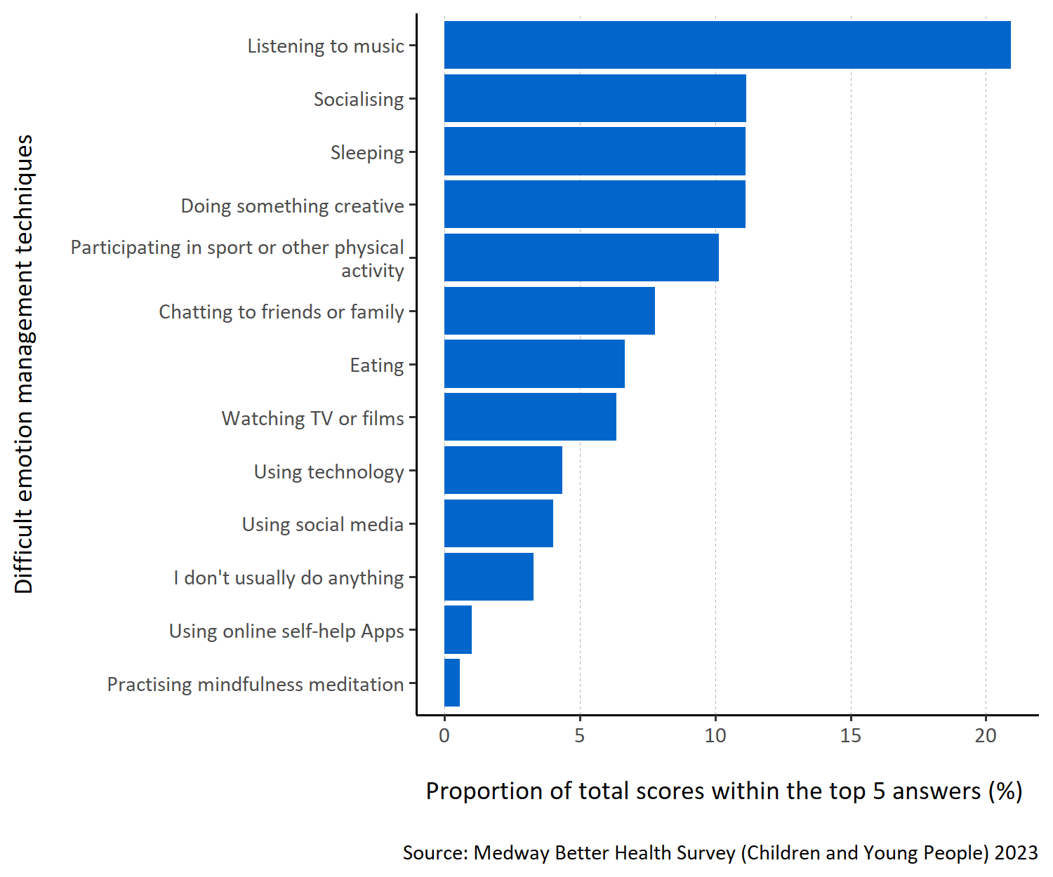
Figure 10: Proportion of total scores within the top 5 answers for each specified difficult emotion management technique.
Figure 10 shows that children and young people in Medway report ‘listening to music’ most helps them manage difficult emotions. Respondents also considered ‘socialising’, ‘participating in sport or other physical activity’, ‘sleeping’ and ‘doing something creative’ to be important methods.
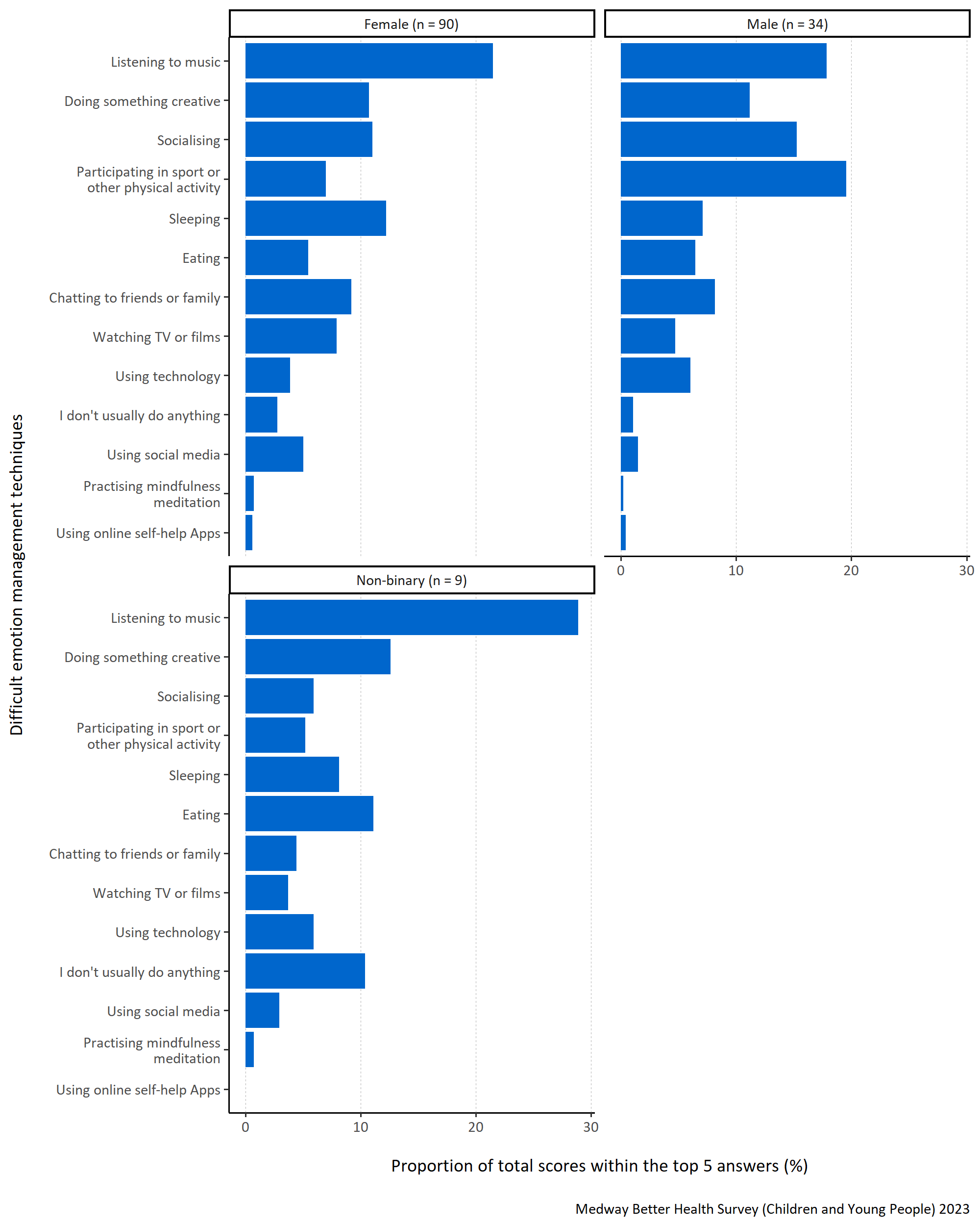
Figure 11: Proportion of total scores within the top 5 answers for each specified difficult emotion management technique by gender.
Figure 11 shows that ‘listening to music’ was used by non-binary and female respondents to manage difficult emotions. Although male respondents also favoured ‘listening to music’, they considered ‘participating in sport or other physical activity’ to be most important. ‘Using online self-help Apps’ was not placed in the top five rankings by any respondents identifying as non-binary.
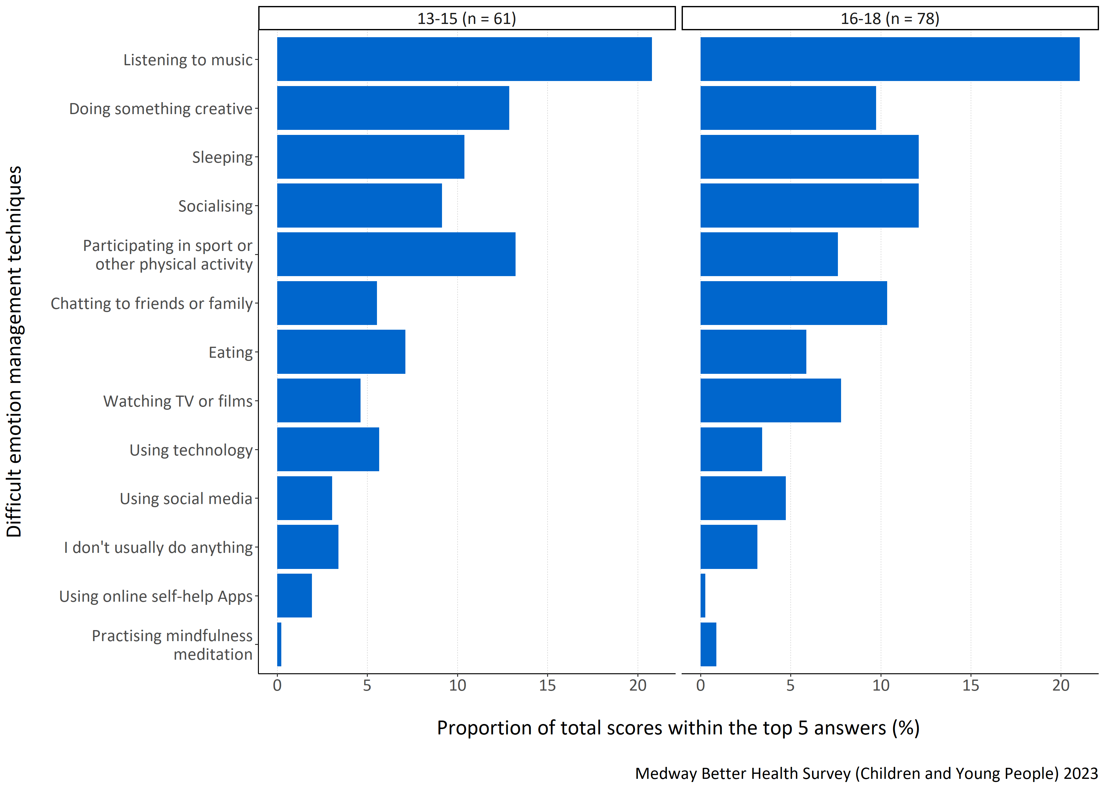
Figure 12: Proportion of total scores within the top 5 answers for each specified difficult emotion management technique by age group in years.
Figure 12 shows that ‘listening to music’ was the best way of managing difficult emotions for both the 13-15 and 16-18 year old respondents. For respondents aged 13-15 years old, ‘participating in sport or other physical activity’ and ‘doing something creative’ were also considered important. For respondents aged 16-18 years old, ‘sleeping’, ‘socialising’, and ‘chatting to friends or family’ were favoured.
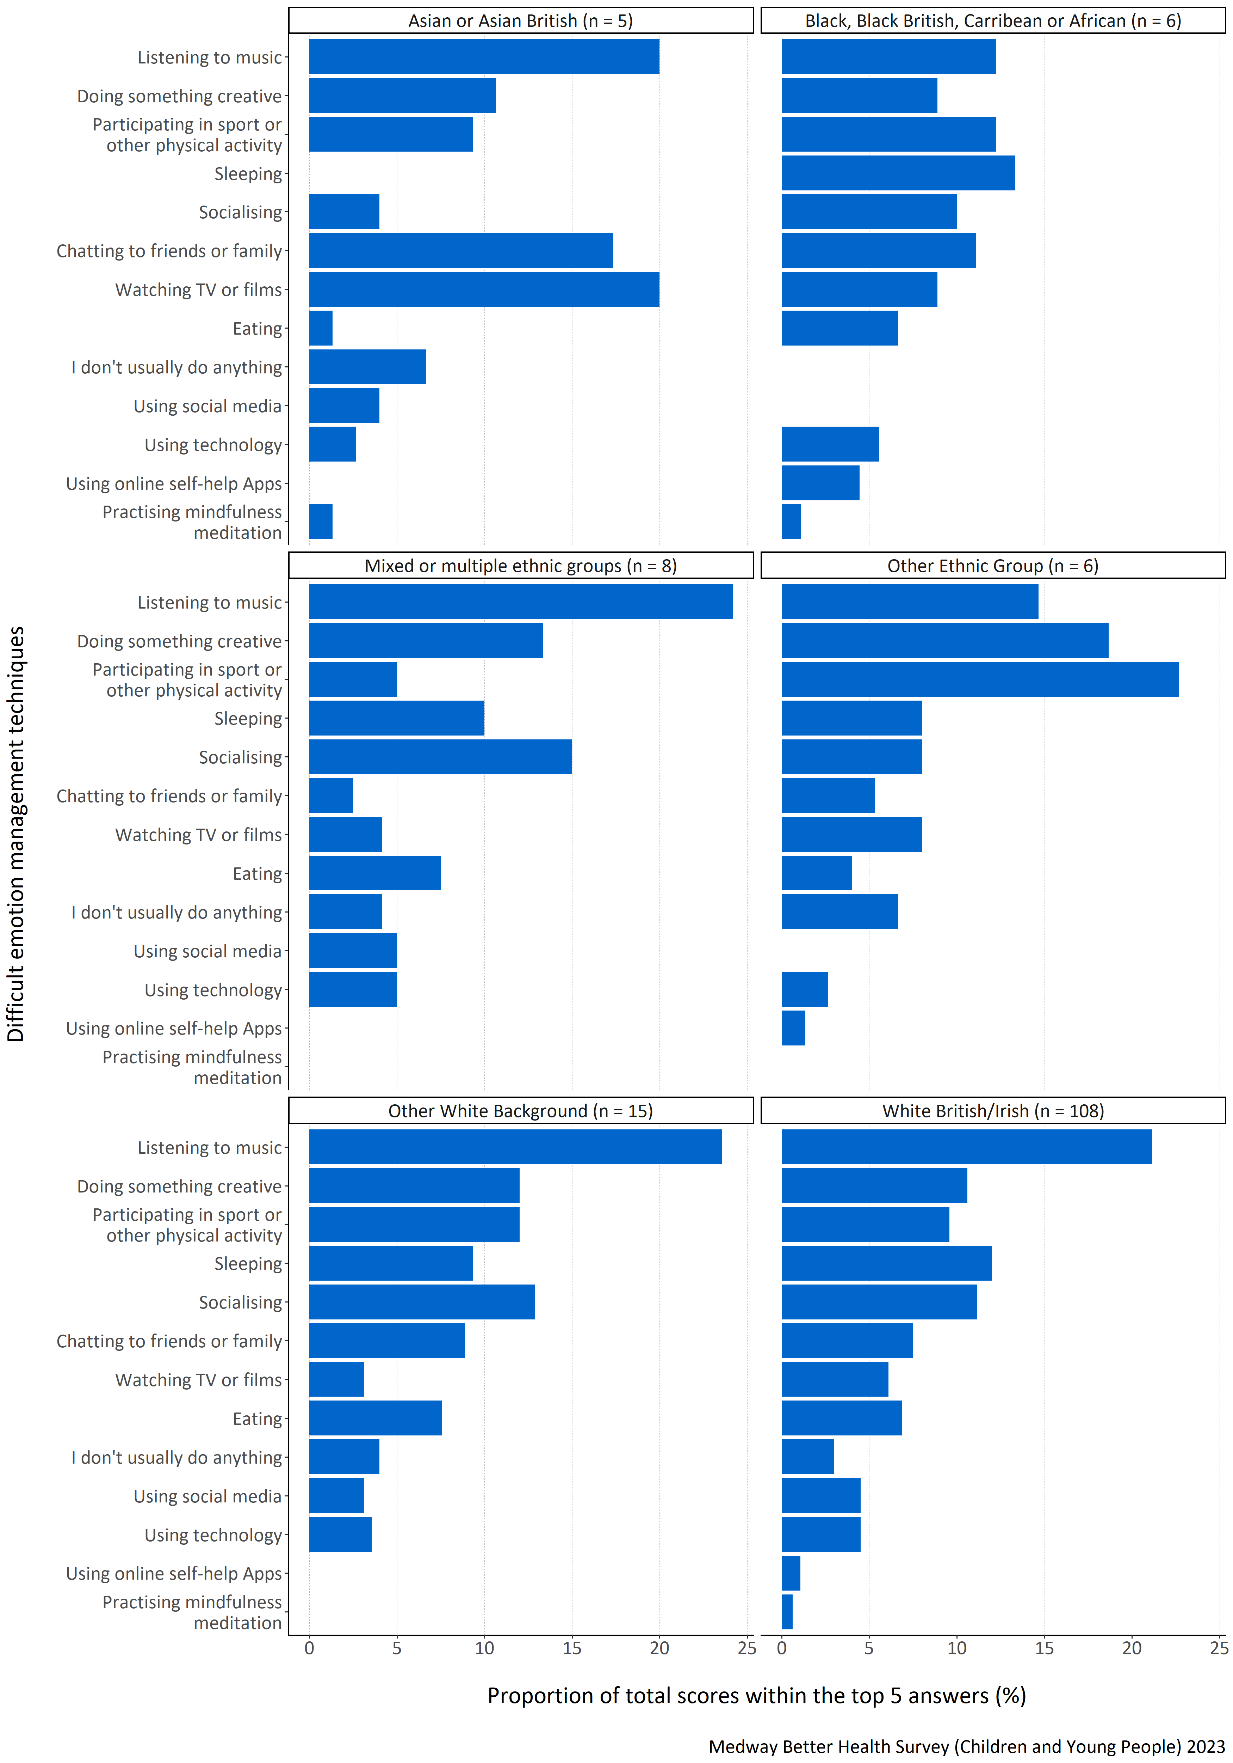
Figure 13: Proportion of total scores within the top 5 answers for each specified difficult emotion management technique by ethnicity.
Figure 13 presents the scores for respondents in the survey grouped up by ethnic background. ‘Listening to music’ was considered most important when managing difficult emotions amongst mixed or multiple backgrounds, other White backgrounds, White British/Irish, and Asian or Asian British ethnic groups. Respondents identifying as from another ethnic group in this survey most commonly placed ‘participating in a sport or other physical activity’ as most important.
The response option given lowest importance also varied by ethnic group. For example, ‘practising mindfulness meditation’ was given the lowest importance or not ranked at all in the top five choices by mixed or multiple ethnic groups, other ethnic groups, people from White British/Irish background and people from other White backgrounds. No respondents from Asian or Asian British backgrounds picked ‘sleeping’ or ‘using self-help Apps’ in their top five methods of managing difficult emotions, and no respondents from Black, Black British, Caribbean or African ethnic backgrounds picked ‘I don’t usually do anything’ or ‘using social media’. It is important to note that the number of respondents in all groups except White British/Irish was low and so these results must be interpreted with caution.
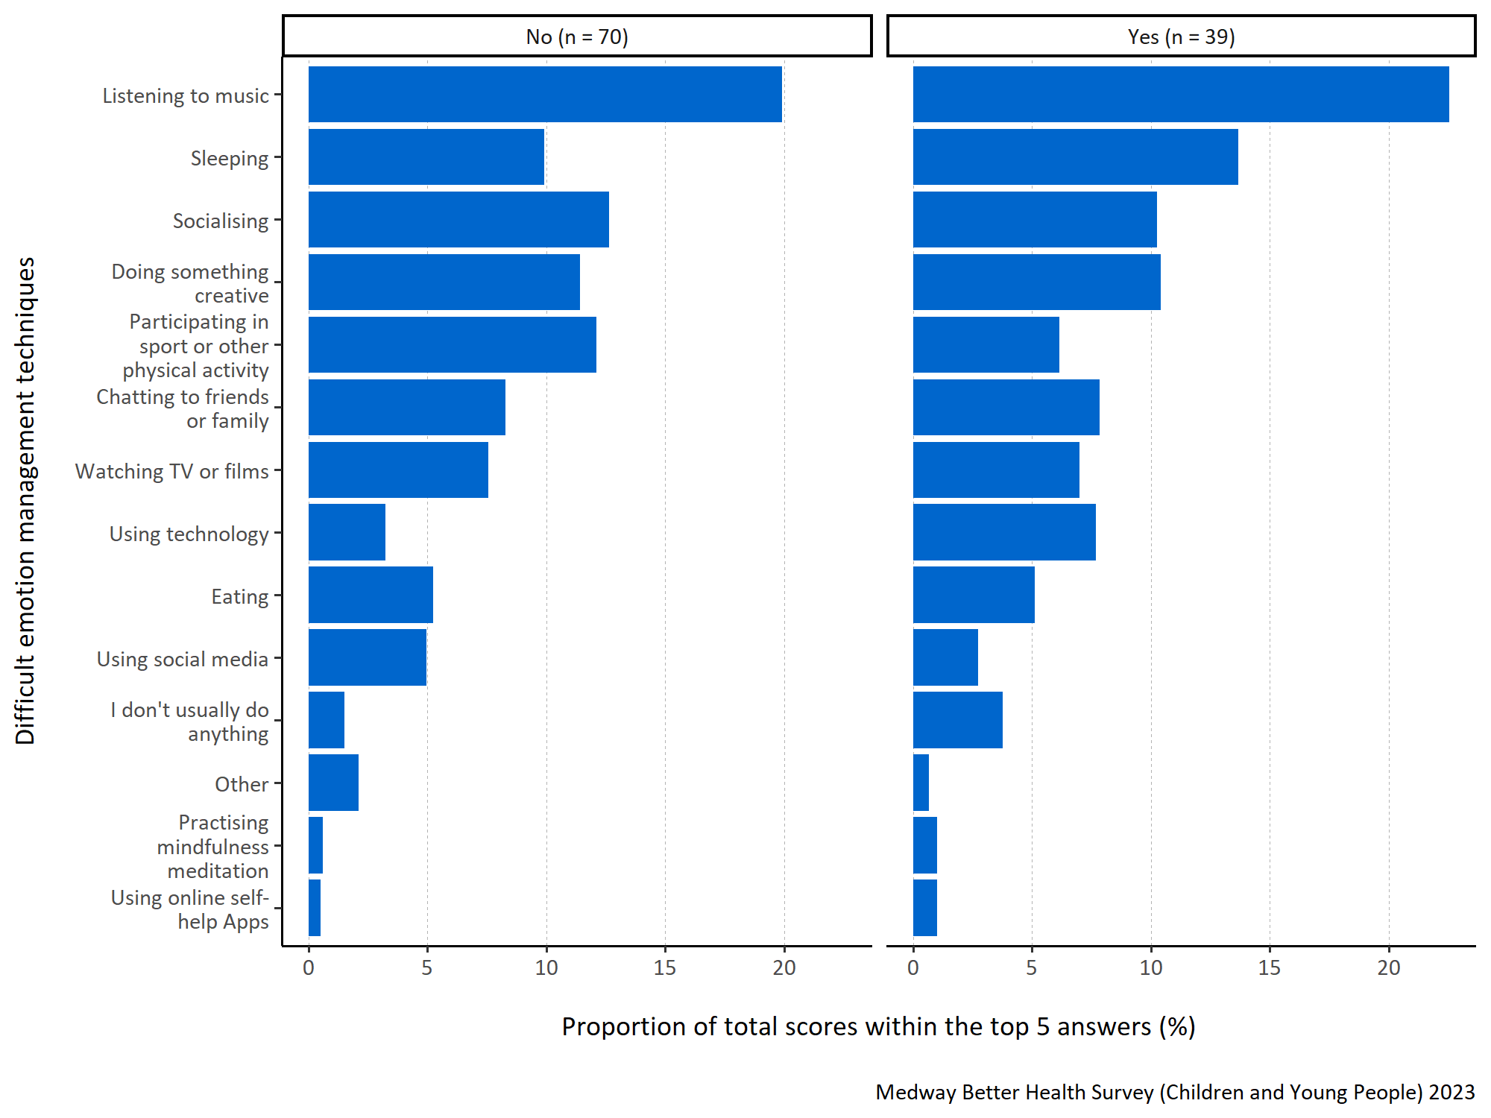
Figure 14: Proportion of total scores within the top 5 answers for each specified difficult emotion management technique by long term physical or mental health conditions.
Figure 14 shows that ‘listening to music is most important to respondents regardless of whether they report a long term physical or mental health condition. For respondents with a long term physical or mental health condition, ’sleeping’ was also considered important. Although those without a long term health condition also considered ‘sleeping’ important, they reported that ‘socialising’, ‘doing something creative’ and ‘participating in sport or other physical activity’ as more important.

Who would children and young people in Medway go to if they needed support with difficult emotions
Question: Who would you go to if you felt you needed support with these emotions? Please number in order of importance, with 1 being ‘most important’.
Answer options:
- Friends
- Parent/care giver
- Other relative (for example, brother, sister, aunt, uncle, grandparent)
- Boyfriend/girlfriend
- Teacher
- Doctor/GP
- Extra-curricular activity teacher (for example, music teacher, sports coach, drama teacher)
- School Nurse
- Online/social media information or support
- Mentor or counsellor
- Scout or Guide leader
- Youth worker
- I don’t have anyone to go to.
Survey participants were asked to prioritise and rank who they thought to be the most important people in their lives to go to, to get support with managing their ‘difficult emotions’. They were instructed to assign a number for the thirteen response options from 1 to 13 to indicate the level of importance, with 1 representing the most significant priority.
To analyse this question, the top five responses were selected for each participant and assigned a score ranging from one to five, with five indicating the highest-ranked response. These scores were then combined to calculate a total score for each response. To determine the importance of each response within the top five, the total score for each response was divided by the sum of the total scores for all the responses in the top five. This calculation produced a proportion. The higher the proportion, the more likely the response was consistently placed and/or frequently ranked highly within the top five responses.
In figures 15 to 19 all the responses shown appear in the top five for at least one participant. A higher proportion indicates that children and young people in Medway are more likely to go to that option if they felt they needed support with difficult emotions.
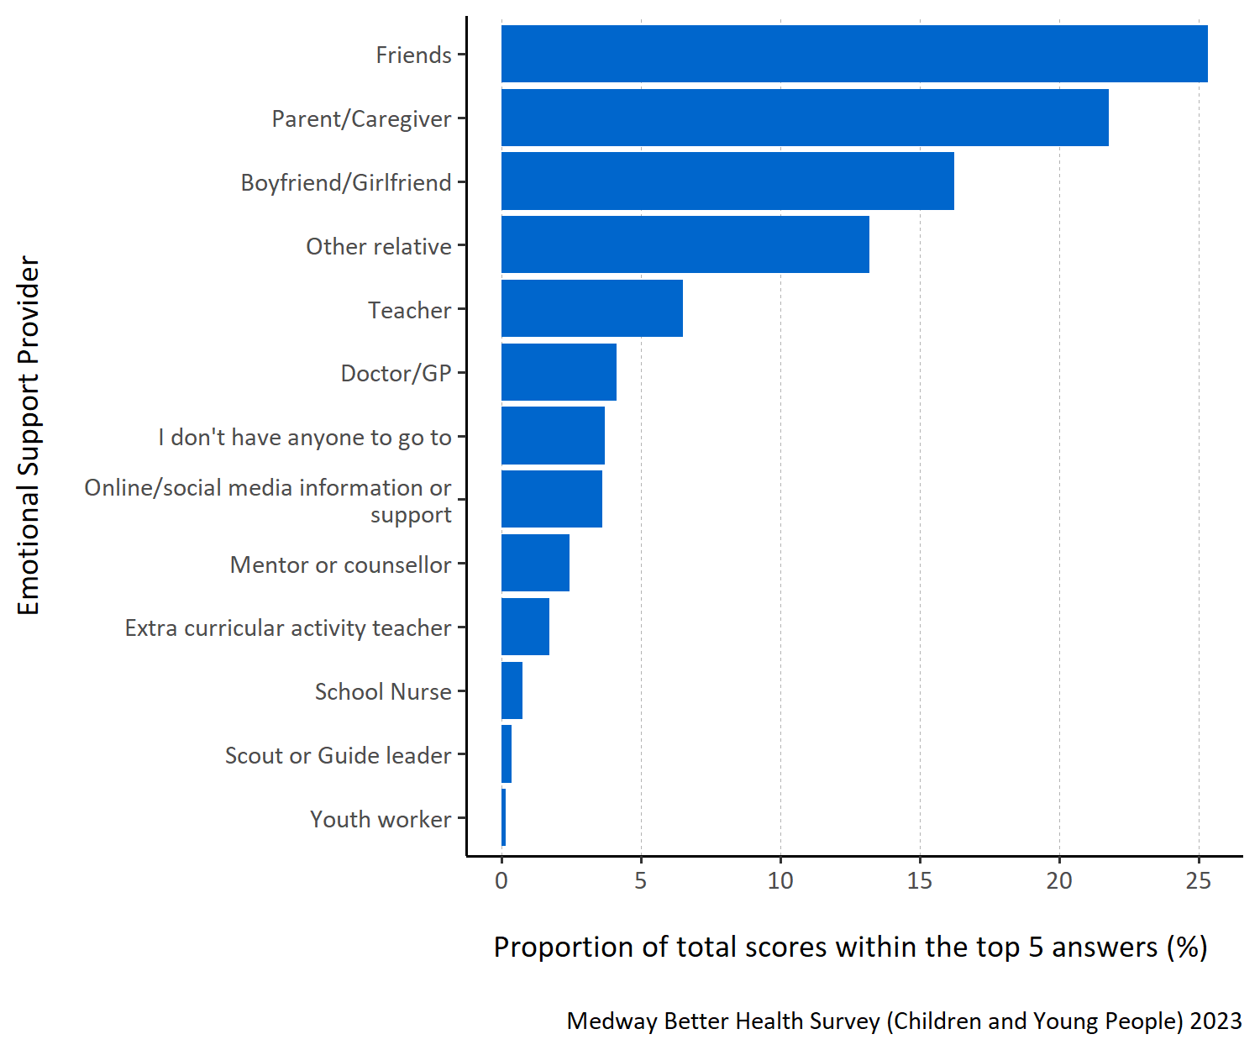
Figure 15: Proportion of total scores within the top 5 answers for each specified emotional support provider.
Figure 15 shows that children and young people in Medway are most likely to go to ‘friends’ if they feel like they need support with their emotions. They also favoured going to a ‘parent/caregiver’ their ‘boyfriend/girlfriend’ and an ‘other relative’.
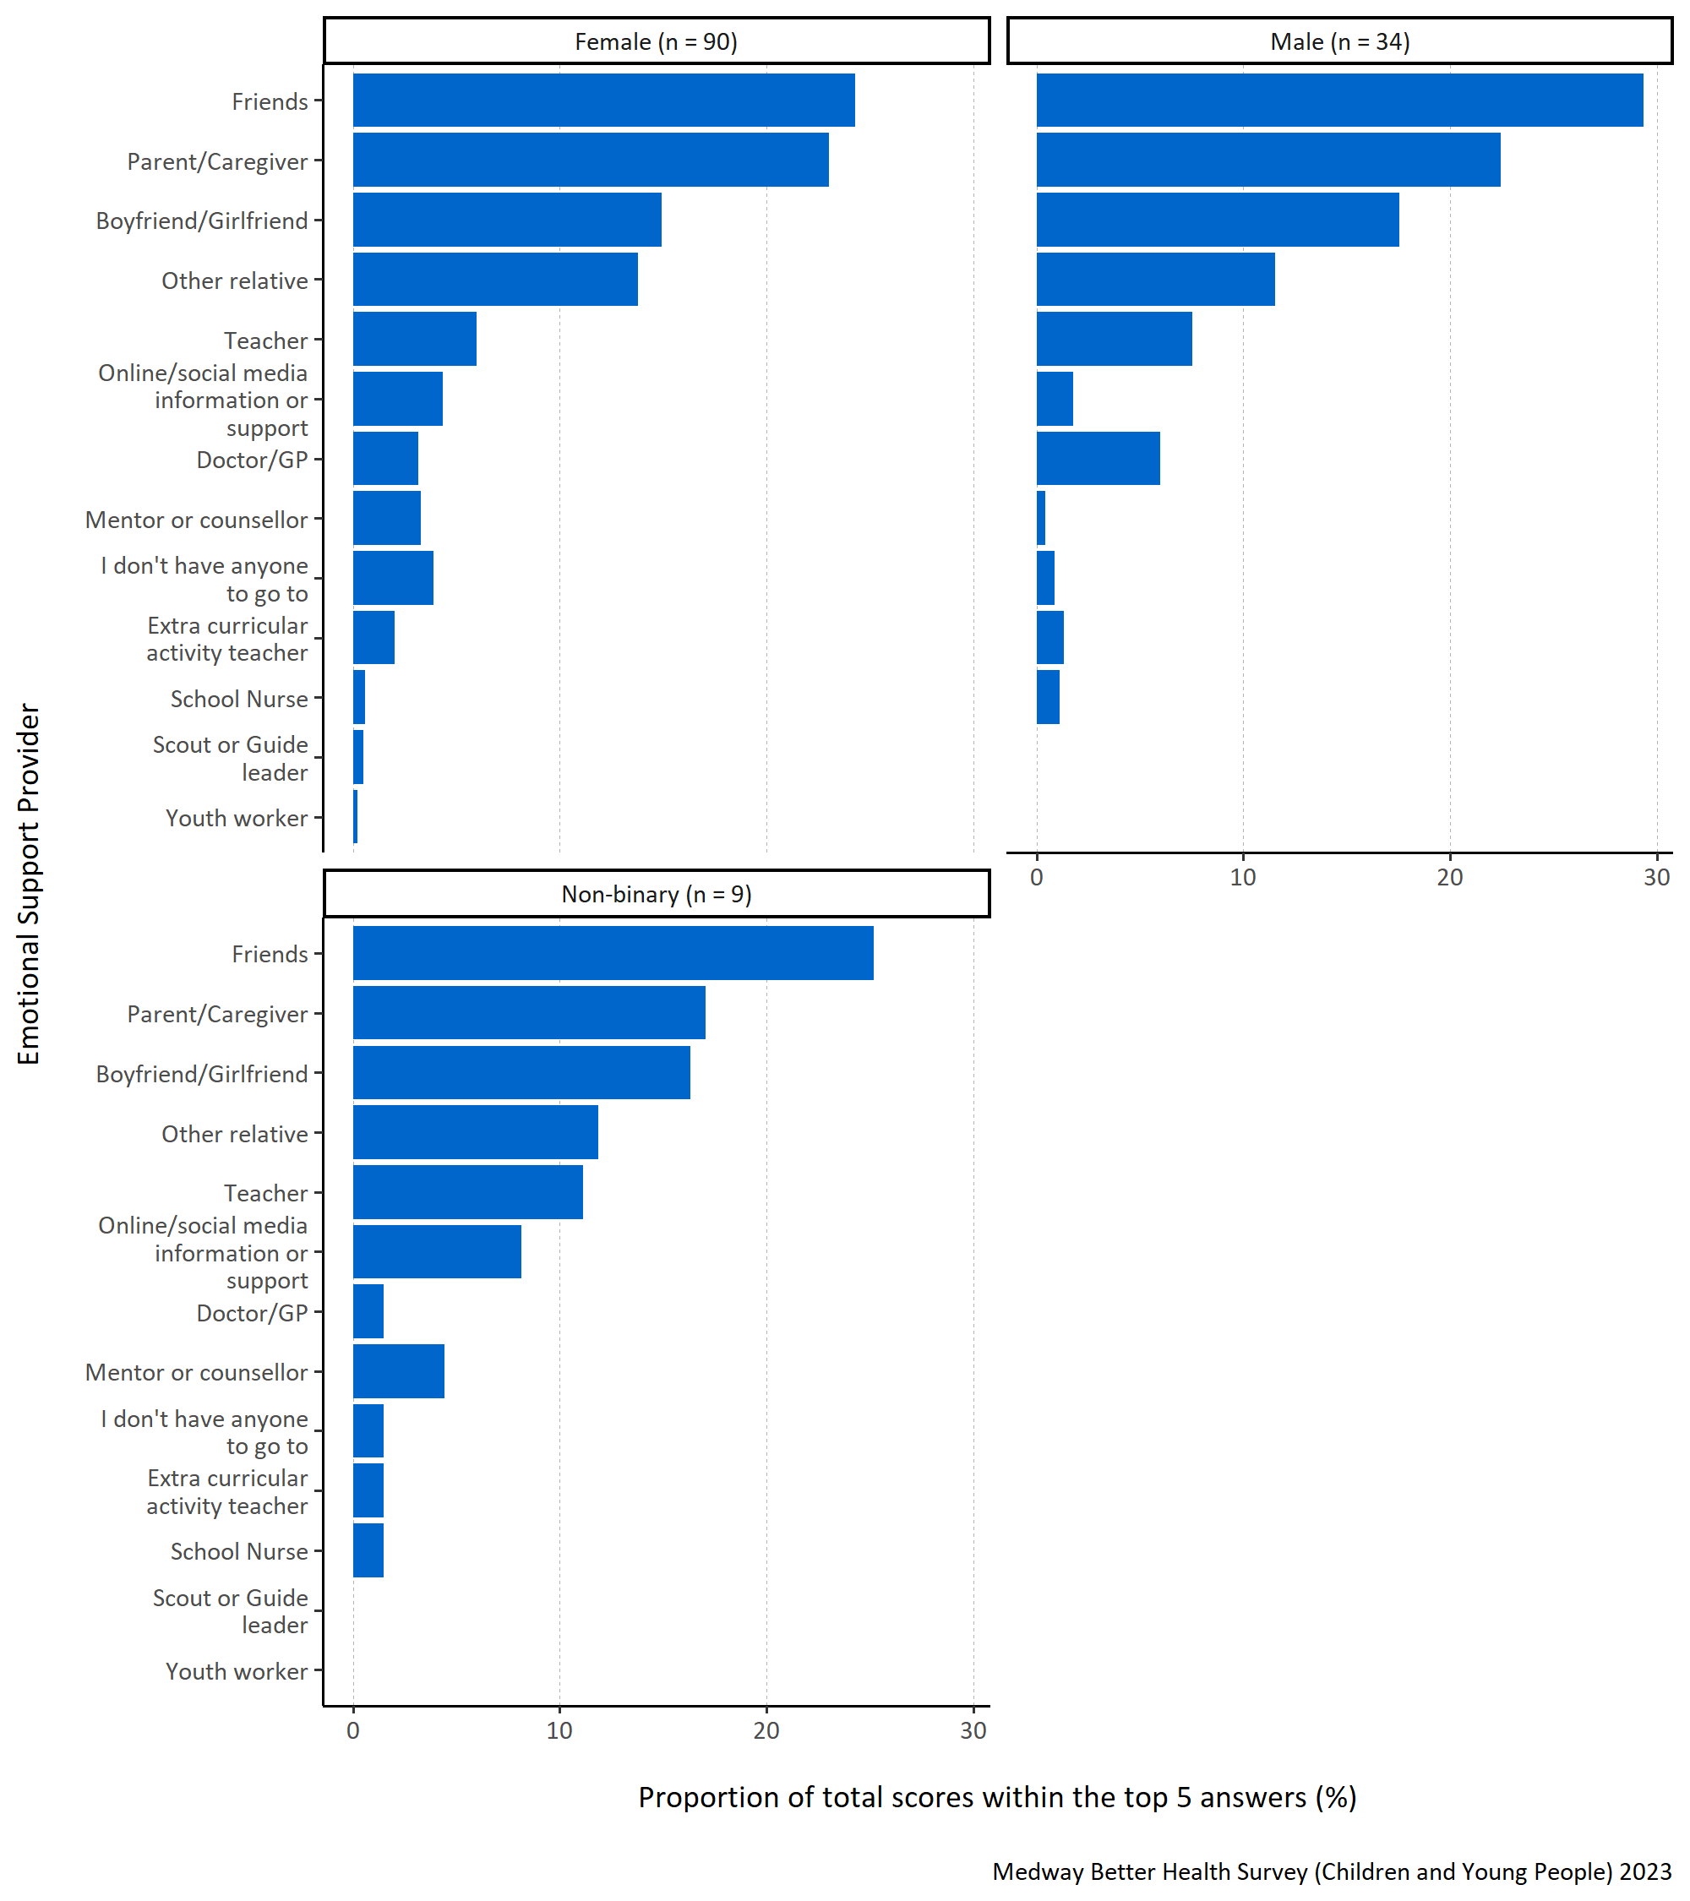
Figure 16: Proportion of total scores within the top 5 answers for each specified emotional support provider by gender.
Figure 16 shows that male, non-binary, and female respondents are most likely to seek out ‘friends’. Additionally, respondents were likely to go to a ‘parent/caregiver’ or ‘boyfriend/girlfriend’. ‘Scout or Guide leader’ and ‘youth worker’ were not placed in the top five rankings by any male respondents or by any respondents that identified as non-binary. It should be noted that there are a small number of non-binary respondents and so caution must be taken when interpreting these data.
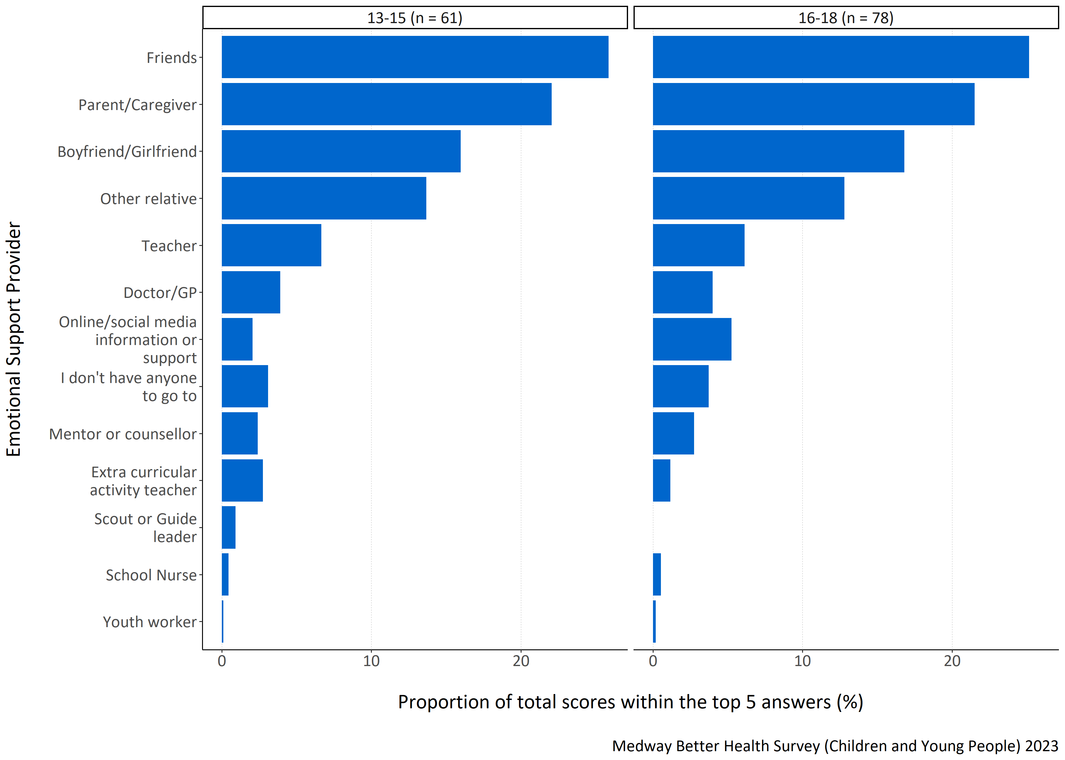
Figure 17: Proportion of total scores within the top 5 answers for each specified emotional support provider by age group in years.
Figure 17 shows that both 13-15 and 16-18 year old respondents are most likely to go to ‘friends’ when they feel they need support with difficult emotions. They are also likely to go to a ‘parent/caregiver’, ‘boyfriend/girlfriend’ or an ‘other relative’. No respondent aged 16-18 years old would go to a ‘Scout or Guide leader’.
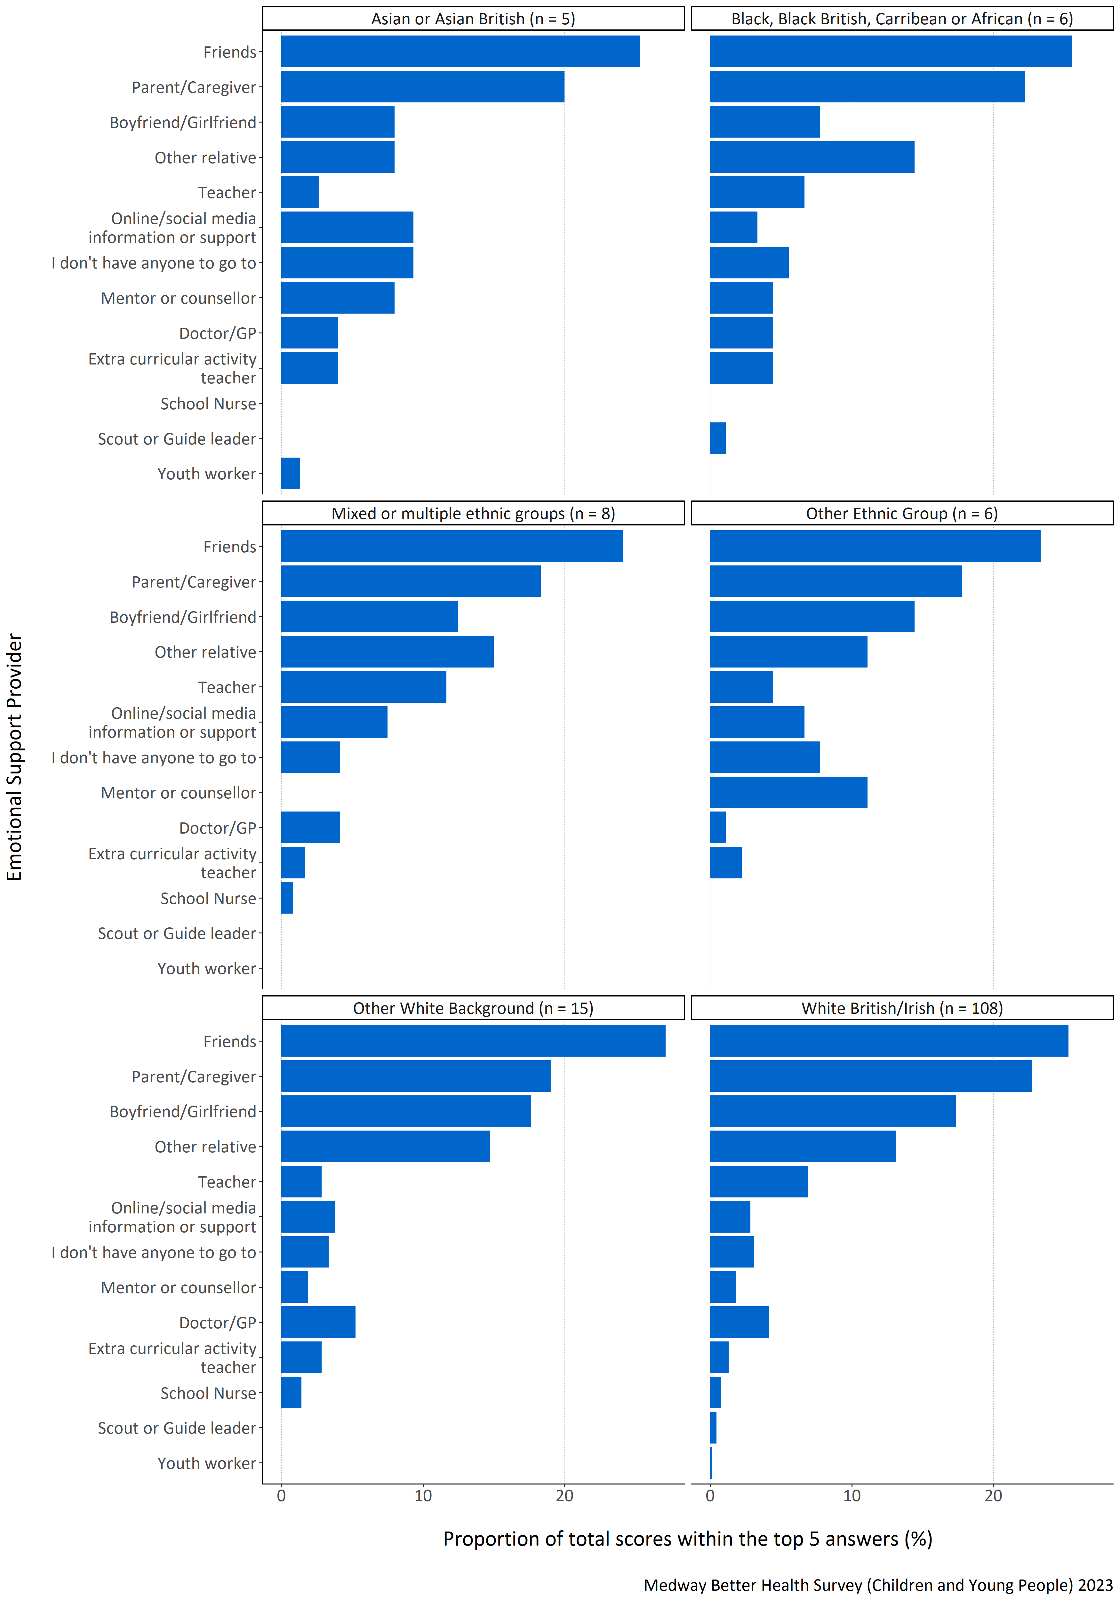
Figure 18: Proportion of total scores within the top 5 answers for each specified emotional support provider by ethnicity.
Figure 18 shows that respondents from all ethnic groups were most likely to go to ‘friends’ if they felt they needed support with difficult emotions with the next most likely being their ‘parent/caregiver’. White British/Irish, other White background, mixed or multiple ethnic groups, and other ethnic group respondents were also likely to go to their ‘boyfriend/girlfriend’, or an ‘other relative’. ‘Scout or Guide leader’ and ‘Youth Worker’ responses weren’t included in the top 5 most important emotional support providers by respondents identifying with mixed or multiple ethnic groups, other ethnic groups and other White backgrounds. Additionally, other ethnic group respondents did not include ‘school nurse’ in their top five, and mixed or multiple ethnic group respondents did not include ‘mentor or counselor’ in their top five. Asian or Asian British respondents did not include ‘school nurse’ and ‘scout or guide leader’ in their top five, whilst Black, Black British, Caribbean or African respondents did not include ‘school nurse’ and ‘youth worker’.
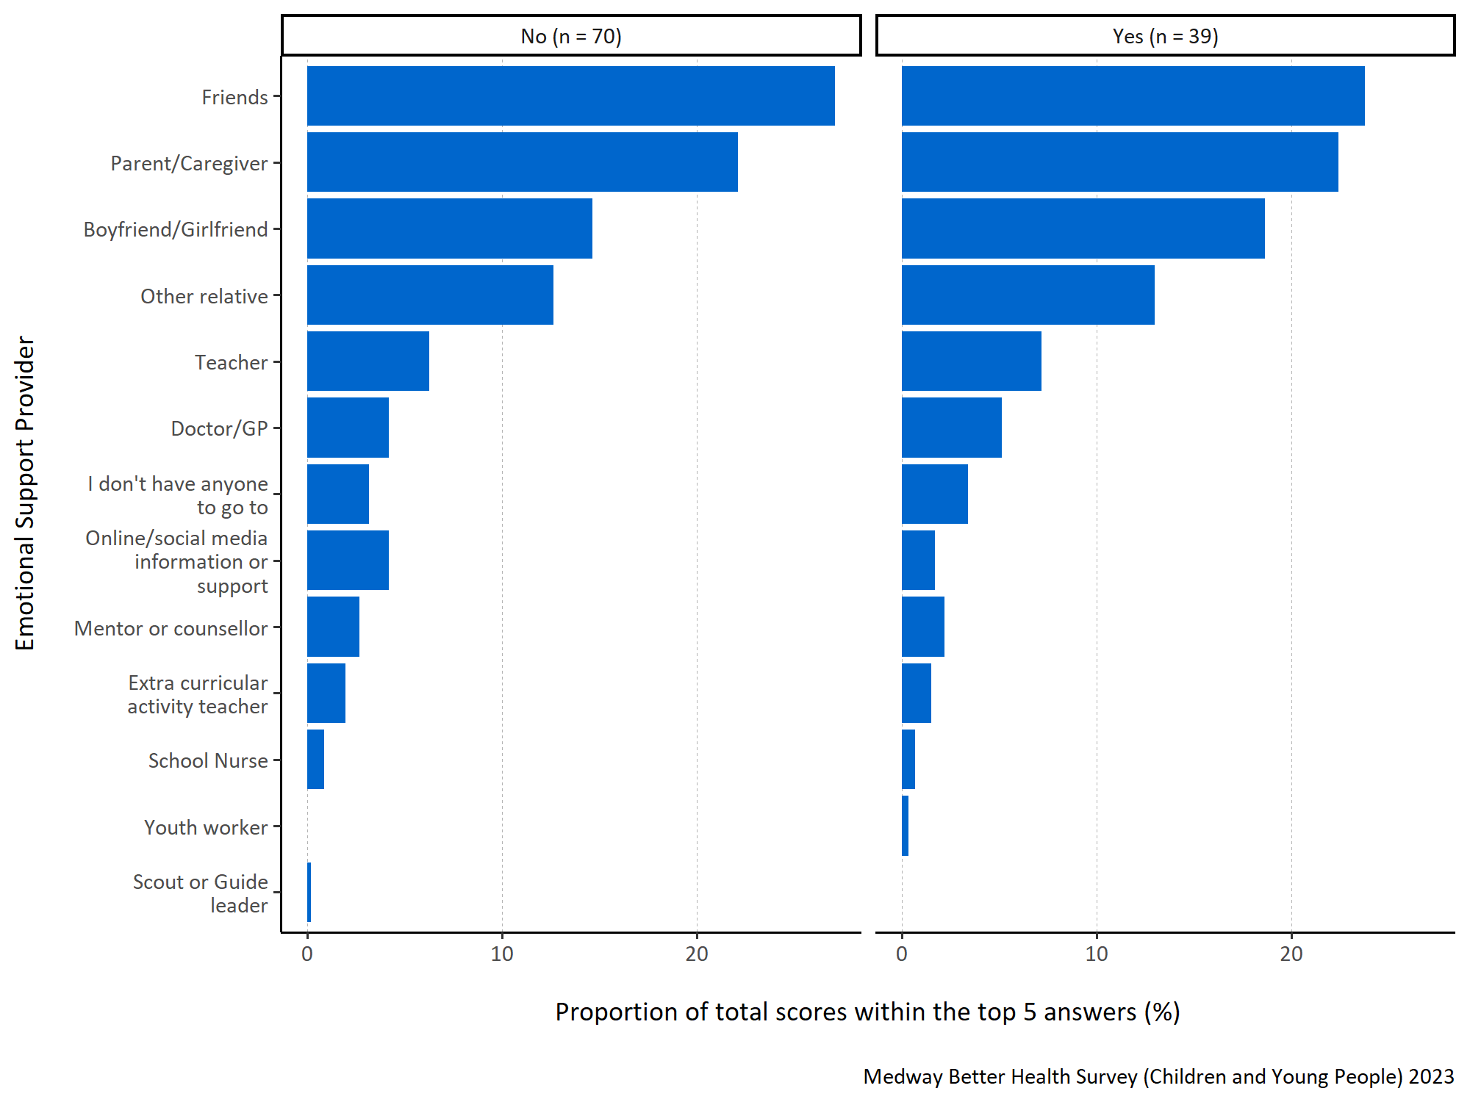
Figure 19: Proportion of total scores within the top 5 answers for each specified emotional support provider by long term physical or mental health conditions.
Figure 19 shows that regardless of whether the child or young person reported a long term physical or mental health condition, they were most likely to go to ‘friends’ for support with difficult emotions. This was also true for other likely options including a ‘parent/caregiver’, their ‘boyfriend/girlfriend’, or an ‘other relative’. ‘Scout or Guide leader’ was not included in the top five rankings by any respondents with a long term physical or mental health condition.

What children and young people in Medway think would improve their health and wellbeing
Question: In your opinion, which of the things listed below would help you to improve your health and wellbeing? Please tick all that apply.
Answer options:
- Doing more physical activities
- My family knowing more about how to cook healthy food
- Being able to spend more time socially with other people
- Better access to the internet
- Better access to public green spaces (like open green spaces and water in urban areas, including parks, playing fields, play areas, allotments and community gardens, woodland and more natural areas, canal paths and riversides).
- For society to tackle environmental issues (like climate change, pollution, traffic congestion)
- Help with managing things like asthma, diabetes, autism, attention deficit hyperactivity disorder (ADHD)
- Help with mental health needs, including anxiety and worry
- Help with managing physical disabilities
- Parenting support for my parent or care-giver
- Support for young people who are providing care for adults
- Support for young people who are providing care for their sibling(s) with special needs
- Better sexual health advice and support within school and the wider community.
Survey participants were asked to prioritise and rank what they thought to be the most important things that can be done to improve their health and wellbeing. They were instructed to assign a number for the thirteen response options from 1 to 13 to indicate the level of importance, with 1 representing the most significant priority.
The respondents were asked to identify what things (out of the answer options above) could help them improve their health and wellbeing. In this question, they could tick as many or as little response options as they wanted and the answers are presented here in Figures 20-23 as proportions of respondents selecting said answers.
A higher proportion indicates that response is more important to what children and young people in Medway think is important when considering what could be done to improve their health and wellbeing.
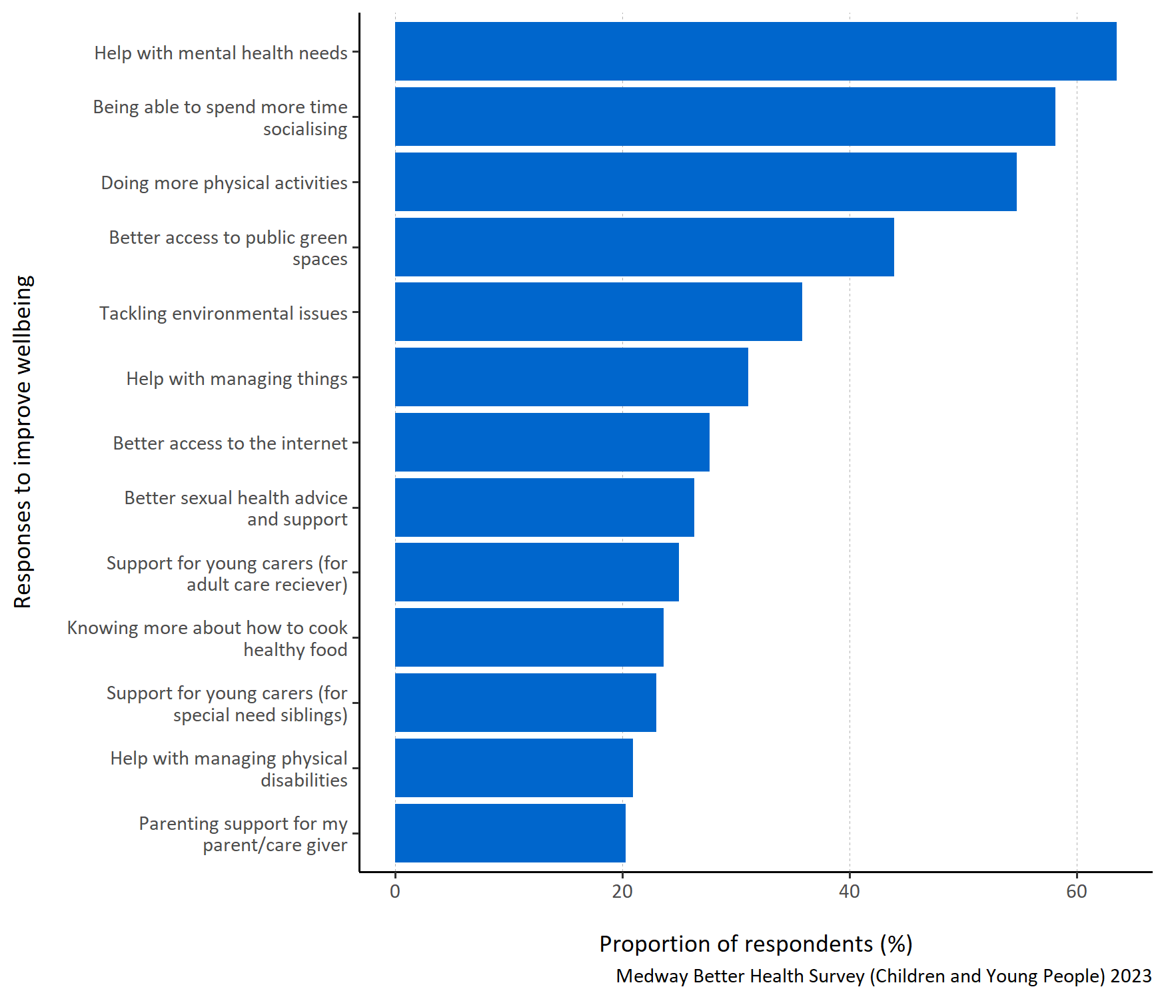
Figure 20: Proportion of respondents selecting each specified way to improve health and wellbeing.
Figure 20 shows that ‘Help with mental health needs’ was most commonly ticked by participants as being important for improving their health and wellbeing. ‘Being able to spend more time socialising’, ‘doing more physical activities’ and ‘better access to public green spaces’ were also commonly ticked by participants. ‘Parenting support for my parent/care giver’ is shown here to have received the lowest proportion of ticks from respondents.
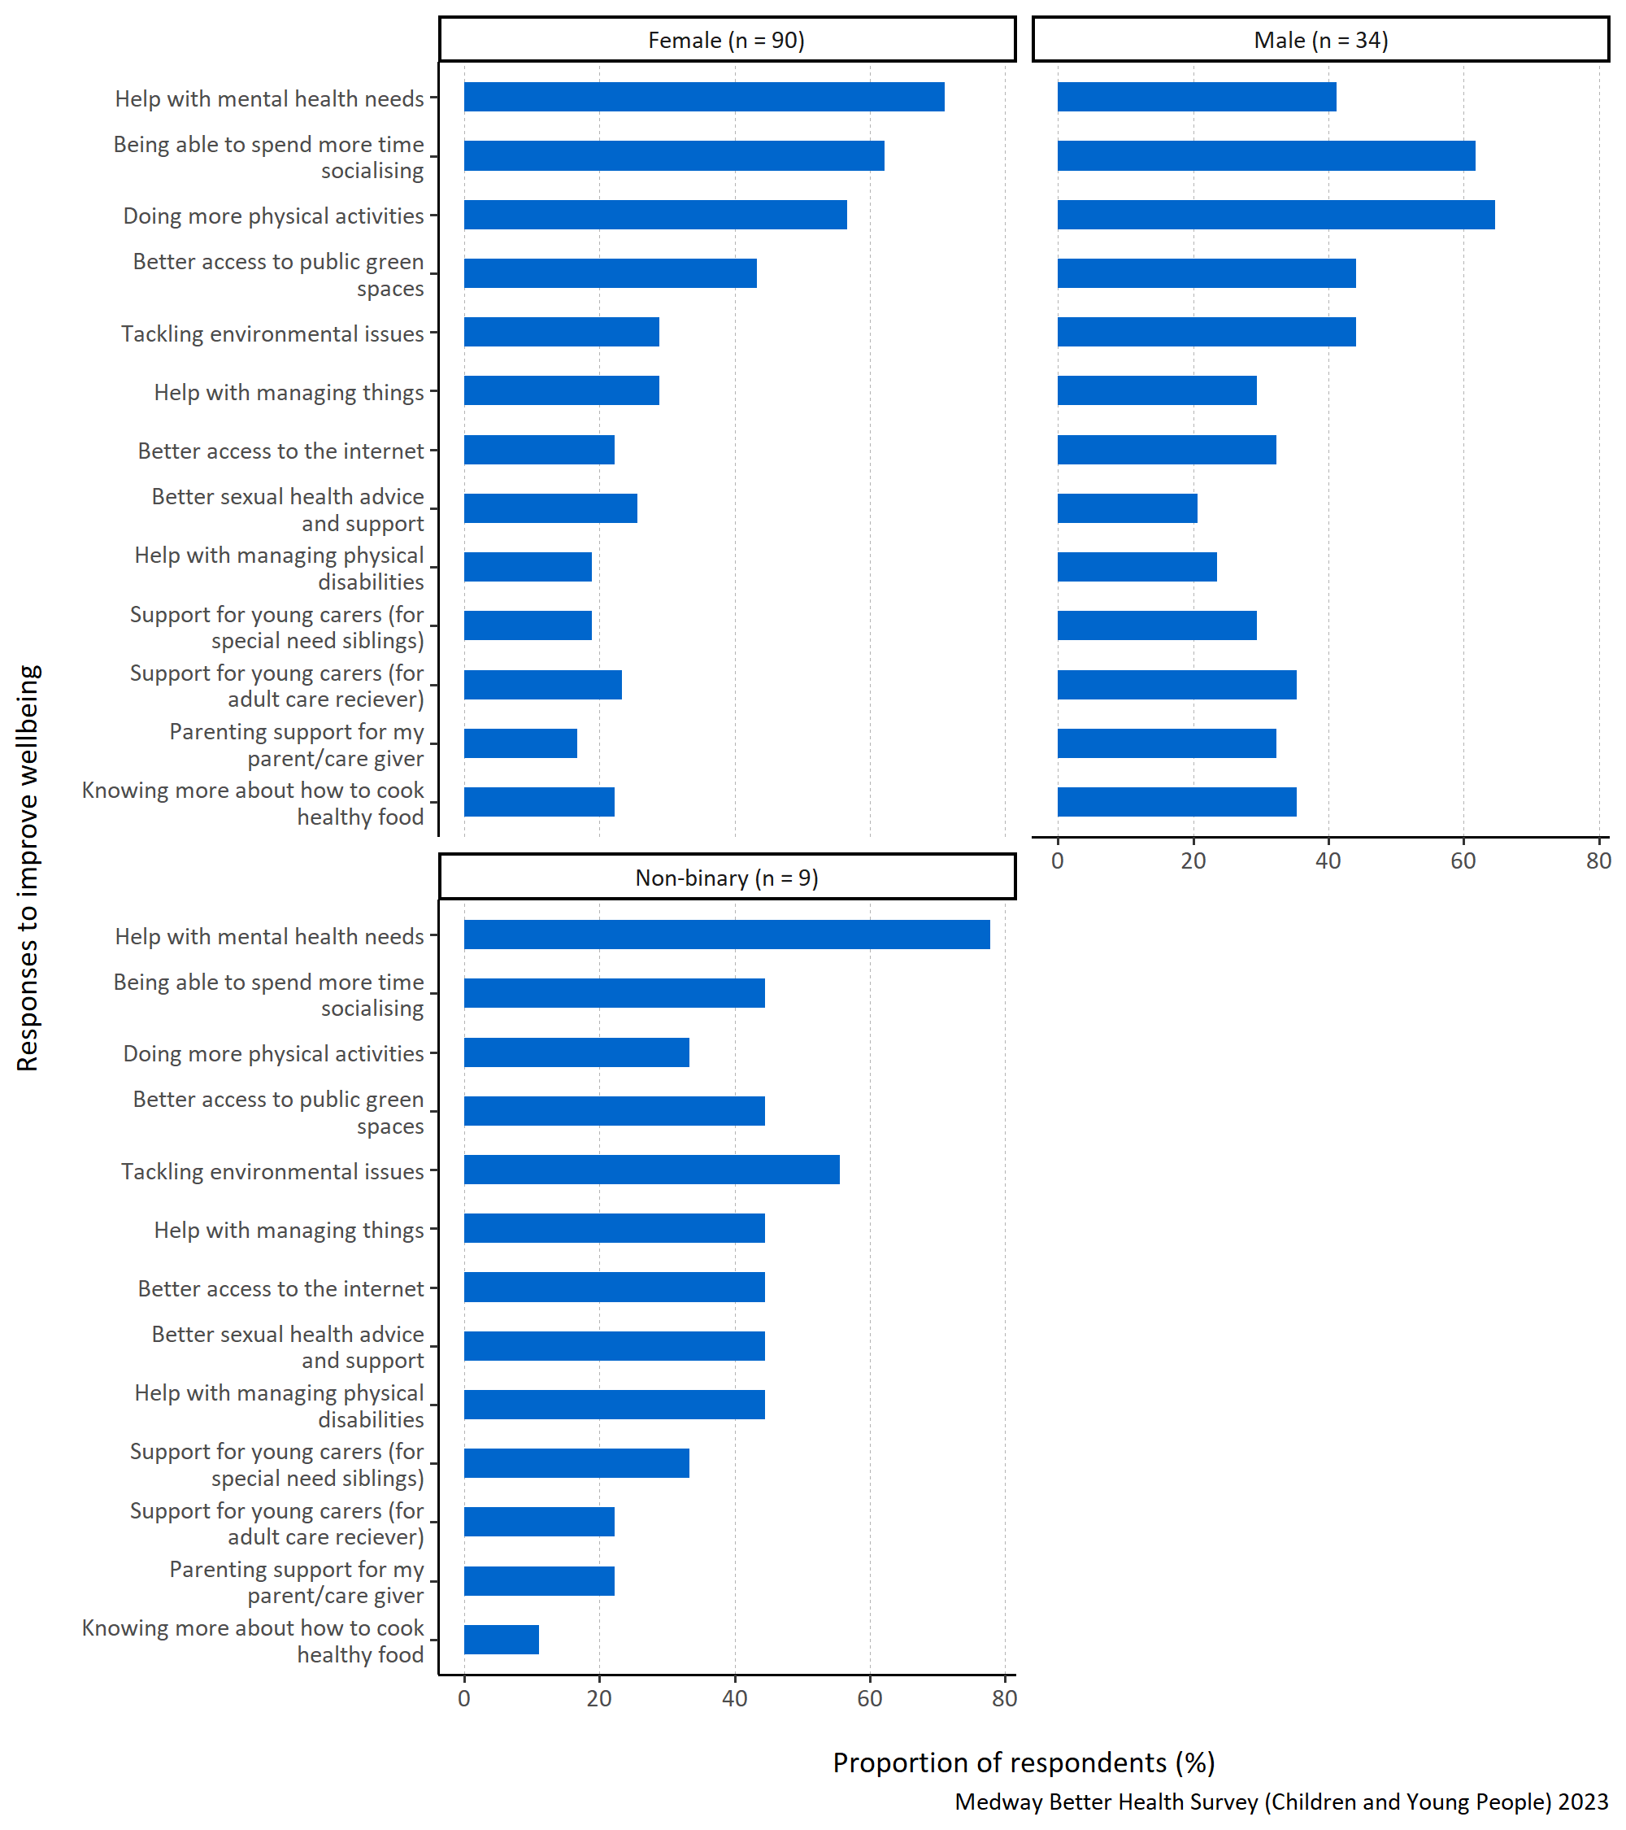
Figure 21: Proportion of respondents selecting each specified way to improve health and wellbeing by gender.
Figure 21 presents the proportions of respondents that selected each response option, split up by specified gender. Each proportion here was calculated based on the total number of respondents from each gender.
Female and non-binary respondents most commonly selected ‘Help with mental health needs’ as being something that could improve their health and wellbeing, with 71% and 77% respectively. In comparison, only 41% of male respondents selected this as being something they perceived that could improve their health and wellbeing.
Male respondents selected ‘Doing more physical activities’ as being something that could improve their health and wellbeing the most, with 65% of male survey participants selecting this as an option. They also commonly selected ‘being able to spend more time socialising’ and ‘doing more physical activities’.
Non-binary respondents frequently selected ‘tackling environmental issues’ as something that could improve their health and wellbeing.
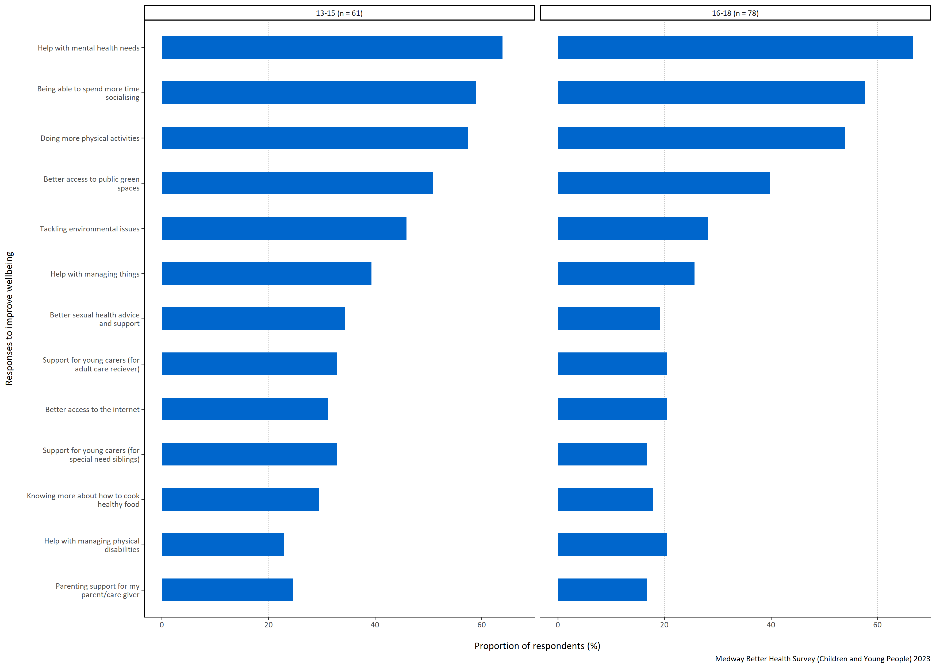
Figure 22: Proportion of respondents selecting each specified way to improve health and wellbeing by age group in years.
Figure 22 presents the proportions of respondents that selected each response option, split up by specified age group (in years). Each proportion here was calculated based on the total number of respondents from each age grouping.
For respondents both aged 13-15 and 16-18 years old, ‘Help with mental health needs’ was the response option selected most commonly with 64% and 67% choosing this, respectively. They both also commonly selected ‘being able to spend more time socialising’, ‘doing more physical activities’, and ‘better access to public green spaces’ as things that they thought could improve their health and wellbeing.
The least selected answer options for those aged 13-15 years old was ‘Help with managing physical disabilities’, and for those aged 16-18 years old was ‘parenting support for my parent/care giver and support for young carers (for special need siblings)’.
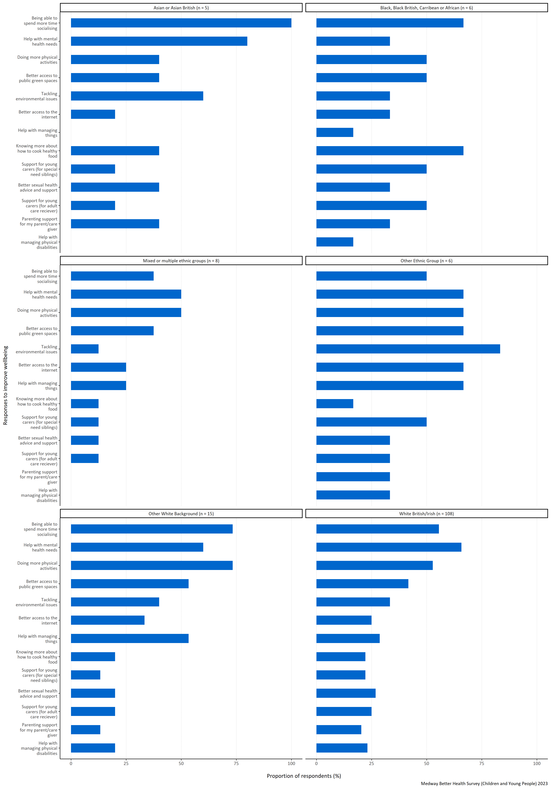
Figure 23: Proportion of respondents selecting each specified way to improve health and wellbeing by ethnicity.
Figure 23 presents the proportions of respondents that selected each response option, split up by ethnic group. Each proportion here was calculated based on the total number of respondents from each specified ethnic grouping.
There is much variation between the proportion of respondents selecting each answer option and their respective ethnic groupings. For example, survey participants identifying as Asian or Asian British, other White background and Black, Black British, Caribbean or African all selected ‘Being able to spend more time socialising’ most commonly. Black, Black British, Caribbean or African respondents also commonly selected ‘knowing more about how to cook healthy food’, ‘doing more physical activities’ and ‘better access to public green spaces’.
Participants identifying with other ethnic groups most commonly selected ‘Tackling environmental issues’ as being something that could improve their health and wellbeing. This group of respondents also commonly selected ‘better access to public green spaces’, ‘help with mental health needs’ and ‘doing more physical activities’. White British/Irish respondents reported ‘help with mental health needs’ as most important to improving their health and wellbeing.
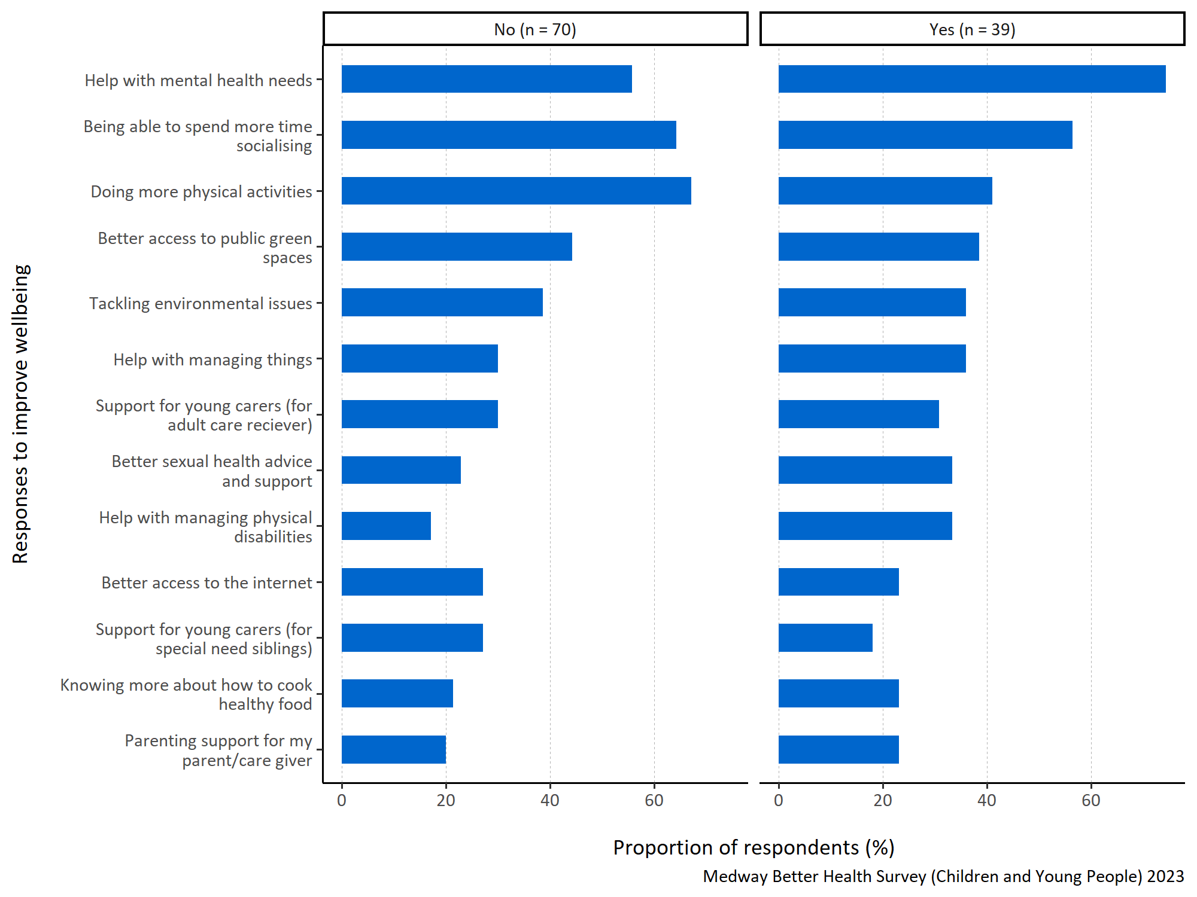
Figure 24: Proportion of respondents selecting each specified way to improve health and wellbeing by long term physical or mental health conditions.
Figure 24 presents the proportions of respondents that selected each response option, split up by whether they have or have not got a long term physical or mental health condition. Each proportion here was calculated based on the total number of respondents from each category.
Participants with a long term physical or mental health condition considered ‘help with mental health needs’ most important when asked about improving their health and wellbeing, with 75% of respondents in that category ticking this answer.
Respondents without a long term physical or mental health condition thought ‘doing more physical activities’ was most important for improving their health and wellbeing.
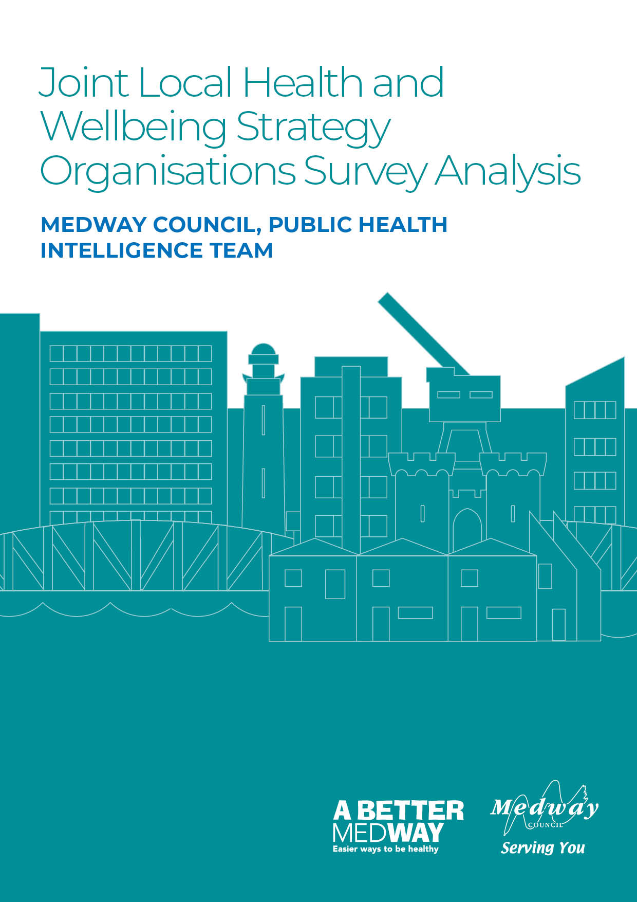

Appendix C: Better Health Survey for Organisations – Quantitative Analysis

Medway Council, Public Health Intelligence Team

Contributors:
- Emmanuella Uwaifo - Public Health Intelligence Analyst
- Dr Natalie Goldring - Senior Public Health Intelligence Manager
- Dr Eluned Broom - Senior Public Health Intelligence Analyst

Introduction
The Medway ‘Better Health Survey’ 2023 was conducted to better understand which aspects of life Medway residents thought were important to their health and wellbeing. The responses also offered insights into what people thought the barriers to achieving this were. Three versions of the survey were developed and tailored to a different group within the Medway population. These groups consisted of adults (aged 18 years and older) and children (aged 13-18 years) who were asked to provide responses about themselves. The third version was designed for organisations, specifically targeting their interactions with individuals they engage with.
This report relates to the ‘Organisations’ survey results which includes insights from representatives of organisations within Medway. It provides an overview of the perceived health needs and obstacles to good health and wellbeing faced by the individuals that these organisations interact with. It will inform actions needed to improve health and wellbeing. These will be set out in Medway’s ‘Joint Local Health and Wellbeing Strategy’ which is being refreshed from the current Medway Joint Health and Wellbeing Strategy (2018-2023).

Summary
The survey had a total of seven questions. It began by seeking the participants’ consent and gathering basic information about the type of organisation they represent. The remaining questions focused on the participants’ perspectives on what is important for achieving good health and wellbeing among the individuals they engage with, as well as the obstacles these individuals may face in maintaining good health. These health and wellbeing questions resulted in a mixture of quantitative (numerical) and qualitative (descriptive) responses. This report will initially summarise the type of organisations represented before focusing on the two quantitative response questions. Each question is examined first for the entire group of respondents, and then the analysis is further broken down by the type of organisation.

Types of organisations that responded
In this survey, 86% of the organisations that responded were from the Voluntary, Community and Social Enterprise (VCSE) sector, whilst the rest were public sector organisations.

What organisations believe the Medway residents they interact with want when considering their health and wellbeing
Question: When thinking about the health and wellbeing of the people you interact with through your role within your organisation, what would you say are the most important things people would want for themselves? Please number in order of importance, with 1 being ‘most important’.
Answer options:
- Feeling happy
- Less worry
- Getting help when feeling stressed
- Sleeping well
- Healthy and affordable food
- Getting enough exercise or being more physically active
- Healthy habits around food and eating
- Drinking alcohol within safe limits
- Being without illness or pain
- Giving up smoking
- Looking after their sexual health.
The designated respondent from each organisation taking part in the survey was asked to think about the people they interact with during their role within their organisation, specifically in terms of their health and wellbeing. They were then asked to rank what they would say were the most important things those people would want for themselves. They were instructed to assign a number for the eleven response options from 1 to 11 to indicate the level of importance, with 1 representing the most important priority for them.
To analyse this question, the top five responses were selected for each participant and assigned a score ranging from one to five, with five indicating the highest-ranked response. These scores were then combined to calculate a total score for each response. To determine the importance of each response within the top five, the total score for each response was divided by the sum of the total scores for all the responses in the top five. This calculation produced a proportion. The higher the proportion, the more likely the response was consistently placed and/or frequently ranked highly within the top five responses.
In figures 1 to 2 all the responses shown appear in the top five for at least one participant. A higher proportion indicates that the respondents from organisations think that response is more important to what Medway residents want when considering their health and wellbeing.
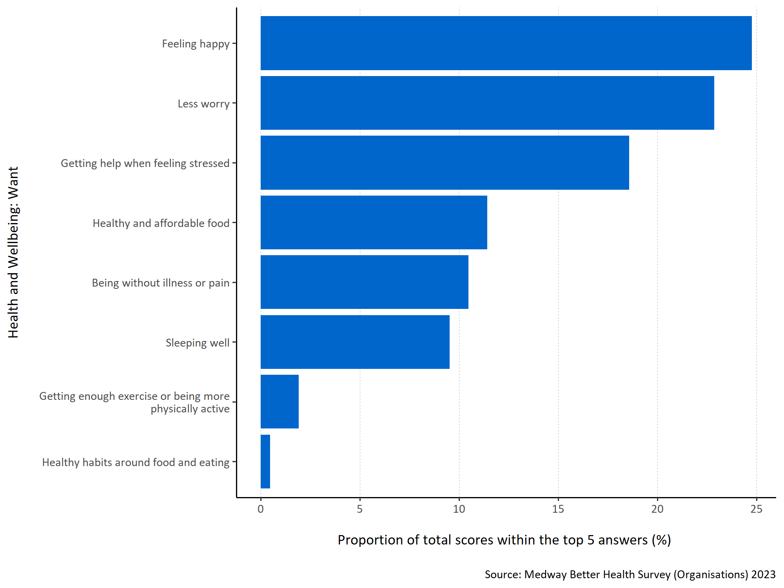
Figure 1: Proportion of total scores within the top 5 answers for each specified health and wellbeing want.
Figure 1 shows organisations considered ‘feeling happy’ to be most important to the Medway residents they interacted with when considering what they want for their health and wellbeing. ‘Getting help when feeling stressed’, ‘healthy and affordable food’ and ‘less worry’ were also considered important. ‘Drinking alcohol within safe limits’, ‘giving up smoking’ and ‘looking after their sexual health’ where not ranked in the top five options by any organisation representatives.
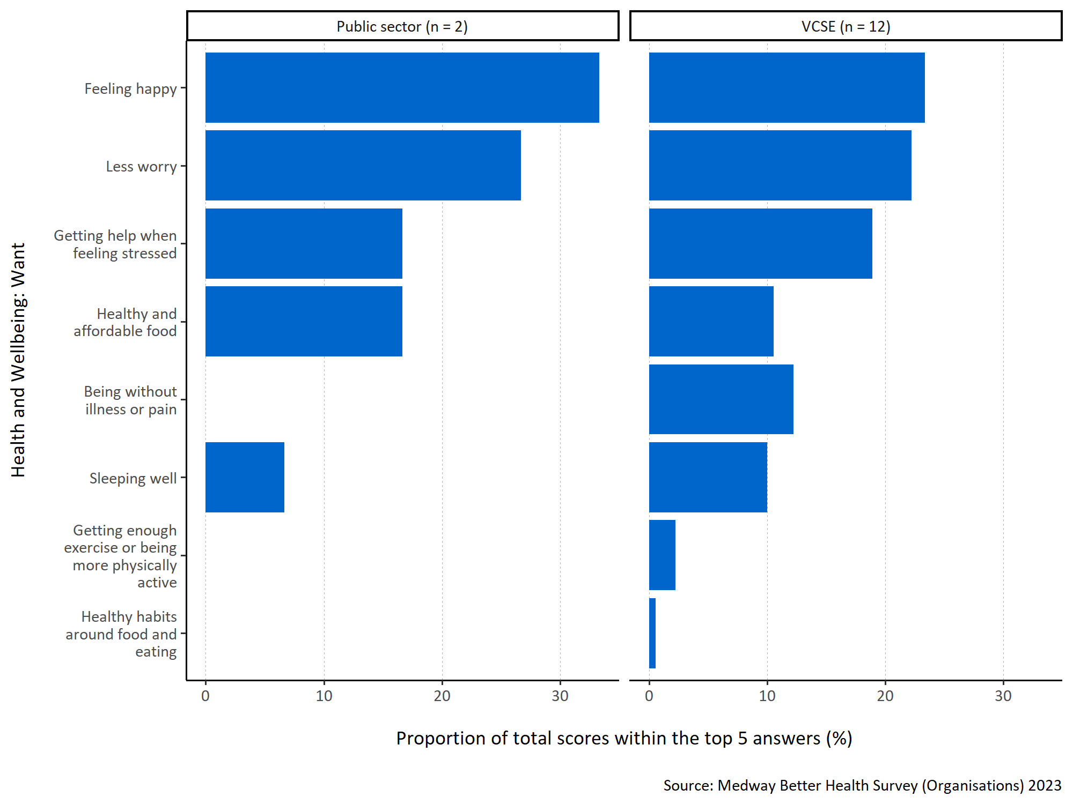
Figure 2: Proportion of total scores within the top 5 answers for each specified health and wellbeing want by organisation type.
Both types of organisation (public sector and VCSE) thought ‘feeling happy’ was the most important response. ‘Less worry’ was also important. ‘Being without illness or pain’, ‘getting enough exercise or being more physically active’ and ‘healthy habits around food and eating’ were not included in the top five rankings for the respondents from the public sector organisations. It is important to note that the number of respondents is low for both organisational groups and so any data must be interpreted with caution.

What organisations believe the Medway residents they interact with want to improve the health and wellbeing of everyone in Medway
Question: Thinking about the people you interact with through your role within your organisation, what do you think they would say are the most important things that can be done to improve the health and wellbeing of everyone living in Medway? Please number in order of importance, with 1 being ‘most important’.
Answer options:
- Affordable, good quality housing
- Having enough money to provide for their/their family’s needs
- Better access to GP services
- Better access to other health and care services (for example, mental health services, social care, hospital care, services that help manage conditions like diabetes, high blood pressure, breathing difficulties)
- Better access to the internet
- Affordable leisure activities
- Being able to spend time socially with other people
- Good-quality, affordable childcare
- Improved job security
- Feeling safe in the neighbourhood
- Support with caring responsibilities
- Better access to green spaces, (like open green spaces and water in urban areas, including parks, playing fields, play areas, allotments and community gardens, woodland and more natural areas, canal paths and riversides)
- Good local schools
- Adult education and training opportunities
- For society to tackle environmental issues (like climate change, pollution, traffic congestion)
- Support with parenting skills.
The participating organisations were also asked what they think the people they interact with would consider the most important things that can be done to improve the health and wellbeing of everyone living in Medway. They were instructed to assign a number for the sixteen response options from 1 to 16 to indicate the level of importance, with 1 representing the most important priority for them.
To analyse this question, the top five responses were selected for each participant and assigned a score ranging from one to five, with five indicating the highest-ranked response. These scores were then combined to calculate a total score for each response. To determine the importance of each response within the top five, the total score for each response was divided by the sum of the total scores for all the responses in the top five. This calculation produced a proportion. The higher the proportion, the more likely the response was consistently placed and/or frequently ranked highly within the top five responses.
In figures 3 to 4, all the responses shown appear in the top five for at least one participant. A higher proportion indicates that the respondents from organisations think that response is more important to what Medway residents want when considering how health and wellbeing can be improved for everyone living in Medway.
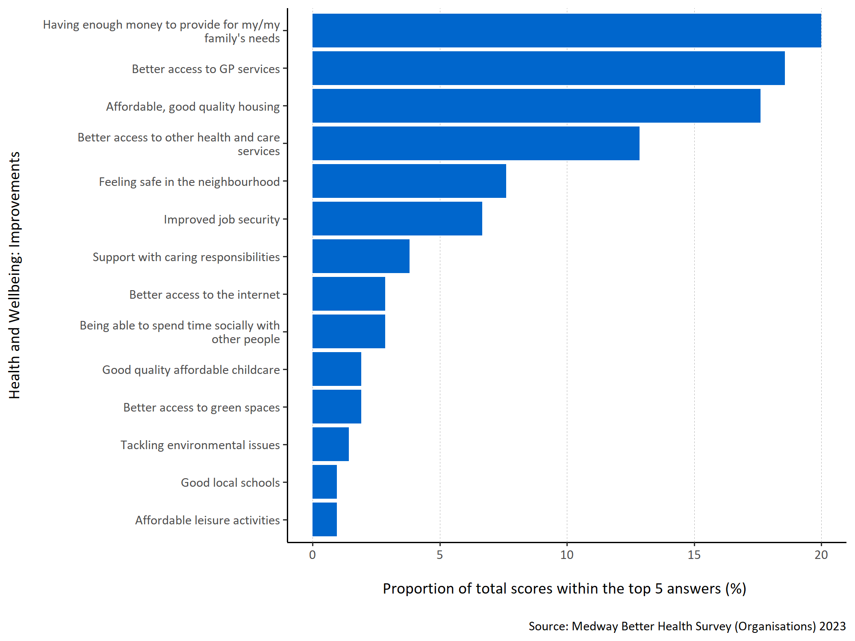
Figure 3: Proportion of total scores within the top 5 answers for each specified health and wellbeing improvement.
Figure 3 shows that representatives of organisations consider ‘having enough money to provide for my/ my family’s needs’ to be most important to the people they interact with in terms of improving health and wellbeing within Medway. ‘Better access to GP services’, ‘affordable, good quality housing’ and ‘better access to other health and care services’ were also thought to be important. No organisations included ‘for society to tackle environmental issues (like climate change, pollution, traffic congestion)’ or ‘support with parenting skills’ in their top five rankings.
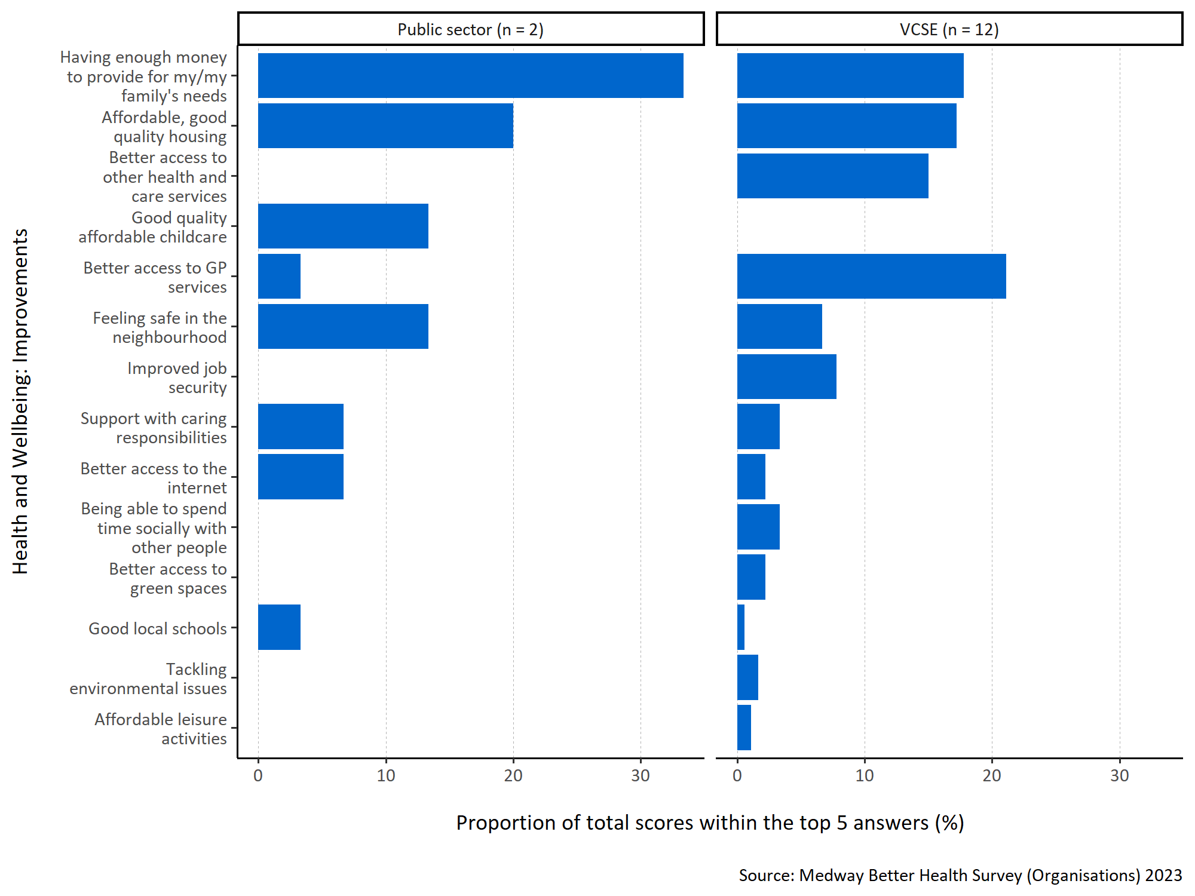
Figure 4: Proportion of total scores within the top 5 answers for each specified health and wellbeing improvement by organisation type.
Public sector respondents thought ‘having enough money to provide for my/my family’s needs’ was most important to the people they interacted with, whereas VCSE organisations believed ‘better access to GP surgeries’ was more important. Both considered ‘affordable, good quality housing’ to be important. VCSE organisations also thought ‘better access to other health and care services’ was important whereas this was not placed in the top five by any of the public sector respondents. Public sector organisations also never ranked ‘improved job security’, ‘being able to spend time socially with other people’, ‘better access to green spaces’, ‘tackling environmental issues’, and ‘affordable leisure activities’ in their top five.

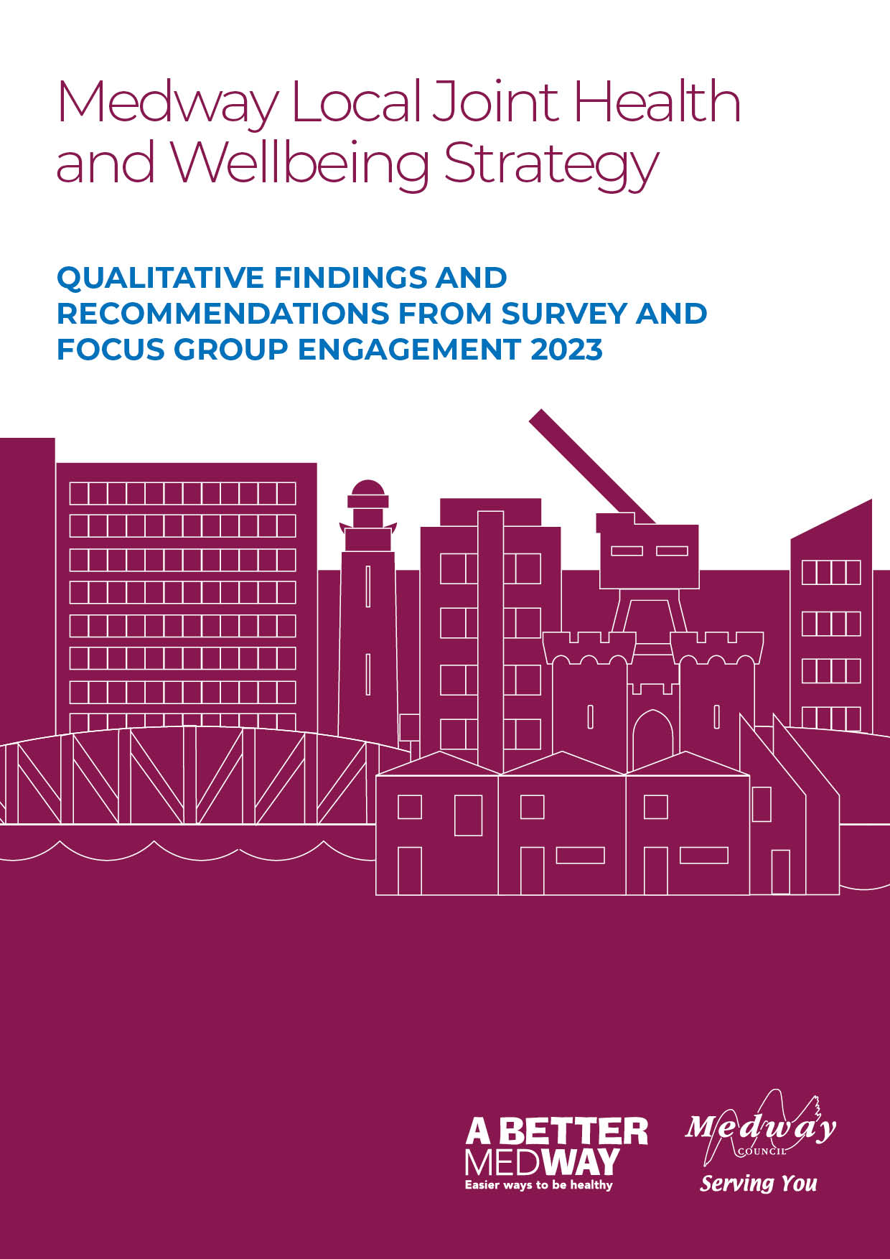

Appendix D: Better Health Survey, Focus Groups, and one-to-one discussions – Qualitative Analysis

Executive Summary

The following provides an overview of qualitative exercises conducted with local communities in Medway, carried out from February to May 2023 to inform the Joint Local Health and Wellbeing Strategy (JLHWS). This includes seven focus groups with communities most impacted by health inequalities and the open-ended questions from two broader surveys to Medway residents (526 adults) and organisations in March/April 2023. A survey of children and young people in Medway which has been excluded from this analysis because of a very small sample size.
This Executive Summary presents an overview of the key findings and recommendations from these qualitative exercises. Further detail can then be pursued in the full report.

Key Findings
- Access to health and wellbeing services. Participants said being able to easily access services was essential to supporting good health and wellbeing. They felt that general practitioners (GPs) were difficult to access (i.e., difficult to get through on the phone to book appointments and long waiting times). Concerns were raised that the increasing use of e-consults and virtual communication methods would make access even more difficult for certain groups and those with existing health inequalities (e.g., homelessness populations, older adults). All participants referred to wanting to learn more about healthy eating and alternative exercise within the community. More health promotion on these topics within community settings would be beneficial but also an opportunity for individuals to manage their own health and wellbeing.
“And they keep saying about an e-mail address and I don’t even know what an e-mail address is. I don’t. I’m 57 and I didn’t do none of that at school, you know…the other day I got six questions from the surgery, and I can’t reply to it cuz I can’t get on the internet.”
Participant from homelessness focus group

“Easy accessible healthcare [is needed]. Not being able to get help, care and advice when you need it is the most worrying and stressful part of my life”
“Much better and more accessible health centre [is needed] because at the moment my present one is overstretched, oversubscribed and difficult to access”.

Adult Survey Responses

- Integrating health and wellbeing into the local community. Participants discussed the importance of having access to information and services to support their health and wellbeing beyond primary care and in the local community. Many felt that they would benefit from health advice but were unsure where to access this. The development of community and health hubs was raised as a valuable way to achieving this and would mean that a broad array of services would be in one place. Services needed to include traditional health and wellbeing support services (e.g., mental health, substance misuse support, health checks), but also consider the wider determinants of health (e.g., financial support, befriending services) as these are a means of reducing pressure on primary care. Local community and health hubs needed to be in an easily accessible place with good transport links and ensure good access for those without personal transport, low incomes and/or mobility issues. It was also recommended that the hubs/services within them are co-created with services users and the public.

“You know, a lot of people now are walking with the trolleys down the High Street, and you know, they can barely put one foot in front of the other…it would be nice for somebody to be central that they could maybe, you know, leave a shopping list with…”
Participant from older women focus group.
“More affordable and safe access to exercise and not just subsidising those who are unemployed or on benefits. For example, the cost of swimming, even in local council pools can be too expensive for many who are working.”

Survey Respondent

“It’d be nice if there’s like a website that listed all the local services available.”

Parish Councillor Focus Group

“Services helping people to understand and gain knowledge about healthy lifestyle, nutrition, and wellbeing. It could improve people's general health and quality of life.”

Survey Respondent

- Strong social support networks. Participants stated the importance of good social support networks in helping to maintain good health and wellbeing. This might include being part of local interest/hobby groups (e.g., allotments, knitting), taking part in group physical activity sessions (e.g., walking, parkrun) or those maintained by services and organisations (e.g., gym and fitness classes). In this way, social support networks were cited as being beneficial to both physical and mental health and wellbeing, where people can socialise, have fun, and engage in interesting conversation. Participants said that the increase in cost of living meant it was more important than ever for local groups/activities to be affordable.
“I know a gentleman that lives across the road from me he's on his own. He has his dog, and I don't see anybody visit. So, who does he talk to in the day? And that goes on for weeks and weeks and months and months. You know, I'm concerned there are a lot of people just sat in doors waiting to die. Umm, literally waiting to die and I’m not exaggerating.”

Older Women Focus Group

A lot of them up there, it’s just a job. They don’t care. People like me, they look at me and judge me…We’re not all the same but you’re judged by that…They call you crackhead and all that.”

Rough Sleepers and Sex Workers Focus Group

“Drop-in places to sit and have a chat if you need to, informal, perhaps somewhere to sit by yourself but with others around you, sometimes you don't want to talk but it is nice to have things going on, I think so many of us live alone or feel lonely 'gathering' places where you feel safe and can be with others might be a good thing to have should you need it."

Adult Survey Respondent

“'Men in sheds' is a great organisation, especially for older or even middle-aged men to socialise.”

Adult Survey Respondent

- Population needs for health and wellbeing in Medway. Participants indicated the growing and unmet need of the population of Medway. Many considered the health and wellbeing needs of resident as being unmet by current services. With concerns around the limited health promotion on exercise and healthy eating to their inability to access primary and secondary services without delay. Introducing new services (e.g., community hubs) or sharing good ways of working (e.g., health fairs and health checks) could support current services to meet the unmet need and offer opportunity for shared lessons of learning for health and wellbeing services in Medway. Continuity of care was important to all participants - in particular, for those most impacted by health inequalities where they may be moving around or not living in a permanent address. Ensuring health care networks are supported to successfully transfer patients between services through increased signposting and better cross network communication, is needed to support the ongoing health improvement of people in Medway. Finally, participants suggested that while some services were available, they would like to see them designed in a holistic model to support the growing and changing needs of Medway residents. This varied from supporting the use of green spaces within the environment to ensuring diversity of the population is valued by the current services.

“People need more bottom up, co designed services dealing with aforementioned issues and that these services need to flexible to the ever-changing needs and landscape we live in.”

Organisations Survey

“I get frustrated that all my medical records for Medway and St Thomas’ are not on computer for me to access when I see a nurse. And they don’t tell one another about any changes to medication. That’s a nightmare as well.”

Older Men Focus Group

“The level of support that we receive here at the Barracks from Medway Council's public health team, in my experience, is unparalleled.”

“I've taken the Medway approach as like a blueprint so I can share with all the medical centres around the United Kingdom to reach out to their Council and see what's available in there for them to have a closer working relationship.”

Barracks Focus Group

Recommendations
- Taking a place-based approach to developing policy on health and wellbeing. The findings indicate that overall Medway residents are aware of the diverse and changing population needs of people in Medway and therefore, a place-based approach to developing policy would be beneficial to improving health and wellbeing in the long term.
- Raise awareness about the multidisciplinary teams that make up General Practice and inform people on how to access help in different ways and signposting them (e.g., pharmacy etc). There is clear need for better access to GPs and given the current climate with a shortage of GPs and appointments, there are alternative routes people can access the help they need without seeing a GP. The use of community and health hubs may also take pressure from primary care, and increased awareness of social prescribing.
- Create local community and health hubs that include traditional and non-traditional health and wellbeing services. Ensure these are co-produced with local communities and are accessible to those groups who may have more challenges accessing services (e.g., homeless communities, sex workers, older people, those with mobility issues). Ensure these are advertised using various communication channels and not just online to target those without these technologies.
- Ensure that healthcare staff are provided with patient compassion training (including training such as Making Every Contact Count) so that no individual or community feels judged, disrespected, or discriminated against.
- Increase availability and/or signpost to services that support mental health and wellbeing. This includes local groups where people can access social support networks, to dedicated mental health services that may be needed for certain populations including those suffering from homelessness.
- Address barriers to physical activity. Participants emphasised the importance of physical activity to their health and well-being, but face barriers to participating. To address this, the council could consider offering free or low-cost exercise classes or workshops specifically for homeless men. The council could also work with local gyms and fitness centres to negotiate reduced rates for homeless individuals or explore options for providing fitness equipment in homeless shelters.
- Increase information about services, support groups available including physical activity options. Participants highlighted a lack of information what is available in their local area. To address this, the council could create a comprehensive directory of local services/support and make it available to individuals through shelters, community centres, shops etc. As many participants do not use smartphones and many have limited access to the internet, this information should be provided in several formats (both electronic and hard copy leaflets, in magazines etc).
- Address financial barriers. Money was identified as a barrier to participating in physical activity. The council could consider providing financial assistance or subsidies for individuals who want to participate in physical activity programs but cannot afford to do so. The council can work with local leisure centres and community organisations to provide low-cost exercise classes for retired individuals.
- Increase support groups for older/retired men. It is important to address the gap in support groups available for older/retired men. Public Health Medway can work with community organisations to provide a range of support groups that cater to the needs of retired men. These could include activities such as walking groups, DIY clubs, and gardening groups.
- The initial investigation uncovered several key themes including a number of issues impacting the health of wellbeing of people in Medway. More research into the health and wellbeing needs would allow the council and health services to better support communities in Medway in managing their own health and wellbeing in the long run. Whilst also adopting an evidence-based approach developing health and wellbeing policy in Medway.

Focus Groups Findings

The following presents the findings from a series of focus groups designed to better understand the health and wellbeing needs and priorities of local communities in Medway. The focus groups were carried out with a range of different groups in Medway and focused on those which are likely to be most impacted by health inequalities including:

- Those living in areas of disadvantage
- Those experiencing homelessness
- Sex workers
- People living with disabilities
- Vulnerable people
- People living in rural areas (via Parish Councils)
- People from armed forces

In total, 7 face-to-face focus group discussions were conducted between February and May 2023. Each focus group had between 2-8 participants. The main topic areas which were explored include health and wellbeing priorities, staying healthy, and Medway’s health priorities. Based on these areas the following questions were asked during the focus group discussions:

- Thinking about health and wellbeing, what are your priorities/what would you want for yourself?
- What do you think people find useful to keep themselves in good health and wellness?
- What type of services or held do you think people will need more of in the coming years?
- Thinking about health and wellbeing, what are the most important things to address for everyone living, working and/or studying in Medway?

Homelessness (Men)

This focus group consisted of four white British male participants in their late 20s to late 50s living in an accommodation in Chatham. One of the participants was in paid employment with support from a homelessness organisation while the other three participants were not in an employment. Of the three unemployed, one was a prison leaver. The main themes that emerged from this focus group included the need for better access to mental health services, and importance of physical activity.

Access to Mental Health Services
Access to mental health services were deemed essential to support the overall health and wellbeing of homeless communities. One participant raised concerns that they were unable to access professional mental health support and felt frustrated that these services are too busy. They explained that the difficultly in receiving professional support has worsened their mental health including increased anxiety and depression.
“But it's like the last thing you really want to do is like, you know, if you're really depressed, it's like and say, oh, we'll contact you within 72 hours and they don't. And it's like, well, why is no one listening to me?”
Another participant on the other hand expressed their positive experience around access to mental health services like Mind which has been very helpful in keeping them in good health and wellbeing. This participant highlighted that the communication and the service itself is very good. This service was referred to the participant through their GP and they might not have found out about them otherwise.

Physical Activity
All three participants expressed the importance of physical activity to maintaining good health and well-being. However, they said that this has been challenging to implement in their day to day lives due to low motivation and mental health issues including depression. One participant who has moved to Medway a year ago, highlighted a barrier to physical activity which is around lack of information and where one can get advice for health. Although they are interested in getting back to physical exercise, they have not heard of anything around the area and have only seen one gym which does not suit their preference. Money and time are two important factors that would determine whether they sign up to physical activities. The cost needs to be reasonably priced.

Older Women
This group consisted of three white British women over the age of 60. All women were retired with different levels of income and lifestyles ranging from affluent to limited financial means. The main themes that emerged from this focus group is the importance of accessible local community hubs, support groups and in particular support groups targeted at men, and accessible information.

Local Services

Local Hubs
Participants explained that as people get older, mobility becomes a major problem, and they raised concerns that local community hubs were not easily accessible for those with mobility issues. They need to be central with good transport links so that people do not have to go a long way to access. Additionally, these hubs need to be a ‘one stop shop’ and offer a variety of services. These might include financial support, medical services, mental health support, befriending services to help with social isolation and loneliness and caring services like support with food shopping. By having these services and information in one accessible place, people especially those with mobility issues will be able to access this information and service easily.
“You know, a lot of people now are walking with the trolleys down the High Street, and you know, they can barely put one foot in front of the other…it would be nice for somebody to be central that they could maybe, you know, leave a shopping list with…”

Support Groups
As the participants in this focus group were mainly retired, support groups were cited as important to all of them so they can socialise with people they will not normally come into contact with. This would help to keep them mentally active. The group said they arrange and participate in several groups and events including coffee mornings, knitting groups, Nordic walking, which they expressed is important for their mental as well as physical health and wellbeing. Additionally, there was emphasis on affordable or free physical exercise activities that they could participate in to keep themselves active. They believed that having access to activities such as Yoga and Pilates was important to their health and wellbeing. A participant mentioned that there used to be a Pilates session each week at MCH which they very much enjoyed but that stopped due to COVID-19. One main issue was raised around an environmental factor affecting the physical activities. A participant mentioned that when they do the Nordic Walking although there are a lot of green spaces in Medway, they are separate. This then means that it is difficult to walk on green parks/fields without having to go on the road.
A crucial gap in the types of support groups available was discussed. All women agreed that men are left out when it comes to support groups due to the types of groups which are usually knitting, and these are more targeted at women. They believed that their men who are mainly retired are left on their own with nothing to do. These women have been taking a proactive approach and arranging for their men to get together however they feel more male support groups need to be available.
One participant mentioned;
“This time of year, it’s just me and him. And of course, I’m coming to my groups. He’s left on his own, first thing he says to me when I get home is ‘what did you talk about?’”.
Another participant added;
“I know a gentleman that lives across the road from me he's on his own. He has his dog, and I don't see anybody visit. So, who does he talk to in the day? And that goes on for weeks and weeks and months and months. You know, I'm concerned there are a lot of people just sat in doors waiting to die. Umm, literally waiting to die and I’m not exaggerating”.

Accessibility of Information
Participants expressed the need for better accessibility of information around activities and support groups that are taking place. One participant explained that she goes to Nordic Walking with Medway Council which is free. However, when she speaks to people about it, they express interest but explain they do not know anything about it or how to access it. The information usually appears in Medway newsletters or in an email, but if you are not signed up, you will not know that they are available. One participant emphasised the importance of having information available on posters or leaflets in areas where people gather for example shops, community centres, and surgeries because the elderly do not use the internet as much.
She said;
“It would be nice thing if you had even posters outside to say oh, this is available. Would you like to come along to this cause people read things. They can’t always access the Internet because some people, especially when they’re older, don’t do Internet and don’t do technology on phones.”

Additionally, this grouped discussed the difficulty in navigating online portals to view their options when it comes to reduced energy costs. Energy companies try to signpost them to view their options to reduce costs via online portals, however due to difficulty in navigating, they end up giving up and paying much higher bills due to digital divide.

Older Men
This focus group consisted of two white British male participants over the age of 60. One of the participants was registered blind. Both have experienced mental health issues with one participant who has experienced problems with excessive alcohol intake. Both participants were retired. The main themes that emerged from this focus group are around the lack but importance of continuity of care, support groups, the difficulty in accessing information, and improvement of local transportation. These themes are very similar to those highlighted in older women’s focus group above.

Continuity of Care
A participant expressed frustration over the lack of continuity of care in general practices. They have not seen their doctor for over 4 years. More so they believe no one is communicating with the system. Their medical history and records which should all be electronic and accessible to nurses and doctors are not.
“I get frustrated that all my medical records for Medway and St Thomas’ are not on computer for me to access when I see a nurse. And they don’t tell one another about any changes to medication. That’s a nightmare as well.”

Support groups
A main priority that all participants discussed was the importance of getting out of the house and doing something whether it is attending a support/community group or going into town. Being part of a group where you can socialise, have fun, and engage in interesting conversations is crucial to their wellbeing. A participant explained how before COVID-19 they used to have coffee mornings at Twydall Library. However, during COVID-19 they had it around their neighbour’s houses around the front in the gardens. Moreso, another participant added that by getting out of the house, you are also engaging in physical activity through walking which is an added bonus to one’s overall wellbeing.

Accessibility of Information
A concern raised by participants was the lack of information around services and support groups available to them. One participant mentioned that they prefer to get their information from word of mouth and posters/leaflets. They prefer word of mouth as the person recommending it has already experienced it therefore it is more credible and relatable. Additionally, if one lives in Gillingham, they believe it is an inconvenience and difficult to access welfare services if they are all located between Chatham and Rochester. They believe there is no proper information around how to access services located in Chatham especially around welfare. One participant would like to know whether they are entitled to any help in terms of their welfare. They mentioned;
“I want to know if I’m entitled to any help. See I haven’t got a bus pass because I’m in the middle of the age group…so I’ll be 64 years this year and I’m still not entitled to whatever. But I’m semi-retired…if I don’t get any help from the council tax or anything like that. So, am I entitled to anything?

Local Transport Service
One important aspect that participants in this group felt was important for everybody in Medway is improving the local transportation which they believe has a knock-on effect on their overall health. One participant mentioned that on Sundays the buses that run are few and far between while in the summer they believe the buses do not run as much. Another participant added that the bus stop should have been left in the Pentagon Centre. They feel the location of the bus stop at the moment by the waterfront is an inconvenience with the wind blowing and rain due to no protection.

Rough Sleepers & Sex workers
This focus group consisted of seven female participants in their early 20’s to 60’s. One of the participants was Russian while the other six were white British. Four participants were currently living in homeless hostels, two in social housing, three had a history of rough sleeping, and two are known to have previously been engaged in sex work. The main themes that emerged from this focus group include importance of mental health services, continuity of care, compassionate care, lack of support from social services, importance of housing and a support network.

Access to Health Care

Access to Mental Health Services
Being in good mental state is an important aspect of the participants’ health and wellbeing. One participant specifically mentioned being clean of drugs as she believes that drugs affected not only her mental health but other aspects of her wellbeing like appetite, weight, and mood. In terms of access to mental health services, the group had mixed experiences. One participant has had positive experience with several services including talking therapies and the mental health team. On the other hand, another participant has found it difficult to get a prescription for mental health medication. She explained that she used to get her mental health tablets from MEDDOC. However, they now won’t prescribe them anymore and she has to go through a doctor. The problem with this is that some doctors she has been to want an ID, but she is homeless. Another GP she went to will not let her in and are redirecting her to ring some phone numbers listed on their door, but these numbers were found not be active when the participant rang them. As she cannot get access to her tablets and being bi-polar, this is having a negative toll on her health and affecting the people around her.

Care

Continuity of Care
Continuity of care is important to these participants’ wellbeing as it helps them to build trust with health and care practitioners. One participant talked about the importance of having the same support worker due to her trust issues. This leaves her helpless and having to repeat herself all over again to a new support worker which she finds frustration and takes a toll on her mental health.

Compassionate Care
The group discussed experiencing discrimination and a lack of respect by healthcare staff (specifically in hospital settings) and how important a compassionate approach is when providing care. One participant explained;
“A lot of them up there, it’s just a job. They don’t care. People like me, they look at me and judge me. But we’re not all the same… there to nick some one’s bag from the next locker. Understand? We’re not all the same but you’re judged by that. And the security up there is disgusting mate. They call you crackhead and all that.”
Participants noted that people judge them and assume that just because they are homeless, they are automatically ‘crackheads’ or ‘prostitutes’. She suggested that one way to improve the way they are treated by others is to have a service that educates and informs people who do not know what is going on in the streets about what it means to be homeless, what it means to be on drugs or alcohol and how these people have still got a heart.
“But people who are out there should think before they approach. You know what I mean? Kids and even adults say get out the road, you crackhead, you staghead like that. You know what I mean?”

Social Services

Justice System/Child Custody
Most participants said they had experienced significant emotional distress and feelings of helplessness as they discussed the Justice System/Child Custody in relation to their children. They felt that there has been significant lack of support from social services adult and children. Two participants from the group have had their children taken away from them by social services and that has impacted their health and they are left helpless and do not know where to go to find help. Although one participant understands there are solicitors and social workers they can go to, they feel their situation is unique and more challenging to resolve. One of the participants who eventually broke down crying mentioned;
“Like every day I’m breaking down and emotional and crying…. I just want to shout at everyone. I hate the world, like I’m angry constantly. I have actually lashed out at people that I love (tearful).”

Housing
There was a consensus regarding the need for more help to support homeless communities. One participant although she now has a room, recounted her experience of being homeless:
“Six months out in the street…and I was dead in Gillingham high street on the floor and people was walking past me while I was unconscious, and it took one person to recognise me and got me an ambulance. And people walked past me. I’m a grandmother, I’m still human, but you don’t knock someone when they’re down. Disgusting. But that’s just life, innit? But I’m in a really good place now.”
She explains how her mind is now at rest because she has a place to stay, and her partner is off the street at night. The group explained that some people are not rough sleeping. They are homeless and are sleeping in other places like pubs or their friends and require help. One participant in particular is not getting the help she needs from the council with her flat. She currently finds it difficult to lift her leg whilst getting in the bath. This has been reported to the council, but they are yet to come and have a look.

Outreach services
Participants believed there needed to be outreach services available seven days a week, not just on Mondays to Fridays.
A participant mentioned;
“Homeless don’t stop at 5pm or Monday to Friday”.

Support Group
This group expressed their need for support groups in order to keep them feeling good about themselves. They believe these groups allow them to talk freely about anything, and it is a way for them to find out more about services and agencies available. Some of the events they attend include ladies’ nights which they enjoyed. Moreso, these support groups provide more than a good conversation and socialising. They can get clothes, showered if they want to, have a hot drink and a safe place to sit away from the streets.

IMAGO clients
This focus group consisted of two white British men in their late 40’s possibly early 50’s living in central Chatham. Both participants had mental and physical health issues. One participant was in employment while the other carried out voluntary work while looking for paid employment. The main themes that emerged from this focus group is the importance of support specifically continuity of care, having people that listen, and eating well.

Support
One main theme that emerged from this focus group was the need for more permanent support groups that provide continuity of care. One participant noted that there is one mental health support group they have been going to for the past two or three years. But every other group he has come across, in six weeks, 12 weeks at most you are out the door with little to no guidance on what to do next and no signposting to other groups. He explained how it does not matter what you say in the sessions because you know at any moment it will come to an end and you are back out the door. He further goes into detail on how depression affects every aspect of your life, from your eating to your hygiene and what you wear. Due to moments like this, the participant is constantly seeking day to day support, contact with one person that can genuinely care for them like a friend and make sure they are taking care of themselves properly (eating, keeping away from alcohol, washing up etc.).
From the discussion with both participants, they seem to value people that care for them and that can genuinely listen to them and want people to understand them better. Having places they can go to speak freely is important to their health and wellbeing and they believe this is important to everyone living in Medway.
Both participants explained the limited nature of support they receive in terms of mental health mainly from the crisis team who come if one has a crisis or attempts to commit suicide. They feel as though they are being treated as just as another number. They believe that the crisis team are quick to ask them whether they are okay or what can they do for them just so that they quickly close the case and move on to the next person, rather than taking the time to assess and make sure they are better. Another participant added that they have been in touch with crisis teams over five times to try and get further diagnosis of their autism but still have not received any help.

Healthy Eating
Eating well has been highlighted by one of the participants as one that that is important to keeping themselves healthy. They believe eating well is the first thing that gets your brain focused. Their experience with dementia and anaemia made them understand the importance of eating well in terms of vegetables and fruits.

Parish Councillors

This focus group consisted of eight male and female affluent Parish Councillors in their late 40s to late 70s. This group considered themselves to be in relatively good health, with some long-term conditions like diabetes but no other mental or physical illnesses. Most of the participants were retired with a few of the working aged participants in professional occupations. This focus group was conducted in Frindsbury. The main themes that emerged from this focus group include the need for better healthcare system, importance of outdoor leisure activities, and better accessibility of information.

Healthcare System
There was a general consensus about the inadequate nature of the healthcare system which comprises of lack of appointments, long waiting times to be seen by a GP, need for another hospital as current hospital is overrun, and better support in terms of mental health services. Particularly for the elderly, access to the GP has been more difficult due to the shift to e-consult. Better support for mental health through the provision of having more beds for patients has been raised. One participant gave an example of how when he used to work in prisons, there was a lot of people who came into prisons with mental health issues, and he saw the effects of lack of support because they did not get the support or help, they needed. One participant highlighted that however much we need and want more GPs, there just are not enough of them. Therefore, the focus needs to shift from opening more surgeries (as there are not GPs to run them) to looking at other healthcare professionals and self-referral schemes so that people can refer themselves to where they think it’s appropriate.

Outdoor Leisure Activities
Participants explained the importance of encouraging people to get out of their cars and walk, cycle. By taking part in physical activities, we are not only improving our health and wellbeing but also doing something to improve air pollution. Leisure facilities including clubs have been highlighted as an important aspect in reducing social isolation and improving overall mental health. One participant explained the current projects that are ongoing aimed at trying to encourage people to be more outside including an outdoor gym equipment that has been recently installed. Another participant highlighted the good things in Medway including the Medway Health walks which is quite popular with people and located in different areas. There is also the free swimming for under 16 to over 60s.

Accessibility to Information
A general consensus amongst participants was the need for better information around what services are on offer. There is need for a more comprehensive directory on what is available. One participant mentioned;
“It’d be nice if there’s like a website that listed all the local services available.”
One participant also mentioned how people need to know how to look after themselves and how to make the right choices as they believe there is a lot of misinformation out there. They believed it is important to have resources that people can turn to for credible information and also able to signpost them to appropriate resources to suit their needs. Another participant noted that the lack of clear and credible information is probably the reason why A&E is always busy because they go to A&E instead if they cannot reach a doctor.

Barracks (Men)

Provision & Access to Primary Healthcare
A consensus amongst the participants was the need for better quality patient care; access to primary health care including access to GPs and mental health services. Participants would like to be able to speak with a health professional (i.e., get an appointment) in a timely fashion. One participant explained the number of times they have phoned and sat in the queue for half an hour at 8am in the morning trying to get through to the GP only to be told all appointments have been taken for that day and having to repeat the process the following day. Additionally, one participant found it difficult to get a doctor that would then refer them to psychiatric services. One participant highlighted the need to better resource Medway Maritime Hospital and the need for a new hospital.
“...Medway Maritime hospital again, it's under resourced, under provisioned. I’ve been treated there on several occasions. The staff are fantastic, but they’re being asked to do too much with too little, and the site cannot grow to meet the needs of the expanding population. So, Medway needs to have a new hospital.”
Lack of continuity of care and the transfer of patient healthcare/records is a major challenge faced by these participants. As military staff, their work requires them to move around either from one county to another or between Northern Ireland, Scotland and England. However, the transfer of healthcare around their medical notes within the NHS does not happen. These participants expressed frustration as the entire process has to begin which is inefficient and quite dangerous.

Local Access Point
One main area of importance for these participants is a local access point where a variety of services are available. Participants were impressed with the support of Public Health Medway Team and believe the team have been instrumental in providing them with the tools and services needed to improve their health and wellbeing.
“I’ve moved all around the country with work, but I’ve never met a Council before this heavily engaged in public health...but the level of support that we receive here at Brompton Barracks from Medway Council’s public health team, in my experience, is unparalleled.”
One main project that participants particularly enjoy, benefitted from and is well received by those on the campsite in Brompton is the Health Fair. These health fairs are like “a one stop shop” for a variety of healthcare services and resources. Some of the services they mentioned which they engage with include sexual health, how to prepare healthy meals, alcohol and drugs support, and domestic abuse services. Additionally, participants explained that because many people in the army have some barriers that make it difficult for them to be open and honest about their health and wellbeing, these fairs break down that barrier. Many people in the army do not disclose certain health and wellbeing issues with the fear of it being seen as a weakness which might serve as a disadvantage to them in many areas of their work and career progression including not being promoted, or worse being discharged.
“...whether it be minor theft because he’s supporting a gambling habit well. But it’s too late. Then, he’s gonna get discharged from the army because he’s a thief. Whereas if we can interact through these health fairs and other support charities, we may be able to put an intervention in place long before it becomes an issue.
Moreso, one participant explained how he is currently embedding services and keen to embed many other projects that Medway Council Public Health have on offer into their Medical Centre. Some of the services that he has been able to obtain support from is the smoking cessation service, the Fibro scan clinic and the COVID vaccine team which have been delivered from within the camp.

Healthy Eating
In the upcoming years, participants expressed the need for support around healthy eating given the current cost of living crisis and financial burdens faced by everyone. This would be even more beneficial as many of the troops are now allowed to cater for themselves in the living accommodations. Some of the provisions that are being improved upon include providing more ovens, grills, and fridges for storing fresh food.
“So if there is any campaigns, processes, teachings, whatever that the Medway public health team are offering around healthy eating on a budget, I think that would really go own well.”
One participant would like to have cookery classes where they can be taught how to make nutritious meals with basic equipment and relatively inexpensive ingredients.

Gardening & Physical Activity
Participants agreed that one of the activities they engage in to facilitate their wellbeing is gardening. One participant explained how gardening itself is physically interacting with green spaces, taking the time to appreciate nature, but it also provides that mental wellbeing. Another participant who also enjoys nature, tends to go out of Chatham and goes for a hike or climb some mountains. Given the importance of gardening and green space, one of the participants mentioned that one of the things they are looking at doing is improving the green space offerings and availability on Camp so that more people can grow their own food.

The Medway Better Health Adult Survey 2023

The Medway Better Health Adult Survey asked 526 Medway residents three questions on; 1) what do they currently do to stay healthy? 2) What local services and organisations do they use to stay healthy? And 3) what would they like to see in Medway in the future to help others to stay healthy?

How Adults in Medway stay Healthy

Movement
~75% of people described some form of movement or regular exercise. The most common way to stay healthy was through a movement activity or “regular exercise”, with three quarters of respondents saying they take part in an exercise activity to maintain their health and wellbeing. This included, ~40 % of people who said they enjoy “walking” or “being outdoors”. A quarter of respondents said they take part in regular individual exercise activities, this included going for a run, to the gym or swimming. And ~11% of people said they take part in regular exercise in a group, this included; yoga, gym classes and team sports such as, football or netball.

Social Interactions
~58% of people described spending time with others as an important health behaviour. Over half of Medway residents considered that forming and maintaining meaningful social relationships as important to sustaining everyday their health and wellbeing. ~43% of these people indicated “spending time with family” and “keeping up with friends” were key to maintaining good health. These social relationships extended beyond family and friends as ~8% described positive connections/experiences at work important to health. These individuals valued work relationships with one resident explaining; “work keeps me mentally alert and happy with my work colleagues”. And ~11% of residents described attending community groups as way of staying healthy.

Recreational Activity
~27% of people described some form of recreational activity from pursuing hobbies to volunteering as supporting general health and wellbeing. Recreational activities described as pastime activities or hobbies were considered by over a quarter of Medway residents as important to staying healthy. This included ~9% of residents described taking part in some type of hobby or club such as “men’s shed” as beneficial to wellbeing and health. ~8% of residents listed volunteering as key to sustaining good health and ~6% of people found gardening and going to an allotment as good for general health. Finally, ~4% of people indicated singing playing and listening to music as important for health and wellbeing. Overall recreational activities that are not considered an expense but can fill in past times are considered good ways to stay healthy.

Healthy Behaviours
~25% of people described actively participating in healthy behaviours. A quarter of respondents described behaviours that are recognised in policy as “healthy behaviours”. ~16% of people indicated they actively try to “eat healthy” from dieting or “cooking from scratch”. ~5% of people suggested they would seek help about their health and wellbeing when needed from health professional in the form of medication or “reaching out” to speak to someone. Others considered a “good night sleep” (~3%) and “stopping/not smoking to reduced/no drinking” (~1%) as a good way they stay healthy.

Usefulness of Local groups, Services and Organisations

Local Groups
Around 30% of respondents described how useful they found local social, fitness and health groups to stay healthy. These responses were split into three subcategories.

Local Groups subcategories; Local Social, Fitness and Health Groups
Local Social groups such as clubs and community groups were popular with ~13% of respondents, alongside online local social groups, and communities such as Facebook groups, were noted by ~5% of people and volunteering groups with ~2%.
One resident explained;
“'Men in sheds' is a great organization, especially for older or even middle-aged men to socialise.”
Another said they like to attend the “friendship club at Sunlight centre and coffee morning with Whoo cares”. Socialising in a community club or group was key for Medway residents as they found it useful to help maintain health and wellbeing. Local Fitness groups were identified as Sports clubs, Walking Clubs and Park Runs with around ~8% of people suggested they found them useful to help them stay healthy, with some residents saying; their “sons attend the local football club” and that the “park run is amazing”. Local Health groups were popular with ~2% of people attending a diet/nutrition group such as slimming world or parental or baby classes groups where people were either, be supported with their healthy behaviours or able to share their experiences with others.
As one resident explains;
“I attend a number of baby groups such as Hartbeeps, Toddler Sense, baby bounce and rhyme at our libraries - these are great for meeting new friends and talking about your experiences”.

Local Facilities
Approximately 24% of respondents explained they found local fitness and activity facilities most useful for themselves and their families to stay healthy.
Medway residents said that local facilities are important to keeping themselves and their families healthy, with almost a quarter of respondents mentioning the various outlets available in Medway. ~21% of people said they made use of gyms/leisure centres for gym/fitness classes and swimming pools, as well as parks and outdoors spaces for regular exercise. Others mentions allotments and libraires as important facilities they used regularly with some saying they “use the library to check out books to read in spare time” and another said, “I have an allotment, which helps in many ways”. Local facilities that were within walking distance or accessible by public transport and low charge or free of charge were popular with residents.

Local Services
Finally, local services were recognised by residents as important to staying healthy. ~10% of respondents said that they use health services such as GPs, Mental Health Support and Medway specific programmes were mentioned such as “healthy way” and “healthy workplace” as good ways to help themselves and employees maintain health. This also included those who mentioned using adult education services and classes, as one resident said they; “attend course at Adult Education for hobby outside of work”.
Local Groups, Facilities and Services are valued by Medway residents who use them, and they consider them useful to help themselves and their families stay healthy.

Services needed in the future to help residents to stay healthy

Access to reliable health care (MH, Social Care, Hospital and LTCs)
Access to reliable health care was considered a top priority for Medway residents with approximately 38% of respondents indicating the current health care services such as GPs were ‘inadequate’ and more health services for specialist areas including mental health were going to be needed in the future. In this context, ‘reliable’ can be considered as reduced waiting time for GP appointments, introducing “walking in clinics and advice hubs” and increasing the option to have face to face consultations to facilitate better accessibility for people who do not have access to computer or apps.
One resident said;
“Easy accessible healthcare [is needed]. Not being able to get help, care and advice when you need it is the most worrying and stressful part of my life” and others agreed “Much better and more accessible health centre [is needed] because at the moment my present one is overstretched, oversubscribed and difficult to access”.
Access to reliable healthcare incorporated several themes such as, social care services, hospital admissions and bed and most importantly, the access and delivery of GP in primary care. Reliable health care is considered the most important need of Medway residents for the future.

Affordable/Accessible activities
Approximately 38% of respondents indicated the importance of affordable and accessible activities to their health and wellbeing (Subthemes; Affordable/Accessible Fitness ~32%, Affordable/Accessible recreational activities ~3% and Affordable/Accessible youth activities ~3%).
Medway residents considered future needs of Medway based on rising cost of living alongside the future health needs of individuals and groups and therefore, considered affordable and accessible activities were necessary to support future health of the population. AA activities included, Fitness, Recreational and Youth activities. AA fitness was most popular in this category, with ~32% of people mentioning or describing possible future AA fitness activities from “subsidised gym membership” to “free fitness classes”.
One person said;
“More affordable and safe access to exercise and not just subsidising those who are unemployed or on benefits. For example, the cost of swimming, even in local council pools can be too expensive for many who are working.”
And another suggested;
“We need more exercise equipment in all parks, my nearest one is too far for me to get to but the park nearest me doesn't have anything”.
Activities that supported or facilitated health and wellbeing opportunities were deemed important by many as long as they were considered as affordable and accessible to those most in need.

Advice/Support on nutrition and healthy behaviours
Advice and support on nutrition and healthy behaviours were mentioned by ~30% of Medway residents. This included anything from healthy eating classes to health promotion on healthy lifestyle changes. This theme was considered by many alongside the increasing cost of living and the decreasing health of people.
As one person explained;
“Education on cooking with fresh ingredients, especially veg - saving money in the process”,
Another suggested;
“Good food costs more and it shouldn't. access to local produce - home grown produce”.
These ideas were grouped with other comments such as “Services helping people to understand and gain knowledge about healthy lifestyle, nutrition, and wellbeing. It could improve people's general health and quality of life.” Nutrition and healthy behaviours were recognised by many as important to future health but also considered as unattainable to many who live in Medway due to wider determinants such as cost of living and education to make informed choices. Therefore, the survey respondents suggested advice and support on nutrition and healthy behaviours would be needed to help Medway people stay health in the future.

Social Interactions
Finally, social interactions were recognised by many as key to their own health and wellbeing and therefore necessary to support others in the future. ~24% of Medway residents referred to supporting others with accessible social groups or places dedicated to social drop-ins to support the impact of loneliness.
One person explained;
“Drop-in places to sit and have a chat if you need to, informal, perhaps somewhere to sit by yourself but with others around you, sometimes you don't want to talk but it is nice to have things going on, I think so many of us live alone or feel lonely 'gathering' places where you feel safe and can be with others might be a good thing to have should you need it."
This was a common theme, and many had similar suggestions such as; integrating or restarting accessible community services that has stopped during COVID or drop ins coffee mornings for people to use ad hoc with reduced pressure.

Medway Organisations Health Survey 2023

This survey was completed by 14 organisations in Medway. This included 2 Public Sector organisations and 12 Voluntary, charitable, social and enterprise sector (VCSE). The organisations were asked the same three questions from the Adult Survey but asked to answer using their experience of working with clients/service users that they encounter.
The questions asked to organisations include; 1) what do the people you interact with currently do to stay healthy? 2) What local services and organisations do the people you interact with use to stay healthy? And 3) thinking about your role in the organisations and the people you interact with, what types of services do you think people in Medway will need in the future to stay healthy?
Using the same thematic analysis for the adult’s survey, the analysis of the Better Health Survey found the top priorities for organisations in Medway to help people stay healthy and maintain wellbeing.
The organisations indicated that the top three ways clients/services users currently stay healthy are 1), Movement, 2), Social interaction and 3) Recreational activities. Over three quarters (11/14) of the organisations recognised Movement, such as going to the gym, walking outdoor and participating in sports teams as the most common way service users/clients stay healthy in Medway. 9/14 organisations found people also found maintaining social interactions or relationships as important to their everyday health and wellbeing. Just over half (8/14) of the organisations suggested people who interact with their organisations found recreational activities such as hobbies or volunteering in their pastime was an effective way to maintain health and wellbeing.
When asked what local services the clients/service users use in Medway the themes were the same as the Adult’s survey. 11/14 organisations said Local Groups such as community groups, social gatherings and organised activities were most popular by the people they interact with. Three quarters (10/14) of the organisations said local health and social care services were used by people, in particular counselling and mental health services were most common answer. Over half (8/14) of the organisations found local organizations such as clients/service users also used places of worship or children/parents’ groups. Finally, local facilities such as gyms or outdoor spaces were acknowledged by 6/14 organisations as something people used in the local areas to help them stay healthy and manage wellbeing.
Future health was considered especially important by the organisations, with many organisations’ offering detailed recommendations for; services, organisations and campaigns that could be implemented in Medway to help support people maintain long term health and wellbeing. One of the key themes was empowering people through support services with 10/14 organisations referring to this. It was evident that organisations wanted to see a change in how the population of Medway needs were met through increased support for services that already existed but also increase opportunity to develop services to support new ventures in Medway.
For example, one VSCE organisation said;
“People need more bottom up, co designed services dealing with aforementioned issues and that these services need to flexible to the ever-changing needs and landscape we live in.”
This was echoed by others with examples of how this can be achieved; “Internet connection is a big factor in bridging the gap of inequalities, giving everyone the same opportunities. Part of the internet is upskilling people to become computer literate, as this will open up a host of opportunities from applying for benefits, jobs, services”. The other key themes in the responses considered the health needs of individuals, with 10/14 recognising the future need of reliable health care in particular mental health and local accessible medical professionals as key to ongoing health for Medway. Increasing social interactions was supported by 9/14, with suggestions that supporting underfunded community groups or introducing new ways in which they can be made accessible was crucial for some target populations.
As one VCSE explained; “There is the app Meet Up - a lot of members use this to see which groups are available for them - they may type ADHD/ Autism- this can be used by the council and other groups to ensure that they are advertising the groups that are taking place.”
Future needs were all associated with the impending impact of the rising cost of living and the growing gap of inequalities that face many residents in Medway.

For this report, the qualitative responses were coded and quantified to illustrate the frequency of response. The percentages were calculated and rounded up to the closest figure. Therefore, we recommend the figures be used with caution and understand they are an estimate of population responses and reporting of behaviour and opinions and be reported as estimates using ~, for example; ~75%.

