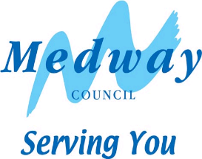
Ashley Road – Carriageway resurfacing
Where will the works take place?
Ashley Road, Rainham – whole road.
What are we planning to do?
As part of Medway Councils commitment to maintaining and improving the Highway Network, we are planning to undertake essential carriageway resurfacing work. Further details of the Council’s Annual Highway Improvement Programme can be found on the Council’s website at www.medway.gov.uk/resurfacing

When will the work start and how long will it take?
The work is programmed to start on or after 11th June 2024 for 1 day, between the hours of 7am and 7pm. Please note that dates may be subject to change if poor weather conditions or other difficulties are encountered.
How will we carry out the work and how will it affect you?
In order to undertake the work, a full road closure is required, including the suspension of on street parking for the period of the planned work. Vehicle lifting equipment may be used to ensure the road space is available.

There may also be times where you will not be able to access your driveway. If you require access to your property during the work, please ask the contractors on site for assistance, who will assist you if it is safe to do so.

Resurfacing works are by their nature noisy, and it would be expected that higher levels of noise will be experienced during the works. Every effort will be made to keep the disturbance to a minimum and the council apologises for any inconvenience this may cause. Please respect our workers space and safety by driving carefully and slowly through the roadworks. Everyone is entitled to a safe workplace. Our men and women work next to moving traffic and risk injury every day.
How to contact us?
If you have any problems or queries, in the first instance please speak to our workforce on site. Alternatively, email highwayops@medway.gov.uk, visit www.medway.gov.uk/YourFeedback or scan the QR code below.

