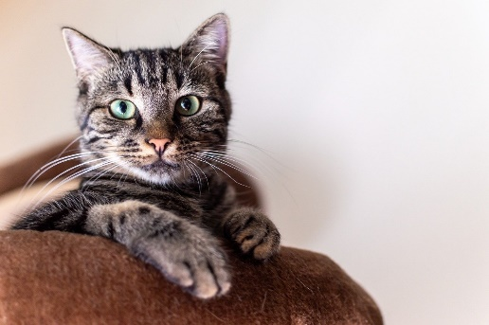
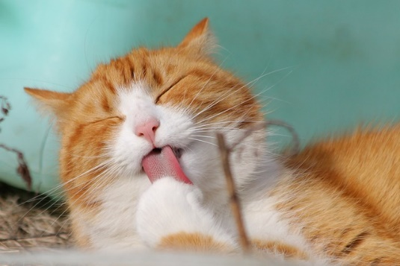
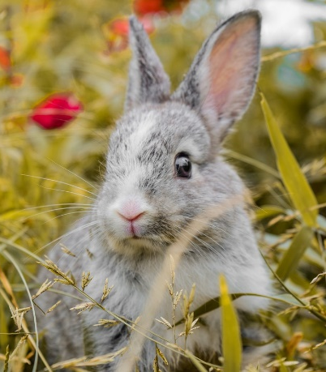
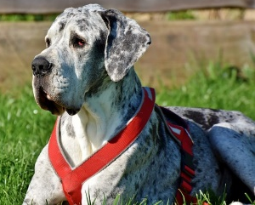
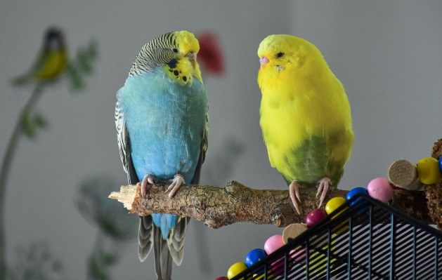
Medway Council HRA Services
Pet Policy 2024

Housing Services Pet Policy

1. Introduction
  - This policy outlines Medway Council Housing Services’ approach to pets within Council owned properties. Housing Services recognises that keeping pets can offer significant benefits to their owners. We aim to be reasonable, consistent, and fair whilst balancing the needs of all residents who may reside within a neighbourhood area.

  - It is also recognised that irresponsible pet ownership can cause nuisance and affect the quality of life of other residents in the area. Further still, we understand that some of our buildings may not be suitable for pets, such as dogs, or for large numbers of dogs within the complex. In some circumstances, these may be designated as ‘dog free’. Where possible Medway Council will consider applications to keep a pet on a case-by-case basis.

  - The purpose of this policy is to:
- Ensure we adopt a fair and transparent approach to pet permission.
- Ensure those living in our properties understand when pets are allowed and when they are not.
- Encourage responsible pet ownership.
- Provide a balance between pet ownership and the rights of others to peaceful enjoyment of their home.
- Outline how to make complaints about nuisance pets or welfare concerns.

  - This policy applies to all tenure and occupancy types.

  - Legislative and regulatory framework
- Animal Welfare Act 2006
- Dangerous Dogs Act 1991
- Anti-Social Behaviour, Crime and Policing Act 2014
- The Microchipping of Cats and Dogs (England) Regulations 2023
- Control of Dogs Act 1992
- The Equality Act 2010
- Landlord and Tenant Act 1985
- Medway Council Housing Services Tenancy Agreement

2. Can I keep a pet?

2.1 Medway Council Housing Services will allow pet ownership in many circumstances, but you must ask permission to keep any pet. Being allowed to keep a pet is based on responsible pet ownership and permission may be withdrawn at any time should issues arise. Both tenants and leaseholders must request permission to keep pets.

2.2 Being allowed to keep a pet will depend on a number of things such as:
- Where you live, size and type of home.
- Whether you have access to a garden/size of the garden.
- How many pets you wish to keep.
- The type of pet you would like to have.
2.3 Tenants are advised to consider the family household, the size of the property and whether keeping a pet is practicable in the environment that they live. Tenants must ensure that pets are limited to manageable numbers. Tenants should contact Housing Services if they need advice on what would be deemed manageable numbers.
2.4 Due to the size, location, number of properties, fire evacuation, and lack of suitable space, blocks of flats in Group A (Appendix 1) have been designated as dog free. Those living in these blocks are able to keep one cat or a reasonable number of caged animals such as hamsters or birds.
2.5 Those living in blocks within Group B, who do not have sole use of a garden, will be permitted to have one small/medium dog. Alternatively, you may keep one cat or a reasonable number of small, caged animals (see Appendix 2).
2.6 Those living in flats or one-bedroom bungalows, with the sole use of a garden will be permitted to have 1 large dog or 2 small/medium dogs. Alternatively, permission would be granted for 2 cats or a reasonable number of small, caged animals (see Appendix 2).
2.7 Those living in 2 or more, bedroom houses or bungalows will be permitted to have a maximum of 2 dogs or 2 cats or a reasonable number of small, caged animals (see Appendix 2).
2.8 We are unable to allow dogs or cats to be kept within Homes for Independent Living Schemes. Residents may however keep a reasonable number of small, caged animals (see Appendix 2).
2.9 Assistance dogs are not just pets, they are relied upon to help with daily activities. They’re trained to help people with disabilities, including sight impairment, hearing difficulties, epilepsy, diabetes, physical mobility and more. Assistance dogs have important rights under the Equality Act 2010. Registered guide dogs, hearing dogs and other assistance dogs are permitted in any property. They must be registered with an accredited member organisation of Assistance Dogs International (ADI) or the International Guide Dog Federation (IGDF).
2.10 Therapy dogs are different. If you wish to keep an animal for therapeutic reasons and your home is within a ‘pet free’ scheme, you’ll need to provide supporting medical information for us to consider.
2.11 Under the Microchipping of Dogs (England) Regulations 2015, all dogs over 8 weeks old must be microchipped and registered. The Microchipping of Cats and Dogs (England) Regulations 2023 means that cats must also be microchipped by 10 June 2024.
2.12 Tenants must ask permission to keep caged domestic animals such as rabbits, guinea pigs or ferrets. Permission will depend on the size and suitability of the space. Where permission is granted, they must be kept in manageable numbers, and have suitable shelter such as a suitable hutch or enclosure. You must follow RSPCA guidelines for their care.
2.13 Tenants must ask permission to keep chickens on their property. If the property is suitable, we may give permission for up to 6 birds. Cockerels are not permitted due to noise nuisance. If you wish to keep any other poultry birds, you will need to discuss this with Housing Services. Please note permission will not be granted to keep chickens in blocks of flats.
2.14 Tenants are not permitted to keep pigeons unless they can evidence that they are a member of the Royal Pigeon Racing Association. Permission will depend on the location, size, and suitability of the property.
2.15 Tenants are not permitted to keep bees. Keeping bees in residential gardens can be challenging and we must consider all residents. Experts recommend finding a site that is not in a garden and we would encourage those interested in keeping bees to approach the local bee keeping association who may assist with advice about suitable locations to keep bees. Medway Bee Keeping Association

3. Getting permission to keep a pet
3.1 You must apply for permission to keep any pet in your home. This must be made in writing using our pet permission request form. This allows Housing Services to ensure animals are being kept within the terms of the pet policy.
3.2 Any permissions granted are for that specific pet. You must apply for permission for every pet. If your pet passes away, you will need to apply for permission for any new pet.
3.3 Once given, permission may be withdrawn by Housing Services without notice if the animal causes a nuisance or annoyance.
3.4 Housing Services will respond within 10 days to advise whether permission has been granted. If permission has not been granted you will be provided with clear reasons.
3.5 Permission will be agreed in principle and not confirmed until receipt of a signed Pet Behaviour Agreement. The tenant must also provide the relevant details such as name, colour, chip number (where applicable). A letter of permission will be sent once Housing Services are satisfied that all information has been supplied.

4. Circumstances where permission will not be granted
4.1 We will not permit any dog that is listed, or fits the description of any dog, as part of the Dangerous Dogs Act 1991 unless permission to keep the dog was already in place prior to too legislation changes and the required exemptions in place. This includes:
- Pit Bull Terrier
- Japanese Tosa
- Dogo Argentino
- Fila Braziliero
- XL Bully from 1st February 2024.

4.2 Where new tenants have previously held permission and have the required exemptions in place, we will grant permission to keep a banned breed of dog, where all other requirements of this policy are met. This permission will cease upon the dogs passing. A special permission form outlining additional measures to be taken by the tenant will be required.
4.3 Tenants and leaseholders are not permitted to keep any animal which is considered dangerous or unsuitable. This includes wild or dangerous animals as listed under the Dangerous Wild Animals Act 1976 as well as poisonous creatures or livestock such as, horses, donkeys, goats, pigs, cattle, geese, cockerels, and some types of tropical birds.
4.4 Tenants and leaseholders should not encourage or feed wild animals (such as squirrels, foxes, pigeons, and other wild birds) either in the property or in communal areas or surrounding area, as this may cause a nuisance to other residents and damage to property.
4.5 Permission will be refused if the tenant or leaseholder or another household member has any convictions for, or history of abandonment, cruelty, neglect, or mistreatment of animals. It will also be refused if there is any conviction for any offences under the Dangerous Dog Act 1991, or the person has been disqualified from keeping animals or a particular type of animal due to conviction.

5. Responsible pet ownership
5.1 Permission to keep a pet is granted on the expectation that the tenant will be a responsible owner.
This means;
- The tenant is responsible for the health and welfare of their pets under the Animal Welfare Act 2006 and have a duty of care that requires proper day-to-day management and care of an animal. You should follow the Codes of practices for the welfare of dogs and cats. Care guidance for other pets can be found on the RSPCA website.
- Dogs or cats must be chipped as required by law.
- The Tenant must seek appropriate veterinary care if a pet requires it.
- No animal in a Medway Council owned property should be used for commercial purposes. Tenants must not breed or sell any animals from the property – this is a breach of the tenancy agreement.
- Pets must not be allowed to foul in communal areas. If this does occur it must be picked up immediately and disposed of appropriately.
- Pets must be kept under control. Dogs must be kept on leads in communal areas.
- Tenants must not leave a pet alone or unattended for long periods of time.
- The pet must not cause damage to the property. Any damage caused by the tenant’s pet or a visitor’s pet will be the responsibility of the tenant and the tenant could be recharged for repairs.
- Pets must not be kept in communal areas, including stairwells.
- Pets must not cause a nuisance to neighbours, staff, or visitors.
- Tenants must not hoard animals; this is the term used when people keep an excessive number of animals without the ability to properly house or care for them.
- Pets should be neutered.

5.2 If a neighbour of other resident believes a pet is being neglected or abused, they are encouraged to inform the RSPCA and to report this to the Housing Team. We will work with the RSPCA, Medway Council’s Animal Warden Team, and other appropriate agencies to investigate and prevent any harm to animals.
5.3 If Housing Services consider a pet is not being adequately cared for, they will raise concerns with the tenant and signpost to support where necessary. If there are concerns for the pet’s welfare, Housing Services will report this to the relevant authorities such as the RSPCA.

6. Withdrawing permission
6.1 We will withdraw permission where (but not limited to)
- A pet is being used for breeding.
- A pet is being neglected or abused.
- A pet is causing a nuisance.
- A pet is not under control at all times.
- A pet damages our property.
- A pet presents a threat or risk to other people, our staff, or other animals.
6.2 If your pet causes a nuisance.
If Medway Council Housing Services receive complaints about a pet, we will investigate the circumstances and work with the tenant to ensure the nuisance is prevented. If the nuisance continues and no remedy can be found Housing Services may withdraw permission to keep the pet and it will need to be rehomed.
6.3 Nuisance may include:
- Fouling in communal areas
- Excessive noise
- Roaming and unattended animals
- Unpleasant odours
- Over-population of animals in a household.
- Aggressive behaviour (threatening or harmful behaviour towards people or other animals)
- Dogs fouling in garden and not being cleared up.

6.4 Tenants who experience nuisance from a neighbour’s pet are encouraged to report their concerns to the Housing Team.
6.5 Complaints of pet nuisance will be considered as to whether they constitute anti-social behaviour (ASB). If this is the case, they will be dealt with in accordance with the ASB policy.
6.6 If a pet is the cause of persistent anti-social behaviour, permission to keep the pet may be withdrawn and legal action may be taken against the tenancy.

7. Keeping a pet without permission
7.1 Where it is found that a tenant or leaseholder is keeping a pet without permission, Housing Services will investigate to see whether permission would normally be granted. If it would, the tenant or leaseholder would be given the opportunity to apply for permission.
7.2 Where Housing Services decided that permission would not be granted to keep the pet, we will ask for the pet to be rehomed. Housing Services will give reasonable timescales for the rehoming of the pet. We will also require evidence that the pet has been suitably rehomed.
7.3 If a tenant or leaseholder continues to keep a pet without permission, Housing Services will take relevant action. This may include applying for an injunction or in the most serious cases we will begin possession proceedings or take action to terminate the Lease (forfeiture).

8. Looking after a pet on a temporary basis
The Council will allow you to look after someone else’s pet temporarily in a property that allows that pet to be there in accordance with this policy. You will require permission to do so. You can complete a temporary pet permission form on our website or request one from your Tenancy Management Officer. This would include circumstances where you may temporarily foster animals on behalf of a charity.

9. Right to appeal
9.1 In the event that a tenant or leaseholder is refused permission to keep a pet or permission has been withdrawn, they may appeal and request a review of the decision. An appeal must be made within 14 days of permission being refused.
Appeals can be sent by email to housingtenancyteam@medway.gov.uk
In writing: HRA Housing Service, Medway Council, Gun Wharf, Dock Road, Chatham, ME4 4TR.
9.2 The investigation will be carried out by a senior officer and independent to the officer who made the original decision. We may also seek advise from our Animal Warden team. When an appeal is lodged, Housing Services aims to make a decision in writing to the tenant or leaseholder within 14 days.
9.3 If you are still unhappy with the decision, the Council’s corporate complaints procedure can be followed. More information about the complaints process can be found on the Medway Council website.

10. Policy Exceptions
In exceptional circumstances, Medway Council Housing Services may consider variations to this policy. Any variation will depend upon the individual situation, any extenuating circumstances and evidence available. Each case will be considered on an individual case-by-case basis. Decisions made by Housing Services will be provided in writing to the relevant parties.

11. Further Information
Medway Council Housing Services has put together a Useful Information Sheet for pet owners or those concerned about an animal. It contains details of vets local to Medway Council property areas, information on free veterinary treatments and a number of local and national pet welfare organisations. This can be accessed on our website.

Appendix 1

Group A - Dog Free Blocks
Barfleur Manor
Benenden Manor
Brennan House
Esmonde House
Flaxmans Court (Unless you have sole use of a garden)
Hazlemere Drive
High St Rainham
Ingram Court
James Street
Longford Court
Manor House
Manor Street
Marlborough House
Mountevans House
Saunders Street
St Albans Close (Unless you have sole use of a garden)
St Marks House
Suffolk Court
Tangmere Close
Temeraire Manor
Tintagel Manor
Victory Manor
Vidal Manor
Woodchurch House

Group B – Limited dog ownership
(Refer to the policy or discuss with your Tenancy Management Officer)
Albert Manor
Andrew Manor
Beatty Avenue
Camperdown Manor
Charlecote Court
Charlton Manor
Chichester Close
Clopton Court
Cornwallis Avenue
Davenport Avenue
Gloucester Close
Greenview Walk
Harbledown Manor
Hathaway Court
Hawkhurst Road
High St Brompton
Holly Close
Mccudden Row
Park Manor
Pearman Close
Pearman Close
Perie Row
Pier Road
Scott Avenue
Skene Close
Wakeley Road
Welcombe Court
Wilmecote Court
Windmill Manor
Wollaston Close
Wood Street

Appendix 2

Examples of a small dog include:
- Chihuahua
- Miniature Dachshund
- Cavalier King Charles Spaniel
- French Bulldog
- Pug

Examples of a medium dog include:
- Beagle
- Cocker Spaniel
- Staffordshire Bull Terrier
- Springer Spaniel
- Schnauzer

Examples of a large dog include:
- Boxer
- Doberman
- Dalmatian
- Labrador Retriever
- Rottweiler

Examples of a giant dog include:
- Bullmastiff
- Great Dane
- Leonberger
- Newfoundland
- St Bernard

Small caged animals
Budgerigars and other similar small, caged birds
Small indoor caged domesticated animals such as hamsters, mice, gerbils, and rats.
Small indoor caged / outdoor hutched domesticated animals such as rabbits and guinea pigs.
Fish suitable to be kept in small, domesticated aquariums.
Non-venomous insects and spiders kept in a suitable, secure environment.
Non-venomous snakes and reptiles under two feet in length when fully grown, kept in a suitable, secure vivarium.

