Adult Care and Support

Summary

Introduction
Care and support for adults refers to help with everyday activities like personal care, moving around the home and living independently. Local authorities must undertake an assessment for any adult with an appearance of need for care and support, regardless of whether or not the local authority thinks the individual has eligible needs or of their financial situation.

Those who may need care and support include (but are not limited to) older people, people with long-term physical or mental health conditions, people with dementia, people with a learning, sensory or physical disability, and people with a mental health condition. Needs for care and support can be prevented or reduced by preventing or delaying ill health and disability and wider support to maintain independence and self-care.

An assessment should not just be seen as a gateway to care and support but should be a critical intervention in its own right, which can help people to understand their situation and the needs they have, to reduce or delay the onset of greater needs, and to access support when they require it. It can also help people to understand their strengths and capabilities, and the support available to them in the community and through other networks and services.

Key issues and gaps
Care and support needs generally increase with age. Medway’s population is ageing and is predicted to continue to age, with the number of people over 80 needing help and support with at least one self-care task and/or one domestic task projected to increase by 43% in women and 53% in men by 2040. A larger number of older people implies increasing age-related conditions such as dementia, multimorbidity (where someone has multiple health conditions), frailty and falls, as well as more older adults with disabilities. Service data indicates a rising prevalence of dementia in care home users, and the number of people with dementia in Medway predicted to rise by 46% between 2019 and 2030. Functional decline is not, however, an inevitable consequence of ageing, and much can be done to prevent, reduce and delay support needs.

Care and support needs are associated with ill health and disability, which are affected by deprivation and wider social, economic and health trends. Significant deprivation and ill health in some areas means that needs are spread unevenly across Medway. Wider trends such as an increase in people with multiple conditions, obesity and long covid must be addressed to prevent future care and support needs. Health and social care systems are interconnected and so pressures on the health care system will also influence future demand for social care. Social care is often the service relied upon in last resort, or after a crisis. This makes a focus on strategies to maintain health and wellbeing across the life course essential.

National and local policy emphasises the importance of keeping people independent in their homes for as long as possible. The proportion of adults receiving long-term social care support who are in care homes (32%) is above the England average (30%), though the rate of long-term support needs met by admission to care homes has decreased recently for both working age and older adults.

Recent service data indicates an increase in requests for support for adult social care among both working age and older adults. Rates are now higher than England and South East averages. The proportion of service users whose primary reason for support is listed as memory & cognition or mental health is lower than national and regional averages, as is the proportion of service users from ethnic minorities relative to the proportion in the population. These could be investigated further to determine whether they represent service gaps, data issues or population differences, alongside further analysis to better understand the specific pathways through which people in Medway are entering social care.

Recommendations for commissioning

- Invest in sustained upstream initiatives to keep adults in good mental and physical health and prevent, reduce or delay care and support needs. This should include promoting physical activity, healthy diet, and addressing lifestyle factors; improving secondary prevention and early diagnosis; maintaining cognitive and mental health, and reducing falls and fractures. There should be a particular focus on areas within Medway with highest need – both deprived urban areas such as Gillingham and Chatham and rural areas such as Strood and the Hoo Peninsula.
- Work with Medway Council’s planning and housing teams to ensure availability of suitable housing, and to support adaptations to keep people living in their own homes, including through the development of the new local plan. This should take into account the likely increase in older adults living alone.
- Health and social care commissioners should ensure appropriate capacity in community, residential and nursing homes to respond to increasing numbers of people with dementia. The wider recommendations of the Dementia JSNA chapter, including offering dementia awareness training to staff, should be followed.
- Commissioners should conduct further analysis of social care provision to inform the market position statement for residential and nursing services and ensure availability of a range of quality provision near to where people live, including ensuring a wide coverage of services across wards in Medway.
- Continue to prioritise community-based solutions keeping residents independent in their own home for as long as possible.
- In line with NICE guidelines, commissioners should ensure services reflect the increasing diversity of Medway including meeting gender, sexual orientation and cultural preferences.
- Services should be co-produced with users, starting at the beginning of commissioning processes. The 2020 engagement exercise with residential and nursing care services should be repeated.

Introduction
Activities of Daily Living (ADLs) are essential everyday activities relating to personal care and moving around the home. Instrumental Activities of Daily Living (IADLs) are further activities which are not as fundamental but represent important aspects of living independently. ADLs and IADLs are used to measure the need for and receipt of social care¹. Support with ADLs and IADLs – referred to as care and support in this chapter - represents one of the most significant provisions within Adult Social Care.

Summary of ADLs and IADLs

Summary of Activities of Daily Living (ADLs):
- Having a bath or shower
- Using the toilet
- Getting up and down stairs
- Getting around indoors
- Dressing or undressing
- Getting in and out of bed
- Washing face and hands
- Eating, including cutting up food
- Taking medicine.

Summary of Instrumental Activities of Daily Living (IADLs):
- Doing routine housework or laundry
- Shopping for food
- Getting out of the house
- Doing paperwork or paying bills.

Those most likely to need support with ADLs and IADLs include:
- Older people (65+)
- People with long-term physical or mental health conditions
- People with dementia
- People with a learning disability
- Autistic people
- People with a physical or sensory disability
- People with mental health conditions
- People who experience substance misuse
- Unpaid carers.

Social care in Local Government
Expenditure by local government in England on adult social care has been increasing along with demand². In 2022/23, local authorities in England received over two million requests for support and a total of 835,335 people were receiving publicly funded long-term care in 2022/23. Requests for support are increasing, especially for working age adults, among whom there were 22% more request for support in 2022/23 than in 2015/16³. Demand and therefore costs are predicted to continue to increase due to an ageing population, better diagnosis of conditions and higher survival rates in premature babies.
Medway’s Joint Health and Wellbeing Strategy aims to enable healthier and longer lives for everyone, including by supporting independence and self-care and supporting and protecting vulnerable adults. Care and support for adults is an important means of meeting these objectives and promoting the health and wellbeing of Medway residents with additional needs. Adult social care contributes to identifying health risks or vulnerabilities and intervening to prevent ill health before problems get worse. It also helps maximise mental and physical health and wellbeing by facilitating social interaction and participation in the community.

Under the Care Act 2014, local authorities are responsible for helping people get the care and support they need and to be safe and protected when they are vulnerable. This is to make sure that people who live in their areas:
- Receive services that prevent their care needs from becoming more serious.
- Can get the information and advice they need to make good decisions about care and support.
- Have a range of high quality, appropriate services to choose from.
- Are protected from abuse or neglect.
- Are supported if they are carers.
In considering whether an adult with care and support needs has eligible needs, local authorities must consider whether:
- The adult’s needs arise from, or are related to, a physical or mental impairment or illness.
- As a result of the needs, the adult is unable to achieve two or more of specified outcomes which include managing and maintaining nutrition, personal hygiene, a habitable home environment, and accessing and engaging in work, training, education or volunteering.
- As a consequence of being unable to achieve these outcomes there is, or there is likely to be, a significant impact on the adult’s wellbeing.
An adult’s needs are only eligible where they meet all three of these conditions. Where a local authority arranges care and support to meet a person’s needs, it may charge the adult, except where the local authority is required to arrange care and support free of charge.
Local authorities must undertake an assessment for any adult with an appearance of need for care and support, regardless of whether or not the local authority thinks the individual has eligible needs or of their financial situation; therefore this chapter considers the needs of any adult with an appearance of need for care and support, at population level.
While this chapter focuses on care needs associated with ADLs and IADLs in adults, further information about the public health issues that may contribute to this area of need can be found in the chapters on:

- Adult mental health
- Carers
- Dementia
- End of life
- Social isolation
- Substance misuse in adults
- Special educational needs and disabilities (SEND)

2) Who’s at risk and why?
Certain population groups outlined in Section one are more likely to need support with ADLs and IADLs. It is important, however, to note that belonging to one of these groups does not directly lead to needs. Needs reflect functional disability which can be prevented or delayed in many cases.

Age-related risk factors
The Health Survey for England (HSE) measures need for and receipt of social care among adults aged 65 and over. The latest survey was conducted in 2021. Needs generally increase with age, but the Chief Medical Officer’s 2023 Annual Report emphasises that this is not inevitable or true for everyone⁴. While 21% of adults aged between 65 and 69 needed help with ADLs or IADLs, the figure rises to 52% for those aged 80 and over. Nationally people are living longer which implies care and support needs are increasing⁵.
Other factors are also relevant alongside age.
- Sex: A higher proportion of women than men aged 65 and over needed help according to the HSE. Around 24% of men and 28% of women aged 65 and over needed help with at least one ADL in the past month. Approximately 21% of men and 29% of women needed help with at least one IADL⁶.
- Long-term conditions (those that cannot currently be cured but can be managed through medications or therapies): The HSE 2021 found that more than half of older adults with a limiting longstanding illness needed help with ADLs (53%) and IADLs (51%), compared with less than 10% of those with a non-limiting longstanding illness or no longstanding illness⁶. The number of people with long-term illness is increasing as people live longer ⁷. As people age, they also are more likely to have more than one long-term condition. These can interact, meaning an adult who was able to maintain independence with one condition may struggle to do so with more ⁴.
- Dementia may result in additional care needs. The primary support reason (PSR) is an indicator that shows what social care an individual is provided with. Support with memory and cognition is a common primary support reason for long-term care, representing 2% of working age adults and 13% of those aged over 65 nationally in 2022/23⁸. A 2014 study by King’s College London and the London School of Economics found that the average prevalence of people living with dementia in care homes was 69%⁹. In 2021, an estimated 944,000 people across the UK were living with dementia ¹⁰.
- Falls and fractures are a common and serious health issue for older people, with one in three adults over 65 and half of those over 80 experiencing at least one fall a year¹¹. Falls can lead to hospitalisation and long-term need for care and support¹².
- Frailty is when someone is less able to recover from accidents, illness or other stressors, and is often characterised by issues including muscle weakness, decreased endurance, balance problems and cognitive decline. Older people with frailty are more likely to experience falls¹³ and the number of people who are frail has been increasing⁷.

Other risk factors
Analysis of the primary support reasons (PSRs) given for social care support gives an indication of other drivers of care and support needs, often associated with health conditions and disability. These are outlined below alongside latest UK trends from the Family and Resource Survey. Other PSRs not discussed below include social isolation, substance misuse and asylum seeker support. A limitation of this approach is that the categories are very broad – for example physical support needs could arise in many different ways.

Overall, the Family and Resources Survey finds that the percentage of working age adults with a disability in the UK has increased from 16% in 2013/14 to 23% in 2021/22, rising from 11.9m to 16m¹⁴. There are more disabled women than men. In 2021/22, the most common impairment types among working age adults with a disability in the UK were mental health, physical impairments, learning, memory, social/behavioural, sensory and ‘other’.

Physical support
This includes access and mobility as well as wider personal care support, and was the most common PSR for long-term social care for the over 65s nationally in 2022/23 (75% of those accessing long-term support) and second most common PSR for working age adults (30% of clients)⁸. FRS data indicates that physical impairments – combining impairments related to mobility, stamina/breathing/fatigue and dexterity - remain the most common impairment type reported among people in the UK who self-identify as disabled, but prevalence has declined 10% from 2012/13 to 2021/22¹⁵.

Learning disability
This is the most common PSR for long-term social care support (46% of those accessing long-term support) for adults under 65⁸. The number of disabled people across the UK reporting a learning impairment was estimated to be 2.2 million in the FRS in 2021/22¹⁴. The number of people with a learning disability is likely to be growing due to better diagnosis and reporting of learning disability (e.g. better diagnosis in school with National Curriculum Tests known as SATs and Special Educational Needs protocols, and better recording by GPs), increased longevity and increases in the survival of premature babies⁷.

Sensory support
This includes hearing and vision impairments, and is another common reason for long-term social care support, representing 1% of those accessing long-term support⁸. Recent trends have seen a decline in FRS survey participants reporting impairments in hearing, memory or vision compared with pre-pandemic, but the data should be interpreted with caution as it may be the result of a change to telephone interviewing during the pandemic¹⁵.

Mental health support
This was listed as the PSR for long-term care among 14% of working age adults and 6% of over 65s⁸. There has been an upward trend in those reporting mental health impairments in the FRS, rising 16% from 2012/13 to 2021/22. Various reasons are proposed for this including increasing underlying rates, changing social attitudes, increasing diagnosis, and increasing provision of mental health services¹⁵. This aligns with GP-recorded data of those with a severe mental illness, which shows a slow increase in the past ten years in England¹⁶.

COVID-19
While the long-term effects of the pandemic are not yet known, data suggests a lasting effect on care and support needs, including through rising prevalence of disability. 1.9 million people in the UK were experiencing long Covid as of March 2023, representing 2.9% of the population. Of these, around 1.3 million people had symptoms that had lasted for more than a year and 762,000 had symptoms lasting for more than two years ¹⁷.

Obesity
The association between obesity and social care need and use of long-term care, informal and formal, has been highlighted by the Local Government Association¹⁸. Obesity is a risk factor for conditions which may give rise to a care and support need or increase needs such as musculoskeletal conditions and type 2 diabetes.

Wider determinants
Wider factors in the environment and community can increase support needs with ADLs and IADLs. Poor or unsuitable housing can lead to falls and fall-related injuries and is a leading precipitating factor for entering social care⁷. Over 65s are more likely to live in a home which does not meet the Decent Homes Standard and people under 65 with disability or long-term conditions also face similar challenges⁷. One in five households including someone with a limiting long-term illness or disability whose condition made it necessary to have adaptations in their home considered their accommodation to be unsuitable in 2019/20¹⁹. Housing standards vary between tenures, with the poorest standards found in the private rented sector²⁰; the number of people living in the private rented sector has increased.

Deprivation
The level of disability is higher in most deprived areas of England compared to the least deprived²¹. Similar pattern can be seen with multimorbidity²².
This association is true for care and support needs. HSE 2021 found that adults aged 65 and over from the most deprived areas were twice as likely to need help with ADLs and IADLs as adults living in the least deprived areas. The proportion of adults aged 65 and over who reported an unmet need for help with ADLs and IADLs was twice as high in the most deprived areas compared to the least deprived areas⁶.

Socioeconomic status
At an individual level, the proportion of adults aged 65 and over who needed help with at least one ADL or IADL varied by household income ⁶:
- In the lowest income group, 33% needed help with at least one ADL, and 31% needed help with at least one IADL.
- In the middle income group, 20% needed help with at least one ADL, and 19% needed help with at least one IADL.
- In the highest income group, 21% needed help with at least one ADL, and 21% needed help with at least one IADL.

Adults aged 65 and over in the lowest household income group were more likely to have an unmet need for help than higher income groups. Lower resources also mean an individual is more likely to meet financial eligibility criteria for adult social care.

Unpaid carers
A 2021 Public Health England (PHE) research paper outlines how (unpaid) caring can be considered a social determinant of health, associated with poor mental and physical health as well as unmet care needs, though evidence is limited²³. Carers are covered by a separate chapter, but more people are providing unpaid care and so the number of people with care and support needs may be increasing.

Ethnicity
There is considerable variation in disability prevalence by ethnicity which may suggest varying levels of need. House of Commons Library analysis of Annual Population Surveys between 2019 and 2021 finds that age-standardised disability is highest among the Bangladeshi ethnic group for adults aged 16 and older at 39% compared to 30% for Pakistani, 30% for Mixed/Multiple ethnic groups, 26% for white, 23% for Black African/Caribbean/British and 15% for Chinese¹⁵. Nationally the number of older people from Black, Asian and Minority Ethnic backgrounds has increased significantly in recent years²⁴. There are also known differences in social care use between ethnic groups. Long-term support by ethnicity. The percentage of adults receiving long-term support who were white went down from 87.8% in 2016 to 83.3% in 2021, with a corresponding increase in the percentage of adults in all ethnic minority groups (excluding white minorities)²⁵.

Trends in how needs are met
Care and support needs can be met formally through services or informally. A large proportion of care is provided informally by friends and family. Those less likely to have access to this informal care include those ageing without children and people living alone. Both of these groups have been increasing in recent years, increasing demand for formal social care. The number of people aged 65+ living alone in England and Wales grew 14.6% between 2011 and 2021, though the proportion of the population aged 65+ living alone has decreased from 31.5% to 30.1%²⁶. Women born in the 1960s are twice as likely to have not had children as women born after World War II²⁷. The level of informal care provided also varies by ethnic group and socioeconomic status.

3) The level of need in the population

Age-related drivers

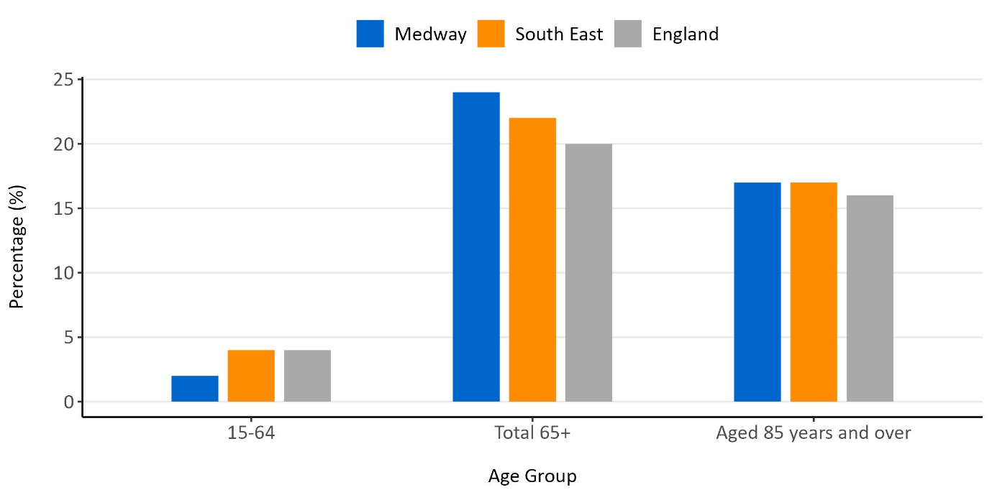
Figure one: Population percentage increase from the 2011 Census to the 2021 Census

Census 2021 recorded 46,053 people over 65 living in Medway. About 16% of the population is over 65 compared to 18% nationally and 20% in the South East²⁸. The number of older people is increasing; there has been an increase of 24% in people aged 65 years and over since 2011, including an increase of 17% in the 85 and overage category. In contrast there has been an increase of only 2% in people aged 15 to 64 years. Trends in England as a whole have been similar, though the increase in the over 65 group is slightly less at 20%.

The number of people over 65 who need help with at least one self-care activity in Medway in 2023 is estimated to be 13,242²⁹. This includes an estimated 1,715 men and 3,381 women over 80. An estimated 13,358 need support with IADLs, of which 1,617 are men over 80 and 3,795 are women over 80. These estimates use population projections from mid-2018 and data from the older 2016 Health Survey for England rather than the latest 2021 version.

Census 2021 reported 48,572 (17.4%) people in Medway with a long-term health problem or disability which limited day-to-day activities a little or a lot, compared to 16.2% in the South East and 17.3% in England. When comparing rates standardised for age, the proportion in Medway has decreased by 1% since 2011³⁰. However, there has been an increase the number of people with a long-term health problem or disability overall due to population growth. Locally, the Medway Health and Wellbeing Survey found that women were more likely to have a long-term health condition than men, as were adults over 55, White British/Irish ethnic group, economically inactive adults and adults who own their home outright.

From 2019/20 to 2021/22, Medway had a significantly lower rate of emergency hospital admissions due to falls for people aged 65+ (1,857) than England (2,127)³¹. This number is likely to be an underestimation of falls resulting in injuries, however, as it does not count cases where falls were a secondary diagnosis, or falls not resulting in a trip to hospital. From 2017/18 to 2021/22, Medway had a significantly higher rate of emergency hospital admissions due to hip fractures (609) than England (564)³¹.

Other drivers
The sub-sections below compare adult social care service data with estimated prevalence data. Individuals can only be given one PSR so this will underestimate the prevalence of conditions as many people will have more than one – for example someone with physical support needs as well as dementia would only be recorded as having a PSR of physical support. It is important to note that PSRs do not match directly onto types of disability or impairment so comparisons should be interpreted with caution.

Medway has a higher proportion of clients with a PSR of physical support (62%) than the England and South East average (both 54%). The proportion of service users with a PSR of learning disability (24%) has been stable recently and was similar to England at the end of 2022/23. The proportion of clients with a PSR of memory and cognition has increased in the last three years to 4%, but is still around half of the England and South East average (both 8%). This may be due to recording issues. The proportion with a PSR of mental health support has decreased slightly and is lower (8%) than the England (11%) and South East (10%) averages³. The proportion of service users with a PSR of sensory support has been stable in the last three years at around 0.8% and was lower than England (1.2%) at the end of 2022/23.

Physical Impairment
A total of 465 adults aged 18 to 64 (25%) and 1,295 aged 65+ (85%) were receiving long term support from adult social care for physical impairment at the end of 2022/23 in Medway. An estimated 9,158 people aged 18 to 64 have impaired mobility, and 1,448 a severe personal care disability³². Additionally, an estimated 8,397 people aged 65+ are unable to manage one or more mobility activity²⁹.

Learning Disability
A total of 625 adults aged 18 to 64 (48%) and 50 aged 65+ (3%) were receiving long term support from adult social care for learning disability at the end of 2022/23 in Medway. There are 1,304 people on the GP learning disability register³³. This has been stable over time and is similar to England but is likely to be an underestimate of all people with a learning disability.

Sensory Disability
Five adults aged 18 to 64 and five aged 65+ were receiving long term support from adult social care for visual impairment at the end of 2022/23 in Medway. The number of registered blind or partially sighted people was 1,375 in 2021. This equates to 494 registered blind or partially sighted people per 100,000 population, similar to England (492 per 100,000)³⁴. The estimated prevalence of sight loss in Medway was 2.80% in 2021 which is lower than the average for England of 3.3%³⁴.
A small number of adults aged 18 to 64 and 65+ were receiving long term support from adult social care for hearing impairment at the end of 2022/23. An estimated 1,013 people aged 18 to 64 and 3,483 people aged 65 + have severe hearing loss in Medway ³².

Mental Health Condition
In total, 175 adults aged 18 to 64 (13%) and 55 aged 65+ (4%) were receiving long term support from adult social care for mental health conditions at the end of 2022/23. There are 1,873 people on the Severe Mental Illness (SMI) register in Medway. This is likely an underestimate – modelling based on national prevalence figures estimates that there are 3,618 people with bipolar and 1,131 with psychotic disorders in Medway.

Memory and Cognition
A total of 15 adults aged 18 to 64 (1%) and 95 aged 65+ (6%) were receiving long term support from adult social care for memory and cognition at the end of 2022/23 in Medway. Internal Medway Council analysis showed a sharp increase in proportion of residential and nursing clients with dementia before the pandemic. Additionally, an estimated 3,170 people had dementia in 2019, of whom 1,835 severe dementia³⁵.
About 30% of adults in Medway were obese in 2022/23, which is higher than England (26%) and the South East (24%)³⁶. As outlined in Section 2, obesity is associated with greater care and support needs.

Wider determinants

Housing
In Medway, 18.1% of households are private rented, which is higher than the South East average of 16.9%³⁷. There were 13,132 people over 65 living alone in Medway in 2021³⁷. A total of 142 Disability Facility Grants applications were approved in 2022/2023, along with six home improvement loans.

Deprivation
In Medway, deprivation is higher than the England average. Medway is ranked as the 68th most deprived upper tier local authority out of 151 in England, with 1st being the most deprived. Medway contains some of the most deprived neighbourhoods in England; these neighbourhoods are in Gillingham and Chatham³⁸.

Caring
Of usual residents aged over 5 in 2021, 8.6% provide unpaid care of some amount, of which 7,380 people or 2.8% provide 50 or more hours of unpaid care per week³⁹.

Analysis by ward
Table one: Demographics by ward in Medway.

Measure | Medway average or total | England average | Wards with highest
Population aged 65+.  Source: Census 2021. | 46,053 (16%) | 18% | Hempstead & Wigmore (27.9%), Rainham South West (25.3%), Fort Horsted (22.9%), All Saints (22.1%), Rainham North (21.6%)
Population aged 85+.  Source: Census 2021. | 5,160 (1.8%) | 2.4% | Hempstead & Wigmore (3.3%), Fort Horsted (3.0%), Rainham South West (3.0%), Twydall (2.7%), Rainham North (2.6%), Rochester West & Borstal (2.5%)
Population aged 65+ living alone.  Source: LG Inform Plus based on Census 2021⁴⁰. | 13,132 (28.5%) | 30.1% | Gillingham South (40.4%), Luton (39.3%), Twydall (36.4%), Rochester West & Borstal (36.4%), Chatham Central & Brompton (35.7%), Fort Pitt (35.6%)
People aged 60+ in deprivation.  Source: LG Inform Plus based on IMD 2019⁴⁰. | 7,500 (13.3%) | 14.2% | Chatham Central & Brompton (25.5%), Luton (23.4%), Gillingham South (22.0%), Wayfield & Weeds Wood (20.6%), Gillingham North (19.5%), Twydall (18.8%), Fort Pitt (17.8%)
Limiting long-term illness or disability.  Source: Medway Health and Wellbeing Survey 2023. | 30.1% | - | Strood Rural (40.5%), Watling (37.5%), Wayfield & Weeds Wood (52.4%), Gillingham South (37.2%), and Hoo St Werburgh & High Halstow (37.3%)
Severe mental illness.  Source: Medway Health Profile³¹. | 0.8% | 1.0% | St Mary’s Island, Rochester East & Warren Wood, Chatham Central & Brompton, Fort Pitt, Rochester West & Borstal
Proportion of households renting privately.  Source: LG Inform Plus based on Census 2021⁴¹. | 18.1% | 20% | Gillingham South (42.2%), Chatham Central & Brompton (29.6%), Gillingham North (28.9%), Luton (28.3%)
Emergency hospital admissions for hip fractures people aged 65+ (directly standardised rate).  Source: Medway Council analysis based on NHS Digital. | 609 (2017/18-2021/22) per 100,000 | 564 | There were significantly higher rates of admission for residents living in Chatham Central & Brompton (1,037), Luton (850), Rochester East & Warren Wood (753) and Watling (737) wards.
Emergency hospital admissions due to falls people aged 65+ (directly standardised rate).  Source: Medway Council analysis based on NHS Digital. | 1,857 (2019/20-2021/22) per 100,000 | 2,127 | The ward with the highest rate of emergency hospital admissions due to falls was Chatham Central & Brompton (3,086)

There is variation in the populations across different wards in Medway. There is a larger older population (65+ and 85+) in the South East, in areas such as Rainham, Hempstead & Wigmore and Lordswood & Walderslade; in Strood; and a significant minority of the total older population in the Hoo Peninsula. While some of these reflect locations of care homes, other areas such as Gillingham South also have a high percentage of older people living alone, and of older people in deprivation. Taken together with Table One, this suggests that there may be higher care and support needs in more urban areas of Medway such as Gillingham, Twydall, Luton and Chatham well as pockets of need in rural areas of Strood and the Hoo Peninsula.

Requests for support
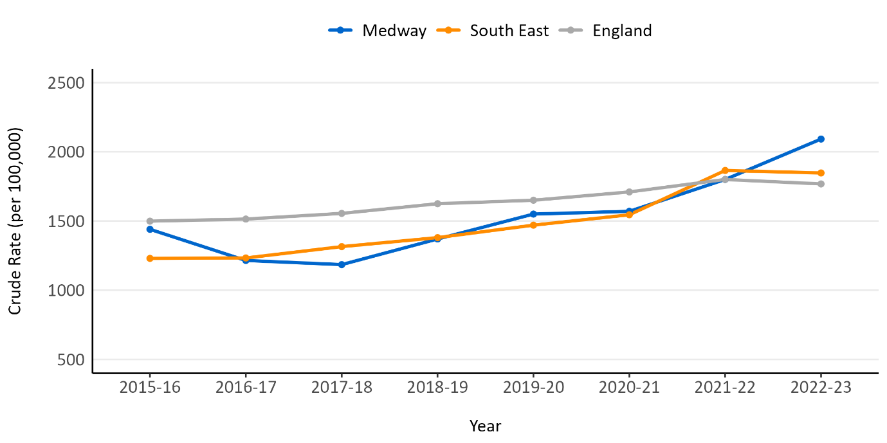
Figure two: New requests for support from adults aged 18 to 64 per 100,000 population.

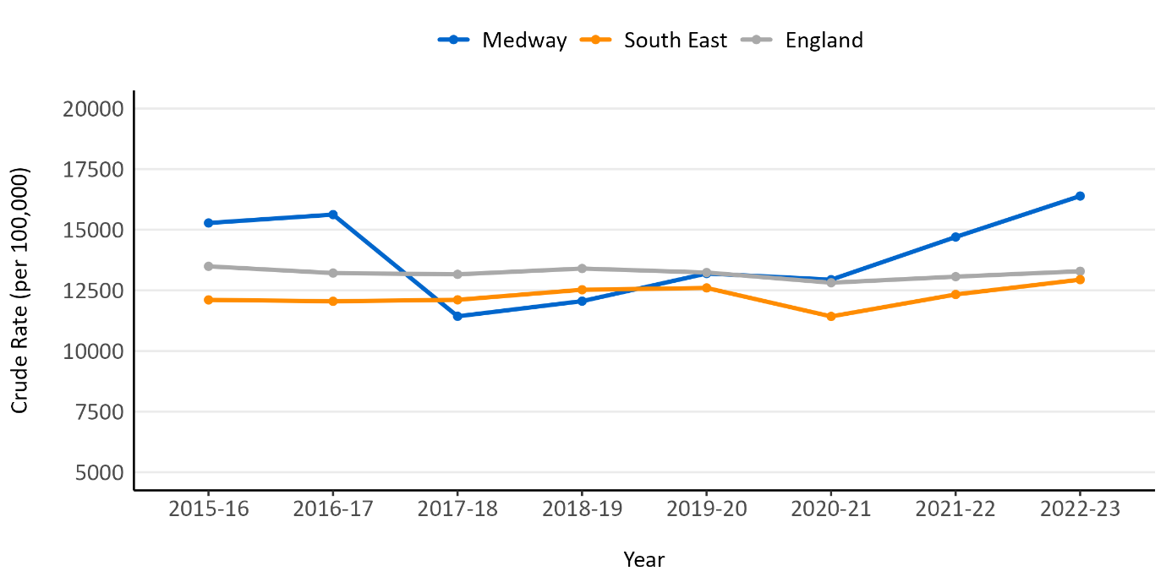
Figure three: New requests for support from adults aged 65+ per 100,000 population.

Requests for support do not represent the full need in the population as not all people with needs will be eligible or come forward for support if eligible. Requests are also influenced by the availability and effectiveness of other support services. Requests for support have increased in the last five years for both working age and older adults and are now above England and South East averages. In total, 11,158 requests for support for adult social care were received from new clients in 2022/23, a 15.2% increase compared to 2021/22. 68.1% of these came from those aged 65 and over^{8,42}.

4) Current services in relation to need

Overview of services
Adult Social Care services are provided following an assessment of an individual’s needs. Where a resident of Medway is over 18 and meets the threshold for services to be offered, a range of services are available. An integrated approach between health and social care includes a strong focus on preventing care and support needs and supporting people to live independently and well for longer. A financial assessment may also be carried out to see whether the resident will be charged for the service or not. Services are designed to empower individuals to maintain their independence, allowing them to live in their own homes whenever possible, and reducing the need for intensive medical support (for example, a hospital stay). In cases where a resident doesn't meet the criteria for services, they receive information and advice about alternative, often community-based options that could help.

Medway Council’s approach to meeting care and support needs is guided by its Adult Social Care Strategy, which emphasises principles of prevention, early intervention and recovery, enablement, and safeguarding. The Medway Council website provides details of the different types of short- and long-term adult social care available. Short-term support includes intermediate care and reablement which provides Medway residents with short term care and the opportunity to retain and regain independence either in their own home or in a reablement care bed for up to six weeks. Long-term services are ongoing and range from high intensity services such as nursing to lower intensity support in the community. This includes:
- Supported living is a service that helps people to retain their independence whilst still having the extra physical and emotional support needed to lead completely fulfilled lives in their own homes.
- Extra care housing combines accommodation with care and support services. The type of support will depend on a person’s needs, which Adult Social Care will usually assess.
- Day care.
- Home care, where support is provided in someone’s own home.
- Residential and nursing care (known together as care homes).

Wider services available for care and support needs, including those funded by the Better Care Fund, include Medway Wellbeing Navigation Services, Medway Integrated Community Equipment Service (MICES), community nursing, Assistive Technology services and dementia support. Further services are provided by the voluntary and community sector.

NHS Continuing Healthcare (NHS CHC) is a package of care for adults aged 18 or over which is arranged and funded solely by the NHS. In order to receive NHS CHC funding individuals, have to be assessed by integrated care boards (ICBs) according to a legally prescribed decision-making process to determine whether the individual has a ‘primary health need’. Where a person has been assessed to have a primary health need, they are eligible for NHS Continuing Healthcare and the NHS will be responsible for providing for all of that individual’s assessed health and associated social care needs. In 2022/23 794 people were supported with CHC in Medway. There was a drop in the number of people supported in 2020/21 associated with the suspension of eligibility testing for CHC as the government funded the cost of new or extended out-of-hospital health and social care support packages for people being discharged from hospital, with a subsequent increase in numbers in the past two years.

NHS-funded nursing care (FNC) is when the NHS pays for the nursing care component of nursing home fees for those meeting eligibility criteria. In 2022/23, 764 people were supported with FNC. The number has been stable for the past three years but is less than the 869 people supported in 2019/20.

Social care providers in Medway
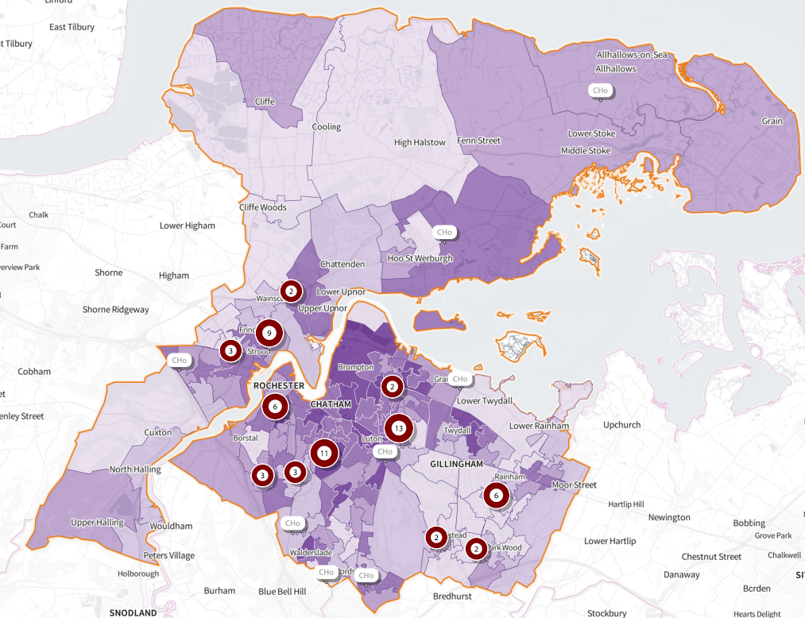

Figure four: Map of Medway indicating the location of residential or nursing home registered with CDQ. Circles indicate the number of these in each location. Colouring is by Income Deprivation Affecting Older People index score 2019. Darker colours represent more deprived areas (SHAPE).

Medway had 8.1 care home beds per 100 people aged 75+ in 2021 which is fewer than the South East average of 10.1 and England average of 9.4. The number has been decreasing in the last ten years from a high of 10.1 in 2012⁴³. Of Medway’s 63 care homes, 41 are rated good, one outstanding, 17 ‘require improvement’ and four have not been inspected. As reported in the Dementia JSNA chapter, Medway faces significant challenges with capacity in nursing homes which provide care to individuals presenting complex and challenging needs as an outcome of their dementia. Internal Medway Council analysis highlights that there is significant provision of services outside Medway, and for a significant minority outside the region, especially for some groups and service types such as residential services for people with a learning disability. Stakeholders consulted as part of the development of the chapter pointed to anecdotal evidence of a lack of capacity in Medway for clients with complex needs and behaviours, people with early-onset dementia, and 18-55 year olds with physical disabilities.

Service trends
The following analyses are based on Adult Social Care Activity and Finance Report unless otherwise stated^{8,42}.

Short-term care
Medway delivers more short-term care than the national and regional averages. Following a decrease in 2019/20, numbers have been steadily increasing for those aged over 65.
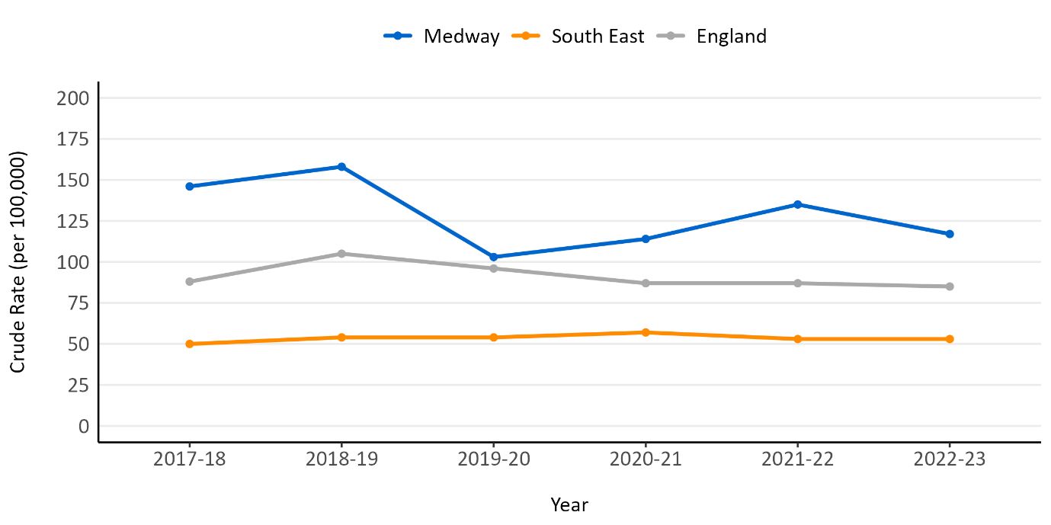
Figure five: Completed episodes of short-term care to maximise independence for people aged 18 to 64. 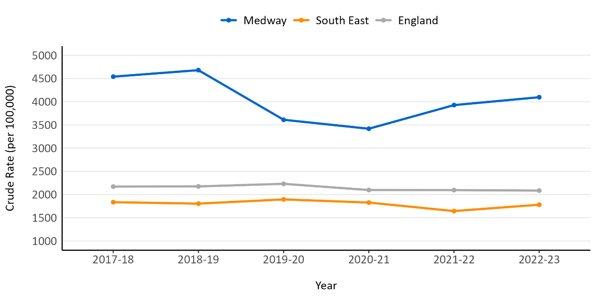
Figure six: Completed episodes of short-term care to maximise independence for people aged 65+.

Long-term support
Figures seven and eight illustrate the rate of people needing long-term support in Medway.
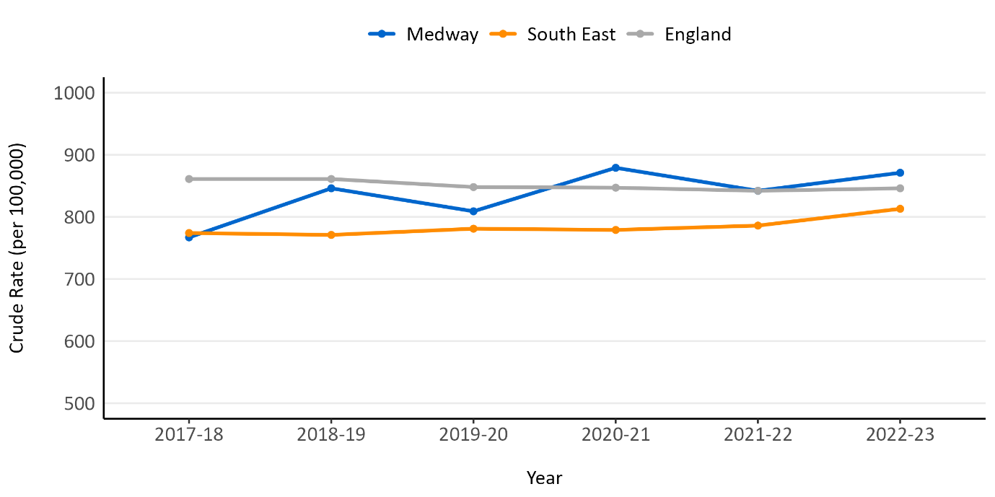
Figure seven: Long-term support during the year for people aged 18 to 64 per 100,000 population. 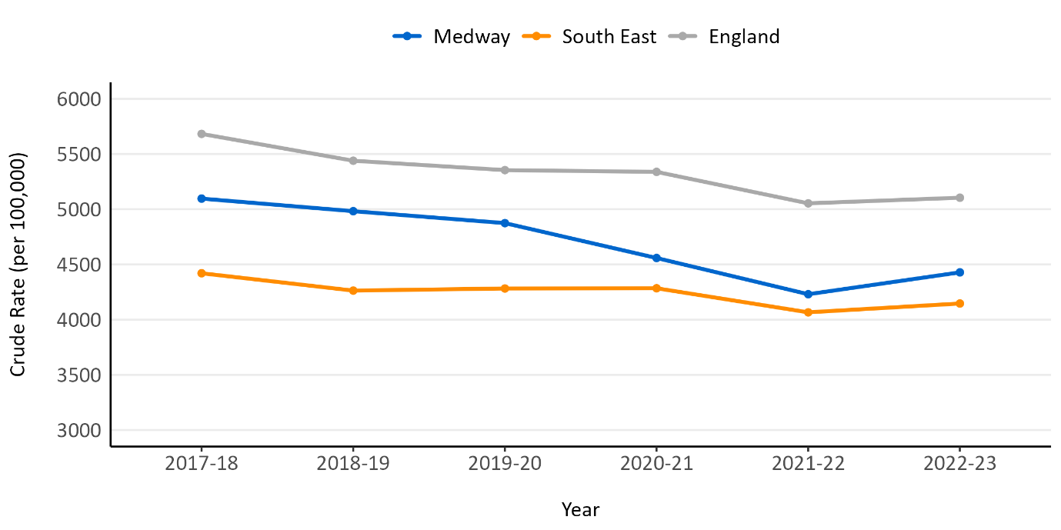
Figure eight: Long-term support during the year for people aged 65+ per 100,000 population.

The number of people aged 18-64 accessing long-term support per 100,000 population has increased 14% since 2017/18 and is now higher than the England and South East averages. The rate of support to people aged 65+ has decreased 13% over the same time period and remains lower than the England average but slightly higher than the South East. A higher proportion of long-term clients are aged 18-64 compared to England, which is driven by the lower relative rate of support for older adults.

Support by setting
Most long-term support is provided in the community rather than in nursing or residential settings, though the proportion of long-term clients supported in care homes is higher in Medway (32%) than the England (30%) average but similar to the South East (32%) average.

Table two: Number of clients accessing long term support during the year, by age band and support setting, 2022/23 from NHS Digital.

 | Care home | Community | Total | Percentage
Aged 18-64 years. | 255 | 1,235 | 1,490 | 42%
Aged 65 years and over. | 900 | 1,180 | 2,080 | 58%
Total. | 1,155 | 2,415 | 3,570 | n/a
Percentage | 32% | 68% | n/a | n/a

Community-based care
Comparing numbers per 100,000 population, the number of people aged 18-64 supported in the community increased 15% from 2015/16 to 2021/22 and converged with the England average. The rate of support for people aged 65+ in the community was decreasing slowly in line with the England average but then dropped sharply from 2020/21 to 2021/22 and is now similar to the South East average.

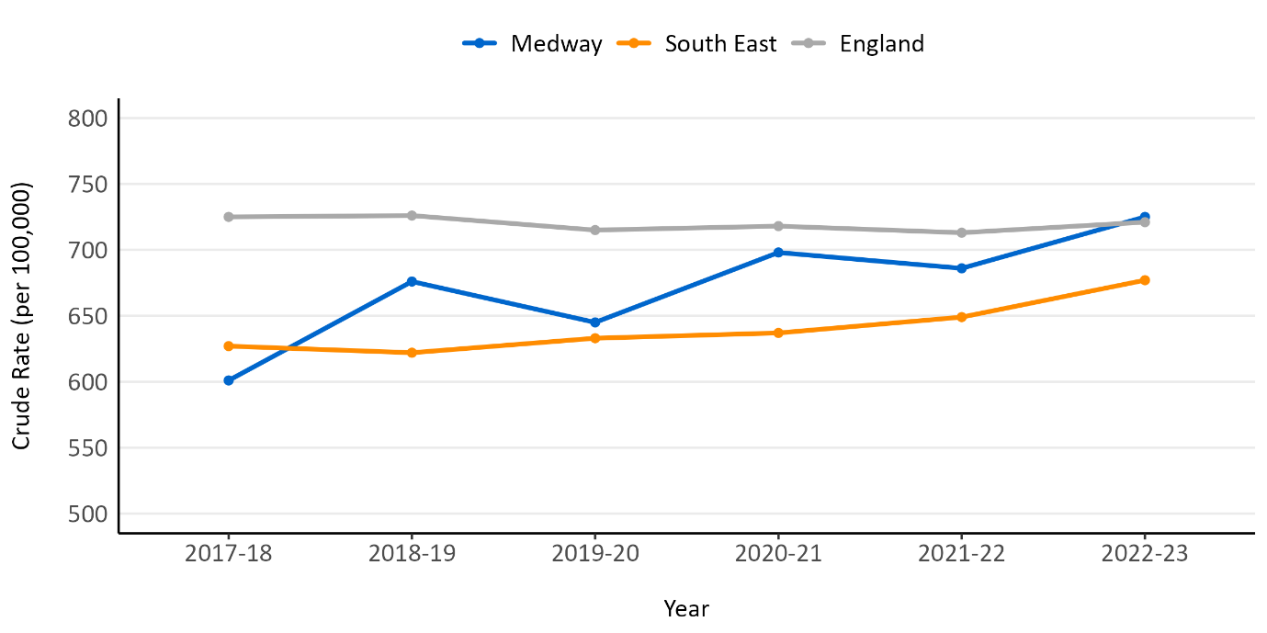Figure 9: Number of people aged 18 to 64 that are supported in the community per 100,000 population.

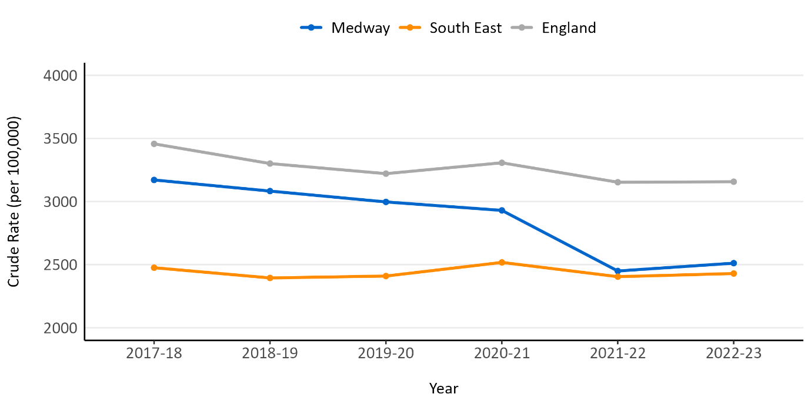
Figure 10: Number of people aged 65+ that are supported in the community per 100,000 population.

Care provided in care homes
The number of people aged 18-64 receiving nursing or residential support per 100,000 has been consistently higher than the England and South East averages. The number of people aged 65+ receiving nursing or residential support has increased in the last two years and is now similar to the England average and higher than the South East average.

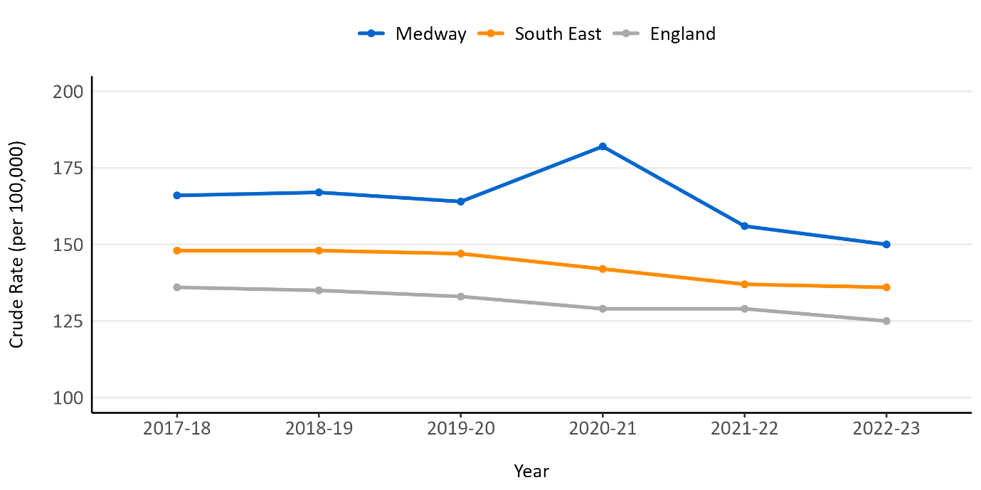Figure 11: Number of people aged 18 to 64 that are supported in care homes per 100,000 population.

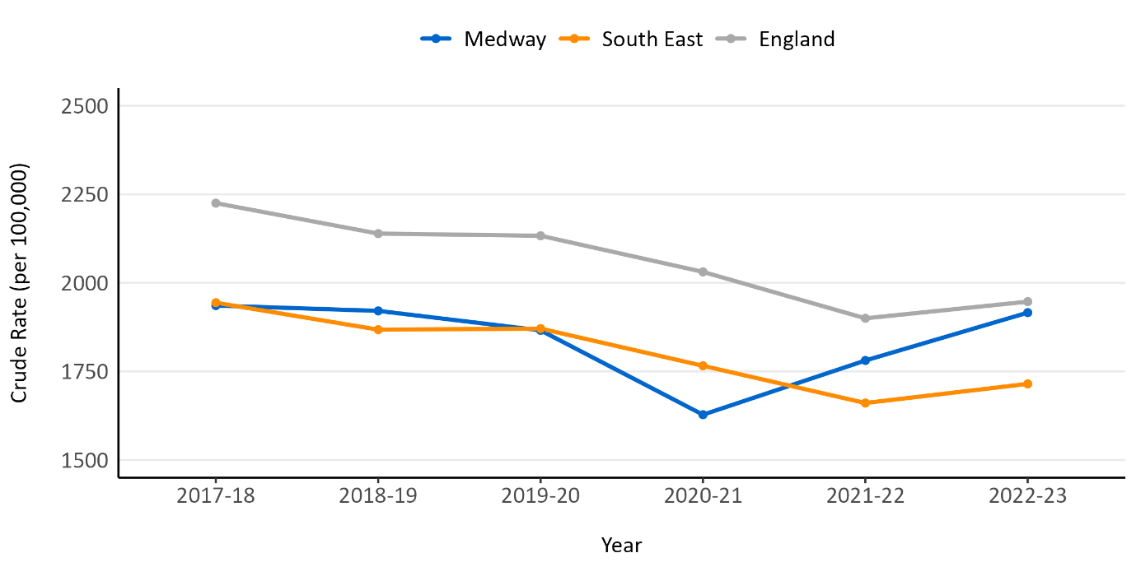Figure 12: Number of people aged 65+ that are supported in care homes per 100,000 population.

Further internal analysis has been conducted for specific services within the categories of community and care homes covering a slightly different time period of 2016/17 to 2021/22. This analysis did not include client contributions except in the case of direct payments where service user charges were also analysed:
- There was an 82% increase in the number of supported living clients from 188 in 2016/17 to 342 in 2021/22. Supported Living provision was entirely concentrated in the 18-64 group with no supported living cases with a PSR of older person or older person mental health.
- There was a relatively stable number of homecare clients of around 1,800 from 2016/17 to 2020/21 until a sharp 19% decrease to 1,461 in 2021/22. This may have been due to COVID-19 or clients being on waiting lists due to a lack of provision.
- A 13% increase was seen in the number of clients receiving direct payments from 595 in 2016/17 to 672 in 2021/22. Direct payments include a means-tested service user charge. Between 2016/17 and 2021/22 the number of people paying a service user charge increased by 46%, faster than the number of clients receiving direct payments. By cost, service user charges increased 174% over the same time period.
- There was a 13% decrease in the number of clients in residential homes over six years from 880 in 2016/17 to 768 in 2021/22, partially offset by an increase in numbers of nursing clients by 15% from 337 to 386.

Self-funders
Data on people who self-fund their care is limited. Experimental modelling from the Office for National Statistics (ONS) and the Care Quality Commission (CQC)⁴⁴ indicates that Medway has fewer self-funders for care home support than the South East but the imprecision of the estimates no not allow us to draw comparisons with England or for community-based care. The modelling estimates that in Medway the proportion of people supported in care homes who are self-funders lies between 19% and 31% and of people supported in the community lies between 22% and 58%.

Adult Social Care Outcomes Framework
The Adult Social Care Outcomes Framework (ASCOF) measures how well care and support services achieve the outcomes that matter most to people. The measures are grouped into four domains, though this will change from 2023/24.
- Enhancing quality of life for people with care and support needs
- Delaying and reducing the need for care and support
- Ensuring that people have a positive experience of care and support
- Safeguarding adults whose circumstances make them vulnerable and protecting from avoidable harm.

Medway’s performance can be viewed using the ASCOF interactive dashboard. Figures refer to 2022/23 unless stated. Recent trends on a selection of indicators are outlined below:
- 1A – Medway’s social-care related quality of life score is 18.7 which was similar to the England (19.0) and South East (19.2) average. Medway is ranked 102 nationally. The trend has been stable over the past five years.
- 2A – Medway has a higher rate of long-term support needs of those aged 65+ met by admission to residential and nursing care homes (621.6 per 100,000) compared to the England average (560.8) and South East (556.9), though this is not confirmed statistically, and ranks 98 nationally. The rate increased to 718 in 2020/21 but has decreased in the past two years. The rate in the 18-64 age group has decreased from 15.4 per 100,000 in 2021/22 to 14.1 in 2022/23 and is now lower than the England (14.6) and South East averages (15.4).
- 3A – The proportion of people using services who are extremely or very satisfied with their care and support in Medway is similar (62.0%) to the England (64.4%) and South East (64.6%) averages. Indicative analysis suggests satisfaction is lower for women than men and for those aged 65+ than those aged 18-64 (68.1%).
- 4A – The proportion of service users who feel safe in Medway is 68.3% which is similar to the England (69.7%) and South East (70.4%) averages. The trend has been relatively stable over the past five years.
- 2B1 tracks the proportion of people 65+ discharged from hospital into reablement services who are at home 91 days after discharge. Performance dropped sharply from 76.2% in 2019/20 to 60.5% in 2020/21. Medway has seen a 13% increase to 69.7% in 2022/23 but is still significantly lower than England (82.3%) and South East (78.6%) averages. The difference between Medway and England is greatest for the 65-74 age group (56.3% vs. 85.1%), for whom performance has been steadily decreasing.

5) Projected service use and outcomes in 3-5 years and 5-10 years
It is possible to make estimates about future trends in support needs for activities of daily living by making assumptions about future population growth and changes in health and wellbeing. The projections are not forecasts and do not account for policy, economic or social trends so should be treated with caution.

Age-related drivers
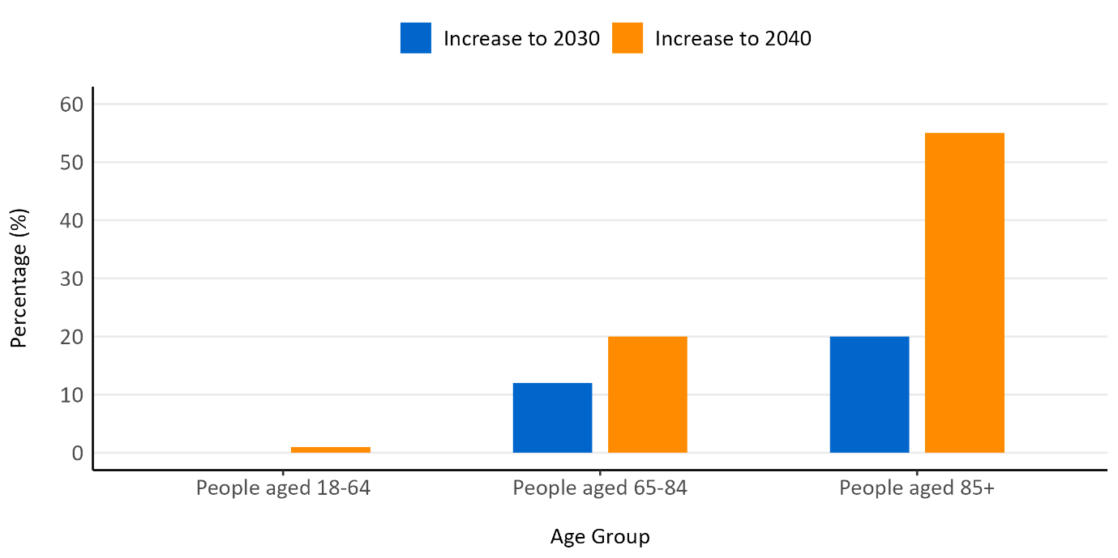
Figure 13: Projected population increase to 2030 and 2040 in Medway by age group.

In Medway it is anticipated that the percentage of residents aged over 65 will increase by 24% by 2040, representing an additional 11,400 number of people. However, the number of adults aged 18-64 is set to see an increase of only 1% in the same period. The largest increases are predicted in the older age cohorts, with a particularly large increase of 55% in those aged 85+, representing an extra 3,100 people²⁹.

The number of people aged 65+ in Medway who may need help and support with at least one self-care task and/or one domestic task are both projected to increase steadily over the next 10-20 years. Both categories see a 13-14% increase over the next 7 years to 2030 reaching a 28% increase by 2040. The age groups which see the biggest increase are the older age groups with those aged over 80 seeing an increase of 43% in women and 53% in men in those requiring help by 2040²⁹. An ageing population is likely to see increases in conditions such as dementia. Applying the population projection method above, there is a predicted 38% increase in the number of older people within dementia between 2023 and 2040. Other projections indicate a greater potential increase, with a rise by 46% over a shorter time period between 2019 and 2030³⁵.
The increase in the number of older adults is likely to lead to an associated increase in the numbers of older adults with a physical disability, learning disability, sensory disability, mental health support needs, older adults living alone. RNIB predict an increase in the number of people with severe sight loss from 1,030 in 2022 to 1,240 in 2032, driven in part by increases in age-related sight-threatening eye conditions such as cataracts and age-related macular degeneration³⁴.
As outlined above, the number of people growing old without children will increase though this may vary by ethnicity⁴⁵. An ageing population is likely to see increases in age-related events such as falls. At a national level, a growing number of older people are also providing care to family members or others close to them. Caring is associated with poorer mental and physical, so this trend may indicate increasing care and support needs in future.

The older population is also likely to be increasingly diverse with changing needs and wants from social care. Increasing ethnic diversity among working age adults in Medway will translate into increased diversity in the over 65s as this cohort ages. Requirements for formal care will be influenced by the differing levels of informal care accessed by different ethnic groups⁴⁵. Diversity in sexual orientation and gender identity is set to increase significantly in the next few years²⁴.

Other drivers
The relatively stable numbers of adults aged 18 to 64, with a predicted increase of only 1%, generates stable projections of the number of working-age adults with a physical disability, learning disability, sensory disability, and mental health support needs by 2040³². They do not take into account emerging factors such as the changing prevalence of disability and deprivation, and of risk factors for ill health and disability such as obesity and smoking. There are, however, reasons to believe that economic, social and health factors may lead to changes in care and support needs.
It is too early to be sure of the impact COVID-19 will have. However, internal modelling for the NHS in the South East suggests that COVID-19 may cause a net increase in care and support needs if other preventive measures are not put in place. The model predicts a 69% increase in the number of people with long covid by December 2027 in Medway compared to December 2022. An increase in the number of people with multiple conditions, rising by 9% between December 2022 and December 2027, and reaching a level 3% higher than it might be in a no covid scenario. This increase is predicted to offset the reduction in needs due to increased mortality during the pandemic.
Health and social care systems work closely together but can place pressures on each other. A lack of social care support can lead to unnecessary GP consultations, A&E attendances and delayed discharges from hospital. Conversely a lack of prevention and prompt treatment in the health system can lead to additional demand for social care, due to increased levels of ill health and disability, or through more short-term dynamics such as delayed elective operations. In Autumn 2023 70% of Directors of Adult Social Services reported that social care staff are undertaking activity that would previously been done by the NHS⁴⁶. ADASS states that the strain placed on the health care system through the COVID-19 pandemic is likely to continue to affect social care demand in the short-term⁴⁷.
More broadly, care and support needs are associated with ill health and disability, which are higher in deprived areas and among disadvantaged groups as outlined above. Social and economic trends such as economic hardship resulting from the cost-of-living crisis are also therefore relevant when planning for future care and support needs.

6) Evidence of what works

Current government policy and implementation plans
Recent government policy, such as the Major Conditions Strategy, has re-emphasised the importance of adopting a preventative public health approach, keeping people healthier and independent for longer and delaying or avoiding the onset of care and support needs.
The Chief Medical Officer’s 2023 Annual Report Health in an Ageing Society emphasises that ill health and disability in older age is not inevitable and highlights the importance both of reducing disease and adapting the environment through a number of actions. These include focusing more on rural and coastal areas where older people are increasingly concentrated; delaying or preventing disease such as through promoting exercise and reducing air pollution; responding to multimorbidity and frailty; and collecting data on neglected aspects of older people’s health and care needs such as hearing loss and mental health.
In 2022 the government published People at the Heart of Care, a comprehensive policy paper setting out a ten year vision for transforming adult social care in England. The vision is broken down into three objectives:
- People have choice, control, and support to live independent lives.
- People can access outstanding quality and tailored care and support.
- People find adult social care fair and accessible.
The evidence review conducted to support the paper highlighted several key themes relevant to commissioning:
- There is some positive evidence linking closer integration between health and care systems with service quality and outcomes for users.
- Poor or unsuitable housing is a major public health risk contributing to care needs, and addressing this, for example by specialist housing and adaptations, can prevent and reduce care needs.
- Prevention and early intervention programmes can prevent or delay the onset of long-term conditions and improve wellbeing and independence. CQC reports that investment in low-level preventive services can result in reduced care and support needs leading to a £880 annual cost saving per person⁴⁸.

Building the Right Support Action Plan outlined six priorities for people with a learning disability and autistic people:
- Keeping people safe and ensuring high-quality health and social care
- Making it easier to leave hospital
- Living an ordinary life in the community
- A good start to life
- Working with changes to the system
- National and local accountability to deliver.

NICE evidence
As of December 2023, the National Institute for Health and Care Excellence (NICE) lists 50 best practice guidelines and 10 quality standards related to adult social care including:

- NICE guideline [NG96] (2019) on the care and support of people growing older with learning disabilities. This makes a number of recommendations to commissioners, such as identifying the number of adults in their area with a learning disability by encouraging GPs to maintain a learning disability register and getting information from other support services; ensuring appropriate housing options including residential and nursing care homes that reflect gender, sexual orientation and cultural preferences; ensuring the availability of appropriate physical and mental health services; and promoting a range of community-based physical activity programmes and transport options to enable people with learning disabilities to remain independent.
- NICE guideline [NG86] (2018) on improving the experience of care and support for people using adult social care services. This makes a number of recommendations including using a strengths-based approach; involving people in decision-making about their care; being aware of the cultural and religious needs of service users; and co-producing services with service users.
- NICE guideline [NG22] (2015) on older people with social care needs and multiple long-term conditions. This makes a number of recommendations including ensuring a single named care coordinator; planning care collaboratively; integrating health and social care planning; and preventing social isolation.
- NICE guideline [NG74] (2017) on intermediate care including reablement. Recommendations include a strengths- and person-based approach; ensuring intermediate care is provided in an integrated way; and providing intermediate care to people in their own homes wherever practical.
- NICE guideline [NG21] (2015) on home care: delivering personal care and practical support to older people living in their own home. Recommendations include ensuring a person-centred approach; ensuring home case packages address social care-related quality of life and the person’s wider wellbeing; and planning care collaboratively.

Academic evidence
The National Institute of Health and Care Research (NIHR) has established a Policy Research Unit in Adult Social Care which investigates four themes: 1) understanding social care needs and models of provisions; 2) impact and quality of services; 3) system organisation and oversight; 4) social care demand and funding challenges now and for the future. A 2022 study by the Policy Research Unit analysing data from the United Kingdom Household Longitudinal Study found that social determinants of health like identifying as female, ethnic minority or lower socioeconomic group – interact with informal care provision to produce greater negative effects on key life domains⁴⁹. For younger people, caring is associated with poorer mental health and social isolation, while for older adults it is associated with worse physical health.

A 2020 NIHR-funded review of academic literature found people in England who pay for their own social care receive little assistance in arranging care compared to older people funded by their local council, and recommended a tailored approach to supporting older people manage their care regardless of their funding status⁵⁰.

7) User views

Service user views
The Adult Social Care Survey surveys adult users in receipt of long-term support services funded or managed by social services following a full assessment of need. In 2022/3. Results are reported in Section 4.

Healthwatch Medway have conducted reports with the public and social care users, including:
- A report on the Enhanced Health in Care Home programme (2023) based on visits to 15 care homes across both Kent and Medway. The report found that people living in care homes were usually very happy with the care received, with Medway and Swale receiving a higher proportion of positive responses than East Kent, West Kent and Dartford, Gravesham and Swanley. Care home residents in Medway and Swale reported challenges, however, around care planning, residents feeling isolated, having their preferences respected, the range of activities on offer.
- A report on the reablement service in Medway (2022), which found that service users felt that they needed more care than they were offered, and particularly that they would have liked more support to build confidence than was offered.

Medway Council engaged with 80 users of residential and nursing care services in July and August 2020, the majority of whom were over 65. Most respondents reported feeling happy, safe and secure in their care home, and that they were involved in important decisions about their care. However, a significant minority disagreed that they were involved in decisions. Others highlighted the lack of choice in care home and difficulties in the move to residential care, lack of confidence that issues raised will be addressed by staff, poor access to GP and dentists, lack of available staff to help residents go outside or participate in activities.

As outlined in the Dementia chapter, NHS Kent and Medway ICB published ‘Improving care for people living with dementia and complex needs across Kent and Medway’ reporting on engagement with local stakeholders. Key themes were the importance of support for carers, the need for increased awareness of dementia symptoms and prognosis and for services to take a person-centred approach to care.

Health and social care professionals’ views
Health and care professionals consulted as part of the drafting of this chapter highlighted particular challenges in Medway such as provision for those with complex needs and behaviour, those with multiple needs such as people with learning disabilities alongside other conditions such as early dementia, and levels of obesity among service users. They highlighted wider drivers of social care needs such as the cost-of-living crisis, and the need to take a preventive approach to avoid people reaching a crisis point at which significant social care needs develop.

Recent national surveys of Directors of Adult Social Services ADASS nationally indicate increasing need and numbers of people coming forward for support, with particular increases among those with mental ill health needs, people sleeping rough, people waiting for NHS treatment, those in prisons, and those facing domestic abuse. It recommends more prevention and investment in community, primary and social care⁵¹.
Age UK’s State of Health and Care of Older People in England 2023 highlights the lasting mental and physical health impacts of the COVID-19 pandemic and inequalities between different groups of older people. It recommends a focus on primary and community health to keep people well and independent for longer, more flexible services, and establishing a ‘home first’ principle for care.

8) Unmet needs and service gaps
Understanding the number of people with care and support needs who are not receiving support, and how these numbers are changing over time, is challenging, in part because there is no agreed definition on unmet need either in the Care Act 2014 on research literature⁷.

Nationally, the 2021 Health Survey for England found that 22% of adults aged 65 and over had an unmet need for help with at least one ADL, and 15% had an unmet need for help with at least one IADL⁶. Adults who had some need for help with an ADL or IADL but who had not received help with that activity in the last month were categorised as having unmet need. Similar proportions of women and men had unmet need (though there are more older women than men particularly in the 80+ category so there are more unmet needs among women in absolute terms). Unmet need for help with ADLs increased with age, from 14% of those aged 65 to 69 to 36% of adults aged 80 and over. Figure 14 applies this to the Medway population to generate estimates of unmet need. These are estimates and not all of those estimated to have unmet care and support needs will be eligible for adult social care services funded by the council.

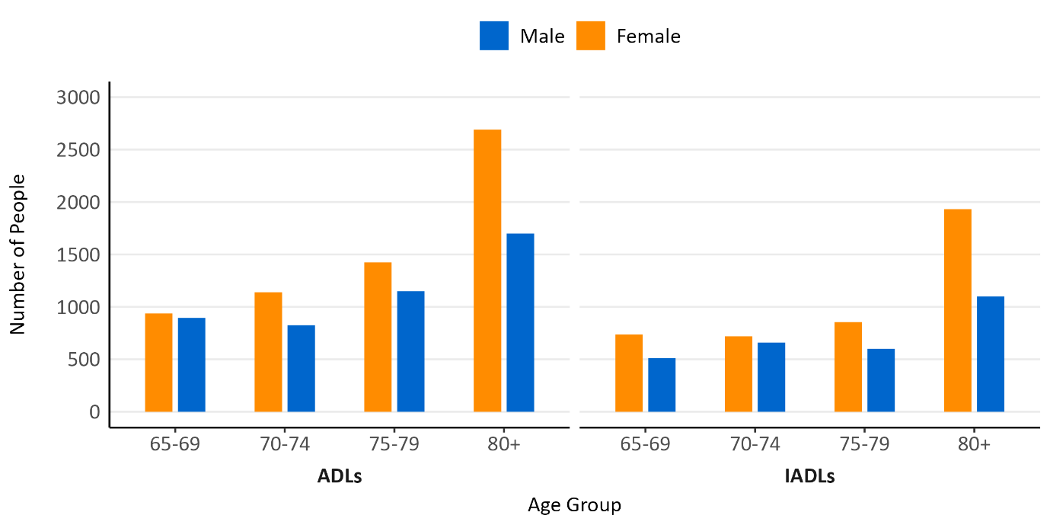Figure 14: Estimated number of people with unmet care and support needs in Medway by ADLs/IADLs, age group and sex. Source: Health Survey for England and POPPI.

A national study by the Care Policy and Evaluation Centre (CPEC) in 2021 aimed to estimate the proportion of over 65s with care needs broadly in line with those receiving local-authority funded support but who are not receiving it or any informal care⁵². Their analysis suggested 1% of older people resident in the community had care needs equivalent to those receiving local authority-funded support but received no support, formal or informal. This would equate to around 500 adults if applied to Medway.

Looking more specifically at council-commissioned services in Medway, the rate of support for older adults has been decreasing as outlined in Section 4, while Section 3 highlighted increasing needs among this age group, and increasing rates of requests for support among older adults. Further analysis could examine why this is the case, including lack of awareness of available services, self-pay trends and availability of services.

Prevalence data presented does not allow firm conclusions about unmet need among those with a disability or dementia. However, as outlined in Section 3, Medway has a lower proportion of service users with a PSR of memory & cognition, and of mental health support, compared to the South East and England averages. Section 7 discussed anecdotal reports of unmet need for particular groups. Further analysis could investigate whether this is due to data issues, differences in the population need, take up of services or other reasons. It does, however, appear likely that dementia needs will increase.

Medway’s ethnic minorities accessing long term social care services is 7.7%, which although an increase on 2021/22 data, is just over half the proportion of ethnic minorities reported in the 2021 Census for Medway of 15.9%. The Medway Health and Wellbeing Survey found a higher prevalence of long-term illness or disability in the White British group, so the difference in service use may reflect differing underlying levels of need or age structures. Further analysis could investigate this further to see if there are ethnic inequities in service use.

9) Recommendations for commissioning

- Requests for social care support have been increasing in Medway for both working age and older adults in the last five years. Medway’s older population is predicted to increase significantly in the next 10-15 years, particularly the oldest old, and this cohort is likely to have higher levels of multimorbidity. There is a recommendation for investment in sustained upstream initiatives to keep adults in good mental and physical health and prevent, reduce and delay care and support needs from emerging. This should include promoting physical activity, healthy diet, and addressing lifestyle factors; improving secondary prevention and early diagnosis; maintaining cognitive and mental health, and reducing falls and fractures. There should be a particular focus on areas within Medway with highest need – both deprived urban areas such as Gillingham and Chatham and rural areas such as Strood and the Hoo Peninsula.
- Work with Medway Council’s planning and housing teams to maximise availability of suitable housing, and to support adaptations to keep people living in their own homes, including through the development of the new local plan. This should take into account the likely increase in older adults living alone.
- The number of people with dementia is growing and predicted to increase significantly in Medway by 2030. This has been seen in service data with the number of adult social care service users with dementia increasing prior to the pandemic. Health and social care commissioners should ensure appropriate capacity to respond to increasing numbers of people with dementia in community, residential and nursing homes. The wider recommendations of the Dementia JSNA chapter, including offering dementia awareness training to staff, should be followed.
- Medway has fewer care home beds per 100 people aged 75+ than the South East and England averages, and there is significant provision of services outside Medway and sometimes outside the South East region, especially for some groups and service types such as residential services for people with a learning disability. Anecdotal evidence from stakeholders indicated potential gaps around clients with complex needs and behaviours, people with early onset dementia and working age adults with physical disabilities. Commissioners should conduct further analysis to inform the market position statement for residential and nursing services and ensure availability of a range of quality provision near to where people live. This includes ensuring a wide coverage of services across wards in Medway.
- The proportion of long-term clients supported in care homes is higher in Medway than the England average for both working age and older adults. However, the rate of long-term support needs met by admission to care homes has been decreasing for both age groups while the rate of people aged 18-64 supported in the community has been increasing (though not for those aged 65+). Commissioners should continue to prioritise community-based solutions keeping residents independent in their own home for as long as possible.
- Medway’s population is more ethnically diverse than ten years ago. In line with NICE guidelines, commissioners should ensure services reflect the increasing diversity of Medway including meeting gender, sexual orientation and cultural preferences.
- Services should be co-produced with users, starting at the beginning of commissioning processes. The 2020 engagement exercise with residential and nursing care services should be repeated.

10) Recommendations for needs assessment work
- Investigate why Medway has a lower proportion of service users with a primary support reason of memory and cognition and mental health support to determine whether this represents gaps in service provision, data issues, differences in underlying population need, take up of services or other reasons.
- Undertake analysis of the pathways into social care going beyond the high level primary support reason categories to better understand the specific reasons people in Medway are developing care and support needs and how these can be prevented, reduced or delayed.
- Conduct further analysis of the gap between the proportion of service users from ethnic minorities and the proportion of the Medway population as a whole from ethnic minorities to determine whether this represents an ethnic inequity. This could include consultation with service users and carers.
- This chapter has not considered in detail the specific needs of vulnerable groups such as people experiencing homelessness, sex workers, vulnerable migrants, and Gypsy, Roma and Traveller ethnic groups, which should be covered in separate needs assessment.
- It is recommended that a full needs assessment for adults with a learning disability be undertaken to inform future commissioning.

References
1. NHS Digital. Health Survey for England, 2021. (2021).
2. The King’s Fund. Key facts and figures about adult social care. (2023).
3. NHS Digital. Adult Social Care Activity and Finance Report, England, 2022-23. Preprint at https://digital.nhs.uk/data-and-information/publications/statistical/adult-social-care-activity-and-finance-report/2022-23 (2023).
4. Professor Chris Whitty. Chief Medical Officer’s Annual Report 2023: Health in an Ageing Society. https://assets.publishing.service.gov.uk/media/65562ff2d03a8d000d07faa6/chief-medical-officers-annual-report-2023-web-accessible.pdf (2023).
5. Office of National Statistics. Profile of the older population living in England and Wales in 2021 and changes since 2011. https://www.ons.gov.uk/peoplepopulationandcommunity/birthsdeathsandmarriages/ageing/articles/profileoftheolderpopulationlivinginenglandandwalesin2021andchangessince2011/2023-04-03 (2023).
6. NHS Digital. Health Survey for England 2021. Preprint at https://digital.nhs.uk/data-and-information/publications/statistical/health-survey-for-england/2021-part-2 (2021).
7. Department for Health & Social Care. Evidence Review for Adult Social Care Reform. https://assets.publishing.service.gov.uk/media/61a7bc688fa8f503780c1c79/evidence-review-for-adult-social-care-reform.pdf (2021).
8. NHS Digital. Adult Social Care Activity and Finance Report, England, 2022-23. Preprint at https://digital.nhs.uk/data-and-information/publications/statistical/adult-social-care-activity-and-finance-report/2022-23 (2023).
9. Prince, M. et al. Dementia UK: Update. https://www.alzheimers.org.uk/sites/default/files/migrate/downloads/dementia_uk_update.pdf.
10. Alzheimer’s Research UK. Prevalence and incidence of dementia. Dementia Statistics Hub https://dementiastatistics.org/about-dementia/prevalence-and-incidence/ (2021).
11. NHS. Overview: Falls. https://www.nhs.uk/conditions/falls/ (2023).
12. Office for Health Improvement and Disparities. Falls: applying All Our Health. https://www.gov.uk/government/publications/falls-applying-all-our-health/falls-applying-all-our-health (2022).
13. Cheng, M. & Chang, S. Frailty as a Risk Factor for Falls Among Community Dwelling People: Evidence From a Meta‐Analysis. Journal of Nursing Scholarship 49, 529–536 (2017).
14. Department for Work and Pensions. Data Tables: Disability, Family Resources Survey, financial year 2021 to 2022, United Kingdom. Preprint at https://view.officeapps.live.com/op/view.aspx?src=https%3A%2F%2Fassets.publishing.service.gov.uk%2Fgovernment%2Fuploads%2Fsystem%2Fuploads%2Fattachment_data%2Ffile%2F1144913%2Fc4-disability.xlsx&wdOrigin=BROWSELINK (2023).
15. Kirk-Wade, E. UK Disability Statistics: Prevalence and Life Experiences. https://researchbriefings.files.parliament.uk/documents/CBP-9602/CBP-9602.pdf (2023).
16. Office for Health Improvement and Disparities. Fingertips: Severe Mental Illness. Indicator ID 90581. Fingertips https://fingertips.phe.org.uk/profile-group/mental-health/profile/severe-mental-illness/data#page/6/gid/1938132719/pat/159/par/K02000001/ati/15/are/E92000001/iid/90581/age/1/sex/4/cat/-1/ctp/-1/yrr/1/cid/4/tbm/1 (2023).
17. Office of National Statistics. Prevalence of ongoing symptoms following coronavirus (COVID-19) infection in the UK: 30 March 2023. https://www.ons.gov.uk/peoplepopulationandcommunity/healthandsocialcare/conditionsanddiseases/bulletins/prevalenceofongoingsymptomsfollowingcoronaviruscovid19infectionintheuk/30march2023 (2023).
18. Mathrani, S. Social Care and Obesity. https://www.local.gov.uk/sites/default/files/documents/1.112%20Social%20care%20and%20obesity_06.pdf (2020).
19. Ministry of Housing, C. & L. G. English Housing Survey: Home Adaptations Report 2019-20. https://assets.publishing.service.gov.uk/media/60e5b6fe8fa8f50c716bcbb3/EHS_19-20_Home_adaptations.pdf (2021).
20. Cromarty, H. Housing Conditions in the Private Rented Sector (England). https://commonslibrary.parliament.uk/research-briefings/cbp-7328/#:~:text=The%20PRS%20has%20the%20worst%20housing%20conditions&text=The%20English%20Housing%20Survey%20(EHS,%25%20of%20social%2Drented%20homes. (2022).
21. Office of National Statistics. Disability by age, sex and deprivation, England and Wales: Census 2021. https://www.ons.gov.uk/peoplepopulationandcommunity/healthandsocialcare/disability/articles/disabilitybyagesexanddeprivationenglandandwales/census2021 (2023).
22. Katikireddi, S. V., Skivington, K., Leyland, A. H., Hunt, K. & Mercer, S. W. The contribution of risk factors to socioeconomic inequalities in multimorbidity across the lifecourse: a longitudinal analysis of the Twenty-07 cohort. BMC Med 15, 152 (2017).
23. Gemma Spiers et al. Caring as a Social Determinant of Health: Findings from a Rapid Review of Reviews and Analysis of the GP Patient Survey. https://assets.publishing.service.gov.uk/government/uploads/system/uploads/attachment_data/file/971115/Caring_as_a_social_determinant_report.pdf (2021).
24. Centre for Ageing Better. State of Ageing. https://ageing-better.org.uk/the-state-of-ageing-2023-4 (2023).
25. NHS Digital. Ethnicity facts and figures: Adult social care - long term support. https://www.ethnicity-facts-figures.service.gov.uk/health/social-care/adult-social-care-long-term-support/latest/ (2022).
26. Office of National Statistics. People’s living arrangements in England and Wales: Census 2021. https://www.ons.gov.uk/peoplepopulationandcommunity/householdcharacteristics/homeinternetandsocialmediausage/articles/livingarrangementsofpeopleinenglandandwales/census2021#couples-age-difference (2023).
27. Office of National Statistics. Living longer: implications of childlessness among tomorrow’s older population. https://www.ons.gov.uk/peoplepopulationandcommunity/birthsdeathsandmarriages/ageing/articles/livinglonger/implicationsofchildlessnessamongtomorrowsolderpopulation#main-points (2020).
28. NOMIS, O. of N. S. Census 2021: Age by five-year age bands.
29. Institute of Public Care and Oxford Brookes University. Projecting Older People Population Information System. Preprint at http://www.poppi.org.uk.
30. Office of National Statistics. Census 2021: Disability. 2021.
31. Medway Council. Medway Health and Wellbeing Profile V2.0. Preprint at https://www.medway.gov.uk/info/200591/medway_s_joint_strategic_needs_assessment_jsna/1590/area_profiles (2023).
32. Institute of Public Care and Oxford Brookes University. Projecting Adult Needs and Service Information. Preprint at http://www.pansi.org.uk/.
33. Office for Health Improvement and Disparities. Learning disability: QOF prevalence (all ages). Indicator ID: 200.
34. RNIB. Medway Sight Loss Briefing. (2023).
35. Wittenberg, R., Hu, B., Barraza-Araiza, L. & Rehill, A. Projections of Older People with Dementia and Costs of Dementia Care in the United Kingdom 2019-2040: CPEC Working Paper 5. https://www.alzheimers.org.uk/sites/default/files/2019-11/cpec_report_november_2019.pdf (2019).
36. Office for Health Improvement and Disparities. Fingertips: Percentage of adults (aged 18+) classified as obese. Indicator ID: 93881. Preprint at (2022).
37. LG Inform Plus. Profile of Households and Housing in Medway Unitary: Census 2021. https://reports.esd.org.uk/reports/9330#c84200 (2021).
38. Ministry of Housing, C. & L. G. English Indices of Deprivation. 2019.
39. NOMIS, O. of N. S. Census 2021: Provision of unpaid care. Preprint at (2021).
40. LG Inform Plus. Housing, Health and Wellbeing in Medway. Preprint at https://reports.esd.org.uk/reports/2345#c35178.
41. LG Inform Plus. LGA Research Report: Housing Profile for Medway. https://reports.esd.org.uk/reports/1187#c11895.
42. NHS Digital. Adult Social Care: Overview by Region and Local Authority - Interactive Report. Preprint at https://app.powerbi.com/view?r=eyJrIjoiODMwNjRjMGMtZDhhZC00ZjQzLTgzYWItZTA3ZWM0ZDcyOGY2IiwidCI6IjUwZjYwNzFmLWJiZmUtNDAxYS04ODAzLTY3Mzc0OGU2MjllMiIsImMiOjh9.
43. Office for Health Improvement and Disparities. Fingertips: Care home beds per 100 people 75+. Indicator ID: 92489. Preprint at (2021).
44. Office for National Statistics. Estimating the size of the self-funding population in the community, England: 2022 to 2023. Preprint at (2023).
45. Office for National Statistics. Living longer: implications of childlessness among tomorrow’s older population. https://www.ons.gov.uk/peoplepopulationandcommunity/birthsdeathsandmarriages/ageing/articles/livinglonger/implicationsofchildlessnessamongtomorrowsolderpopulation#social-care-and-older-people-by-ethnicity-and-socio-economic-classification (2020).
46. Association of Directors of Adult Social Services. Autumn Survey Report 2023. (2023).
47. Care Quality Commission. State of Care 2022/23. https://www.cqc.org.uk/publications/major-report/state-care/2022-2023 (2023).
48. Care Quality Commission. Beyond Barriers: How Older People Move between Health and Care in England. https://www.cqc.org.uk/publications/themed-work/beyond-barriers-how-older-people-move-between-health-care-england (2018).
49. Brimblecombe, N. & Cartagena Farias, J. Inequalities in unpaid carer’s health, employment status and social isolation. Health Soc Care Community 30, (2022).
50. Baxter, K., Wilberforce, M. & Birks, Y. What Skills Do Older Self-Funders in England Need to Arrange and Manage Social Care? Findings from a Scoping Review of the Literature. The British Journal of Social Work 51, 2703–2721 (2021).
51. Association of Directors of Adult Social Services. Spring Survey 2023. https://www.adass.org.uk/media/9751/adass-spring-survey-2023-final-web-version.pdf (2023).
52. Fernandez, J.-L. et al. Unmet Social Care Needs in England: CPEC Working Paper 6. (2020).

Age-standardised proportions are more relevant as different ethnic groups might have different age structures
Severe mental illness refers to mental health issues that are so debilitating that a person’s ability to engage in functional and occupational activities is severely impaired. The need for care and support is therefore likely to be associated with more severe rather than mild mental illness.
NB this is includes long-term illness or disability which is not judged to have an impact on daily living activities. It is useful as an indication of which wards have higher levels of care and support needs but is therefore not a direct measure.
Community includes extra care, supported living, home case, direct payments.

