Adult Oral Health

# Summary

## Introduction

The World Dental Federation (FDI) has recently defined oral health as ‘the ability to speak, smile, taste, touch, chew, swallow and convey a range of emotions through facial expressions with confidence and without pain, discomfort and disease of the craniofacial complex (head, face, and oral cavity)’1. This has built on the World Health Organisation definition and reflects that oral health is more than just the parts of the mouth namely teeth, gums, tongue, hard and soft palates.

The oral health status of an individual will change over the entire life course from early life to old age and these changes are important to a person’s health and wellbeing. Good oral health allows people to socialise through speech and expressions, eat a varied diet, and prevents diseases. Poor oral health can have a negative impact on existing systemic health conditions. Oral diseases and conditions include dental caries (tooth decay), periodontal (gum) disease, tooth loss, oral cancers, dental trauma, and birth defects (e.g., cleft lip and palate). Oral diseases are among the most common non-communicable (cannot be spread directly from person to person) diseases worldwide. The most vulnerable and disadvantaged populations will experience inequalities in oral health across the life course.Oral health inequalities are the differences in oral health between different groups that are avoidable and deemed to be unfair, unacceptable, and unjust. The impacts of poor oral health will affect the most vulnerable and socially disadvantaged individuals and groups in society more.

## Key issues and gaps

There is a lack of access to affordable, quality dental health services, particularly NHS dental services. This is likely due to the impact of the COVID-19 pandemic on waiting lists and availability. Certain population groups are particularly vulnerable to the effects of poor oral health. In adults, these groups include:

* Older adults, especially those in care.
* Individuals suffering with substance misuse or homelessness.
* Pregnant women.
* Those with certain medical conditions or disabilities.
* Socially isolated groups such as immigrants and refugees, the elderlies living alone, including travellers and the homeless.

Awareness and understanding of the importance of good oral health practices could be improved. Knowledge of the impact of a poorly maintained mouth on general health and well-being is low amongst the population. This is particularly true for the vulnerable population groups mentioned.

## Recommendations for commissioning

Medway already offers a wide range of oral health services and has over 30 dental surgeries offering NHS provision. When, however, considering areas with high levels of deprivation, along with a forecasted rise in the older population (65 years and above) over the next five to 10 years, more effective oral health initiatives and inclusive dental care are needed.

Medway commissioners should therefore consider the following recommendations:

1. Improve access to specialist services to support the complex needs of elderly and vulnerable adult populations who cannot visit dentists due to immobility or other reasons by expanding the capacity of the domiciliary service in Medway being delivered by Kent Community Health Foundation Trust (KCHFT).
2. Develop targeted oral health promotion initiatives for vulnerable adults and elderly populations and promote engagement to improve service uptake among the target populations.
3. Effectively meet the needs of the adult population, promote training and development of skills among the workforce in oral health along with strengthening signposting in all the healthcare settings through the Making Every Contact Count (MECC) agenda.
4. Improve the capacity of oral health services to enhance accessibility and uptake of services in the population.
5. Promote preventive initiatives targeting younger adults using Delivering better Oral Health - a toolkit for prevention.
6. Ensure accuracy of dental practice information on the NHS website.
7. Support data collection through oral health needs assessments of specific populations.
8. Improve access to dental care through specialist services, for those unable to visit a dental surgery and addressing barriers such as geographic location, socioeconomic status or disability.
9. Develop targeted oral health promotion initiatives for vulnerable adult populations.
10. Enhancement of collaborative partnerships to create a cohesive approach to oral health

# 1) Introduction

Oral health is a critical aspect of general health, overall well-being, and quality of life. It plays a significant role in our ability to eat, speak, maintain self-esteem, interact socially, and our overall quality of life. The World Health Organisation defines oral health as “the state of the mouth, teeth and orofacial structures that enables individuals to perform essential functions such as eating, breathing and speaking, and encompasses psychosocial dimensions such as self-confidence, well-being and the ability to socialise and work without pain, discomfort and embarrassment”2. There have, however, been significant changes to that definition. The World Dental Federation (FDI) has released a new definition of oral health which is “multi-faceted and includes the ability to speak, smile, smell, taste, touch, chew, swallow and convey a range of emotions through facial expressions with confidence and without pain, discomfort and disease of the craniofacial complex (head, face, and oral cavity)”1. This highlights that oral health is more than just the constituents of the mouth namely teeth, gums, tongue, hard and soft palates.

There are a variety of oral health problems that affect adults such as tooth decay, gum disease, oral cancer, and chronic diseases. If these are left untreated, they can cause severe pain, discomfort, and potentially tooth loss. This in turn affects an individual’s ability to chew, drink, sleep, and carry out daily activities. All of this can negatively impact an individual’s general health, self-esteem, confidence, and overall quality of life3. Other conditions such as cardiovascular disease, pregnancy complications, pneumonia, and endocarditis (a potentially fatal infection of the inner lining of the heart)3 can develop or get worse because of poor oral health4–7. Endocarditis is most often caused by bacteria entering the blood and travelling to the heart. Access to dental services, oral health education and self-care practices are essential to promote good oral health hygiene and preventative care measures.

## Key issues and gaps

There is a lack of access to affordable, high quality dental health services and additionally, there is inadequate awareness and understanding of the importance of good oral health practices among adults, especially among those in socially marginalised communities and older adults. In broad terms, many adults are unaware of the importance of regular brushing with fluoride toothpaste, regular dental check-ups, and the role of diet and lifestyle in maintaining good oral health. This knowledge gap contributes to preventable oral health issues and limits many individuals’ ability to make informed decisions about their oral health. Addressing these gaps is crucial to ensuring equitable access to dental services and promoting a culture of preventative and proactive oral health across communities.

Following the COVID-19 pandemic and other historic factors with the NHS Dental Contract, NHS dentistry is experiencing difficulties resulting in a lack of available appointments. Many dental surgeries have more private appointments available than NHS, adding to the oral health inequalities that already exist. Those who can afford to access private appointments or dental insurance are likely to attend regularly and have better oral health whilst requiring less treatment. Individuals who cannot access NHS dentistry nor afford private appointments are likely to experience poorer oral health with higher levels of tooth decay and gum disease, which may result in pain and the need for emergency treatment.

The oral health inequalities that exist in at risk and vulnerable populations are significantly increased by the inability to access regular dental appointments. Dentists check for mouth cancers at each check-up appointment and provide X-rays annually, resulting in the early diagnosis of oral health problems for individuals who attend regular appointments.

Oral health issues have broader societal implications, with significant economic and social consequences. The financial burden of treating oral health problems is substantial, placing strains on healthcare resources and budgets both to the individual, the employer and the NHS7. Additionally, individuals with poor oral health may experience difficulties in seeking employment or maintaining steady employment due to the impact of dental problems on their appearance and ability to communicate effectively.

Certain population groups are particularly vulnerable to the effects of poor oral health. In adults, these groups are older adults, individuals suffering with substance misuse or homelessness, pregnant women and those with certain medical conditions or disabilities. This can exacerbate existing health inequalities, further isolating already vulnerable populations.

2) Who’s at risk and why?

Although oral health in England has improved substantially over the past 30 years, it remains a major public health challenge. An oral health survey of adults attending general dental practices in 2018 found that 27% of participants had tooth decay, having an average of 2.1 decayed teeth, and 53% had gum bleeding4. This means that nearly a third of the population in England is affected by tooth decay. This oral health survey also found that prevalence of tooth decay was higher in men (31.5%) than in women (23.6%) and most common in those aged 25 to 34 (35.3%). Furthermore, the survey highlighted that some population groups are disproportionately affected by poorer oral health, most notably older people and those living in the more deprived areas of England4. Rates of tooth decay are considerably higher for people living in more deprived areas, with one in three having untreated tooth decay. This compares to one in five people living in less deprived areas. Additionally, approximately two in three people aged 85 and older did not have a functional dentition. The survey identified that participants who had not visited a dentist for two years or more were more likely to have untreated tooth decay (48.8%)4.

In 2021, Public Health England (PHE) now Office for Health Improvement and Disparities’ (OHID) analysis of oral health inequalities stressed that the impacts of poor oral health disproportionally affect vulnerable and socially disadvantaged individuals and groups in society. These include people entitled to free NHS dental treatment, such as children and young people, pregnant women, and those in receipt of low-income benefits, and people from ethnic minorities.

## Risk Factors (Fixed/non-modifiable)

These are risk factors that cannot be shown to change and include age, gender, learning disability, ethnicity, and genetics.

### Age

Older adults, particularly those who live alone or in care homes are at increased risked of poor oral health and dental diseases which is compounded by the general health challenges they face that make oral hygiene practices, dental treatment planning more difficult and might require modifications. Growing older is a non-modifiable risk factor which increases the incidence of oral diseases. Living in a care setting or being reliant on the care of others for personal needs removes control from an individual to take care of their own mouth or attend a dentist of their own accord regularly.

### Ethnicity

Some minority ethnic groups have lower use of dental services experiencing higher prevalence and severity of dental decay and gum diseases especially when they are more likely to be living in areas of disadvantage. They may also encounter language and cultural barriers to accessing care and advice8,9. For example, the use of an interpreter services may be necessary when giving oral health advice or accessing dental services to modify the risk to oral ill health.

### Long Term Health Conditions and Disabilities

Long term medical conditions and the medications used to treat these can increase the risk of poor oral health10, especially when the only medication available for treatment results in a reduction in saliva flow. For example, those with diabetes are more prone to periodontal (gum) disease and premature tooth loss. Also, dry mouth (xerostomia) is a common side effect of many prescribed and over the counter medications. Those with mental illness have poorer oral health11 and so also are hospice patients who are at risk of poor oral health due to the under delivery of oral care for the terminally ill12.Having a dry mouth which lacks saliva increases the risk of dental decay. However, this risk becomes non-modifiable if alternative medications without the side effect of reduced saliva flow are available. People with physical, mental, or learning disabilities. Due to the extra needs of this group of people, the risk is non-modifiable. However, with the right support and care, the ability to maintain the health of the teeth and mouth is certainly possible.

## Risk Factors – Modifiable

Modifiable risk factors are behaviours and exposures that can raise or lower a person’s risk of oral health issues. These include the following:

### Social Isolation

People who are socially isolated such as immigrants and refugees, the elderlies living alone, including travellers and the homeless. Although a modifiable risk factor, it can be difficult to change. Access to dental care is very limited and usually only sought when pain develops. The ability to care for the mouth is also compromised through a lack of facilities or the tools with which to do so.

### Poor Diet

Individuals who have a poor diet are at increased risk of poor oral health. The rise in the consumption of Ultra-Processed Foods and Drinks (UPFDs), which are high in free sugars, saturated fats and salts, increases the risk of tooth decay, gum diseases and oral cancers. This is due to a lack of essential vitamins (like A,B,C,D and E) and minerals (like calcium, magnesium, copper and phosphorus) from fruits, vegetables and milk. These help in the development of healthy teeth and gums and contribute to reducing the susceptibility to tooth decay, gum disease and oral cancers. This risk is modifiable with support to eat a well-balanced diet13.

### Substance Misuse

People with substance (alcohol, drugs, tobacco) misuse issues are at increased risk of poor oral health14. The risk of dental diseases and oral ill health is modifiable with the cause being the misuse of substances which have a detrimental effect on the hard and soft mouth tissues and teeth. Illegal drugs like cocaine, methamphetamine, and heroin can cause dry mouth and sugar cravings which increase the risk of dental decay. Some cause clenching and grinding of teeth, resulting in severe tooth wear. These substances significantly increase the risk of mouth cancers15 and dental trauma. Substance misusers are associated with reduce compliance with oral hygiene instructions and dental appointment attendance.

## Risk factors (Wider Determinants)

Good oral health can also be influenced by social determinants of health. These are social and economic circumstances that influence health. They include things like education, employment and the environment in which people live. Lower socioeconomic groups will have difficulties modifying the behaviours that increase the risk of oral ill health having less choice in the food that they can access and may be unable to afford dental costs or the cost of travel.

### Refugees and Asylum Seekers

Certain migrant groups including asylum seekers and refugee groups undocumented migrants, and people who have been trafficked. Poor oral health is closely linked to factors which may affect migrant groups, including economic deprivation; social exclusion; cultural differences in perceptions about oral health; availability of dental services in migrants’ countries of birth or origin. Prior to their arrival in the UK, some migrants may have never received any dental examinations, treatments or advice on oral hygiene and disease prevention. Asylum seekers and refugees also face barriers when accessing NHS dentists due to misconceptions about their entitlements and language barriers due to lack of translation services for their language. The Office for Health Improvement and Disparities (OHID) offers advice to Local Authorities in its model of oral healthcare to support asylum seekers and refugees. This includes guidance on processes, rights and entitlements to care, and includes supporting information, making the risk to poor oral health for this group modifiable16. Although a modifiable risk, dental and health service delivery to these groups can be complex and the use of interpreter services may be necessary.

### COVID-19

The COVID-19 pandemic potentially exacerbated oral health inequalities, especially among marginalised communities. It also had a big impact on the progress in prioritising oral health. The British Dental Association indicated a fear among ethnic minority communities to attend dental check-ups. This fear of contracting the virus has potentially delayed necessary dental check-ups for this community and increased the level of oral health risks and needs. This also potentially has a long-term effect on acquiring future timely dental appointments due to irregular and inconsistent attendance. Data shows that between 2020 and 2022, at least 7 million fewer patients saw an NHS dentist when compared with pre-pandemic levels of 201917,18.

### Adult care and guidelines

The Care Quality Commission (CQC) Smiling Matters report in 2019 looked at how well care settings were following the National Institute for Health and Care Excellence (NICE) guideline NG48, published in July 2016 which covered oral health, including dental health and daily mouth care, for adults in care homes with the aim of maintaining and improving their oral health and ensuring timely access to dental treatment. It emphasised the importance of reviewing and updating people's oral care needs in their care plans to meet their changing needs29. The findings showed that care staff awareness of the guidance was low and people living in care were not always supported with oral care. In addition, care homes and dentists did not work together, and many people could not access routine NHS dental care. The progress report in 2022 inspected 50 care homes and found a much greater awareness of the NICE oral health guidelines which is likely to translate into better oral care and support. Staff training in oral health had doubled in the 3-year period and oral health assessments had increased for people entering care. More care plans included oral health and were reviewed regularly (figure one), linking other health issues to oral health and the care required to maintain a healthy mouth. However, some care plans were very basic and only included whether someone had teeth or dentures19.

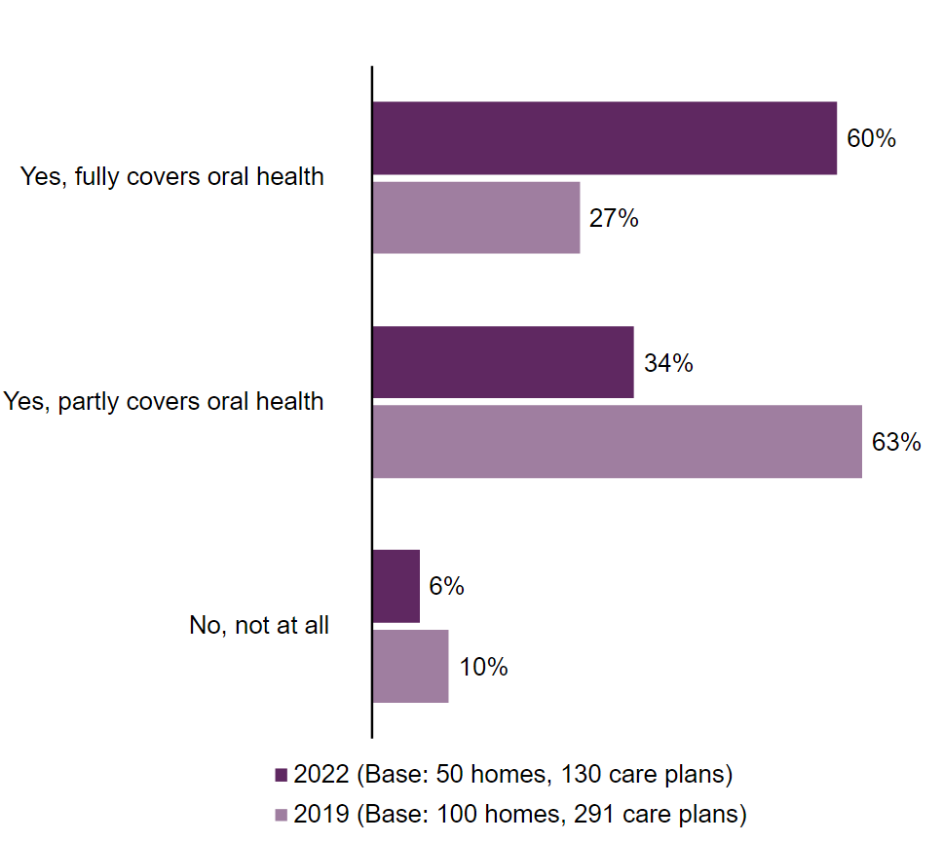

**Figure one:** *Inspector reviews of care plans: How well do care plans cover oral health needs of residents?19*

Despite improvements between 2019 and 2022, settings showed variations, and improvement is necessary in some areas such as the lack of support with oral care affects people's quality of life and their ability to eat, talk and socialise which could put a greater pressure on family and other carers, the need for all care homes to have an 'oral health champion' to promote good practice and provide a link between care homes and dental professionals. Only a quarter of care settings had an ‘oral health champion’, despite its benefits. There is still concern for people living in care homes who are missing out on vital dental care at the right time and in the right place. The proportion of care home providers saying that people who use their services could 'never' access NHS dental care rose from 6% in 2019 to 25% in 2022. It was highlighted that not enough dentists were able or willing to visit care homes to treat residents with limited mobility. The care home sector continues to be a hard space to engage with, despite training and awareness campaigns for oral health, as messages are easily lost among other health campaigns and concerns.

Medway’s experience is very similar to the reported issues, and the ability to access timely NHS dental appointments remains low within Medway despite the offer of specific domiciliary dentist services by the Kent Community Healthcare Foundation Trust (KCHFT). [Oral health trainings](https://healthtraining.medway.gov.uk/training-courses/57b9ee90-640b-11ec-8b3a-672da0f457ca/oral-health-oral-health-awareness-and-improvement) are available to care setting staff through the oral health team of Medway Council’s Public Health Directorate and the online bitesize [oral health modules](https://www.careportal.medway.gov.uk/Page/18920) on the Medway Care Portal which is maintained and run by the Adults Commissioning Team at Medway Council, but engagement and attendance has dropped in the past four years.

# 3) The level of need in the population

The 2022 local population estimates suggest that Medway has a total population of 282,702, a growth of 0.8% since 2020 and 5.4% over the last decade. Trends in life expectancy at birth in Medway are also increasing, despite the impact of COVID-19, with males having an average life expectancy of 78.7 years and females 82.5 years in 2022. A growing population and longer life expectancy implies an increasing level of need and demand across Medway over time if this trend continues. You can find a more detailed breakdown of Medway’s population estimates over the years on the [Medway JSNA dashboard](https://app.powerbi.com/view?r=eyJrIjoiZGZkYTAyMGMtODZhNy00NjE0LTgzMGYtYmM4NTMxOTcyNmQwIiwidCI6IjY4NTAzZTkzLTNjZTctNGEyMi1iZmM1LWZmZWU0MjFhMWY1NyJ9).

The 2021 census provided a breakdown of ethnic group across Medway. A total of 84.3% of the Medway population identified their ethnic group in the 'white' category, 5.9% as 'Asian, Asian British or Asian Welsh, 5.6% as 'Black, Black British, Black Welsh, Caribbean or African' and 2.8% in the 'Mixed or Multiple' ethnic group20.

The Adults Oral Health Survey for England 2021 details that the Southeast reported the highest number of crowns and filled teeth across all NHS regions. Furthermore, when surveying symptoms of gum disease they found that 21% reported being told by the dentist that they have gum disease and 22% having bleeding gums when brushing their teeth7.The proportion of adults (18+ yrs) living in Medway seen by an NHS dentist in the last 24 months as of October 2023 was 44.8% which is the highest across the South-East region. This is an increase from 79,468 adults in June 2022 to 95,431 in October 2023. Access to NHS dental care in Medway has generally been seen as robust for population need when compared to Kent. From July 2022, NHS England delegated the commissioning of primary care dental services in the South East region to the six Integrated Care Boards (ICB), with the total count of courses of treatment done in Medway between 2022/2023 being 190,28718. From data identifying the areas of greatest need for GDS based on the availability of existing services per head of population and level of deprivation - six new dental practices in Kent have been commissioned for 2023, none of these are in the Medway area.

A survey on oral health and dental service use in people aged 65 and over living in supported housing in Medway revealed that 21.5% of respondents had reported oral health impacts fairly or very often. This is higher than the England average of 17.7%. Furthermore, 44.6% of them had not seen a dentist within the last two years, with the most common reason being that respondents could not afford NHS charges (20.7%). A total of 24.4% of dentate respondents reported currently having pain in the mouth, which is considerably higher than the England average of 9.5%. In addition, 4.6% urgently need treatment and 6.2% require domiciliary treatment (treatment for patients who cannot access a dental surgery due to mental or physical disability). Both figures are above the England average, where 3.2% urgently need treatment and 5.1% need domiciliary treatment. Overall, this suggests that there is a high need for dental services for adults aged 65 and over living in supported housing in Medway, and that for some this need remains unmet21,22.

The NICE guidelines suggest that individuals are required to visit the dentist at least once every two years5. Despite these guidelines, the national 2021 Adult Oral Health survey reported that only 63% were attending regular dental check-ups. This aligns with the two surveys completed by Healthwatch in March and September 2024. These showed a two-year NHS dentist appointment rate of 60%. In response to the 2009 Adult Oral Health Survey, 85% of respondents suggested they would prefer a visit from a dentist closer to home as the current average distance is approximately 3.5 miles7. Individuals in Medway have access to approximately 39 general dental practitioners offered through the NHS within a five-mile radius of their home. Findings indicate that in comparison to surrounding Kent areas, access to dental care in Medway is significantly more robust, possibly due to access to services or greater awareness. In terms of affordability of services, 23% of individuals surveyed said they could not afford NHS treatments, and 8.8% said it was challenging to get an appointment21.

Figure two shows the uptake of NHS dental treatment in Kent, Surrey, and Sussex (KSS) over the 24 months up to January 2018 by deprivation quartile and treatment band. Only deprivation within KSS is compared because national comparisons do not provide the local detail. It suggests that most patients who access treatment in urgent band 1 (which covers an examination, diagnosis and care to prevent problems, X-rays, a scale and polish and planning for more treatment), band two (which covers all treatment covered by band 1 and treatment such as fillings, root-canal treatments or extractions), and band 3 (which covers all necessary treatment covered by band one and two and more complicated procedures such as crowns, dentures or bridges) are from the most deprived quartile (quartile 1). This suggests that most urgent and complex dental care is provided to the groups with the highest level of need. In contrast, quartile 3 (50-75% least deprived) accounts for the highest proportion of patients receiving treatment in band 1. This corresponds with population needs because the least deprived groups generally have less oral disease and less commonly require treatment beyond a check-up (band 1)22.

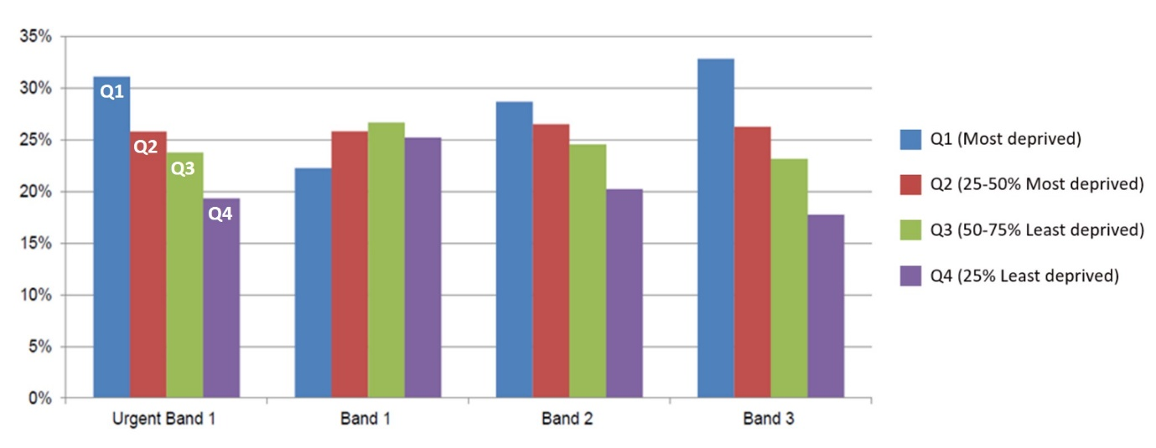

**Figure two.** *Comparison of percentage of adults from each deprivation quartile in Kent, Surrey and Sussex who received NHS treatment in 24 months up to January 2018, by treatment band22.*

The Medway Health and Wellbeing (HWB) survey 2021/22 provided information within Medway estimates of key health states and risk factors. These are shown for both wards and Primary Care Networks in Medway. Two questions were asked concerning dental health within the health section of the survey. The first was ‘Are you registered with a dentist?’. Note that patients cannot register with a dentist like they do with a GP as they are on a dental list for the period of their treatment only. The HWB indicated about 77.8% of Medway residents were registered with either an NHS or private dentist. This mirrors a YouGov survey conducted nationally in March 2023 with one in five Britons (22%) stating they are currently not “registered” with a dentist. However, these figures do not match the NHS digital data for adults seen by an NHS dentist in the 24 months to 30th June 2022 which reports just 37.2% of adult patients living in the Medway Local Authority area accessing an NHS dental appointment23. Healthwatch England and the CQC have called for more clarity for the public around NHS dentistry. For instance, people are often not aware that dental practices do not operate in the same way as GP surgeries as patients are not formally “registered” and will need to attend regularly to maintain a place on a dentist’s patient list. In addition, patients are not required to live in a specific catchment area to attend a practice.

The HWB survey also showed that in Medway, those less likely to attend a dental surgery include men, younger people aged 25 to 34, ethnic minority groups as opposed to White British/Irish, those living in areas of high deprivation, the unemployed and those paying rent, with or without receipt of housing benefit. Where people live within Medway also has an impact on dental attendance and registration. Adults living in the Medway wards Luton, Chatham Central & Brompton, Gillingham North, Gillingham South, and Hoo St Werburgh & High Halstow, are least likely to be registered with a dental practice according to the HWB survey (Figure three). The Local Government Association highlights that people living with the highest levels of deprivation are more likely to miss out on NHS dental provision nationally. Local evidence from Medway supports this. You can find the full HWB survey analysis including the oral health topic analysis on the [Medway Council Health and Wellbeing Survey webpage](https://www.medway.gov.uk/info/200591/medway_s_joint_strategic_needs_assessment_jsna/1650/medway_health_and_wellbeing_survey).

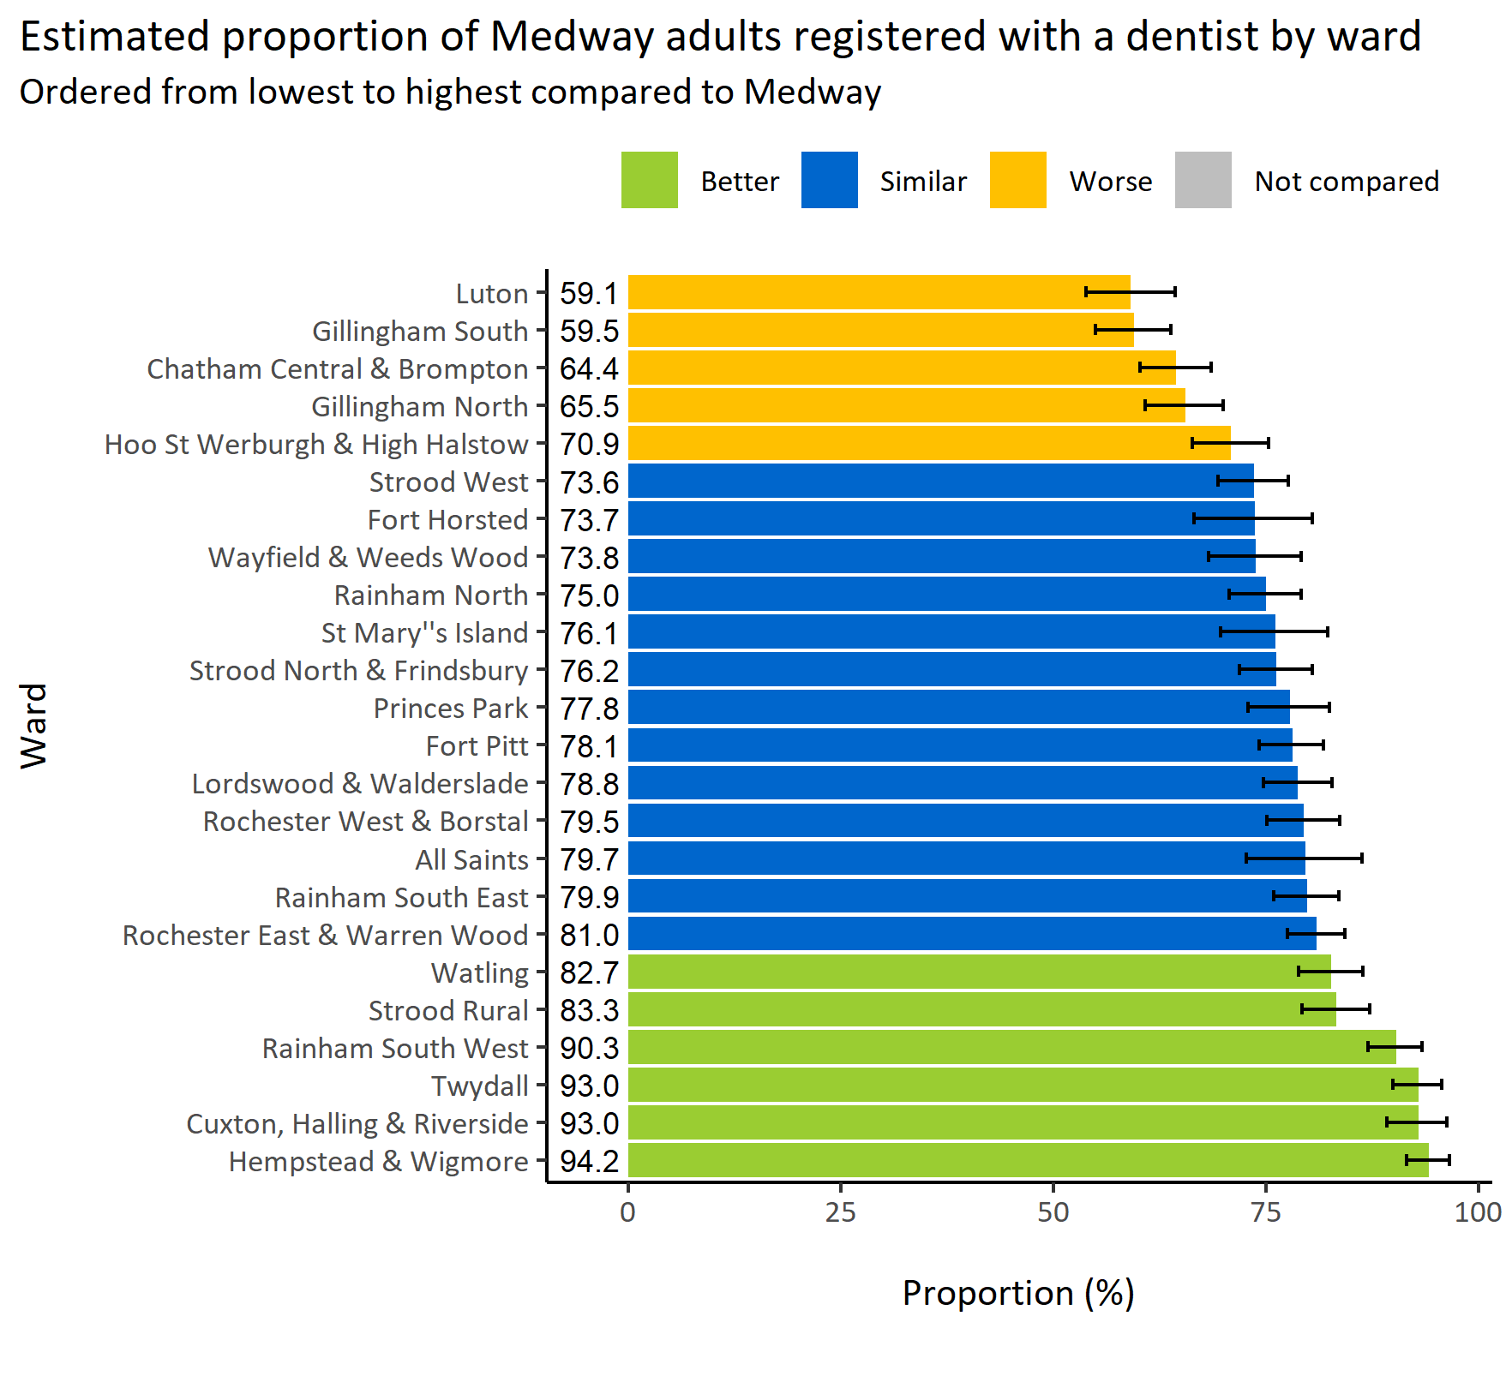

**Figure three**: Estimated proportion of Medway adults registered with a dentist by ward (Medway Health and Wellbeing Survey 2021).

The second question from the Medway HWB survey was ‘In the last 12 months, did you experience pain or other problems with your teeth/mouth which affected eating, sleeping or work?’. An estimated 12.8% of Medway adults reported experiencing teeth or mouth pain which affected eating, sleeping or work. Results from a YouGov survey in February 2023 showed that 10% of respondents admitted to attempting their own dental treatment, with over half of these within the last two years and a third within the last year24. The main reasons given for this include the cost of NHS dental treatment and the inability to find an NHS dentist or be given a timely appointment. Healthwatch England reports dental issues being the second most common enquiry to their help lines, while Medway Healthwatch reports dental issues being their most common enquiry in 202225.

The HealthWatch Medway report ‘Focus on Dentists February 2022’ stated that they receive more feedback about NHS dentists than anything else, with 32 people contacting Healthwatch since June 2021 because they had been unable to find an NHS dentist accepting new patients. For the report, 94 people were spoken to in total. More than half of these were either not registered with an NHS dentist or had problems getting an appointment with their NHS dentist. This is not unique to Medway and reflects the national picture with pre-existing inequalities to accessing dental care being made worse by the COVID- 19 pandemic17,26. The report findings include the cost of NHS and private dentistry being a barrier to accessing dental care and people having to wait long periods for an NHS appointment, while those able to afford private care can get an appointment very quickly, within a week. Some people were in pain and needed emergency treatment which could only be offered privately at an unaffordable cost. Healthwatch Medway spoke to 28 people on the street in Medway and of these, 16 said that not being able to find an NHS dentist has had an impact on their physical or mental wellbeing. Others said they could not eat certain foods, or that their teeth made them feel self-conscious or had impacted their sleep and/or stress levels.

An online survey by HealthWatch Medway found similar issues, although six people with a dentist praised the service they received. Six older people were spoken to at Age UK Medway, and of these, four said that they would only go to the dentist if they experienced problems and that the cost of dentistry was preventing them from accessing dental services.

Following interviews with provider services in 2021 when developing options papers for the Medway Oral Health Strategy Report 2022, substance misusers and the homeless were seen as a group who struggle to look after their own oral health and cannot access mainstream dentistry. The need for relevant oral health materials was highlighted, as well as the possibility of a mobile dental unit visiting Medway as being the only way this population could or would access dentistry.

Families from the Armed Forces in Medway, Brompton Barracks, have reported difficulties accessing dental appointments in Medway. The priority to find a dentist becomes a regular problem due to being posted away after two years, with army children often not accessing routine or regular check-ups and treatment. However, this is being addressed with the Armed forces families included as part of the cohorts for the additional hours scheme. Also, appropriate referrals can be made to the Community Dental Service26.

Taking all of this together, it is important to note that understanding Medway’s local population in terms of age, culture, socio-economic group is important when the identifying the differences in oral health needs across the population. This becomes helpful in planning and commissioning of oral health programmes and services that benefits the population with none excluded or missed out.

# 4) Current services in relation to need

Medway Council’s recent Oral Health Strategy (2022) reports the following three main priorities for oral health promotion and service delivery in Medway:

1. Increase fluoride application through regular tooth brushing routines from birth to old age.
2. Reduce free sugars in the diets of service users.
3. Support and increase dental checks and access to dental services from birth to old age.

Additionally, the Oral Health Strategy also sets out four priorities specific to adults, and particularly vulnerable adults:

1. To limit practical and social barriers to accessing oral health services, particularly for older adults and those living with disabilities.
2. To leverage peer mentor oral health promotion work.
3. To develop targeted and realistic oral health promotional campaigns.
4. To better integrate oral health signposting into existing services (e.g., substance misuse, smoking cessation, homeless outreach).

**Oral health services in Medway should be oriented towards these priorities.**

The NHS search finder for dental practices located in the Medway Towns lists 33 practices showing that Medway has the highest number of GDS dentists of any local authority area across Kent and Medway. Of these, one is an orthodontic practice, and four others offer specialist services requiring referral from another general dental practitioner. For the remaining 28 practices, the NHS site gives details of those accepting new NHS patients, although this is reliant on each practice updating the site. The number of dentists within each practice offering NHS appointments is not listed.

Medway Community Healthcare (MCH) hosts the Community Dental Service (CDS) for the treatment of patients with special physical, mental or social needs which require the support of a specialist dental service. Armed Forces families are also eligible. Patients may be referred by another dental surgery or other health professionals. Normal NHS Dental charges apply unless the patient is exempt. DentaLine is the MCH out of hours emergency dental service for dental emergencies and urgent symptoms during evenings, weekends, or bank holidays. Appointments are by telephone assessment only. Treatment provided by DentaLine prevents deterioration in a patient's oral health or will give temporary control of pain. Patients are required to return to their own dentist or join the list of a dental practice following any emergency treatment to resolve their dental need27. Also, Medway residents have access to the KCHFT dental service which provides both dental helpline (in hours) and dentaline (out of hours) services28 General Dental Practices (GDP) will offer emergency NHS or private appointments.

Patients do not have to register with a dentist in the same way as with a GP to receive NHS treatment and therefore should not be asked to have an examination or pay for any private work before being accepted by an NHS dentist.

Medway residents can attend dental services outside of the area e.g., Swale, Maidstone, or Gravesend, if they are able to travel. This would have, however, higher cost implications and may add to inequalities for the most deprived residents. Residents who have relocated to Medway can choose to remain with the dental practice where they lived previously. Although services are panelled geographically, beneficiaries can choose their dentist according to their preferences. A 2018 needs assessment by NHS England indicates that Medway falls in the category of intermediate performance level for adult’s general dental services access. In Medway, the average distance travelled to physically access an NHS dentist was 4km, and for 80% of adults the maximum travel was 6 km (Figure four22).

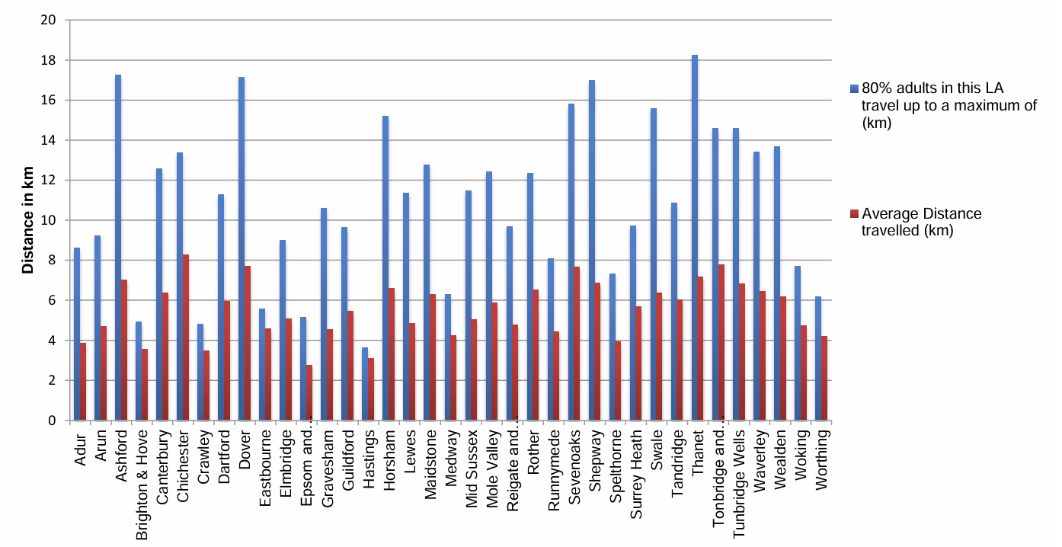**Figure four.** *Mean travelling distance and maximum distance travelled by 80% of adults to see an NHS dentist, by local authority in Kent, Surrey, and Sussex (Jan 2017 - Jan 2018)22.*

From data identifying the areas of greatest need for GDS based on the availability of existing services per head of population and level of deprivation, six new dental practices in Kent have been commissioned for 2023. None of these are in the Medway area. However, the ICB’s approach to commissioning dental activity is to explore a rapid commissioning approach rather than a competitive tendering process in the first instance and this allows the ICBs to seek additional activity from existing dental providers. In 2023/24 an extra 28,000 units of dental activity was commissioned from existing Medway GDS practices. A further 7790 units of dental activity are also being sought in 2025.

The ICB also commissioned an “additional hours” dental service which is offered on a sessional basis. The service is commissioned on a voluntary basis and two of the twelve providers are in Medway. The scheme aims to increase urgent access for new ‘un-associated’ patients that were unable to be seen by a dentist, with definitive treatment provided to those patients who agreed to receive the treatment. The scheme targets specific patient cohorts:

1. Clinically vulnerable persons, for example, those requiring dental treatment before cardiac surgery, cancer patients, or those immuno-suppressed.
2. Children in Care (CiC) are a priority group to meet the statutory assessment requirement.
3. Care home residents who can travel to a practice.
4. Children who require orthodontic extractions before orthodontic treatment can commence and whose usual GDP no longer offers NHS services are now included.
5. Expectant and nursing mothers.
6. Armed Forces families.

As previously stated, Patients do not register with a dental practice in the same way they do for a GP. At the first appointment for a check-up, an assessment is carried out and if required, a treatment plan agreed upon with further appointments arranged29. It is worth noting that a dentist can terminate treatment if appointments are missed without letting the surgery know, which can result in having to pay again for treatment if the patient is asked to find another dental surgery. Anecdotally, it is apparent that people think they remain registered with a dental practice despite not attending regular checkup appointments which is not the case. Patient lists are updated, and non-attending patients will be removed from the list to allow new patients to be seen.

From June 2023, funding was awarded to Kent Community Health NHS Foundation Trust (KCHFT) to expand its Rough Sleeper Service to provide new podiatry and dental services to Medway and East Kent for 12 months. In addition to this, Medway was included as a beneficiary of the ‘Dentaid’ Mobile Dental Unit (MDU) for the homeless, rough sleepers and those suffering from substance misuse. The MDU presently sets up at ‘Chatham Caring Hands Day Centre’ monthly. Appointments are by referral and clinics have proved successful in helping patients out of dental pain, helping to improve oral care and restore their self-esteem. The mobile service is run by volunteer dentists and dental nurses working with the charity ‘Dentaid’ to help vulnerable people receive dental care that they cannot otherwise access. Patients are offered dental services such as screening, pain-relief treatments, and oral health advice, as well as the chance to talk about any dental concerns and engage with dentistry30.

A new Oral Health Hub has been created as a go-to place for advice and information for the public with additional information for professionals, covering vulnerable groups and general oral health advice and signposting16. Local initiatives and oral health promotional activities implemented by the Council are embedded within Public Health programs and encouraged across a wide range of stakeholders through the Oral Health Strategy Group that sits within the Medway Food Partnership. [The Medway Care Portal information hub](https://www.careportal.medway.gov.uk/Services/5728) has an oral health page which is updated with relevant information and e-learning for oral health.

Oral health promotion and prevention awareness services are integrated within the Medway Council Public Health Team, including the Healthy Pregnancy Team, Stop Smoking Service, Supporting Healthy Weight Team, 16+ Care Leavers Service and Healthy Schools Awards. Oral health messages are also included within the Beside You are Breastfeeding support and Water Refill campaigns. Oral health initiatives are well established with the Early Years workforce with oral health training provided for the Medway Community Healthcare Public Health Children’s Health Team and Health Visiting Services and Healthy Early Years (HEY) childcare settings. The Gold HEY award expects oral health promotion to be evidenced by childcare settings. There is an Oral Health Promoter within MCH who visits nursery settings and makes home visits when necessary. Oral health advice for pregnancy is included within the 0-19 health visiting contract, covering advice at ante-natal appointments and their attendance to the dentist as well as a follow-up at 12 months postnatally which covers the baby as well.

Oral Health training for care home staff is available and included in the Medway Food Partnership visits to care settings when discussing food provision. Oral health interventions for the homeless have taken place working with Medway Council Housing Services and Caring Hands support hub. Interventions for service users accessing the newly commissioned RIVER substance misuse service, treatment, and recovery programmes will be explored, including a needs assessment for oral and dental health.

# 5) Projected service use and outcomes in 3-5 years and 5-10 years

Accessibility of dental services in Medway was ranked in the intermediate category by NHS England in a needs assessment covering Kent, Surrey, and Sussex. This means that access to dental services based on the '5 As’ theme of Availability, Accessibility, Acceptability, Affordability and Accommodation of service was just below the England average.9 In terms of deprivation, however, Medway ranked six out of 37 local authority districts in Kent, Surrey, and Sussex. This reflects a high level of deprivation with regards to the seven themes used in measuring the Indices of Multiple Deprivation (IMD), which are income, employment, education, health, crime, barriers to housing & services and the living environment. All of these have been shown to have a negative impact on oral health and if not adequately addressed early would worsen the oral health status of the population. The homeless population are disproportionately affected by poor oral health, putting greater demand on dental services that are inadequate. Since unemployment rates are high in Medway, and with the number of benefit claimants having increased by 110% since March 2020, there is a potential chance of increase in homelessness and, in turn, poor oral health31.

Residents are reluctant to attend general clinical (inclusive of dental services) appointments in this area and do not attend preventive health services, potentially leading to worsening of health outcomes31. This is concerning as Medway has an ageing population with the Office for National Statistics (ONS) population projections from 2018 estimating that the number of people aged 65 and over in Medway will rise from 44,209 in 2018 to 52,756 in 2030, an increase by 19.3%32. People aged 65 and over will account for 18.5% of Medway’s overall population in 2030, while the number of people aged over 80 in Medway is projected to increase from 10,835 in 2018 to 15,233 in 203032 which represents a projected rise of 40.6%32. Given that older people are generally at higher risk of poor oral health, this will likely increase the demand for oral health services. Oral health services need to adapt to the changing demographics and needs of Medway’s population.

Medway already offers a wide range of oral health services, however, considering the high levels of deprivation in some areas along with a forecasted rise in the older population over the next 5 to 10 years, more effective and inclusive dental care is imperative.

# 6) Evidence of what works

The CQC has made recommendations in its progress report on Smiling Matters to ensure that people living in care settings receive the support they need to maintain and improve their oral health. Recommendations include:

* OHID should include care home providers in future adult oral health surveys and consider commissioning a separate survey for those living in care settings to understand the level of oral health care and the need for more targeted resources.
* Care home providers should promote what prospective service users and their families can expect when they enter a care home regarding their oral health and care needs e.g., oral health needs assessment and NHS costs and entitlement to free dental services.
* A mandatory oral health component is included in the Care Certificate
* Guidance is developed to support through the ICBs:
  + Dental professionals to treat people living in care - domiciliary care.
  + Care home staff to support people resistant to oral health care and support.
* Commissioners promote partnerships between care settings and dental teams to improve the oral health and well-being of care home residents and use local initiatives like peer-to-peer support schemes to increase dental access.
* The Government should consider automatic exemption from NHS dental charges when people move into care homes.

Current evidence on effective interventions and activities to achieve improved oral health and reduce oral health inequalities comprises the following tools and guidelines, containing recommendations for improving oral health.

**Public Health England (PHE) now the Office for Health Improvement and Disparities (OHID) and the UK Health Security Agency (UKHSA).**

The following is a list of links leading to relevant resources from the above organisation:

* [PHE’s ‘Delivering better oral health: an evidence-based toolkit for prevention (2021)’](https://www.gov.uk/government/publications/delivering-better-oral-health-an-evidence-based-toolkit-for-prevention) is an evidence-based toolkit to support dental teams in improving their patient’s oral and general health, however the advice is relevant to all health professionals promoting oral health.
* [PHE’s ‘Commissioning better oral health for vulnerable older people: An evidence-informed toolkit for local authorities (2018)’](https://assets.publishing.service.gov.uk/government/uploads/system/uploads/attachment_data/file/738722/CBOH_VOP_V16_Final_WO_links.pdf). This is part of a suite of resources supporting local authorities to review, develop or commission services to improve the oral health of vulnerable older adults so that they can lead a healthy, meaningful, and independent life for longer.
* [PHE’s ‘Evidence review for an evidence-informed toolkit for local authorities: Commissioning better oral health for vulnerable older people (2018)’](https://assets.publishing.service.gov.uk/government/uploads/system/uploads/attachment_data/file/738724/CBOH_VOP_Evidence_review_Final.pdf). This evidence review is the basis for recommendations for effective interventions and approaches detailed in ‘Commissioning better oral health for vulnerable older people.’
* [PHE’s ‘Smokefree and smiling: Helping dental patients to quit tobacco (2014)’](https://assets.publishing.service.gov.uk/government/uploads/system/uploads/attachment_data/file/288835/SmokeFree__Smiling_110314_FINALjw.pdf). This is the second edition of ‘Smokefree and smiling’, aimed at helping dental teams provide a supportive role to patients who use tobacco and encourage them to quit to improve their general and oral health. There is a focus for the need to work together with local stop smoking services.

**National Institute for Health and Care Excellence (NICE):**

The following is a list of links leading to resources from the above organisation:

* [NICE Public health guideline [PH55] ‘Oral Health: Local Authorities and Partners (2014)](https://www.nice.org.uk/guidance/ph55). This guideline covers improving oral health by developing and implementing a strategy that meets the needs of people in the local community. It aims to promote and protect people’s oral health by improving their diet and oral hygiene, and by encouraging them to visit the dentist regularly.
* [NICE guideline [NG30] ‘Oral health promotion: general dental practice (2015)’. This guideline covers how general dental practices can offer advice about oral hygiene and the use of fluoride. It also covers diet; tobacco use and alcohol intake.](https://www.nice.org.uk/guidance/ng30)
* [NICE Quality Standard [QS139] ‘Oral health promotion in the community (2016)’](https://www.nice.org.uk/guidance/QS139). This quality standard covers activities undertaken by local authorities and general dental practices to improve oral health. It has a particular focus on people at high risk of poor oral health and who find it difficult to access dental services.
* [NICE guideline [NG48] ‘Oral health for adults in care homes (2016)’](https://www.nice.org.uk/guidance/ng48). This guideline covers what is expected for daily mouth care to improve and maintain the oral health of adults living in care homes, including ensuring timely access to dental treatment preventing long term pain.

Oral health interventions at an individual level primarily include the training of professionals, carers, and health/social care workers, as well as conducting home visits, the provision of fluoride toothpaste, encouraging brushing teeth twice daily, and healthy eating and drinking practices. It also includes regular screening for mouth cancer, especially in high-risk populations. Interventions fostering supportive environments for improving oral health include the fluoridation of public water supplies and healthy food and drink policies in workplaces.

Table one summarises recommendations for oral health improvement programmes for adults, including vulnerable adults.

**Table one.** *Oral health improvement programmes for adults*

|  |  |  |  |
| --- | --- | --- | --- |
| Type of intervention | Intervention | Target population | Priority area for Medway |
| **Supporting consistent evidence-informed oral health information** | Oral health training for wider professional workforce, including skills training for carers. | All adults. | Increasing dental checks, increasing fluoride application and reducing free sugars in diets. |
| **Supporting consistent evidence-informed oral health information** | Integration of oral health into targeted home visits by health/social care workers. | Vulnerable adults. | Increasing dental checks. |
| **Community-based prevention** | Targeted provision of high strength fluoride toothpaste and mouth cancer screening for people at high risk. | Vulnerable adults. | Increasing fluoride application. |
| **Supportive environments** | Encouraging tooth brushing twice daily with fluoride toothpaste to prevent dental decay and periodontal disease. | All adults. | Increasing fluoride application. |
| **Supportive environments** | Healthy food and drink policies in workplace settings. | Working adults. | Reducing free sugars in the diet. |
| **Supportive environments** | Fluoridation of public water supplies. | Whole population. | Increasing fluoride application. |
| **Community action** | Targeted peer (lay) support groups/peer oral health workers. | Vulnerable adults. | All three priorities. |
| **Healthy public policy** | Influencing local and national government policies. | All adults. | All three priorities. |

# 7) User views

Service Providers were interviewed for the options paper stage of the Medway Oral Health Strategy 2022. Views on promoting oral health with service users gained from a series of questions included:

As opposed to setting up new services to promote oral health, the focus should be to utilise those already in place.

* ‘I think that’s like where you can capture them, instead of kind of starting something new where you have to reach out to a lot of people. It’s finding places where you’re going to get a lot of people and you’re going to get the message across to a lot of people’ - Healthy Early Years Programme.

The value of providing a package of resources for clients in substance misuse services.

* ‘I think if we could have the resources to give to clients and actually that would promote conversations a lot more often…, a professional would be on-site like running a clinic…’ Substance Misuse services.

The value of using peer mentors within vulnerable adults’ services to improve client engagement and using different values for oral health promotion was also seen as important.

* ‘We do find that clients [substance misusers] do engage more with peer mentors because, you know, they’ve got that lived experience, that shared experience, and they are able to open up …’ -Substance Misuse services.
* ‘Depending on the setting that you're in, tapping into the different values that are relevant to them… because different things are important to different groups’ - MCH Speech and Language Therapy Services.

Limited knowledge of client groups regarding availability and accessibility of dental services was mentioned. Providers working together to promote the oral health services would help people.

* ‘If GP surgeries could have like a sign in their waiting room, you know, ‘you've registered your child, have you registered with the dentist?’ - MCH Children’s Services
* ‘Not a lot of parents, unless we tell them, I've noticed they don't know that it's free for children under the age of 18... and they think that it's going to be expensive’ - MCH Children’s Services.

Views on accessing a dentist from people who contacted the Healthwatch Medway signposting and information service cited the most frequent issue being finding a local dental surgery who would take new NHS patients. Comments included the following:

* ‘I’ve called about 10 different dentists about registering as an NHS patient and the closest I got to registering is an 18-month waiting list.’
* ‘I have just moved to Chatham and would like to register with an NHS dentist, but I have rung 15 dentists so far and none of them are taking on NHS patients.’
* 'My daughter has just turned one, and we've been trying to get her registered with a dentist, and they either don't answer the phone or won't accept NHS. Our health visitor told us to go on a certain site to check who has availability, but no one updates it.’

Four people said they had lost their registration due to a lapse in attending the dental practice.

From the surveys carried out by Healthwatch Medway it was noted that the cost of private dental treatment when offered instead of NHS was again a barrier:

* ‘I had a private consultation with a private dentist, however they have charged me a ludicrous and unaffordable price, so I need help finding an NHS dentist to get the work done.’
* ‘I’ve got money, have been saving up, but can’t get an NHS appointment. It’s not fair. I can’t afford private healthcare; I’m on disability benefit and that’s not covered for dentist’.
* ‘I tried for over a year to get into a dental practice including emailing the NHS and couldn’t get in anyway. In the end I had to go private which caused me to take out a loan to pay them back’.
* ‘I have been refused dental work because I can’t pay private fees. I have been quoted £3,000 for the work that needs to be done.’

Some people (six in total) were happy with their dental practice with one commenting:

* ‘My dentist is brilliant. Been able to get appointments all through lockdown. The only thing they wasn't doing was routine check-ups. The dentist would call and triage over phone first then offer an appointment’.

Young adults remain a harder to reach group and oral health messages need to be relevant to the population including the links to smoking, alcohol, high sugar diets, social interactions and forming personal relationships.

# 8) Unmet needs and service gaps

Poor oral health is almost entirely preventable. Although progress has been made to increase awareness of best practice for oral health over the last few decades, oral health inequalities remain a significant public health problem in England.

Although access to dental health services in Medway is robust, further capacity is needed in some areas such as for more practices to accept NHS patients, and action is needed to promote equitable access to dental services. Whilst access to oral health services must be ensured for the whole population, some groups may need particular consideration due to their higher risk of having poor oral health such as those with Special Educational Needs and Disabilities (SEND) and dementia.

## Older Adults

Medway’s ageing population means that service needs in this age group will increase, particularly considering that older adults are more likely to experience oral health problems. Furthermore, a 2016 survey investigating oral health in people aged 65 and over living in supported accommodation suggests that there is unmet need among this group in Medway. A total of 24.4% of Medway participants reported current pain in their mouths and 88.9% had visible plaque deposits. Overall, most of the participants (68.7%) required further investigation or treatment including more detailed examinations, the removal of calculus and fluoride preventative treatments. The cost of treatment was seen as a barrier for not attending dental appointments. Dental services need to be affordable and accessible to all, the CQC has suggested that NHS dental treatment is free to those living in care settings to address this need. Moreover, services need to adapt to a likely increase in complex dental needs, including more patients who may be medically compromised or unable to leave their homes because of immobility. Dental professionals need training and financial support to adapt to treating people away from the dental surgery environment21,22.

Older adults living in supported housing could be regarded as the group most likely to become more dependent as they age. Consideration for interventions to improve the oral health of this population will help reduce the risk of dental problems in the future as the mouth is considered functional if 21 or more teeth are present. With programmes that address a range of issues including improving self-care with oral hygiene and diet, awareness of the need for regular dental checks and how to access appointments, including for those with few or no natural teeth, and awareness of the good oral health plays in improving general health and well-being.

## Substance misuse

Substance misuse can have many adverse effects on oral health outcomes as the use of drugs can lead to behaviour that harms teeth, such as jaw-clenching and teeth grinding, and a dry mouth due to reduced saliva flow. Additionally, alcoholic drinks with high acidity can cause erosion of enamel leading to increased teeth sensitivity and dental decay. Being intoxicated or under the influence of drugs also significantly reduces the likelihood of oral hygiene practices, contributing to poor oral health. Education about the consequences of substance misuse will aid in the prevention of dental disease incidence and prevalence. Additionally, access to oral health services for people who use substances must be ensured33,34.

## Homelessness

In 2023/24, The Housing Options team had 4760 households approach the service to make a homeless application. This is a 77.5% increase of people in Medway seeking assistance from the Council since the last Homeless review in 201835. For the homeless, access to dental services, oral health education and self-care practices are essential to promote good oral health hygiene and preventative care measures36.

## Individuals living with disabilities

A study on oral health outcomes among individuals with learning disabilities found a slightly higher proportion of adults with learning disabilities had calculus (also known as tartar, which is formed when plaque left on the teeth becomes hard and chalk-like over time from calcium deposits) and oral health difficulties as compared to healthy community volunteers. Special care centres for adults with disabilities should be more accessible and proactive in providing education, guide, and care packages for adults with learning disabilities37.

# 9) Recommendations for commissioning

The following recommendations for commissioning are given to improve oral health in Medway:

1. Improve access to specialist services to support the complex needs of elderly and vulnerable adult populations who cannot visit dentists due to immobility or other reasons by expanding the capacity of the domiciliary service in Medway being delivered by Kent Community Health Foundation Trust (KCHFT).
2. Develop targeted oral health promotion initiatives for vulnerable adults and elderly populations and promote engagement to improve service uptake among the target populations.
3. Effectively meet the needs of the adult population, promote training and development of skills among the workforce in oral health along with strengthening signposting in all the healthcare settings through the Making Every Contact Count (MECC) agenda.
4. Improve the capacity of oral health services to enhance accessibility and uptake of services in the population.
5. Promote preventive initiatives targeting younger adults using Delivering better Oral Health - a toolkit for prevention.
6. Ensure accuracy of dental practice information on the NHS website.
7. Support data collection through oral health needs assessments of specific populations.
8. Improve access to dental care through specialist services, for those unable to visit a dental surgery and addressing barriers such as geographic location, socioeconomic status or disability.
9. Develop targeted oral health promotion initiatives for vulnerable adult populations.
10. Enhancement of collaborative partnerships to create a cohesive approach to oral health.

# 10) Recommendations for needs assessment work

There is a lack of data on the dental needs for adults in Medway, with the most recent Medway Adult Oral Health survey dating back to 2009. Furthermore, there is a lack of data on the oral health needs of at-risk groups such as Looked-After-Children (LAC), Unaccompanied Asylum-Seeking Children (UASC), elderly people in care homes and adults with disability.

Medway is participating in the first national oral health survey for those 65 years and above with capacity residing in nursing and residential care homes. This would be delivered in the first half of 2025 with the epidemiological clinical examination revealing the oral status of this population group enabling the council as a local authority to meet its responsibility for health needs assessment, understand the oral health needs of +65-year-olds for strategies and commissioning decisions in collaboration with the ICB and inform our improvement strategies. It will also reveal the reported experience of residents in access to clinical treatment services, degree of dependency, the impact of poor oral health and need for mouth care support.

# Bibliography

1. World Dental Federation. FDI’s definition of oral health. Accessed March 21, 2025. https://www.fdiworlddental.org/fdis-definition-oral-health

2. Office for Health Improvement and Disparities (OHID) D of H and SCNENI. (2021) Delivering Better Oral Health: An Evidence-Based Toolkit for Prevention. Accessed March 21, 2025. https://www.gov.uk/government/publications/delivering-better-oral-health-an-evidence-based-toolkit-for-prevention

3. Li X, KKM, TL, & OI. (2000) Systemic diseases caused by oral infection. *Clin Microbiol Rev*. 2000;13(4):547-558.

4. Public Health England (PHE). (2020) Oral Health Survey of Adults Attending Dental Practices 2018. Accessed March 21, 2025. https://www.gov.uk/government/publications/oral-health-survey-of-adults-attending-dental-practices-2018

5. National Institute for Health and Care Excellence (NICE). (2014) Oral health: local authorities and partners. Published October 2014. Accessed March 21, 2025. https://www.nice.org.uk/guidance/ph55/chapter/What-is-this-guideline-about

6. Office for National Statistics. (2024) Estimates of the population for the UK, England, Wales, Scotland, and Northern Ireland. Published October 2024. Accessed March 21, 2025. https://www.ons.gov.uk/peoplepopulationandcommunity/populationandmigration/populationestimates/datasets/populationestimatesforukenglandandwalesscotlandandnorthernireland

7. Office for Health Improvement and Disparities (OHID). (2024) Adult Oral Health Survey 2021: Self-Reported Health of Teeth and Gums. Accessed March 21, 2025. https://www.gov.uk/government/statistics/adult-oral-health-survey-2021/adult-oral-health-survey-2021-self-reported-health-of-teeth-and-gums

8. Arora G, Mackay D, Conway D, Pell J. (2016) Ethnic differences in oral health and use of dental services: cross-sectional study using the 2009 Adult Dental Health Survey. *BMC Oral Health*. 2016;17(1). Accessed March 21, 2025. https://bmcoralhealth.biomedcentral.com/articles/10.1186/s12903-016-0228-6

9. Delgado-Angulo E, Mangal M, Bernabé E. (2019) Socioeconomic inequalities in adult oral health across different ethnic groups in England. *Health Qual Life Outcomes*. 2019;17(85). Accessed March 21, 2025. https://hqlo.biomedcentral.com/articles/10.1186/s12955-019-1156-3

10. Zemedikun D, Chandan J, Raindi D, et al. (2021) Burden of chronic diseases associated with periodontal diseases: a retrospective cohort study using UK primary care data. *BMJ Open* . Published online 2021. Accessed March 21, 2025. https://bmjopen.bmj.com/content/11/12/e048296

11. The Dentist. (2021) NHS dentistry and oral health update: patients with mental illness. Published November 2021. Accessed March 21, 2025. https://www.the-dentist.co.uk/content/news/nhs-dentistry-and-oral-health-update-patients-with-mental-illness/

12. Soileau K, Elster N. (2018) The Hospice Patient’s Right to Oral Care: Making Time for the Mouth. *J Palliat Care*. 2018;33(2):65-69. Accessed March 21, 2025. https://journals.sagepub.com/doi/10.1177/0825859718763283

13. NHS. (2022) The Eatwell Guide. Published November 2022. Accessed March 21, 2025. https://www.nhs.uk/live-well/eat-well/food-guidelines-and-food-labels/the-eatwell-guide/

14. Arora G, Freeman R. (2021) Oral Health and Addiction: Consequences of Substance Use. In: *Textbook of Addiction Treatment*. Springer, Cham; 2021. Accessed March 21, 2025. https://link.springer.com/chapter/10.1007/978-3-030-36391-8_75

15. NHS. Mouth cancer. Accessed March 21, 2025. https://www.nhs.uk/conditions/mouth-cancer/

16. Public Health England (PHE). (2021) Model of Oral Healthcare for Asylum Seekers and Refugees. Accessed March 21, 2025. https://assets.publishing.service.gov.uk/government/uploads/system/uploads/attachment_data/file/1010952/MoC_Local_authority__2_.pdf

17. Stennett M, Tsakos G. (2022) The impact of the COVID-19 pandemic on oral health inequalities and access to oral healthcare in England. *Br Dent J*. 2022;232:109-114.

18. NHS England. (2023) NHS Dental Statistics for England, 2022-23, Annual Report. Accessed March 21, 2025. https://digital.nhs.uk/data-and-information/publications/statistical/nhs-dental-statistics/2022-23-annual-report

19. Care Quality Commission (CQC). (2023) Smiling Matters: Oral Health in Care Homes - Progress Report. Accessed March 21, 2025. https://www.cqc.org.uk/publications/smiling-matters-oral-health-care-homes-progress-report/introduction

20. Office for National Statistics (ONS). (2023) How Life Has Changed in Medway: Census 2021. Accessed March 21, 2025. https://www.ons.gov.uk/visualisations/censusareachanges/E06000035/

21. NHS. (2024) GP Patient Survey. Published 2024. Accessed March 21, 2025. https://www.gp-patient.co.uk/analysistool?trend=0&ccgid=13668

22. NHS England. (2018) A Needs Assessment for General Dental Services in Kent, Surrey and Sussex. Accessed March 21, 2025. https://www.england.nhs.uk/south-east/wp-content/uploads/sites/45/2020/02/General-dental-services-needs-assessment-Kent-Surrey-and-Sussex-June-2018.pdf

23. Public Health England (PHE). (2021) Inequalities in Oral Health in England: Summary. Accessed March 21, 2025. https://www.gov.uk/government/publications/inequalities-in-oral-health-in-england/inequalities-in-oral-health-in-england-summary

24. Morris J. (2023) One in ten Britons have performed dentistry on themselves, half in the last two years. YouGov. Published 2023. https://yougov.co.uk/politics/articles/45450-one-ten-britons-have-performed-dentistry-themselve?redirect_from=%2Ftopics%2Fpolitics%2Farticles-reports%2F2023%2F03%2F22%2Fone-ten-britons-have-performed-dentistry-themselve

25. Healthwatch. (2023) New report calls for fundamental reform of NHS dental care. Published 2023. https://www.healthwatch.co.uk/news/2023-07-14/new-report-calls-fundamental-reform-nhs-dental-care

26. Healthwatch Medway. (2022) Focus on Dentists. Accessed March 21, 2025. https://www.healthwatchmedway.com/sites/healthwatchmedway.com/files/Healthwatch%20Medway%20Focus%20on%20Dentists.pdf

27. Medway Community Healthcare. Dental (emergency). Accessed March 21, 2025. https://www.medwaycommunityhealthcare.nhs.uk/our-services/a-z-services/dental-emergency

28. Kent Community Healthcare NHS Foundation Trust. Dental Services. Accessed March 21, 2025. https://www.kentcht.nhs.uk/service/dental-services/

29. NHS. (2025) What happens when you visit an NHS dentist. Published March 2025. Accessed March 21, 2025. https://www.nhs.uk/nhs-services/dentists/what-happens-when-you-visit-the-dentist/

30. Kent Community Health NHS Foundation Trust. (2023) Hundreds of Homeless to Benefit from Healthcare Boost. Accessed March 21, 2025. https://www.kentcht.nhs.uk/community-health-online/hundreds-of-homeless-to-benefit-from-healthcare-boost/

31. Medway Council. (2020) Health Inequality in Medway Annual Public Health Report 2019/20. Accessed March 21, 2025. https://democracy.medway.gov.uk/mgconvert2pdf.aspx?id=57209

32. Office for National Statistics (ONS). (2020) Population projections for local authorities: Table 2. Published March 2020. Accessed March 21, 2025. https://www.ons.gov.uk/peoplepopulationandcommunity/populationandmigration/populationprojections/datasets/localauthoritiesinenglandtable2

33. Oral Health Foundation. Cheers to oral health: The positive impact of giving up alcohol. Accessed March 24, 2025. https://www.dentalhealth.org/Blog/cheers-to-oral-health

34. Medway Council. Oral health. Accessed March 24, 2025. https://www.medway.gov.uk/info/200238/check_your_health/1000/oral_health/5#:~:text=Substance%20misuse%20can%20weaken%20the,oral%20cancer.

35. Medway Council. (2024) Medway Council Homelessness Review. https://democracy.medway.gov.uk/mgconvert2pdf.aspx?id=75943

36. Kent Analytics. (2025) Rough Sleeper Estimates in Kent: Autumn 2024. Accessed March 21, 2025. https://www.kent.gov.uk/__data/assets/pdf_file/0020/91361/Rough-sleepers-in-Kent-report.pdf

37. Public Health England (PHE). (2017) Dental Health among Adults with Learning Disabilities in England. Accessed March 21, 2025. https://assets.publishing.service.gov.uk/government/uploads/system/uploads/attachment_data/file/773653/Adults_with_learning_disabilities_dental_summary.pdf